23rd Ave E Vision Zero Project

Summary for 2nd Phase of Outreach

DRAFT
Project overview
We’re enhancing safety and mobility on 23rd Ave E and 24th Ave E between E John St and E Roanoke St. The 23rd/24th Ave E corridor provides access to Capitol Hill, the Montlake neighborhood and business district, SR 520, and the Montlake Bridge crossing into north Seattle.
Since 2014, there have been 134 crashes between E John St and E Roanoke St. Today, people are driving at speeds higher than 40 mph where the posted speed limit is 30 mph. As part of our Vision Zero plan to end traffic deaths and serious injuries by 2030, we are proposing safety enhancements on this corridor for all travelers.
Outreach overview
After gathering initial feedback in Spring 2017 on safety concerns in the project area, we conducted a second outreach period in Fall 2017 to gather feedback on proposed elements of the project design.
We engaged with Montlake and Capitol Hill neighborhood residents and businesses to gather their input on the proposed safety changes. Public input combined with technical analysis and transportation plan recommendations will help us design a corridor that satisfies the project goals and the needs expressed by the community. We’re also coordinating with the Washington State Department of Transportation’s (WSDOT) development of the SR 520 Construction Neighborhood Traffic Management Plan (NTMP) to ensure our design coordinates and supports recommendations.
How we reached people
- Direct mail, email listserv, project website, Twitter, Facebook posts and ads targeted by zip code advertised the outreach period
  - Top two ways people said they learned about the project: our mailer (40%) and our email listserv (38%)
- Article in the Capitol Hill Seattle Blog http://www.capitolhillseattle.com/2017/10/23rd-ave-corridor-vision-zero-work-to-continue-in-2018/
- A public drop-in session was held at Montlake Community Center on October 19, 2017
- An online survey ran from October 20, 2017 to November 7, 2017
- Community feedback was received via the online survey, paper surveys at the drop-in session, and email comments

Participation by the numbers
- 54 people attended the public drop-in session on October 19, 2017
- 39 surveys completed from October 20 – November 7, 2017
- 24 email comments received from October 1 – November 30, 2017

Survey feedback
- Respondents ranked areas which could benefit most from a new traffic signal on 23rd/24th Ave on a scale from 1 - 4. The scores are as follows (with higher scores indicating higher priority):
  - E Lynn St (3.6)
  - Other (3.4)
  - Interlaken Blvd E (2.7)
  - Interlaken Pl E (2.5)
- 51% were interested in having on-street parking on 24th Ave E in the Montlake Business District during off-peak hours
- 43% indicated their top transportation priority was to reduce speeding within the corridor
- Another 43% selected improving pedestrian and bicycle crossings within the corridor as their top transportation priority
- 41% want to prevent additional cut-through traffic
See Appendix A for full survey results.

Summary of written comments
Below are some of the themes that emerged in the open-ended survey questions (Appendix A) and email comments (Appendix B):
Comments related to 24th and 23rd avenues E
Reducing the number of general purpose lanes will increase congestion on 23rd/24th and increase cut-through traffic
Speeding is an issue that needs to be addressed
Install more pedestrian crossings
Install a protected bike lane
Install more unrestricted parking/parking during off-peak
Install speed bumps on 23rd/24th
Adding a bus lane creates unsafe conditions for those crossing the street
Install additional signals
Better time signals

Appendix A
Complete results: 23rd Ave E Drop-In Session survey

Question 1
What is your name?
answered question | 38
skipped question | 1

Question 2
What is your email address?
answered question | 35
skipped question | 5

Question 3
Prioritize where you'd like to see a new traffic signal on 23rd/24th Ave E with 1 being the highest and 4 being the lowest.
Answer Options | Total Response Count | Score
E Lynn St | 24 | 3.5
Interlaken Pl E | 12 | 2.5
Interlaken Blvd E | 18 | 2.7
Other | 9 | 3.4
answered question |  | 30
skipped question |  | 9
Higher scores indicate more “high priority” votes (i.e., more “1” or “2” rankings).

Question 4
Prioritize where you'd like to see a new traffic signal on 23rd/24th Ave E with 1 being the highest and 4 being the lowest.
“Other” locations (and priority # if provided).
All Responses
Unspecified –Prefer no additional stop light
Thomas – Priority #4
E Miller St (pedestrian crosswalk only)
24th Ave E and Boyer Ave E (note: signal already exists in this location)
Mid way down hill (speed) – if anything, put a light on the hill to slow traffic, not on the flat
Mid way down hill (speed) – A light midway down the hill – to slow cars down as they speed north
Mercer or Roy
E Lee St
None of the above
Unspecified – Please no light at Interlaken Pl E
Unspecified –Connect the two parks on either side of 24th for better pedestrian access - Priority #2
answered “other” question | 12
skipped question | 27

Question 5
Would you be interested in having on-street parking on 24th Ave E in the Montlake Business District during off-peak hours?
Answer Options | Response Percent | Response Count
Yes | 51% | 18
Maybe | 20% | 7
No | 28% | 10
answered question |  | 35
skipped question |  | 4

Question 6
Circle your top 2 transportation priorities for this street:
Answer Options | Response Percent | Response Count
Reduce Speeding | 43% | 17
Prevent additional cut-through traffic | 41% | 16
Reduce congestion | 17% | 7
Support frequent and reliable bus service | 30% | 12
Improve pedestrian and bicycle crossings | 43% | 17
Other | 17% | 7
answered question |  | 39
skipped question |  | 0

Question 7
Comments:
All Responses
The biggest problem with the neighborhood is speeding. People come through at 40-50 miles per hour consistently, and that’s unacceptable. The speed camera that currently catches people speeding during school hours is great, but it should be expanded to stop speeding at all times of day. If you didn’t have to worry about folks driving 45 mph, it would be much easier to cross the street.
I do not think that a new traffic light is necessary. Again, if speed were controlled better, crossing the street wouldn’t be a major issue.
I would not have an objection to providing more parking during off-peak hours, but I don’t think it’s necessary right now. I’m also concerned that if the City provided parking during off-peak hours but don’t have tow trucks on standby to tow people at the start of rush hour, then during rush hour there could be amazing backups as people get stuck behind illegally parked cars.
Finally, the formatting of this comment card is really challenging. Please consider using a survey service in the future.
I like the proposal to reduce and narrow the general purpose traffic lanes, using the reclaimed space for a bus lane and center turn lane. It would be nice if there was space for an uphill protected bike lane, especially from Boyer to Aloha where traffic is usually less congested. The bus lane will definitely be useful south of Aloha, especially near John and Madison. Although it seems out of scope for this phase, a northbound bus-only lane would be very helpful north of Boyer.
A new signal at Interlaken Blvd would provide a good, safe connection between the Central Greenway terminus in Interlaken Park and the Lake Washington Loop route on 26th Ave E.
Consider additional improvements to make crossing 23rd Ave E safer and easier between John and Aloha. The only signalized crossing between these streets is at Republican, which doesn’t continue any further east and takes a long time to give pedestrians a walk signal. Many people, including students at Meany, try to cross 23rd Ave E at Thomas but drivers rarely yield.
1. If adding signals, make sure they are timed to match the neighboring signal (Lynn and McGraw, Boyer and Interlaken).
2. If traffic signals only change when a pedestrian or car are present, make them respond quickly. The wait at McGraw used to be so long that it made it tempting to jaywalk.
3. Regular service of the 43 is badly missed, I think. I would suggest that SDOT ask King County Metro to accelerate implementation of route 3123 from the King County Metro from the long range plan. This route seems to be intended to service the U District Link Station when it opens, but it would be useful in the short term because it avoids the 520/Montlake Blvd interchange and goes down Boyer/Fuhrman and across the U Bridge.
4. Make the intersection at Boyer Ave E and E Lynn St safer for pedestrians and more efficient for drivers by making it smaller and removing the island. As this intersection will face increased traffic due to the work on 23rd and 520/Montlake interchange, it’s worth improving its safety and efficiency. I am attaching a pdf that describes the problems with the intersection and my proposed solution: 1) remove the island, 2) advance the stop signs on Boyer Ave E until they are close to the edges of Lynn, 3) make 16th Ave E one way out of the intersection, 4) add triangular pedestrian islands on the SE and NW corners of the intersection that allow right turns from Boyer onto Lynn and make pedestrians
My priority as a resident is to have safe pedestrian crossings for the families walking to and from Montlake Elementary school and other destinations. There is a crosswalk at McGraw and one at Roanoke but nothing between, for families and transit commuters who walk across this corridor every day. Even a crosswalk without a traffic signal in the northern zone would help immensely.
I realize that SDOT and the City Council have a glorious vision of spending our money in order to attempt to move people from cars to bicycles and buses, but what you are doing is driving people away from Seattle. Do you have any idea how long it would take to go down 23rd/24th Avenue on garbage day with only one lane? And why is a bus lane so important for a street that currently has only two bus routes? Get your priorities straight. Spend our money wisely to get this city moving. Leave 23rd/24th with two lanes both directions. There are other means of reducing speed such as speed tables.
* Northbound 24th@ Galer needs the stopline moved back to old location South of intersection, allowing Galer traffic to come out & also gives visibility to pedestrians.
* PLEASE install a flashing beacon @ the arrow signpost top corner of 23rd (Northbound) & Turner, in addition to a 25mph ‘recommended’ sign at same location.
*Left turn signal for southbound 23rd Ave E @ John is desperately needed. Backed up traffic scoots into right lane then quickly needs to get back into left lane to continue straight on 23rd. Hazard!
*Eliminate misleading green ball for Southbound 23rd right lane @ Madison. Keep green arrow ONLY as this is a turn right only lane & signage is hard to see from 1 block away.
*Consider all-walk pedestrian crossings: 23rd/Aloha (99% of eastbound traffic is turning at same time WALK signs are activated) , 23rd/Jefferson, 24th/McGraw
Re #5: we already have parking on 24th in the Montlake business district.
I do not support the "road diet" project on 24th. People simply move over to neighborhood streets, making them much more dangerous. Traffic on the main street gets more congested. Backups at lights are longer. Traffic is bad enough in this city without taking away lanes that already work to move people.
Please change the timing of the turn lights and pedestrian crosswalk lights so that the left turn arrows are red before crosswalks say walk. This is especially important during rush hours - cars are watching lights and other cars and not looking for pedestrians. Three pedestrians have been hit since I attended the last Vision Zero drop in session this year....including a 12-year old child.
Please don't reduce the number of lanes - it only leads to more traffic on the side streets. Add more lights on 23rd/24th and add one-way traffic calming measures on side streets.
1. Please do not have a bus lane on Aloha-John. Way too dangerous for 800 Meany Middle schoolers trying to cross 23rd to/from school.
2. Way too congested Aloha and 22nd Ave E. Teenage drivers taking left onto 23rd from Aloha westbound from 23rd Ave. Backed up and dangerous.
3. Roy St between 28th and 23rd need traffic circles. People race up to Roy St to all the schools using Roy St as a cut-through to 28th and Madison. Very dangerous and too much side-street traffic.
4. Instead of turn lane have planted grass/trees walk/path.
I am 100% opposed to this plan. Figure out another way to deal with safety. 23rd/24th is major arterial. Keep it that way with 4 lanes. One lane going northbound is insane. People won't be able to back out of driveways. Back-ups to access I-5 and 520 will go on for a mile. Pollution will increase. Leave it alone.
We want efficient traffic movement on 23rd/24th, not lane diets or other measures that impede traffic flow there. Please stop saying Montlake residents want this new phase. Most do not.
Excellent info by both Jim and Dawn. Came away w/more clarity re: rationales on determining traffic solutions. Good job!
Re #5: All of 24th!!!! WTF?
A route by bike from the 21st/2nnd greenway north to the Montlake Bridge is a must. Additionally, safe crossing for bike and pedestrians across Boyer is needed on the Lake Washington Loop.
There is plenty of neighborhood parking for business that parking on 24th is not necessary. It will only create more traffic.
Yes - this would encourage a more vibrant business community if they felt the opportunity for more customers from nearby neighborhoods.
Off 23rd Ave E before Aloha and John...
1. Please enforce 30' from stop sign parking - these intersections jam up dangerously.
2. Consider creating 2 one-way streets before 23rd and MLK extension
3. Consider arterial left turn at E John (southbound).
To help Montlake interchange congestion please give us, on northbound 23rd/24th a small sign (XX minutes to Husky Stadium... U Village - choose one) one-two blocks before E Aloha and E Boyer
Light rail infrastructure is too expensive. Need to blanket city with buses that run frequently and along all major streets, such as Fuhrman/Boyer. Need to bring back in full service 43 bus route. The neighborhood around the Montlake Community Center needs public transportation.
Re #5: There is too much restricted parking areas in Montlake. Need to open up the active area to parking.
I think all items under #6 are important.
Your current plan reduced 23rd/24th to one lane downhill with no bus turnouts. This will encourage drivers to use the turning lane to pass buses. Also currently bicyclists use the outside lane to speed downhill and cars can pass them on the inside lane. Cyclists will not appreciate the lane reduction. And they will not use slower cycling routes. Your plan for downill 23rd/24th is a mistake!
Boyer Ave E: from 24th to Howe is now a very congested area due to build of non used bike way (another topic I guess).
How can we resolved e-bound (and same non complying w-bound) vehicles racing to Boyer/24th stoplight. Also - why? Why? Is the bus stripe on the south side of Boyer unpainted? (I could do it myself if you wanted me too!)
DO IT!
(And bring back the 43)
I think having off street parking during off peak hours in the Montlake Business district would encourage small business to open.
Stopping the 2 lane improvement at Boyer instead of continuing is a complete cop out. Continue to Roanoke as planned.
Disappointing that Vision Zero has zero benefits for Montlake . We will keep 4 lane highway through this residential neighborhood and traffic degrades from D to F.
Absolutely need action to make business district safe for pedestrians and good for businesses. Absolutely need to stop cut-through traffic up E Lynn St to Boyer and past Montlake Elementary School.
Protected Montlake Elementary students. Light at E Lynn St/24th Ave E (no turn up Lynn). Safer business district in Montlake for pedestrians.
If you slowed down traffic you wouldn't need so many lights.
Reduce lanes. Make Montalke less of a highway. You are missing a huge opportunity to connect the south side to the north side by making it so difficult to live on the south side of the bridge. In the future, I would love to see a street w/bicycles and peds, lined w/businesses and apartments. We'll never get to an affordable, livable city w/o the basic foundation in place.
Ped light at the Blvd needs to be responsive so people will use it. Slowing traffic through Montlake Business District would be good.
I've asked this before and again: no right on red at any intersection w/a persistent backup (eg. Montlake and Lake Wa Blvd) or where the turn is dangerous (eg Boston and 10th Ave).
I do not agree with using a lane for the uphill traffic to bypass the bus lane. Once the surface is repaved, the buses will go faster and there will be less need for a slow lane. Further, uphill traffic today is 25mph, where you want the limit long term. Much better would be to aim for a through bike lane along 24th/23rd on each side of the street. The side street bike access won't be used - even today people bike down/up 24th. Why will they stop? Or are you planning to ban bike traffic?
I'm pretty frustrated and discouraged and disappointed with SDOT. I feel like you're not really interested in what the people who live here want and need now. I feel like you're totally hedging your bet because you have very little idea what is going to happen when Lake Wa Blvd entrance to E/B 520 closes. I am at a loss as to why you think that 24th ave E south of Boyer need 3 lanes of traffic movement and somehow north of Boyer the traffic gets miraculously worse by... what? ... people who live north of Boyer? and that 4 lanes is okay. It really seems like there is a failure of leadership and vision within SDOT for a holistic integrated response to the problems facing this section of Seattle today and now.
I find it absolutely maddening that after the amount of effort I personally have put into communicating explicit areas of need for this street the best you have come up with is changing from 4 to 3 lanes of directed traffic flow. Why has SDOT itself not directed an ask for budget to improve this street instead of relying on the magnanimity and interest of city council to drive the money request.
Re #5 above, ever since the angle parking across from the library was eliminated, it has been much more problematic to use the business district.
Re: #6: I live just off Boyer Ave on E Easton St and the traffic situation on Boyer is completely untenable. At some times of day I can't even get out of my neighborhood w/my car and it's dangerous to try on foot. Just yesterday at about 5pm the traffic was solid eastbound from the infamous 5-way (at Lynn, Delmar, Boyer, etc.) all the way to 24th. I am concerned that slowing traffic on 23rd/24th will only make things worse. People turn onto Boyer and step on the accelerator. Anger makes this all worse. You really need to do something positive about the northbound traffic flow through the construction zone. We won't survive another 7 years.
It is equally important to have traffic signals at E Lynn St and Interlaken Blvd. Both are dangerous crossings for bikes and pedestrians. Also they just might slow down the traffic. We need a bus service to take us from Montlake downtown without transferring.
Bring back 43 bus service to Downtown
As a resident of 23rd Ave E (and E Harrison) for over 20 years, I'm glad you are making the proposed changes. Safety is our priority. I would like to get ride of the proposed bus lane also. I feel this will encourage cars travelling southbound to drive faster. Not safe. Too many kids and schools in the area. Thanks for listening!
1. Would it be possible to either have bus lane in both directions on 23rd or provide bus pull outs at stops to allow vehicle traffic to pass while bus is stopped?
2. Getting bus 43 or 48 southbound to use Light Rail requires waiting at 2 crossings. Can this be improved?
1. No opinion. Prefer no additional stop light.
2. b. Maybe – yes but only if it does not reduce the through-traffic driving lanes
3. a. Reduce speeding - #3
b. Prevent additional cut-through traffic - #2
c. Improve pedestrian and bicycle crossings - #1 -- Safety for children and pedestrians is top priority. All three if the choices I flagged relate to this.

Memo attached. (Appendix B)
answered question | 37
skipped question | 2

Appendix B: Email Comments

I wanted to voice my concerns about the excessive speeds, illegal passing and increase in traffic on Boyer and the intersection of 24th and Boyer Ave E.

- We live across the street from Boyer Children’s Clinic. In case you aren’t familiar, this is a school for special needs children under the age of 3. Almost every parent parks on Boyer and then carries (sometimes with additional children in tow) their child over to the clinic. There have been many many near misses with parents who are legally crossing either 23rd (non-arterial off Boyer) or E Howe. As well as Boyer.
- In addition, many neighborhood cars have been side swiped because cars try to make Boyer in to four lanes so they can race to the light. Having additional patrol and the reduction in speed has helped temporarily but it now feels like the speeds are the highest they have ever been within the last block just west of the intersection/light. There is a dramatic increase in cut through traffic because of 520 but also because of South Lake Union.. It is very difficult getting out of my car and almost impossible to leave my house in my car during rush hour. We have had to stop using our driveway because it is now so dangerous to back out on to Boyer. We are saving our dimes to try to build a turnaround on our driveway so we can get our car off the street.
- Lastly, cars drive excessively fast coming down the hill on 24th heading north.. They frequently run the red light on Boyer intersection turning left or just going straight.. There are at least six accidents a year…every year…in the 13 years we have lived here. One winter we counted eight accidents. I personally pulled a passenger out of one over-turned vehicle. One accident several years ago was a fatality. More will come if nothing is done about the speeds.

More patrols, one additional Boyer speed bump closer to the intersection of 24th repainting the white lines repainted so drivers might think first before swerving in to parked cars at a minimum is needed. This will only get worse once the Lake Washington ramp to 520 gets removed. I don’t know what can be done about the increase in traffic but I know there are very serious accidents up ahead if nothing is done. Can you please help?

As a Montlake resident I've been paying close attention to the whole "traffic calming" discussion, and I do not recall ever being asked specifically if I was in favor of reducing the number of lanes in the 23rd Avenue corridor. I am most definitely not in favor of reducing the number of lanes, and no one I have spoken with in Montlake is in favor of reducing the number of lanes on that corridor. I would like to see any survey results or data you have regarding that specific question. Not "reduced speeds", or "pedestrian safety", or "traffic calming" -- specifically reducing the number of lanes. My guess based on lots of feedback from neighbors is that is a wildly unpopular proposal. I do not appreciate it when it is billed as what Montlake residents want. It likely is the opposite of what we want. Our gridlocked traffic during rush hour is bad enough as it is, and that will make it much worse. I am getting the impression that SDOT has wanted to do that project all along and is just going through the motions of getting community input because it is required, not because you actually want our feedback. If you have any specific meaningful data regarding Montlake resident's opinions about lane reductions specifically, I would love to see it.

Thanks for sending the flyer last week -- really clearly communicated information. The project management and communication has continually been excellent, so thanks to you all!

My only feedback/question is around the interaction between this project and the Montlake Neighborhood Greenway connection.

With the decision to hold off on 24th Ave traffic pattern changes north of Boyer until the 520 project is done, I would assume that the north options for the greenway connection (Roanoke, Miller, and McGraw) are no longer under consideration. It wouldn't make sense to do work for that connection that'll then need to get re-done a few years later.

If that's the case, I'd really like to advocate for the Interlaken Place to Crescent option from the south options. The other two options (Boyer to 21st to Peach; and Interlaken Blvd to 21st to Peach) involve hills that are simply unrideable, due to the grade and/or steps. And our block of Interlaken Place just to the east of 24th badly needs traffic calming to prevent drivers from continuing to treat it like a freeway onramp onto 24th. Traffic calming isn't needed on Interlaken Blvd, and the stretch of Boyer being considered is so narrow that it is unsafe for biking no matter what calming measures are considered.

I am against wasting money on this project. Count me down as a no on moving forward with this project.

Nothing important to add to the conversation, just wanted to say well done to you and your team on the pamphlet you mailed out regarding the 23rd Ave E project. Both beautiful and informative - very engaging! Quite a stark contrast from the local government engagement in Richmond, VA where I recently moved from.

I recently received a flyer in the mail about the 23rd Vision Zero Project and would like to give some input as someone who lives on 23rd where this project is happening. Having lived on 23rd for the past two years, I agree that adding a turn lane will improve the safety of 23rd, as cars changing lanes frequently to pass turning vehicles greatly increases the chance of an accident. However, I feel that you also need to take into consideration how this revision will impact the flow of traffic. In particular, I feel that reducing the northbound lanes to one lane at the intersection of John and 23rd is a bad idea. There is a bus stop on the north corner of John and 23rd, which both the 43 and 48 stop at. By reducing the northbound lanes to one single lane, traffic will become completely stopped every 10-15 minutes during peak hours as drivers will be unable to pass the bus. Drivers are already impatient at this intersection, often making the free right without looking or making the left onto 23rd after the green arrow has changed, and I believe this revision will only make drivers even more impatient and reckless. Traffic safety projects should balance the safety of the community while maintaining its livability, and I strongly believe that this project with its current design will fall short on both fronts.

What steps will the city take to track the ability of 24th Avenue East to handle peak traffic volumes after you eliminate two heavily traveled lanes? Currently, summer traffic backs up far south of Boyer, and going to one lane here will double the length of that queue. Your plan calls for a center turn lane which will serve six different turns for approximately 150 single family homes, the turners today do not slow traffic at all in the two lane setup.

Would not your calming efforts be better served by installing speed bumps, similar to those on Lakeview Boulevard between Howe and Roanoke? Without improved bus service for 7 years, and no need for a turn lane, your plan ensures that traffic will get worse. Is that the intent? Please answer the two questions in this email, stated below again for your convenience

1) What steps will the city take to track the ability of 24th Avenue East to handle peak traffic volumes after you eliminate two heavily traveled lanes?

2) Would not your calming efforts be better served by installing speed bumps, similar to those on Lakeview Boulevard between Howe and Roanoke?

3) Is the intent of this project to reduce automobile mobility in favor of other transportation?

I am extremely excited and hopeful that the city will pursue aggressive change to the 23rd ave corridor. The basic street design hasn't changed since.. how long? 1930? 1950? Maybe in 1980 it got a left turn arrow at 23rd and boyer? As a youngster in the 1970's and 80's I used to regularly bicycle up this street, which wasn't particularly pleasant, but in today's traffic volume it would seem to be nearly suicidal. The city obviously has vastly increased density and traffic, and streets like this need urgent and vigorous redesign to support other practical and sustainable modes like high capacity buses, and bicycles, and become more pedestrian friendly.
I hope the city planners will be sufficiently empowered in their roles to overcome the inevitable NIMBY Naysayers and Who-Moved-My-Cheese-Obstructionists in order to make sufficient improvements that not merely catch up to where we should be, but create a visionary infrastructure that will lay the path for sustainable use in the decades to come.

Thank you for your time and engagement at the 23rd Ave Vision Zero Project meeting last night. (As well as the May 9th meeting which we were also at).
We are writing to confirm what we heard from Dawn in terms of next steps and let you know how we intend to try and engage with the project moving forward.

Our Idea

We have spoken with each of you about our safety concerns of the intersection at 23rd Ave E and Turner Way. This is a low visibility, high speed, short reaction time merge intersection quite close to the stoplight at 23rd & Aloha.

Our idea is to terminate 23rd Ave E at Turner Way -- with some sort of cul-de-sac or other turnaround -- and re-route local traffic to either the intersection at E Lee & 24th Ave E or E Aloha St & 23rd Ave E.
Map of affected intersections here.

Next Steps

Our understanding from Dawn is that it would be helpful if we could mobilize our neighbors along the street with a unified voice of support, and that this input within the next 30 days or so would be especially helpful.

We have mentioned this idea to most of the neighbors on the street, either ad hoc or at this year's Block Party and believe there is a high level of support for this.

As such, we will take this initiative on and coordinate our neighborhood's input to you.

What We Would Ask

We are happy to take this on -- and would ask for any other counsel or advice you have on how to best move through this process.

Please advise if you'd have us provide this input in another way. If not, we'll get to work and have something to you by Thanksgiving.

We hope you know how appreciative we all are for this effort. We've also seen and experienced the improvements heading south on 23rd past Union Ave, and are excited to enjoy some of those closer to home.

I recently attended the meeting at the Montlake Community Center concerning the upcoming traffic revisions on 23rd between Boyer and Aloha/John?). I can accept and understand the plan to have on lane northbound (since it is downhill and buses would not slow down traffic). But I totally disagree with the idea that the two southbound lanes will be converted to one lane for vehicles and one lane dedicated for buses. Since #48 bus is the main bus that would travel in that lane (n.b. the #43 bus schedule has been greatly cut back), this would mean that the right hand lane going uphill from Boyer towards Aloha (I am not certain if the plan is to continue this all the way to John) will be mostly unused......since the #48 bus might run only every 15 minutes. That means for 14 minutes, there will be no traffic in that lane!!!!!
Seems like real poor planning! I live on McGraw and frequently travel south on 24th to John to get to Group Health.

Another criticism I have is the plan to install an extra traffic light at Lynn.. There is one at McGraw........and another one on a street that is south of Lynn and north of Boyer. If an additional traffic light is installed on Lynn....that would mean that drivers would have to go thru three traffic lights to just get to Boyer. Too many lights for such a short distance.

Thanks for writing back and asking for further feedback.

Yes, E Lynn is more important for having a traffic light.

And I would love there to be a light for pedestrians at E. Interlaken Pl.
[So that the light would only turn red when a pedestrian presses the button].

Yes! on street parking in the business district during off-peak hours.

I do support the single north bound lane for the downhill section of 23rd/24th Ave E.
I feel this will slow traffic.

Better sidewalks north of Boyer AVe E- Wonderful !!!

I am so very appreciative that you have written back asking for specific feed back.
My husband and I are both avid walkers in and around our neighborhood. Safety
is so very important for everyone!

Thanks for your reply and for considering the concerns of this frustrated bus rider who is seeing travel times increasing. There is almost never a bottleneck going up the hill, even in the busiest times. It would be great to think about a northbound HOV/bus/bike lane going north to encourage ride-sharing. It frequently takes 15 minutes to go half a mile there during rush hour. Sometimes people just get off and walk the last half mile when that happens. The SR-520 interchange seems to have made it worse for bus riders.

My concern about adding a new signal on 24th Ave either at Interlaken Pl or Blvd is that no matter which street you put it on, it'll be just a block away from another traffic light, and it feels like that'll mess up traffic on 24th. So instead of adding an entirely new signal, why not make an existing one more useful? The existing intersection at 24th Ave E, E Crescent St and E Galer St has been underutilized and awkward for years because the intersection doesn't actually extend to include Galer. The result is that cars going west on Galer up the hill to 24th are blocked from turning left or going across 24th onto Crescent when the light is stopping traffic on 24th. I think that actually forces traffic onto Interlaken Place because from the end of our street, it's more reliably possible to head south on 24th or get up the hill onto Crescent.

So my idea -- illustrated in the attached image -- is to modify the existing intersection there to actually make it functional for cars coming up Galer. I think it'd be far less expensive to do that than to add a new signal, and in the end, I suspect the result will be just as good if not better.

Maybe with the savings, the city can do speed humps on our street? :)

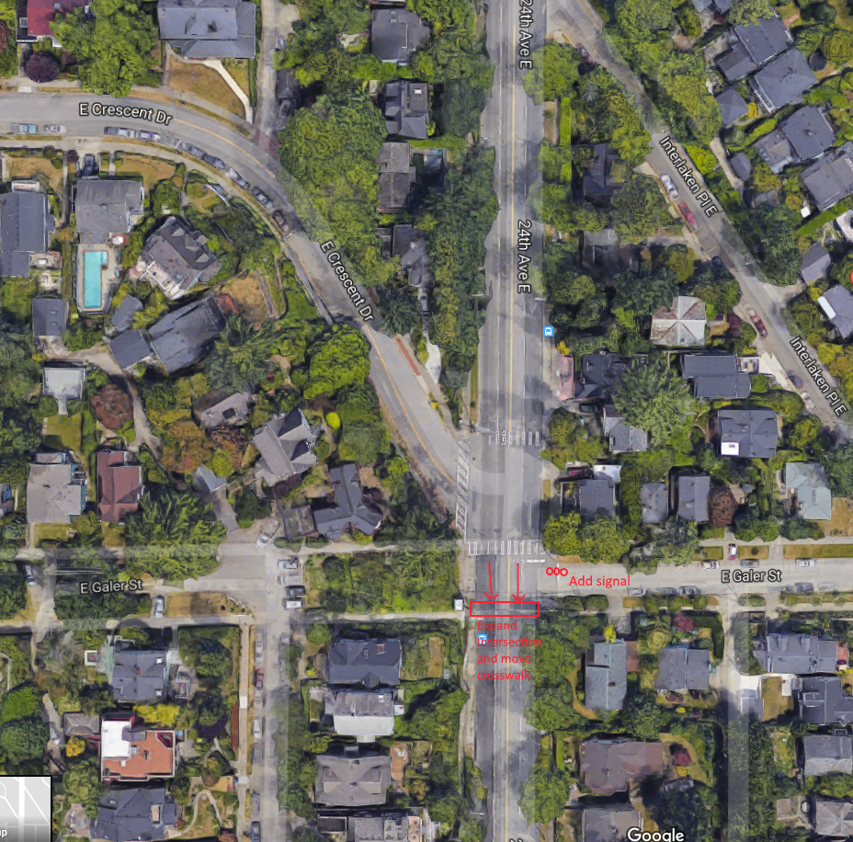

- I attended the recent open house in Montlake for the 23rd Ave. Vision Zero project and wanted to share my thoughts on the complex, interrelated issues along 24th Ave. E.
- First, every time I travel along the 3-lane configuration of 23rd Avenue through the Central District, be it on a bus, in a car, on a bike or on foot, I think, wow, this so much better, safer and more pleasant than it used to be. Thank you to SDOT for doing such a great job designing and building that segment.
- I enthusiastically support the proposed configuration of 24th Avenue between Boyer and John; it seems like the best approach to address chronic downhill speeding (sometimes in excess of 60mph) while preserving or enhancing transit reliability. The street will be easier for pedestrians to cross with only one downhill lane, and it should be easier and safer for drivers to take a left turn (southbound or northbound, from any of the intersections) with only one lane of general purpose traffic to cross. That said, we need a traffic signal at Interlaken Boulevard (not Interlaken Place), which wants to be a great bicycle connection from the Arboretum. Without that signal, it's necessary to travel on sidewalks down to Boyer and back up, which makes the whole experience of Interlaken Blvd. discontiguous. Interlaken Place is a cute street but it's sort of a glorified alley; Interlaken Blvd. is the natural bicycle and pedestrian route from the Arboretum to Interlaken Park. I don't think the proximity of this intersection to Boyer is an issue; lots of streets have signals in close proximity. Design it to be visible. Perhaps a landscaped median here might ease the crossing and knit together the two halves of Interlaken Blvd.
- North of Boyer, it's clear that at least some of the time, two northbound lanes are required on 24th Ave. E for queue storage on this principal arterial approaching the often-congested SR 520 interchange and the Montlake drawbridge. Unfortunately, with no transit priority, buses are chronically delayed heading northbound during congested times. I have seen traffic back up all the way to Boyer in the extreme; I'm not sure what can be done about that even in the long-term and even with a potentially large expenditure. We missed the only real opportunity to fix the Montlake Bridge bottleneck when the state elected not to fix the Montlake Bridge bottleneck as part of SR 520 reconstruction with something like the Pacific Street Interchange plan; a second drawbridge for vehicular traffic would be expensive and hugely disruptive without fixing this problem. So I am begrudgingly okay with two northbound lanes in this stretch, at least during the day.
- Southbound, the proposal to retain the status quo (two southbound travel lanes) seems overly generous, a missed opportunity. In the 25 years I have lived here, I have never once seen traffic back up southbound, even when one lane is temporarily closed. Could the leftmost of the two southbound lanes be turned into a center turn lane for a stretch, as is proposed south of Boyer? Could curb parking be extended further north and south of the business district, southbound on 24th Ave., at least for part of the day? Parking for a portion the hours of the day seems to work fine on other arterials like NE 50th St. in Wallingford... why couldn't that work here? It seems like something more can be done.
- When the traffic is not crawling through Montlake, it's moving too fast. At the open house, I learned two disappointing things: (1) apparently Federal law prohibits the use of traffic signals to manage traffic flow, and (2) apparently state law prohibits the use of traffic cameras for general speed enforcement (beyond school hours.) I believe these policies are sorely misguided, but the city is not in a position to change them for this project. Given that, what else can be done to limit speeding along the relatively flat stretch of 24th Ave. north of Boyer? The status quo is not OK. I feel like I am taking my family's life in my hands every time I walk even a block along 24th Ave. in this stretch, with cars and trucks speeding through like it's a highway. I feel irresponsible walking a dog along that sidewalk with traffic zooming by at 45mph a few feet away, even just outside the door of the cafe at 24th/Lynn. Something must be done. What does the City propose? So far I'm not seeing anything to address the speeding problem in Montlake.
- The proposed traffic signal at E Lynn St. should be constructed; it would serve existing and new mixed-use construction in that area and help to signal to drivers that this is a neighborhood and a business district, not a highway. I would support an additional signal at E Miller St. if the money can be found as the existing crossings at E Louisa and E Miller Streets are so unsafe (with poor visibility) they are an attractive nuisance.
- We need curb ramps on the sidewalks along 24th Ave E. Recently, I've been finding and using shared bicycles along 24th Ave. and riding to the UW Link station. From there, I typically take the sidewalk because the street is too dangerous and the greenway is uphill. The sidewalks along 24th Ave. need curb ramps all along the corridor for bicycles, baby carriages, wheelchairs and other wheeled-vehicles to be able to travel safely. Sidewalks along 24th Ave E are often broken up and foliage often impedes visibility and access. Maintenance of this right of way is the responsibility of adjacent residents, but many of those residents seem to be largely ignoring that responsibility. The west side of 24th Ave E between Roanoke and Louisa is particularly unpleasant.
- The southbound bus stop in front of the Montlake Library at 24th/McGraw has received a Metro bus shelter, which is good, but placement of this shelter and related signage and street trees impede pedestrian access along the sidewalk in this location. The shelter could and should be pulled back onto adjacent library property that is otherwise essentially unused, preferably via a simple agreement but via eminent domain if needed. The small waste can in this location has no cover and is constantly being disrupted by crows, so the area is frequently full of garbage which makes for a depressing place to wait for the bus as traffic zooms by. As this is the primary southbound transit stop for the library and business district, we must do better.
- Regarding the nearby greenway: I heard that the stairway upgrade along the greenway from Boyer up to Interlaken is at 60% design. I haven't heard any firm commitment on the scope of this project. If the scope does not provide for a continuous ramp (similar to what was constructed from the Burke-Gilman Trail to Children's Hospital) then I and the next generation of bicyclists will be deeply disappointed. A reconstructed stairway that is not usable by bicycles is a virtually useless upgrade, and without a ramp connection (and a runnel does not count!) here the greenway is incomplete. I don't understand why a paved ramp should be an issue; this isn't a protected wetland and we have ramps in parks all around the city. Just build it please!
- $3.5 million for this project is better than nothing, but frankly it's a lot less than what is deserved for this vitally important corridor that will eventually host a RapidRide route. The $4.5 billion spent on SR 520 is over 1200x this figure. We're familiar with 1% for art, but it's less than one tenth of 1% for 24th Ave. That is a shamefully low amount for the region to be budgeting on a major arterial street that carries a significant fraction of the volume of SR 520 itself, especially when the SR 520 project is sending more traffic to 24th Ave. than ever before in its new configuration.

Regarding the proposed revised street section for 23rd Ave with a bus lane, two vehicular lanes and a center turn lane, given that this area is almost completely residential the turn lane does not seem that useful. Between major intersections its function seems mainly just to be a spacer between the opposing traffic lanes. Are there studies to show the center turn lane configuration to be particularly safe?

Instead of including the center turn lane throughout, how about adding a parking lane on the northbound side of the street at locations between major intersections? At major intersections the turn lane configuration would be used. Street parking has been shown to slow down traffic, and the changing position of the northbound travel lane should also slow drivers down.

Thank you for the opportunity to comment on needed changes on 23rd Ave East.

Going south, it is practically impossible to turn left off 23rd at John. Since there is no turning lane and the oncoming traffic is so heavy, people (including myself) have taken to turning left on Aloha, Roy, Mercer, in order to get down to MLK and avoid the bottleneck at 23rd and John, with a noticeable increase in traffic in this neighborhood.

Furthermore, when you are traveling south and get in the right lane nearing John, so as not to wait forever behind a car trying to turn left in the center lane, you must immediately get back into the center lane after crossing John if you want to continue south. The right lane is reserved for right turns. There is only room for about six cars between John and Madison in the center lane.

This could all be solved with a left turn arrow signal for both north and south traffic on 23rd at John, or a turning lane.

Please restrict the traffic on 23rd Ave E by tolling the road and adding a bike lane. Any less aggressive action is unlikely to rid the street of the congestion that it currently has.

I realize that SDOT and the City Council have a glorious vision of spending our money in order to attempt to move people from cars to bicycles and buses, but what you are doing is driving people away from Seattle. Do you have any idea how long it would take to go down 23rd/24th Avenue on garbage day with only one lane? And why is a bus lane so important for a street that currently has only two bus routes? Get your priorities straight. Spend our money wisely to get this city moving. Leave 23rd/24th with two lanes both directions. There are other means of reducing speed such as speed tables.

Attn: Dawn Schellenberg, Community Engagement Liaison

Hello 23rd Ave Corridor team,
I am attaching comments regarding much-needed measures to improve pedestrian safety in the northern 24th Avenue zone between E Boyer and E Roanoke Streets.

Especially because the current plans calls for maintaining 4 lanes of traffic north of E Boyer Street, it is imperative to consider pedestrian safety for residents crossing to/from Montlake elementary school, as well as the many transit commuters walking along and across this corridor each day. Specifically, I suggest additional pedestrian crosswalks (even apart from traffic lights). Pedestrian safety would increase with an additional pedestrian crosswalk at or near E Miller Street, between Roanoke and McGraw, at the northern-most part of the corridor where foot-traffic is very high for commuters and families.

Thanks for your consideration of my comments.

I wasn't able to attend the meeting, but my completed comment form is attached.

I like the proposal to reduce and narrow the general purpose traffic lanes, using the reclaimed space for a bus lane and center turn lane. It would be nice if there was space for an uphill protected bike lane, especially from Boyer to Aloha where traffic is usually less congested. The bus lane will definitely be useful south of Aloha, especially near John and Madison. Although it seems out of scope for this phase, a northbound bus-only lane would be very helpful north of Boyer.

A new signal at Interlaken Blvd would provide a good, safe connection between the Central Greenway terminus in Interlaken Park and the Lake Washington Loop route on 26th Ave E.

Consider additional improvements to make crossing 23rd Ave E safer and easier between John and Aloha. The only signalized crossing between these streets is at Republican, which doesn’t continue any further east and takes a long time to give pedestrians a walk signal. Many people, including students at Meany, try to cross 23rd Ave E at Thomas but drivers rarely yield.

Seattle Dept. of Transportation,

Regarding 24th Avenue street changes at north Capitol HIll

Please note:

This immediate neighborhood west of 24th Ave, east of Interlaken Park, north of Crescent and south of Boyer will be significantly impacted by the proposed changes to 24th Ave. E.

Reducing road capacity from 2 to 1 lanes will create a continuous backup on 24th, resulting in vehicles finding alternative routes through adjacent neighborhoods to destinations on Capitol Hill.

The adjacent neighborhoods are typically designed with very narrow roads for 1 lane of travel shared by vehicles moving in opposite directions. In the best of times, this results in “jockying” about to allow on-coming vehicles to pass. This now occurs on Interlaken Pl. and Crescent St. Neither of these streets can accommodate significant additional traffic.

Please convey to the adjacent neighborhoods how you are going to manage increased traffic on residential streets and resolve increased safety problems caused by the reduction in capacity of 24th Ave E.

I was unable to attend the 23rd Ave drop-in event at the Montlake community center, but I am attaching my comment card for the 23rd Ave corridor project and also a pdf file that suggests an alternate configuration for the intersection of Boyer Ave E and E Lynn St that I think might improve both the safety and the throughput of the intersection. In short, I suggest removing the island and making the intersection smaller to improve visibility for both drivers and pedestrians. My wife was almost hit by a car at this intersection earlier this year, and I cross it almost daily with my daughter, so that I tried to think carefully about what might help make the intersection safer.

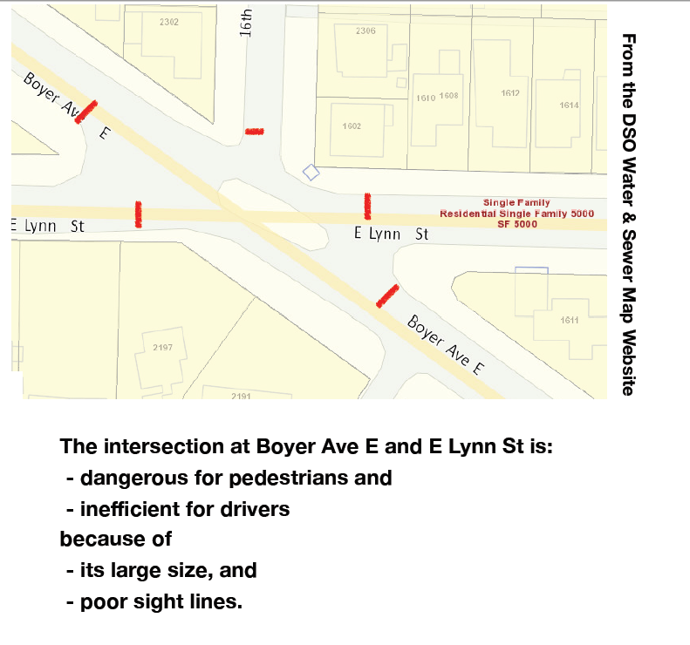

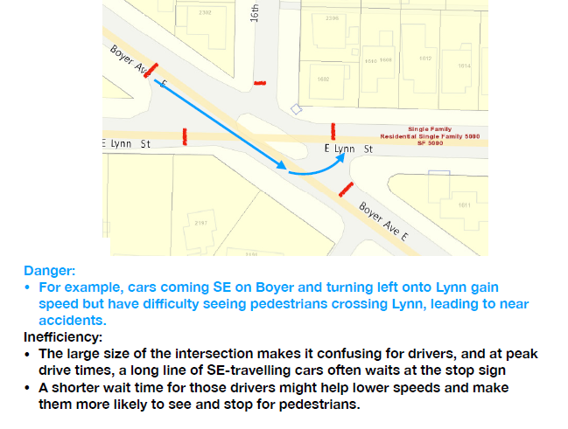
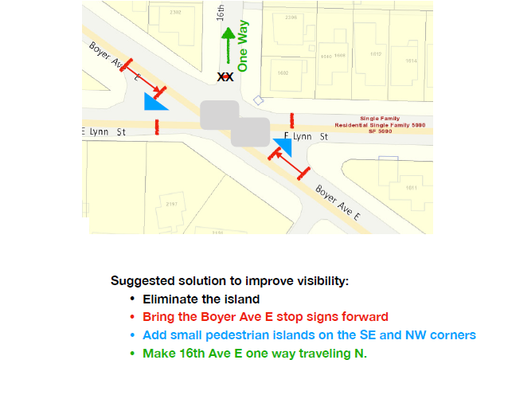

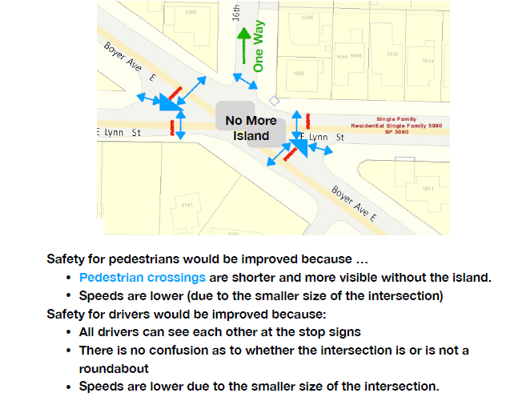
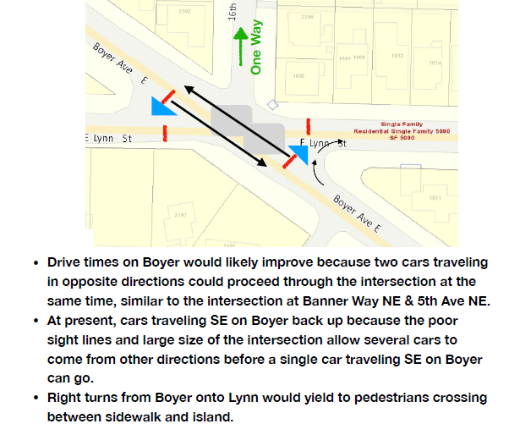

Those of us who are parents of the many, many children who cross or catch their school buses at the intersection at 23rd Avenue East & East Aloha worry about many dangerous aspects of this fast, offset, busy intersection. Please read the attached analysis of school bus & student pedestrian usage of this intersection and include safety improvements of the intersection in your 23rd Avenue Corridor plans.

