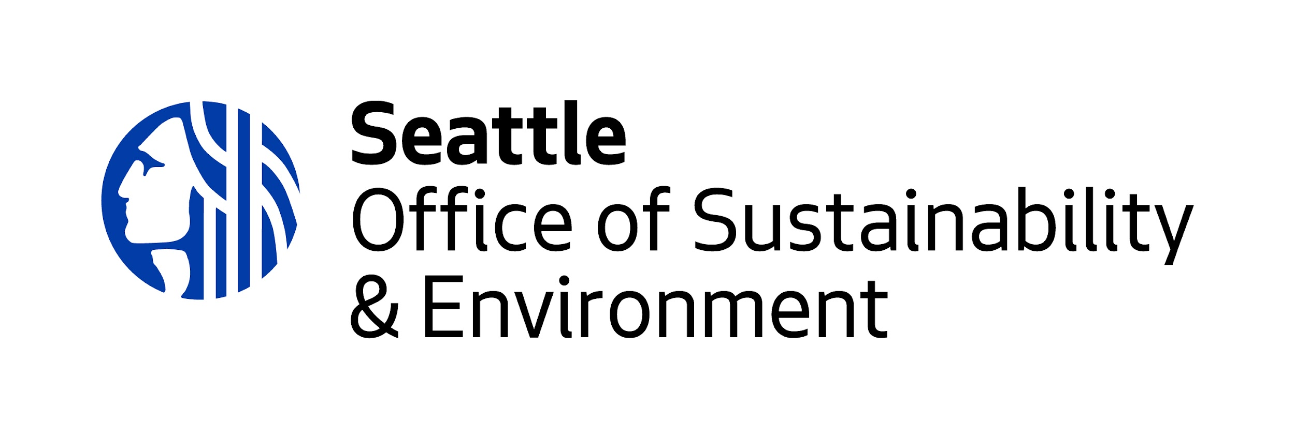

Duwamish River Opportunity Fund
2023 Project Narrative Application Questions

Please note this worksheet is intended to be a resource while you develop your proposal. Your proposal will need to be submitted online here.

Response length: We encourage brief responses whenever possible (1-3 paragraphs), keeping in mind the capacity of the community reviewers. If reviewers want more details or clarification, they can ask for them during the Q&A period (Sept 18 - 29).

1. PROJECT DESCRIPTION: What will you do, and how will you do it? What is the DROF priority area this project will advance?

2. COMMUNITY BENEFIT: Please specify the Duwamish Valley community(ies) this project would serve. How will the community benefit from this project?

3. COMMUNITY LEADERSHIP: How are Duwamish Valley community members or organizations involved in this project? Who is leading the project and what lived experiences/skills does the project team bring?

4.MILESTONES: Provide a list of the main activities (milestones) that will be completed through this project. (Could be a bullet point list.)

5. PROJECT OUTCOMES: What are your main project outcomes? How do these outcomes help improve the quality of life for the Duwamish Valley??

6. RACIAL JUSTICE: What practices and approaches does your organization or group use to advance racial justice? How do you measure the success of your practices and approaches?

