Sample mobilization message for organizations
(can be adapted for individual messages, Facebook postings, as well)

Dear ___________:

[Name of organization] urges you to come to the 2020 Tax Amazon campaign launch on Monday evening, January 13. Please join us, Councilmember Kshama Sawant, Association of Flight Attendants President Sara Nelson, and hundreds more:

Tax Amazon 2020 Kickoff
Monday, Jan. 13, 2020
6 pm
Washington Hall
153 14th Avenue
Seattle 98122

Working people in Seattle just made history in beating Amazon and the Chamber of Commerce by re-electing Kshama Sawant to City Council, along with other progressive candidates. The election was a repudiation of city government business-as-usual, and sent a clear message to Amazon that Seattle is not for sale!

On January 13, [name of organization] will participate in launching the new Tax Amazon movement, dedicated to taxing the wealthiest big corporations in our city to build thousands of new homes: quality, social housing that is union-built, publicly-controlled and permanently affordable. Amazon and the other super-wealthy corporations in Seattle, who are raking in tens of billions in profits annually, must be taxed to fund this new housing - not working families and small- and medium-sized businesses.
We’re fortunate to be joined by Sara Nelson, the dynamic national union leader, who will be administering the oath of office to Kshama Sawant at the Jan. 13 rally.
Sara is a fighter and hero of the labor movement, who captured the attention of working people globally earlier this year when she courageously called for a general strike against Trump’s government shutdown, and led the way in defeating it. Sister Nelson has continued to call for workers to unite and fight back against the ravages of capitalism - here, and worldwide.

There is tremendous momentum to Tax Amazon and major corporations to build the affordable housing we so desperately need. But it will take a powerful movement to to win. Big business spent $4.5 million trying to defeat Kshama Sawant and other progressives, and they will spend even more to protect their profits. Our work begins on January 13.

Here’s what you can do to make jan. 13 a great Tax Amazon kickoff:

- Come to the event!
- Spread the word on Facebook to all of your friends!
- Post this event graphic on Instagram!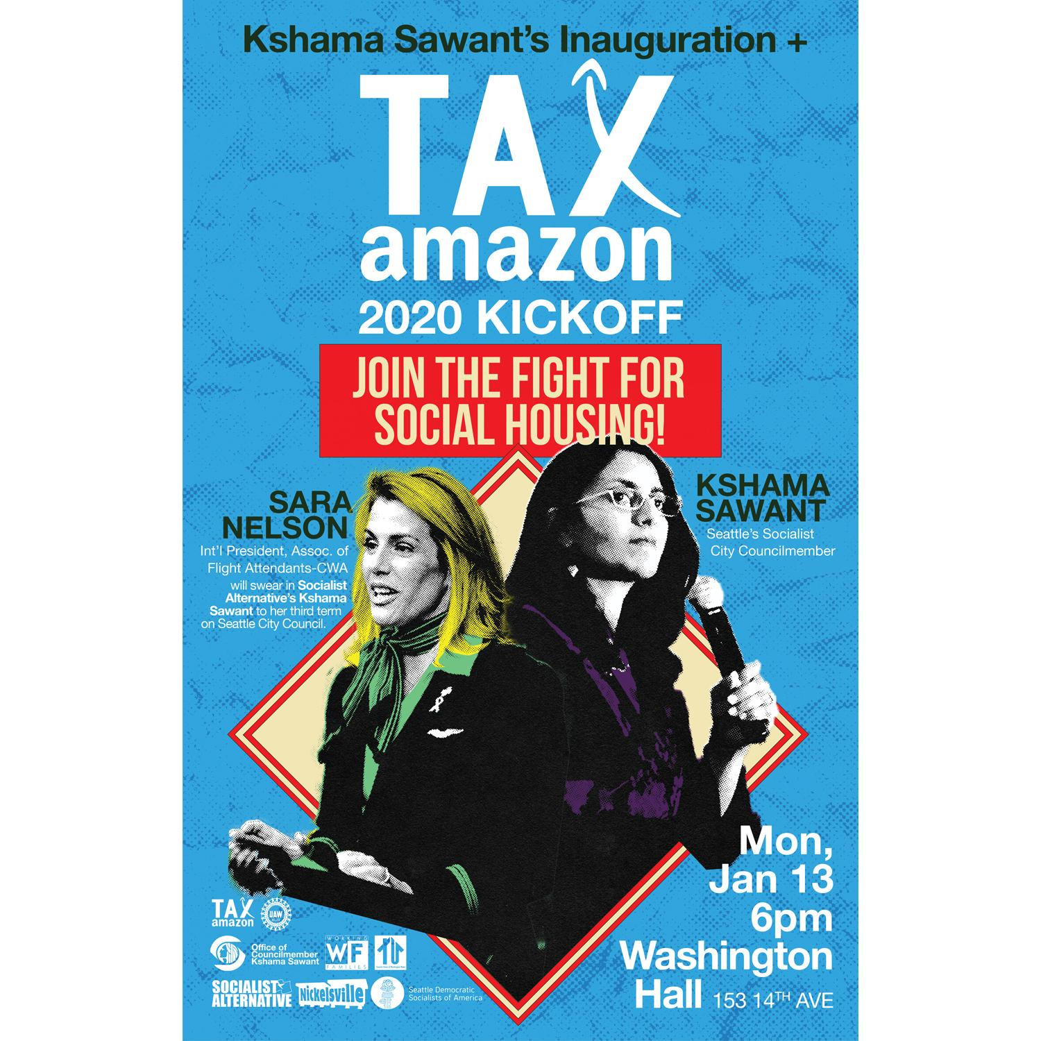
- Hand out leaflets to your co-workers, friends and neighbors! You can download a leaflet.
- Contact Kshama Sawant’s Council office at 206-684-8016 if you want to volunteer for postering, phone-banking, and other mobilization activities.

Please join us!

In solidarity,

[names of signers]

