RapidRide J Line

Frequently Asked Questions about the RapidRide J Line project
Last updated September 1, 2021

Project status

Is the RapidRide J Line project still moving forward?
Yes! With existing planned funding, we’ll be able to continue to plan for RapidRide J Line service from downtown Seattle through South Lake Union to Eastlake and the University District. The project needs to receive an environmental determination before proceeding into final design. The project will then secure all grant funding prior to starting construction which is currently planned to start in 2023. The RapidRide J Line could begin service as soon as 2026.

Now that the line is being shortened, will you be able to complete the project faster?
No. The project is required to submit a Supplemental Environmental Assessment to the Federal Transit Administration as part of the National Environmental Policy Act process to evaluate potential impacts associated with the shortened route, which will add additional time to the project’s overall schedule. Including the Supplemental Environmental Assessment process, the project is expected to begin construction in 2023. We also don’t expect the shortened route alignment to reduce the overall construction schedule because construction activities along Eastlake Ave E are likely to require the longest duration.

What is the Supplemental Environmental Assessment?
In January 2020, the Seattle Department of Transportation (SDOT) and Federal Transit Administration released the Environmental Assessment and Section 4(f) Analysis for the RapidRide Roosevelt (J Line) project in accordance with the National Environmental Policy Act (NEPA). The document provided a comprehensive analysis of the project, including proposed improvements, technical details, potential impacts, and mitigation strategies.

Before we advance into final design, the project is required to submit a Supplemental Environmental Assessment to the Federal Transit Administration to analyze any new impacts from the shortened route, north of the University Bridge. The Supplemental Environmental Assessment will include a formal public comment period in 2021. The Federal Transit Administration will then make an environmental determination based on both the original assessment and the Supplemental Environmental Assessment.

If no significant issues are identified during the comment period, the Federal Transit Administration would make the determination to issue a Finding of No Significant Impact (FONSI). A FONSI allows the project to move forward with final design. During final design, the project will advance the engineering and continue to work with community members on access strategies, construction phasing, and other concerns.

The nearly 400 comments we received on the original Environmental Assessment will be addressed when the environmental determination is issued.

With the Supplemental Environmental Assessment process, construction for the project is now expected to start in 2023.

Will the modified RapidRide J Line still maintain RapidRide levels of service?
Yes. The modified route will still meet RapidRide levels of service.

The Supplemental Environmental Assessment will evaluate the shortened alignment’s specific impacts on service, including travel time and frequency. Some stations near the U District Link Station may include a modified RapidRide station design due to space constraints and rider needs. For example, the final northbound station will not include a shelter because riders are only dropped off there, so people aren’t waiting for a bus at this location.

Will the project name be changed from RapidRide Roosevelt to something else?
When service starts, the route will be called the RapidRide J Line, so we’ve started to use RapidRide J Line to describe the construction project as well. To support that transition, we’ve used a combined name for the past year: RapidRide Roosevelt Project (RapidRide J Line). The ongoing Environmental Assessment refers to the project as the RapidRide Roosevelt project. To avoid confusion, we’ll continue to use both names until we receive an environmental determination.

With COVID-19 changing travel patterns, is RapidRide J Line still needed?
While COVID-19 is unprecedented, our communities still need RapidRide J Line.
  - The University of Washington and surrounding commercial district are more stable demand drivers. During COVID, the current route 70 has maintained a high ridership.
  - Given the rise in telework, households may also decide to downsize to one car and rely on transit more actively.
  - Even if the job and population growth along the route stagnates, the route would benefit from the infrastructure upgrades that improve transit frequency, travel time, and reliability.
  - Transportation is the largest source of emissions, contributing 62% of greenhouse gas emissions in Seattle. Providing attractive alternatives to driving alone is critical to meeting Seattle’s climate change goals.

Shortened route in the U District and Roosevelt neighborhoods

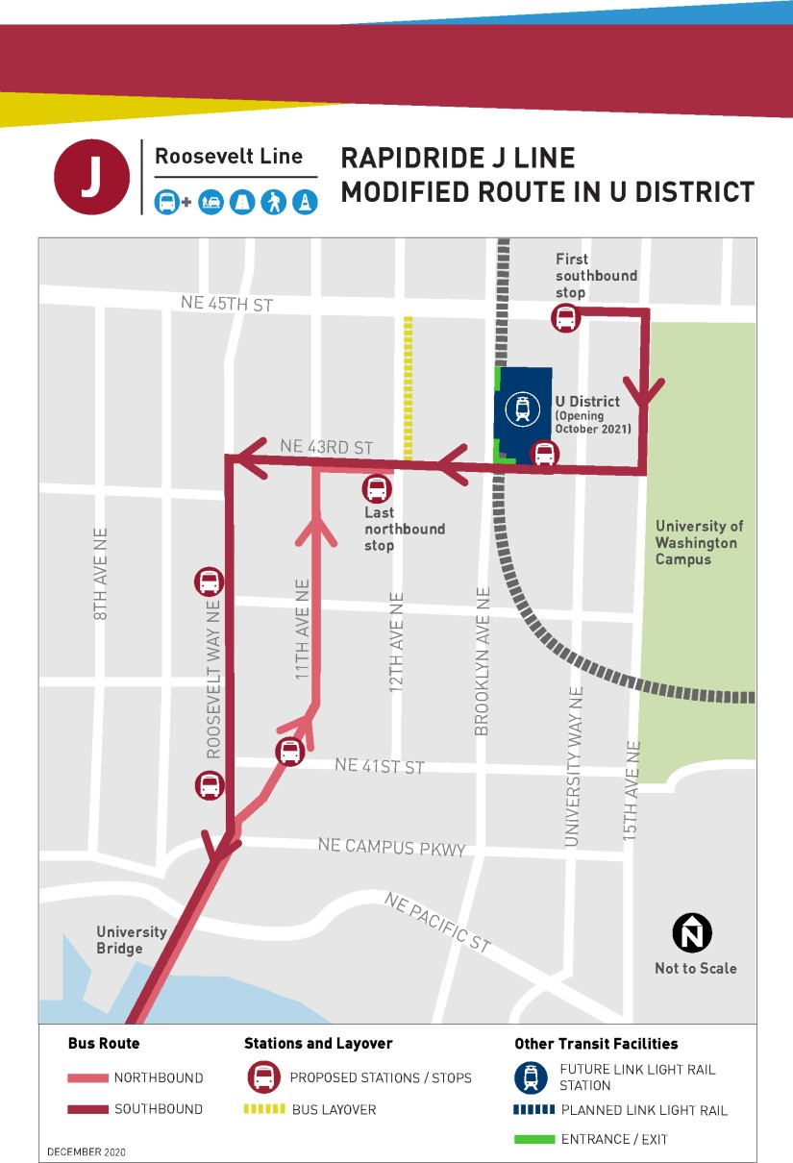
Where will the RapidRide J Line actually end, turn around, and layover?

  - The last stop when traveling northbound on the modified route is near the NE 43rd St and 12th Ave NE intersection, one block from the U District Link light rail station.
  - The modified route plans to use the layover that will be implemented as part of the North Link Connections restructure in September 2021. The layover is on 12th Ave NE between NE 43rd St and NE 45th St.
o What is a layover? After finishing a trip, King County Metro buses often wait for a few minutes before starting their next trip. These planned layovers are important. They help buses start their next trips on time. Layovers also allow bus operators to take necessary breaks, helping them stay alert behind the wheel.
  - The modified route plans to turn around and start its southbound service on NE 45th St after laying over on 12th Ave NE.

Does this mean RapidRide J line will never be extended to Roosevelt as originally planned?
At this time there is no budget or plan to do so, but the option does remain open to extend this project further north in future years if additional funding becomes available. You’ll still be able to take the Route 45, 67, and 73 bus between the Roosevelt and U District Link light rail stations. You can learn more about north end transit connects on King County Metro’s North Link Connections Mobility Project website.

Why is the last northbound station one block away from the U District Link light rail station?
We tried to balance getting the northbound route as close to the U District station and University of Washington campus as possible while balancing capital and operational considerations. For example, the operational improvements are expected to improve reliability and reduce the time for the bus to travel which will offset the additional time it would take to reach your final destination. With the North Link Connections restructure, several other transit routes will also connect more directly to campus, some of which will share stops with the RapidRide J Line to streamline transfers. You can learn more on King County Metro’s North Link Connections Mobility Project website.

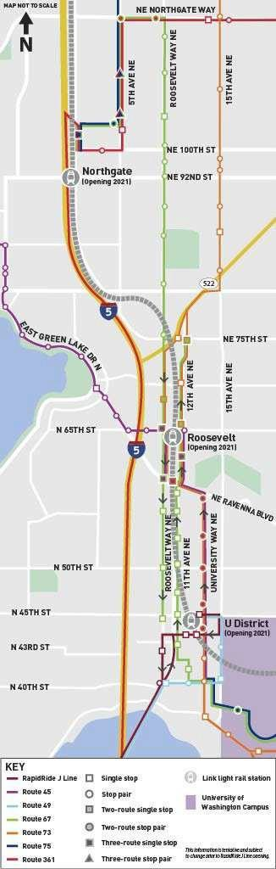
What are my alternative transit options in Roosevelt now that the RapidRide J Line will end near the U District Link light rail station?
There are other transit alternatives in the Roosevelt neighborhood that connect to the RapidRide J Line and the U District Link light rail station, providing options for transit riders in this area.

The originally planned RapidRide J Line route ran parallel to Link light rail between the Roosevelt and U District stations. Riders can use Link light rail to travel directly downtown or transfer to RapidRide J line at the U District station for access to Eastlake and South Lake Union.

King County Metro also plans to implement network changes through the North Link Connections restructure in September 2021 to improve local transit connections to Link light rail. The revised network offers a couple of alternatives for riders between the Roosevelt and U District Link light rail stations, including:
  - Route 45 provides a frequent, all-day connection between Roosevelt and U District stations via University Way NE.
  - Route 67 provides frequent, all-day transit options between the two stations via Roosevelt Way NE and 11th/12th Ave NE.
  - Route 73 provides local service between the two stations along 15th Ave NE, Roosevelt Way NE, 12th Ave NE, and University Way NE.

Route 361 will also provide a connection between Northgate and South Lake Union during peak hours.

The RapidRide J Line will further improve transit connections to the Eastlake and South Lake Union neighborhoods with the Roosevelt neighborhood and University District.

With the North Link Connections restructure, several other transit routes will also connect more directly to campus, including 44, 48, 49, 65/67, 75, and 372.

Several of these routes will share stops with the RapidRide J Line to help streamline transfers.

* King County Metro implements service revisions every six months to improve service. There may be minor revisions to some of these routes before the RapidRide J Line opens. As the overall transit system evolves, we’ll continue to refine RapidRide J Line’s connections to other routes.

Why not continue to use the revised route 70?
King County Metro plans to implement network changes through the North Link Connections restructure in September 2021 when the three new Link light rail stations open in north Seattle. When RapidRide J Line service starts, it would replace the revised Route 70.

The modified RapidRide J Line deviates from the revised Route 70 to travel along Roosevelt Way NE and 11th Ave NE. We chose to keep this consistent with the original RapidRide J line because it is:
  - Consistent with community expectations and input over the last several years on the RapidRide J Line as well as Seattle and King County Metro’s long-term planning, including the Transit Master Plan and Metro Connects.
  - Consistent with existing grant funding for the project.
  - Forward compatible by keeping the option open to extend the RapidRide J Line to the Roosevelt Link light rail station in future years if additional funding resources become available.

The RapidRide J Line will also improve transit speed and reliability by avoiding some of the congestion and additional turns along NE Campus Pkwy and 15th Ave NE. Each signal a bus passes through increases the over travel time and unpredictability. North of the University Bridge, the proposed RapidRide J Line only goes through two signals north, while the modified Route 70 goes through seven.

The RapidRide J Line also plans to add stations at NE 41st St and Eastlake Ave NE. Compared to Route 70, this would add about an additional 4 minutes for students walking to the dorms along NE Campus Pkwy or for anyone who wants to use the pedestrian overpass on 15th Ave NE.

With the North Link Connections restructure, several other transit routes will provide service more directly to campus, some of which will share stops with the RapidRide J Line to streamline transfers.

King County Metro can’t implement the U District portion of the RapidRide J Line route now instead of the revised Route 70 because the RapidRide J Line would require additional capital improvements, like overhead trolley wire, and the project is pending environmental approval. In the meantime, the revisions to Route 70 improve access to the U District Link light rail station by using existing infrastructure and adding a new stop on NE 43rd Street at Brooklyn Avenue NE.

Revised Route 70 in U District Planned for 2021
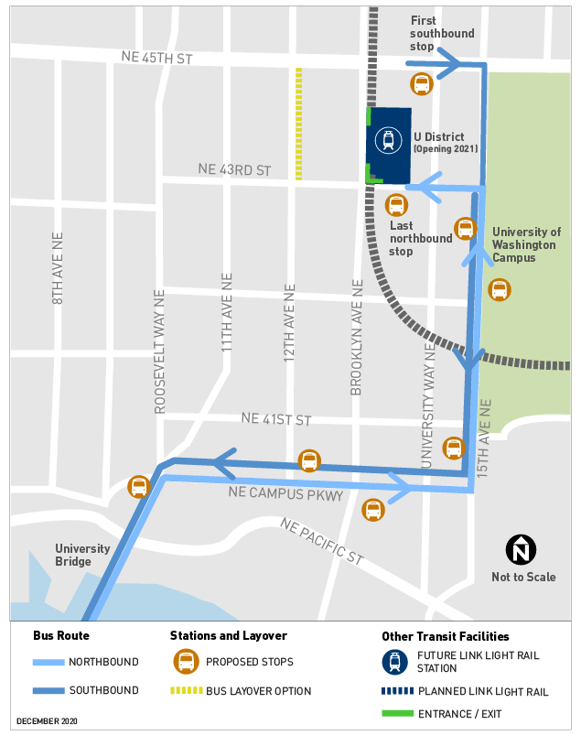
RapidRide J Line Modified Route in U District
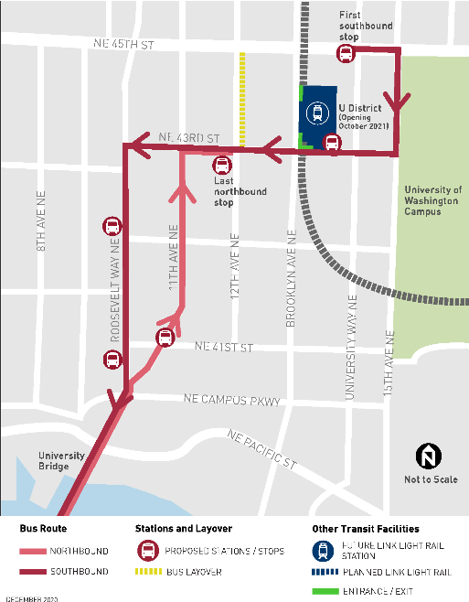

Will there be additional construction and upgrades on NE 43rd St for the RapidRide J Line?
With the U District Link light rail station opening in 2021, several projects are upgrading NE 43rd St to improve connections for people walking or riding their bike to the station and University of Washington campus. In addition to repaving and upgrading sidewalks with ADA ramps, these projects are adding protected bike lanes on NE 43rd St and installing secure bike storage at the U District station. To improve traffic flow, we are also converting NE 43rd St to westbound only traffic between 15th Ave NE and Brooklyn Ave NE, with transit only between University Way NE (“The Ave”) and Brooklyn Ave NE.

Projects upgrading NE 43rd St include the:
  - NE 43rd Street Improvements project
  - 12th Ave NE and NE 43rd St Paving project
  - Sound Transit U District Link light rail station project

RapidRide J Line will harness and expand on existing plans to upgrade NE 43rd St between Roosevelt Way NE and 12th Ave NE, including:
- Add new pavement on NE 43rd St between Roosevelt Way NE and 12th Ave NE and continuing down 11th Ave NE to NE Campus Pkwy.
- Extend the protected bike lanes on NE 43rd St and add northbound protected bike lanes on 11th Ave NE down to the University Bridge.
- Upgrade the intersections with ADA ramps to improve accessibility.
- Evaluate the sidewalk and lighting conditions to see if upgrades are needed to improve accessibility and safety for people walking.
- Extend the Overhead Contact System (OCS), the overhead trolley wire that will allow the RapidRide J Line to run on electricity.
- Modify the existing traffic signal at 11th Ave Ne and NE 43rd St to support the trolley wire and analyze if a dedicated phase for people biking would be beneficial.
- Evaluate adding a traffic signal at Roosevelt Way NE and NE 43rd St. Analyze if this will make it easier for buses to turn left onto Roosevelt Way NE as well as improve the experience for people walking and biking.

How many buses per hour will be stopping along 43rd and at the U District Station?
During peak hours (from 7 – 9 AM and 4 – 6 PM weekdays), RapidRide J Line will arrive every 7.5 minutes. This means up to 8-10 RapidRide J Line buses will stop along NE 43rd St at the U District Station per hour. Following the North Link Connections restructure, several bus routes will also travel along NE 43rd St.

King County Metro’s North Link Connections Mobility Project will improve bus connections to the three new Link light rail stations in 2021, so several other routes will also stop along NE 43rd St.

Will the University Bridge openings cause the RapidRide J Line to be delayed?
We analyzed the potential impact the University Bridge openings could have on the RapidRide J Line in the original Environmental Assessment. The University
Bridge is not allowed to open during RapidRide J Line’s peak hours (7 – 9 AM and 4 – 6 PM weekdays) except for rare situations that only occur a few times a year. The bridge opening typically takes up to 4.6 minutes, which the RapidRide J Line can make up for along the rest of the route. The bus only lane planned near the University Bridge will also help minimize the impact. Overall, the bridge openings will have a minor impact on RapidRide J Line’s speed and reliability.

When revising the RapidRide J Line did you consider terminating at Husky Stadium to provide better connections to the University of Washington Medical Center?
The original alignment to the Roosevelt Link light rail station was identified back in 2016. Shortening the RapidRide J Line to the U District Link light rail station is consistent with community input over the last several years, maintains grant funding, and keeps the option open to extend to the Roosevelt Link light rail station if additional funding becomes available in the future.

Rerouting the RapidRide J Line to Husky Stadium would have been a more significant change to the RapidRide J Line design. Link light rail and other transit routes also provide better access to Husky Stadium and the University of Washington Medical Center.

Station/stop locations

Will RapidRide J Line service come with increased fare enforcement along the route compared to the Route 70?
The use of all-door boarding on RapidRide service usually comes with fare enforcement that is different from regular bus service.

Fare enforcement is currently suspended on all Metro bus service—including RapidRide service—at least through 2020. An update on this decision is expected soon. As part of the adopted 2021-2022 King County budget, Metro is exploring the relationship between safety, fare enforcement, policing, and its impact on
equity. Metro is working with King County, the King County Sheriff’s Office, cities, and community stakeholders to explore ways to provide safety, security and equity to all of our passengers.

When RapidRide J Line service starts in 2026, fare enforcement will likely look much different—both as part of the move from regular service to RapidRide
service, and as part of Metro’s reimagining of safety across the mobility network.

Will you be updating any of the bus stops in the U District?
Yes, we plan to install several new stations and upgrade some existing stops in the U District. We’ll continue to study and refine the station designs as part of the Supplemental Environmental Assessment.

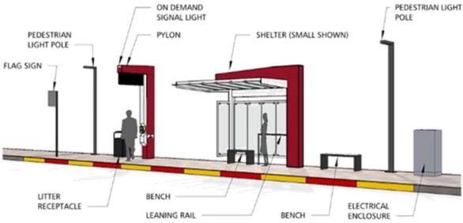
RapidRide stations have more amenities than a standard bus stop, including real- time arrival information, shelters, and all- door boarding. We plan to install several new RapidRide stations in the U District:
  - On Roosevelt Way NE near NE 41st St
  - On 11th Ave NE near NE 41st St
  - On Roosevelt Way NE near NE 42nd St

The last northbound stop on NE 43rd St near 12th Ave NE will likely just be a standard sign post with the route name because riders are only dropped off at this location. Since people aren’t waiting for a bus, real-time arrival information and a shelter aren’t necessary.

The first southbound stop on NE 45th St near University Way NE is an existing stop that currently relies on the adjacent building’s overhang to shelter riders while they wait. There’s limited space, so while we plan to add real-time arrival information, we likely won’t be able to install all of the typical RapidRide stop amenities.

Sound Transit is currently installing the southbound stop at the U District Link light rail station, which will include some additional amenities. The revised route 70 will use this stop once King County Metro’s North Link Connections Mobility Project is implemented in 2021. We’re coordinating with Sound Transit and may upgrade this stop further when we construct the RapidRide J line.

Why not shift the southbound stop on NE 45th St to the west so it’s
closer to the U District Link light rail station?
This is an existing stop that will be served by several routes. We’ll analyze the feasibility and impact of shifting the stop to the west, closer to Brooklyn Ave NE. If it’s feasible from a technical and operational standpoint, then we’d work with not only riders, but also nearby residents and the Neptune Theater to discuss potential impacts and tradeoffs given the limited space.

Will the RapidRide J line lengthen the southbound bus island on Roosevelt Way NE at NE 42nd St?
We’re exploring whether improvements like lengthening the bus island are.
needed at this stop. We’ve started analyzing this station as part of the Supplemental Environmental Assessment but may not get to that level of detail until the final design.

How will people walking, biking, and riding transit interact at the upgraded RapidRide stations?
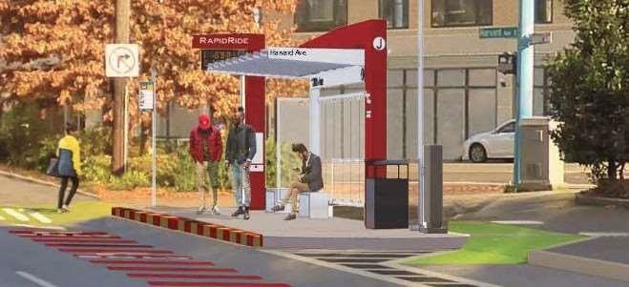
We’ll refine the station plans during final design and each station may be slightly different.

Based on the current best practices, we’ll likely route the protected bike lane behind the bus station to reduce conflicts between the bus and people biking. We
may also raise the protected bike lane at the station to encourage people biking to slow down. The bus shelter helps create a buffer between people biking and waiting for transit.

Bike facilities

Will SDOT still install protected bike lanes in the U District?
Yes, SDOT still plans to install protected bike lanes through RapidRide J Line and other projects on:
  - 11th Ave NE from the University Bridge to NE 43rd St
  - NE 43rd St

SDOT is still exploring several options to extend protected bike lanes on 11th Ave NE to the Roosevelt Link light rail station as originally planned.

Will the protected bike lane on 11th Ave NE be on the left or the right side of the street?
The protected bike lane will be on the right hand (east) side of 11th Ave NE between the University Bridge and NE 43rd St.

If another project extends the protected bike lane farther north towards the
Roosevelt Link light rail station, we’d decide then whether to shift the protected bike lane to the left side at NE 43rd St as shown in our preliminary plans.

Best practices for protected bike lanes are continuing to evolve locally as well as nationally. For example, we’ve heard some concerns about conflicts on Roosevelt Way NE between people walking and biking, particularly near bus stations.
Seattle’s latest Right-of-Way Improvements Manual recommends placing protected bike lanes on the left side for one-way streets with high-capacity rapid transit, such as RapidRide Roosevelt (RapidRide J Line).
Locating the protected bike lane on the left:
- Improves safety for bicyclists by separating them from other modes and removing them from mixed traffic.
- Reduces the number of potential conflicts with cars at driveways and side streets compared to locating the protected bike lane on the right side.
- Maintains the greatest amount of parking on 11th and 12th Avenues NE.
- Optimizes connections to the Roosevelt Link light rail station for people biking.

When the RapidRide J Line and protected bike lane were originally going to go all the way to the Roosevelt Link light rail station, we were planning to shift the protected bike lane from the left to the right side at NE 43rd St.

Since the RapidRide J Line will now end at NE 43rd St, we’re still planning to install the protected bike lane on the right (i.e., east) side of 11th Ave NE between the University Bridge and NE 43rd St.

- Will the project still install protected bike lanes on Eastlake Ave E? Yes. As part of the RapidRide J Line project, SDOT still plans to install protected bike lanes on Eastlake Ave E, north of Fairview Ave N. As originally planned, we anticipate these protected bike lanes will open when RapidRide J Line service starts.

In response to community concerns we reviewed other bike facility and route options for the project. The one-way protected bike lanes on Eastlake Ave E provided the highest-quality bike facility. Even the least impactful bicycle route that passed the initial screening would still remove 250 spaces on Eastlake Ave E.

Separately, the Eastlake Avenue Protected Bike Lanes Project plans to install protected bike lanes farther south on Eastlake Ave E between Fairview Ave N and Stewart St. You can find the latest updates on the two phases of this project on the project page. Construction for Phase 1 of this project will begin as soon as spring 2021, in alignment with King County Metro's Eastlake Layover Facility. Phase 2 of the project, between Roy St and Fairview Ave N, is still in the early stages of design.

Will the protected bike lanes reduce the width of the sidewalk?
The RapidRide J Line project will typically not impact the sidewalk width. The sidewalk may be slightly narrower immediately behind some of the RapidRide J Line stations but will always be at least 3 feet wide and ADA accessible.

Maintained route in Eastlake, South Lake Union, and Downtown neighborhoods

Are there any updates on the parking mitigation strategies in Eastlake?
We know many community members are eager to advance the parking mitigation strategies and for responses to your comments on the original Environmental Assessment. Responses to the 400 comments we received on the original Environmental Assessment and any new comments received on the Supplemental Environmental Assessment will be responded to in the environmental determination.

To minimize potential delays, SDOT issued a Request for Qualifications (RFQ) in summer 2020 and selected a final design consultant in fall 2020. Once the environmental determination is issued, we can move more quickly to refine the project design and advance key community considerations like parking mitigation strategies including supporting shared parking, relocating load zones, and updating Restricted Parking Zone (RPZ) 8.

Given the updated timeframe, will Eastlake Ave E be repaved in advance of the project?
We’ve considered whether to repave Eastlake Ave E sooner. That would expand the overall construction timeframe and impacts on nearby businesses and residents though because there would be construction for the paving and then additional construction for the RapidRide J Line.
At this point, we’re still planning to complete the paving along Eastlake Ave E during RapidRide J Line construction, which could start as soon as 2023. To avoid rework, minimize costs, and limit the impact on the community we typically try to do the deepest work first. In Eastlake, the water main upgrade is deeper than repaving.

Has the project determined whether to shift the northbound RapidRide station planned on Eastlake Ave E between E Boston St and E Lynn St to the south, closer to the E Boston St intersection?
We have not advanced any analysis or design for this station location beyond what was presented in the original Environmental Assessment published in
January 2020. We’ve heard a lot of interest from the community in this station location, so look forward to analyzing it further as part of our final design. The station will be considered as we advance into final design after the Supplemental Environmental Assessment and environmental determination. Particularly given the driveways nearby, we want to be thoughtful in considering the potential impacts to general traffic, transit reliability, businesses, and access for people walking.

Will the SDOT cycle track on S Main St and turnaround on S Jackson St impact the RapidRide J Line reliability?
The RapidRide J Line doesn’t include any revisions to this portion of the route.

