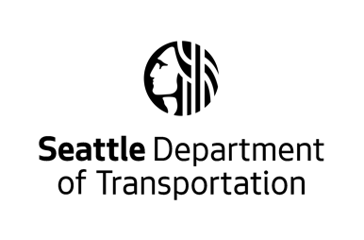
PUBLIC NOTICE OF APPLICATION FOR SHARED USE OF BUS STOP
The Seattle Department of Transportation (SDOT) is reviewing a SHARED TRANSIT STOP PERMIT application. The permit would allow EMPLOYER to share bus stop NUMBER at STREET and STREET with King County Metro buses to pick up and drop off employee passengers using shuttles. There will be no other changes to this bus stop at this time. You may submit written or verbal comments concerning this application to SDOT. Please see below for more information.
____________________________________________________________________________________
Business: Employer Name Here
Route Name: Employer Shuttle Route Name/Description
Application #: Permit Number Here
Bus Stop #: Bus Stop Number Here
Bus Route #s: Bus Route Numbers Using Bus Stop Here
Location: Street and Cross Streets Here
Comment Period: (Minimum 10 Business Days from Posting)
Date Range Here from expected posting date

Submit comments to the Employer Shuttle Program, no later than the end of the comment period:
Via email: EmployerShuttles@Seattle.gov
Via phone: 206-256-5511
____________________________________________________________________________________
Additional Information:
- Information about the shared transit stop program can be found at: https://www.seattle.gov/transportation/projects-and-programs/programs/transit-program/employer-shuttles-program

