Front Counter Services 

The **Seattle Police Department Public Request Unit** is currently fingerprinting for new/original concealed pistol licenses, firearm dealers, Seattle business licenses, as well as general fingerprinting services. While we accept walk-ins, we encourage you to make an appointment as we are subject to intermittent closures for administrative backlog processing.

To make an appointment, continue to our online scheduling tool at

<https://outlook.office365.com/owa/calendar/SeattlePoliceDepartmentFingerprints@seattlegov.onmicrosoft.com/bookings/>

***Should you prefer to seek 3rd party fingerprinting services to submit with your Concealed Weapons application by US mail or need general fingerprinting services for any other reason, please review the below chart.

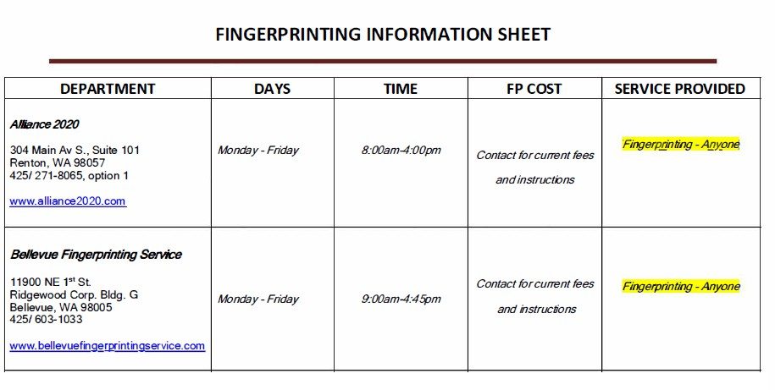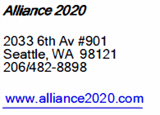

|  |  |  |  |  |
| --- | --- | --- | --- | --- |
| Seattle Area Zip Codes |  | | | |
| 98101-98119 | 98133-98134 | 98148 | 98168 | 98185 |
| 98121-98122 | 98136 | 98154-98155 | 98170 | 98188 |
| 98124-98127 | 98138-98139 | 98158 | 98174-98175 | 98190-98191 |
| 98129 | 98141 | 98160-98161 | 98177-98178 | 98194-98195 |
| 98131 | 98144-98146 | 98164-98166 | 98181 | 98198 - 98199 |