Park District Oversight Committee Briefing Paper
Major Projects Challenge Fund
September 18, 2018

Requested Committee Action
- On July 17, SPR staff provided an overview of the fourteen (14) Major Projects Challenge Fund proposals received. The Park District Oversight Committee (PDOC) requested additional information. PDOC also recommended an alternative funding strategy that would allocate the remainder of Major Project Challenge Fund appropriations for the current cycle of the Seattle Park District.
- At the September 18th meeting the PDOC will deliberate and make a recommendation to the Superintendent as to which proposals should receive funding.

Additional Information
Based on the discussions at the July 17th PDOC meeting, the following is the requested additional information to assist the Committee with their deliberations and recommendation.

Status and actual expenditures for the 2016/2017 proposals:

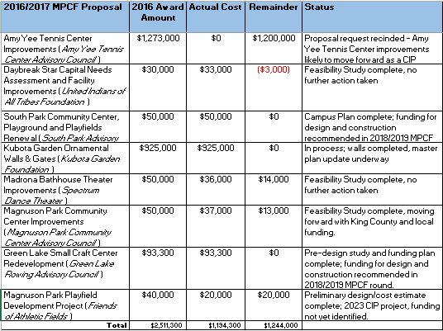

South Park Community Center Campus Plan – the question was asked if additional funding above the recommended $1million for South Park could be found, how much of the project could be completed:
- The base project with the sports field and lights, walking path and children’s play areas could be constructed with the identified funding sources in the proposal and $1million from the MPCF;
- With $1.5Million from the MPCF, the spray park and planting buffer could be included in the project; and,
- With $2 Million from the MPCF, the off-leash area and the multi-sport court could also be included which accomplishes almost the complete build out of the campus.

Bundling all of the elements into one project affords some economies of scale; it could be bid as one project and there would be one contractor doing the site grading for the whole site at once.

The Volunteer Park Amphitheater has updated their cost estimate using our budget template to include both hard and soft costs; total cost remains approximately $2.7 million, they have submitted grant applications for other funding and are fund raising similar to other project proponents.

Finally, we have resolved outstanding budget questions and have attached a spreadsheet which outlines a potential funding strategy to fund the staff recommended proposal and includes the additional $30,000 to support Sail Sand Point fundraising plan and an additional $1Million for the South Park Community Center campus plan. Note that this allocates the remainder from the 2016/2017 round and the appropriations for 2018, 2019 and 2020.

Additional Information
David Graves, david.graves@seattle.gov, ph.: 206.684.7048

Attachment: MPCF September 2018 Allocation

