DRAFT MEETING MINUTES
Forest Trailhead Exhibit, Woodland Park Zoo
Bruce A. Harrell  Mayor  Rico Quirindongo  Director, OPCD  Jill Crary, Chair  Adam Amrhein, Vice Chair  Matt Aalfs  Jay Backman  Phoebe Bogert  Elizabeth Conner  Ben Gist  Kevin O’Neill  Puja Shaw  Molly Spetalnick  Michael Jenkins  Director  Valerie Kinast  Strategic Advisor  Windy Bandekar  Planner  Juliet Acevedo  Administrative Staff | January 18, 2024  Convened 10:00 am  Adjourned 2:50 pm  Projects Reviewed  Commission business  Forest Trailhead/Woodland Park Zoo  Morgan Junction Park  Commissioners Present  Adam Amrhein (9:00 – 10:00 am; 1:00 - 2:00 pm)  Elizabeth Conner  Puja Shaw (9:00 – 10:00 am, 1:00 – 2:40 pm)  Kevin O’Neill  Ben Gist  Phoebe Bogert  Jay Backman  Matt Aalfs (9:00 am - 2:40 pm)  Molly Spetalnick (acting Chair)  Commissioners Excused  Jill Crary  Staff Present  Michael Jenkins  Valerie Kinast  Juliet Acevedo
Office of Planning and Community Development
600 4th Avenue, Floor 5
PO Box 94788
Seattle, WA 98124-4019
TEL 206-615-1349
FAX 206-233-7883
seattle.gov/designcommission

January 18, 2024 Project: Forest Trailhead Exhibit
10:00 am – 12:00 pm Type: Capital Improvement
Phase: Design Development
Previous Reviews: Concept 5-5-2022; Schematic 6-1-2023
Presenters: Katie Bang, Ken Kroeger, Woodland Park Zoo; Jennifer DuHamel, Scott Crawford, LMN Architects; DeShaun Bennett, Liza Higbee-Robinson, Hummingbird Cooperative
Attendees: Osama Quotah, LMN Architects

Project Description:

Woodland Park Zoo is proposing to redevelop a 1.2-acre site within the Woodland Park Zoo’s gated area for a new exhibit – Forest Trailhead. Until 2016, the site was the location of the zoo’s Day and Night Exhibits. The structure housing those exhibits suffered significant fire damage and will be replaced by this new project.
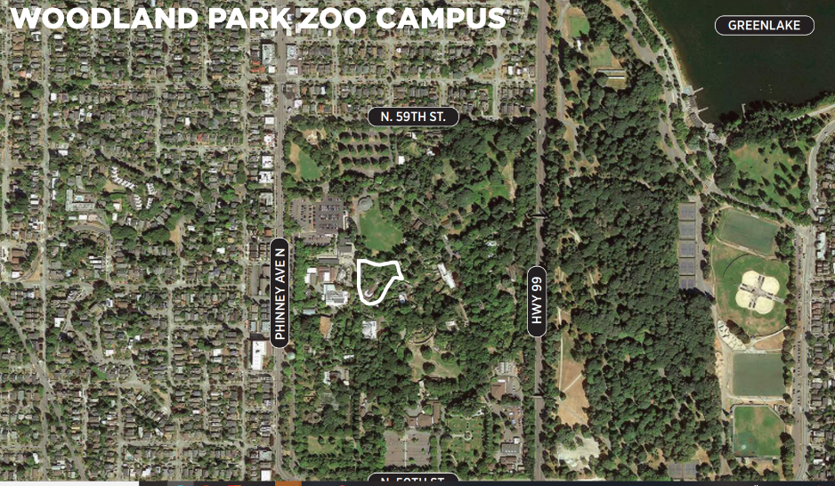

The site is located just east of the West Entrance and the Penguin Exhibit, along the main loop trail.

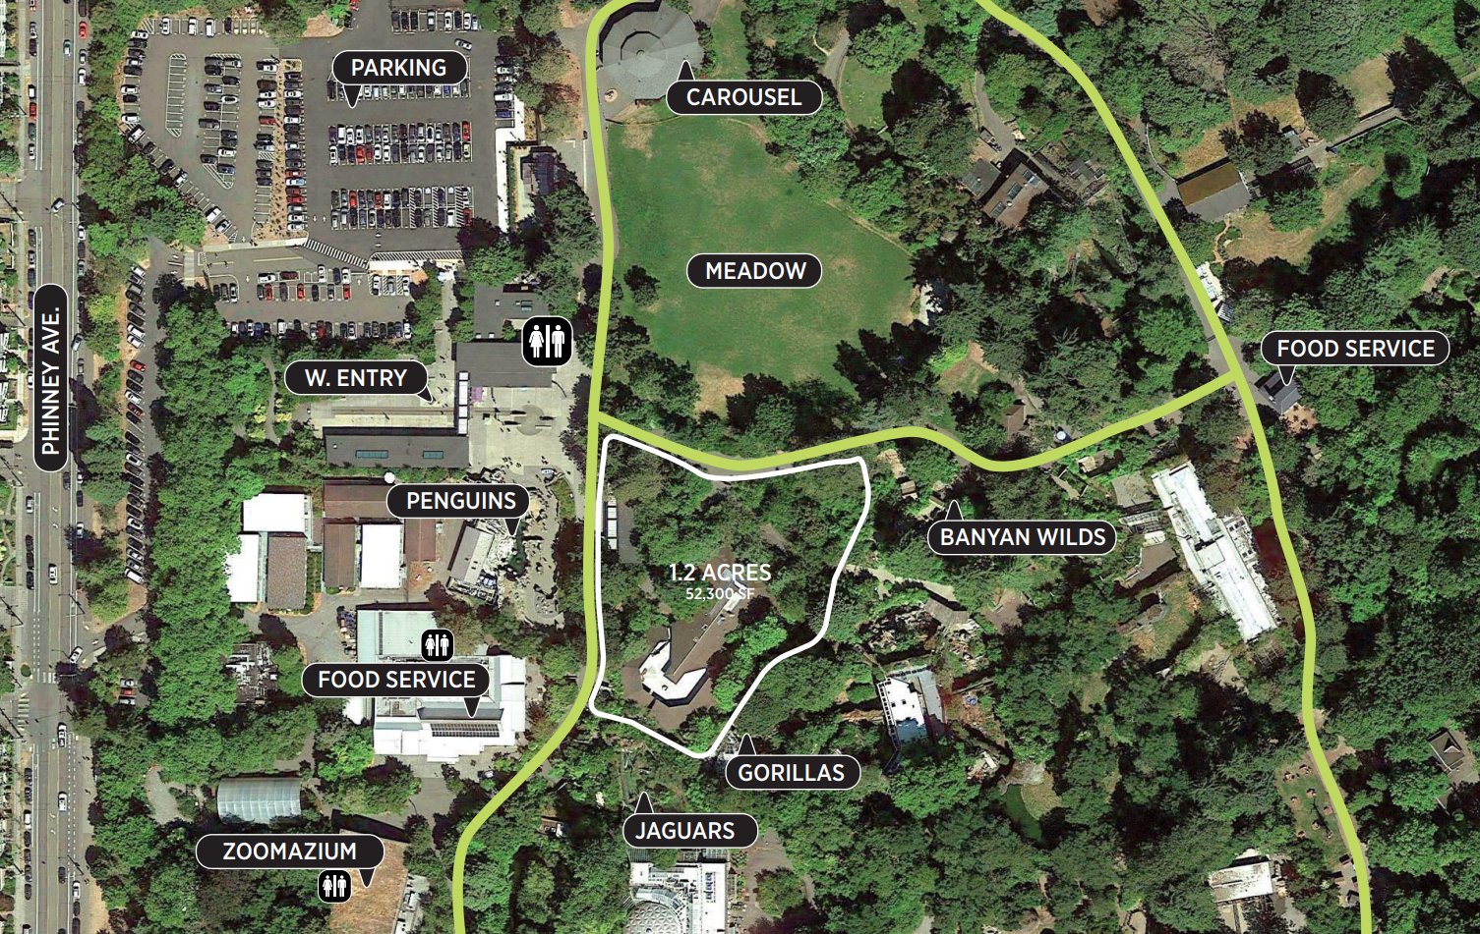

The Forest Trailhead exhibit includes:

- Trailhead Pavilion – Habitat Gallery atrium, Conservation Gallery, Plaza, holding areas.
- Canopy Path – Elevated walkways.
- Forest Floor Path
- Landscape Zones: Cloud Forest, Alpine Forest aviary.

The new Forest Trailhead exhibit will expand Woodland Park Zoo’s efforts to highlight global conservation.

Meeting Summary
This was the Seattle Design Commission’s (SDC) third review of the Forest Trailhead Exhibit. The purpose of this meeting was to review the design development phase for the project. After the presentation and discussion, the SDC approved the project 7-0 and provided recommendations for further development of the design. The SDC does not anticipate reviewing the project again.

Summary of Presentation
Jennifer DuHamel and Scott Crawford of LMN Architects, Katie Bang of the Woodland Park Zoo, and DeShaun Bennett, Liza Higbee-Robinson of Hummingbird Cooperative presented the design development phase for the Forest Trailhead Exhibit project. The presentation began with a brief overview of the goals and principles of the project. The aim of the project is to provide an experience that motivates guests to support conservation.

The presenters noted the breadth of the team that was assembled for the project: LMN Architects; CLR, zoo designer; Walker Macy, landscape architect; Tahoma Peaks, Indigenous education; Headwater People, tribal engagement; Hummingbird Cooperative, community engagement; Mayfly, civil engineer; Pae, MEP engineer; Lund Opsahl, structural engineer.

The project team recited the menu of program spaces that were being provided.
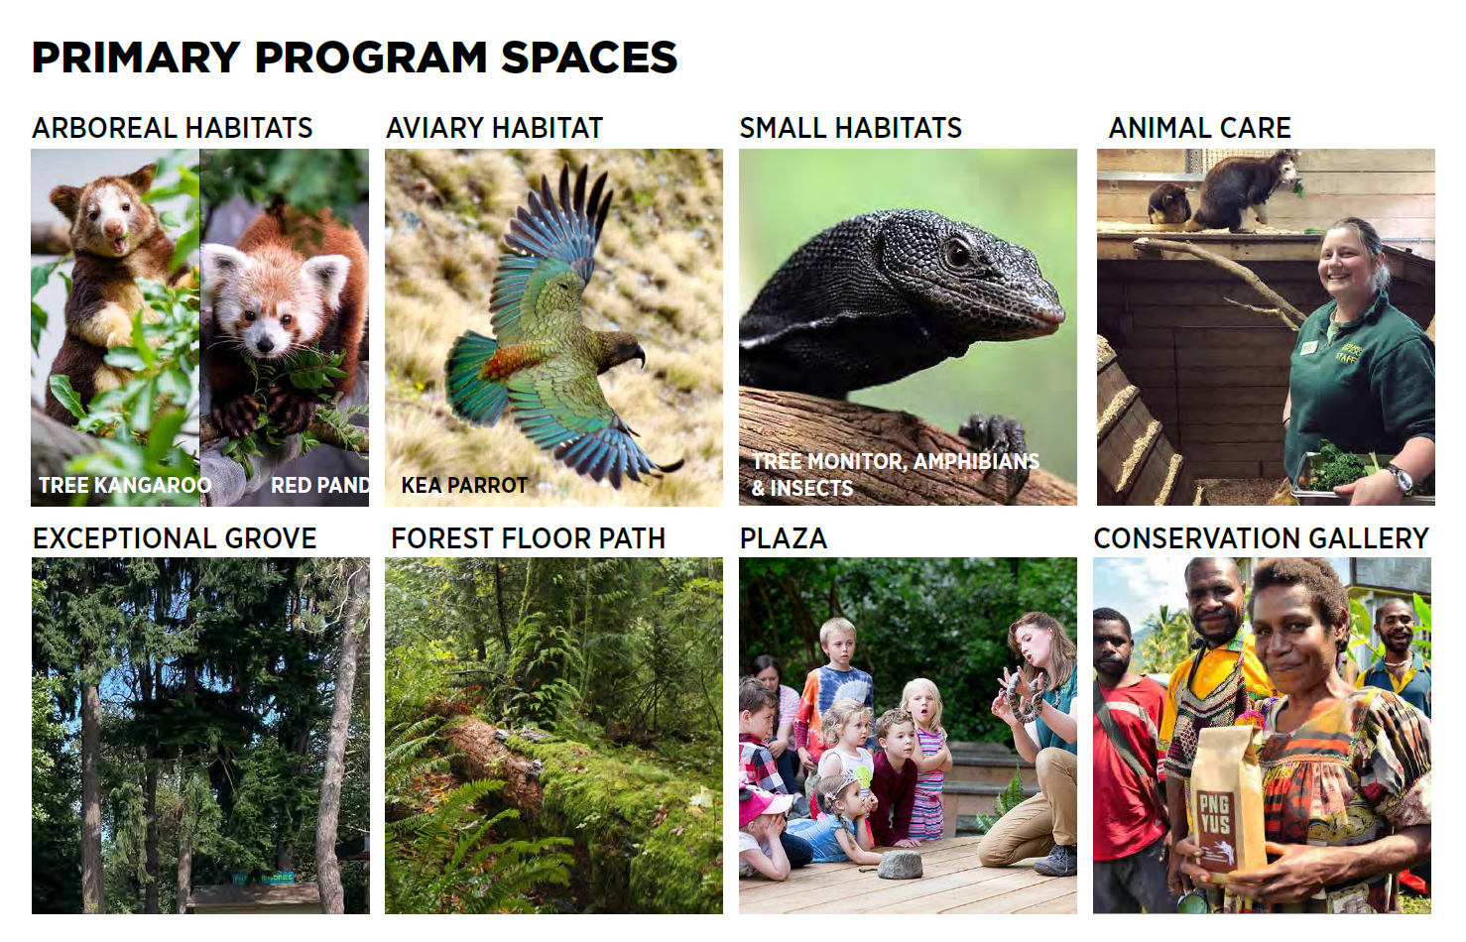

Since the last review the design has changed in these ways:
- The existing guest services building, which was slated for removal, will be retained.
- The entry plaza that was previously planned for this location has been eliminated.
- The path into the exhibit was shifted northward, so that guests will now be able to gather on the zoo’s West Plaza before entering the exhibit by way of a path through the forest.
- A series of landings along the route will provide moments to pause and look out into the forest.

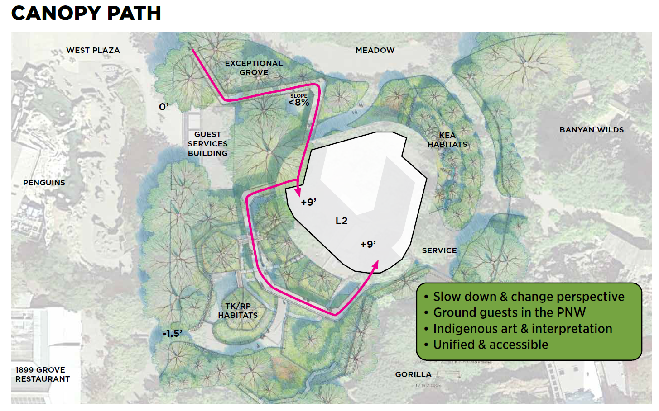

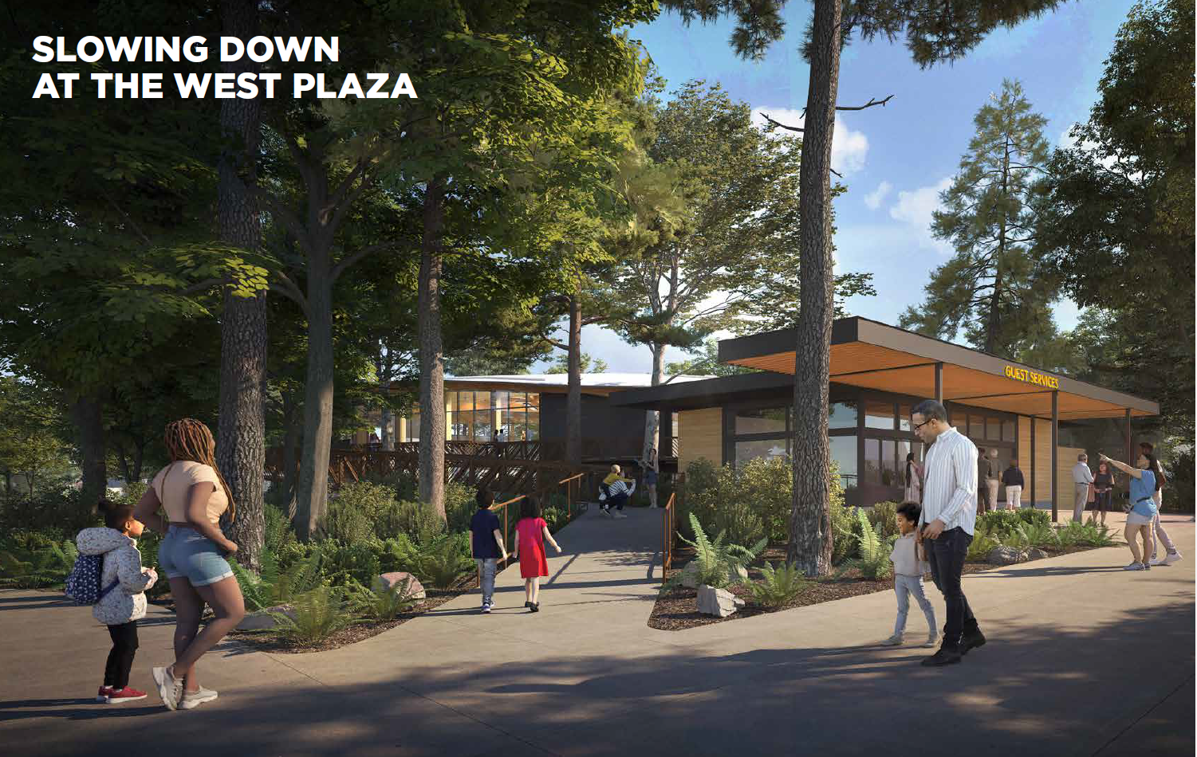
The presenters explained that the materials for the elevated pathway structures will be concrete, fiberglass grating, and weathered steel for the elevated paths. Where the path weaves through the Exceptional Grove care will be taken to avoid tree roots. Indigenous advisors are being consulted on developing the grove as a community resource.

Another change since the last review was that the structure that supports the tree kangaroo habitat nets was shifted to be on the outside of the nets. This allows for a large tree and climbing vines to be added.

Agency Comments
None

Public Comments
None

Commissioner Deliberation and Comments

The Commission discussed the following topics:
- The overall design and its ability to achieve the goals of the project
  - Changes to program: retaining Guest Services Building
  - Circulation: Refinements made to the circulation inside and out, including the stairless/ramping concept
  - Quality of spaces: inside and out. Decisions on materials and finishes, plants, lighting.
- Previous comments and how the project responds
  - Increase the sustainability of the project. Continue to search for opportunities for cost-effective measures to achieve this.
  - Solicit and consider how to integrate the input of local Indigenous leaders in the project, perhaps around forest stewardship.
  - Continue to refine the design so that it offers a premium, universally accessible experience.
  - Plan to survey BIPOC users throughout design and construction. Also monitor whether interpretation and opportunities for hands-on-activities are resonating with users.
- Interpretative elements: Advice for continued development to advance the richness of the user experience

Action

The Commission thanked the project team for the presentation. They expressed appreciation for:
- In depth, multi-faceted approach to design and engagement as well as attuned response to commissioners’ previous comments.
- The continued approach to community engagement, agency collaboration, and ‘out of the box’ strategies used to advance and refine outreach.
- Materiality – aesthetics and sustainability of selected materials, in particular the use and application of weathered steel.
- The stairless approach within the structure and its role in advancing the overall user experience.
- Integrating this project into the bigger strategic plan of the zoo.
- The focus of ‘seeing oneself’ in a project and in the story, and encouraging the question, “What actions can I take toward conservation after I leave.” The zoo is a ‘third place’ built upon multiple visits.
- Sustainability –reduction to carbon footprint, and the innovative approach towards addressing sequestered concrete.

The Commission voted 7-0 to approve the project with recommendations for further development of the design.

Recommendations:

- Continue integrating this project into the Zoo’s overall strategic plan
- Continue to evolve the ‘slow down’ concept advanced through public engagement, using this feedback to refine user experience and the sense of place using art, articulation of spaces, and learning opportunities.
- Continue to refine the entry experience of this exhibit, given the decision to retain the guest services function at the west entry. Consider how you articulate the sense of entry and achieve the goal of providing a ceremonial experience with the space
- Continue to refine how you weave the ‘at grade’ and ‘elevated’ paths so the experiences are distinct yet balanced. Refine design of the underside of the elevated path and its relationship to the at grade path to have the two features ‘work together’. Consider how materials are used to enhance the space, including how the grating and potential water infiltration impacts the use of the at grade paths.
- Bring in a larger and more diverse pool of artists for interpretative art, including expanding engagement with Indigenous and BIPOC art and artists.
- Identify opportunities in the architecture, in addition to the art and interpretive elements, to integrate and express local Indigenous culture.
- Continue to improve the experience of users with a range of physical and sensory abilities.
- Embrace and showcase seasonality throughout the site.
- Maximize the opportunities for partnering with industry on the sustainability of this project. Investigate the area of construction mitigation and offsets. This is a strong story that can be conveyed through the project and its ultimate development.

