MEETING MINUTES
Carkeek Park bridge replacement project
Bruce A. Harrell  Mayor  Rico Quirindongo  Director, OPCD  Jill Crary, Chair  Adam Amrhein, Vice Chair  Matt Aalfs  Jay Backman  Phoebe Bogert  Elizabeth Conner  Ben Gist  Kevin O’Neill  Puja Shaw  Molly Spetalnick  Michael Jenkins  Director  Valerie Kinast  Strategic Advisor  Windy Bandekar  Planner  Juliet Acevedo  Administrative Staff | December 7, 2023  Convened 10:00 am  Adjourned 3:00 pm  Projects Reviewed  Commission business  Carkeek Park bridge replacement  Sound Transit Transit Oriented Development program  Commissioners Present  Jill Crary, Chair  Adam Amrhein, Vice Chair  Elizabeth Conner  Puja Shaw  Kevin O’Neill  Ben Gist  Phoebe Bogert  Jay Backman  Matt Aalfs  Molly Spetalnick  Commissioners Excused  Adam Amrhein (recused)  Staff Present  Michael Jenkins  Valerie Kinast  Windy Bandekar  Juliet Acevedo
Office of Planning and Community Development
600 4th Avenue, Floor 5
PO Box 94788
Seattle, WA 98124-4019
TEL 206-615-1349
FAX 206-233-7883
seattle.gov/designcommission

December 7, 2023 Project: Carkeek Park Bridge Replacement Project
9:30 am – 11:00 am Type: Capital Improvement
Phase: Pre-concept review
Previous Reviews: None
Presenters: Scott Crawford, Jessica Miller, Evan McQuillen, LMN Architects;
Colin Campbell, Seattle Parks and Recreation; Owen Oliver, Headwater People; DeShaun Bennett, Hummingbird Cooperative
Attendees:

Project Description

This project will replace the Carkeek Park Railroad Overpass Pedestrian Bridge, which was originally built in 1955. This bridge connects the western portions of Carkeek Park with a beach on the western side of the railroad tracks. $ 4.9M in in City funding has been provided for planning, design, and construction, with $2.3M in additional funds from Washington Wildlife and Recreation Program (WWRP) and Aquatic Lands Enhancement Act (ALEA). Project planning and design will continue through 2024, with construction completion anticipated by 2026,

Project Location and Context

Carkeek Park is a 220-acre multi-featured park facility in NW Seattle. Carkeek Park includes a variety of programming that includes play areas, trails, picnic areas. Carkeek Park is marked with several significant natural features including mature stands of evergreen and deciduous trees, natural ground and understory vegetation, a segment of the Pipers Creek watercourse, and other similar nature features.

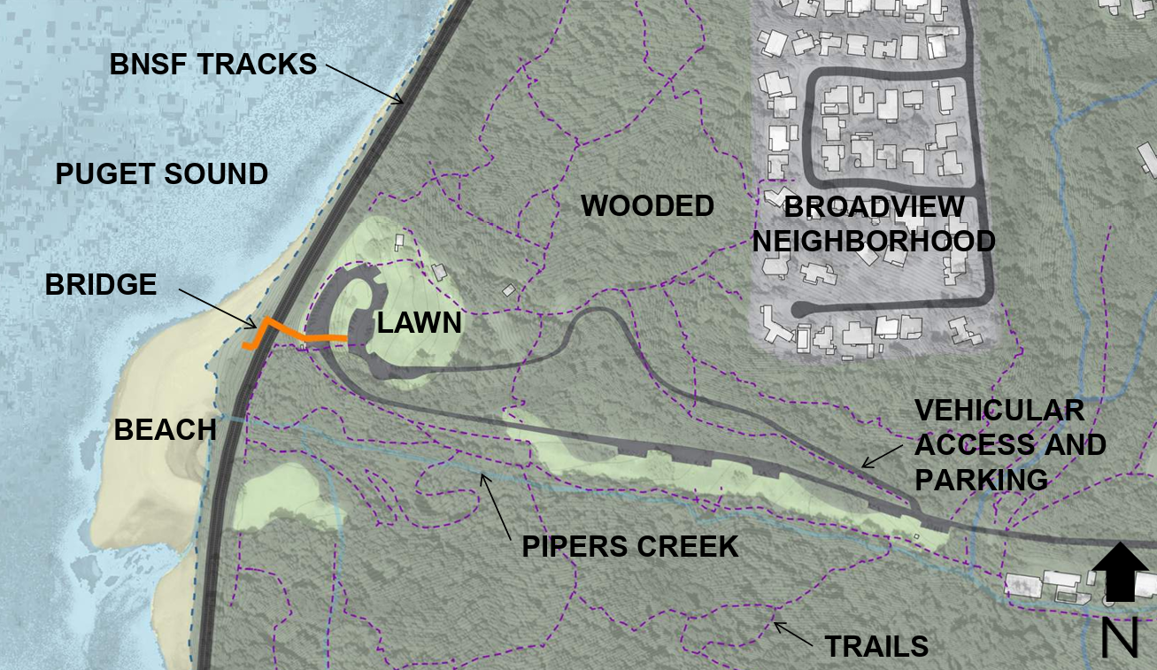
The project area is located at the western portion of Carkeek Park. The existing bridge was initially installed in 1955. The existing bridge crosses over Burlington Northern railroad tracks and their related infrastructure. The western terminus of the bridge provides a stair connection to a beach to the west of the rail track.

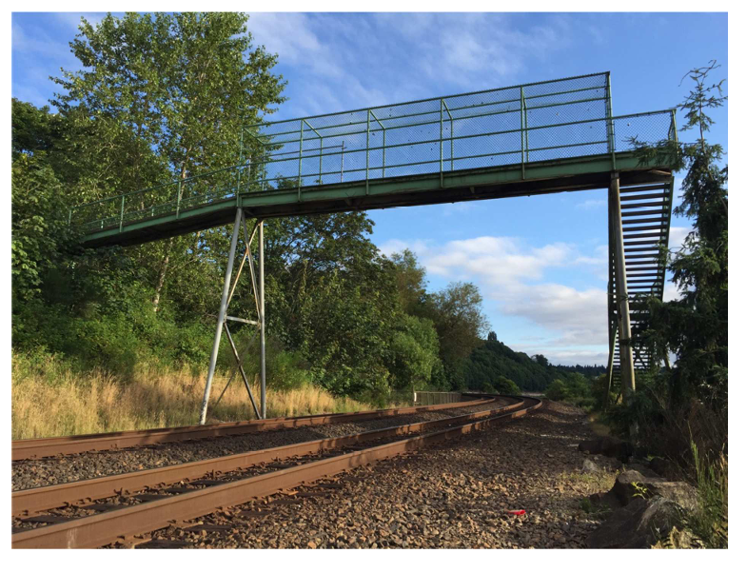
In addition to the subject bridge, there are several related project features to the east of the exisitng bridge including play areas, picnic tables, restroom, an amphitheater, and lawn areas. There are two parking areas that provide vehicular access to the site, along with a series of trails and other pedestrian improvements around the project area as well as to other portions of Carkeek Park. Seattle Parks and Recreation has separate work planned to the play areas and restrooms that are not funded with this project.

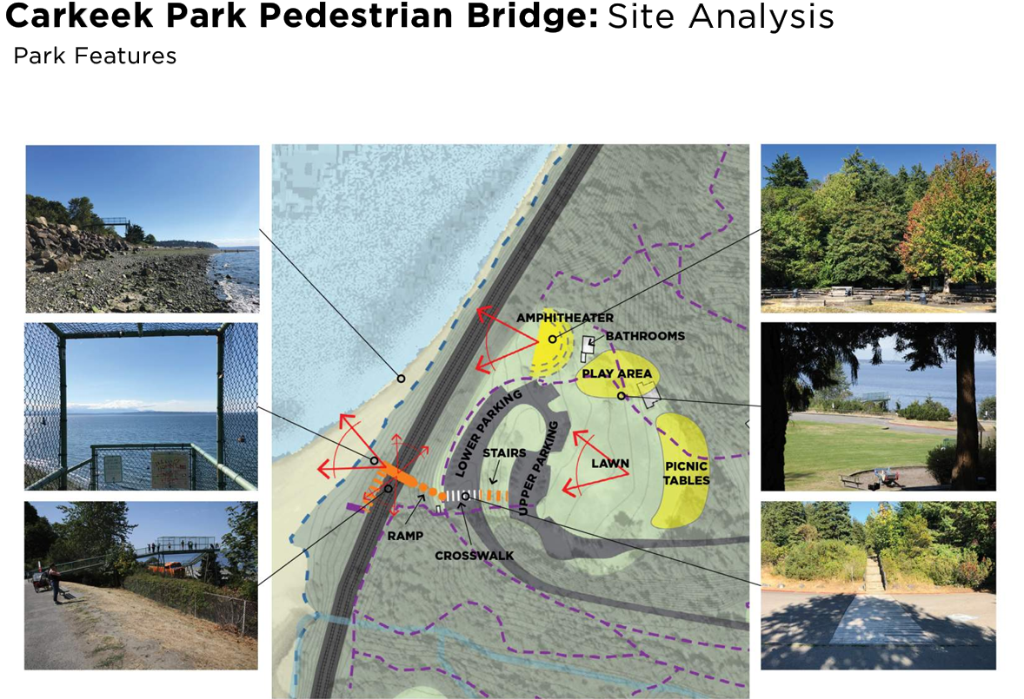

Public comments:

None

Agency comments:

None

Presentation Overview:

The presentation was divided into four segments. Following a brief introduction by Scott Crawford on the overall goals of the project, the project context and the program scope, presentations were made by the following individuals:

- DeShaun Bennett of Hummingbird Cooperative – overview of public engagement and strategies related to equity and equitable outcomes
- Owen Oliver of Headwater People – overview of engagement with indigenous communities and its relationship to project outcomes
- Scott Crawford, Steven VanDyke, and Jessica Miller of LMN – presentation of three bridge alternatives and their related features
Summary of public engagement and equitable outcomes

DeShaun Bennett provided an overview of the public engagement process developed for Carkeek Park. The work was informed by demographics comparing populations reflected in a nearby elementary school with those found in an elementary school found in Rainier Beach. The purpose of the comparison was to highlight the need of equivalent funding regardless of near by demographics. DeShaun also highlighted surveys of users to understand what motivates people to come to Carkeek Park, stay at Carkeek Park and visit it more frequently.

Summary of engagement with Indigenous communities

Owen Oliver provided an overview of his engagement with Indigenous communities, focusing on his work with a Puyallup elder and their understanding with the area now known as Carkeek Park and Piper’s Creek through Southern Lushootseed. Owen also highlighted how Indigenous identity expressed in basket making and water quality can provide a basis in design development and detailing expressed in the bridge or abutting features.

Summary of bridge alternatives

LMN presented three bridge alternatives. All the alternatives included a bridge crossing from the parking area over the railroad tracks to a western terminus marked by a viewing platform and stairs to the beach. The vision established by the design team for the bridge includes:

- Enhances safety and access
- Connects to current and future park infrastructure
- Fits the natural character of Carkeek Park
- Minimize maintenance especially over tracks
The following graphic shows the three alternatives:

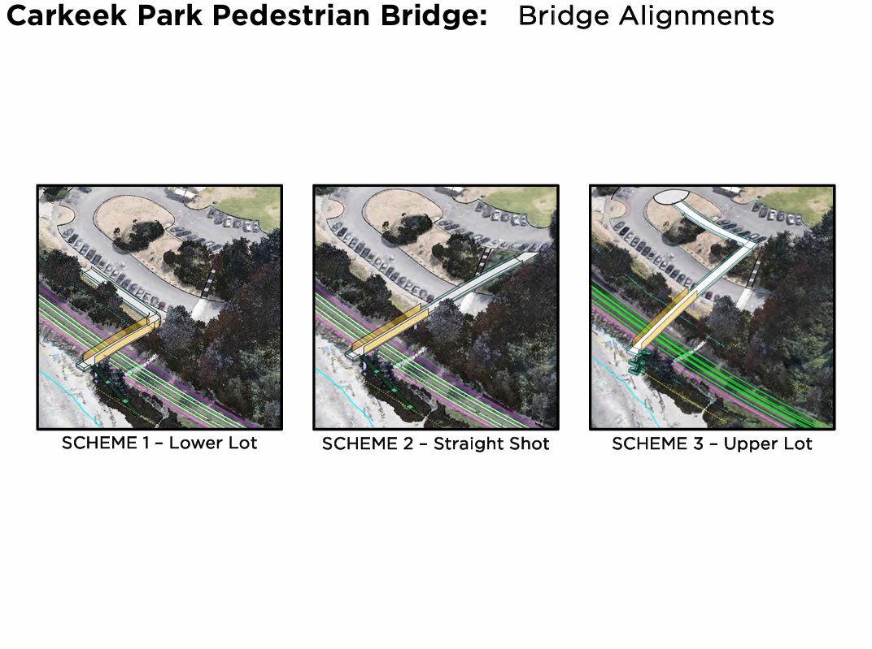Alternative 1 would have the eastern edge of the bridge terminate in the lower lot, near the location of the current bridge. Alternative 2 would terminate in the upper parking lot, spanning over the lower parking lot. Alternative 3 would terminate in an open space area between the upper and lower parking lots. All alternatives meet minimum requirements to ensure safe railroad operations, ADA requirements for the bridge that do not exceed 5% slope, and a western bridge viewing platform that can integrate to future stairs to the beach (not part of current contract).

Commission discussion and deliberations:

- Overall bridge concepts
- The extent of public engagement and its relationship to project program features
- The relationship of the bridge to beach access
- How indigenous communities can shape design outcomes
- Existing versus future park users and the predominate role of vehicular access
- The relationship to nearby improvements to restrooms and pedestrian access outside of the bridge program
- Designs that reflect needs of all users, including those with limited or impaired mobility
- How bridge designs impact automobile circulation

Commission Action

The Commission voted 9-0 in support of the project. Commissioners indicated that the design team:
- Continue to explore all three schemes.
- Prioritize simplicity in the design and project delivery
- Expand the analysis to more thoroughly address the overall park program and circulation, resilience, and the experience for users with disabilities.
The Commission provided the following recommendations:

Scope and Vision
- Develop a more encompassing vision and concept for all of the projects in the park – the bridge, restrooms, play area, parking, and trails. This is needed as a basis for decision making about the bridge design. Align and leverage the design of all projects to this overarching vision.
- Don’t allow the current parking configuration to constrain the possibilities. Evaluate the cost of grading and reconfiguring the parking in conjunction with the three alternatives, so that you accurately identify which alternative is most cost effective. Explore reconfiguring the parking and pedestrian routes so that a shorter, less costly bridge, such as scheme 1 or 2, will be enough.
- Diagram the larger context circulation and destinations. Consider desire lines and the various other destinations when designing the bridge.
- Examine the routes that people enter the park and approach the pedestrian bridge without a car. Take into account the directions people will be approaching from, and their numbers, and their experiences as you decide between the options and where to terminate and connect pathways to the bridge on the land side.
- Develop the bridge and entry sequence as a place. It should be a strong visual expression in the park informed by the public.
- In a more expanded scope, develop a welcoming entry experience to the playground and consider how users will connect to the bridge, views, and the restrooms.
- Explore expanding areas for viewing on the landward side of the bridge.
- Consider the visual, but also other sensory experiences of the site.
- Pick up on the ideas of freshwater meeting saltwater in a larger vision.
- Expand the scope of this project to include analysis of the parking. Consider how much parking is really needed and whether it can be reduced.
- Consider an option that eliminates parking spaces in the lower lot and expands the landing area. Reinvest savings in improvements to connectivity.
Aesthetics and Experience
- Keep the bridge simple, and allow the landscape and location to shine. Avoid unnecessary structure and elements. Consider this goal of elegance and simplicity as you compare the schemes.
- Continue to consider a truss bridge. The opportunity for an integrated throw fence is interesting with this bridge type.
- A cable stay/cantilevered bridge type is less appropriate in this location because adding a mast would be too much of an intrusion in this natural setting. It’s more appropriate in an urban environment.
- Consider whether angling the bridge might improve the landings and overall aesthetic of the bridge.
- Examine the potentials for designing a great experience for people with physical disabilities. Expand outreach with the disabilities community.
- Consider mobility needs at transitions between the ramps and stairs to the bridge, including a potential bottle neck experience if the bridge width is considerably wider than the adjoining stair and ramp accesses.
- Explore the potentials for creating larger viewing areas along the upper edge of the escarpment.
- For concepts with longer structures needed on the landward side, consider methods to reduce cost such as walkway width and alignment.
Community Engagement
- Engage with the community on a broader, more comprehensive vision for the bridge, playground, restrooms, and parking.
- Continue to engage with BIPOC communities and other park users. Use the physical models and three dimensional visualizations in engagement.
- Involve the community of people with disabilities as comprehensively as you did under represented communities.
- Continue the conversations with Indigenous communities across the Sound and integrating what you learn in the design. Look to structures in addition to baskets.
Sustainability
- Examine resilience more thoroughly. Consider the true cost of design choices over time. Weight resilience more heavily when you consider cost. Futureproof the design.
- Look at examples in Europe for building with sea level rise in mind. Explore whether you can improve experiential qualities while improving resilience.
For the next presentation
- Diagram the larger context. Show desire lines and destinations through-out the park, linking the various amenities, and of routes for reaching the bridge when people enter the park without a car.
- Describe more thoroughly the various considerations that drove decisions. Design, costs, context, desire lines, structure type, etc.
- Be clear how engagement is playing out in the evolution of the design.
The Design Commission anticipates reviewing the project again at Schematic (60%) design.

