MEETING MINUTES
Bitter Lake Reservoir Covering Replacement Project
Bruce A. Harrell  Mayor  Rico Quirindongo  Director, OPCD  Jill Crary, Chair  Adam Amrhein, Vice Chair  Matt Aalfs  Elizabeth Conner  Puja Shaw  Phoebe Bogert  Kevin O’Neill  Ben Gist  Jay Backman  Molly Spetalnick  Michael Jenkins  Director  Valerie Kinast  Strategic Advisor  Windy Bandekar  Planner  Juliet Acevedo  Administrative Staff | November 16, 2023  Convened 9:30 am  Adjourned 3:00 pm  Projects Reviewed  Commission business  Bitter Lake Reservoir Covering Replacement Project  1305 Stewart Public Benefit  Commissioners Present  Jill Crary, Chair  Adam Amrhein, Vice Chair  Elizabeth Conner  Puja Shaw  Kevin O’Neill  Ben Gist  Phoebe Bogert  Jay Backman  Matt Aalfs  Molly Spetalnick  Commissioners Excused  Staff Present  Michael Jenkins (virtually)  Windy Bandekar (virtually)  Juliet Acevedo
Office of Planning and Community Development
600 4th Avenue, Floor 5
PO Box 94788
Seattle, WA 98124-4019
TEL 206-615-1349
FAX 206-233-7883
seattle.gov/designcommission

November 16, 2023 Project: Bitter Lake Reservoir Replacement Project
9:30 am – 11:00 am Type: Capital Improvement
Phase: 60%
Previous Reviews: 30% Concept
Presenters: Lael Alderman (Consor); Andrew Karch (SPU); Kevin Burgsrud (SPR); Aaron Luoma
(HBB); Kate Clark, Planning Artist - Parkeology; Becky Johnson, ARTS
Attendees: Bill Wells, SPU

Project Description

Seattle Public Utilities (SPU) is building a new drinking water reservoir in the Bitter Lake neighborhood. The new 21-million-gallon Bitter Lake Reservoir will replace the existing reservoir that is reaching the end of its service life. The new reservoir will be partially buried and hold the same amount of water as the old reservoir. The project also includes new open space that will be designed and integrated with investments made by Seattle Parks and Recreation, on land abutting the reservoir. Seattle Parks and Recreation intends to construct the new park after the new reservoir is built.

SPU is collaborating with the Seattle Office of Arts & Culture (ARTS) and Seattle Parks and Recreation (SPR) on designing the reservoir to include public art and more open space. Engagement efforts among the three agencies will be coordinated, and public feedback will be shared across the three agencies, and project design team members.

Project Location and Context

The reservoir is located on a 13-acre property located southwest of the intersection of Linden Ave N and N 143rd St in North Seattle. About four acres are currently occupied by open space, a playground, and a community garden.

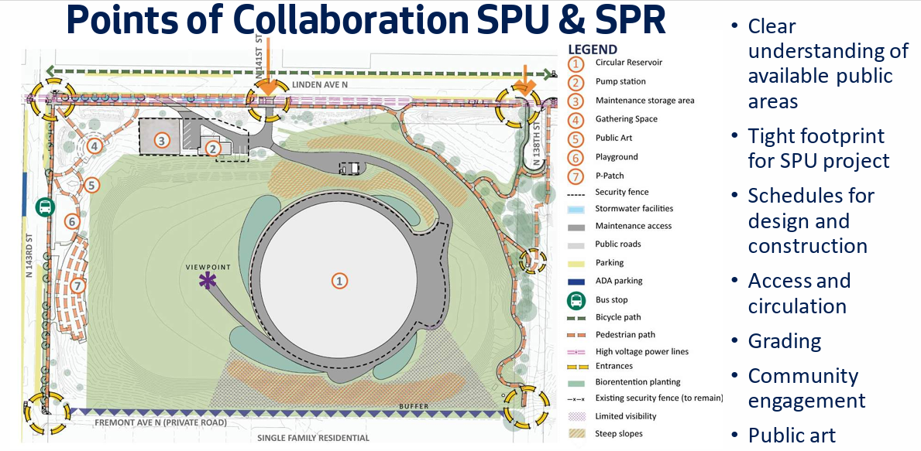
Public comments:

None

Agency comments:

None

Presentation Overview:

The design team's responses to the Seattle Design Commission's recommendations for the Bitter Lake Reservoir project were comprehensive and targeted towards enhancing the project in various aspects.

Addressing the concerns about the site and topography, the team emphasized their increased collaboration with Seattle Parks and Recreation (SPR) to develop opportunities that align with the combined goals of the multi-departmental team. This collaboration involved coordinating schedules to optimize the involvement of SPR, SPU, and the Seattle Office of Arts & Culture (ARTS), ensuring a cohesive approach to the project's development.

In terms of architecture, materials, and massing, the team focused on the reservoir's structural and seismic resilience, considering site constraints and engineering necessities. The team highlighted efforts to minimize soil hauling and manage stormwater effectively, while ensuring the reservoir's design — a circular, prestressed concrete structure with a unique “floating” floor-wall connection — met both functional and aesthetic requirements.

The team detailed their continuous work on public outreach and engagement. They provided demographic information on recent efforts, aiming to deepen community involvement, especially among youth. One idea is to integrate youth voices into the project, enhancing community identity and ownership. Planning artist Kate Clark has reached out to many neighborhood residents, organizations, and individuals, and has hosted hands-on meetings/workshops to generate ideas and explore community needs and values.

Art integration was another significant area covered by the team’s presentation. The team noted the project's allocation of 1% funding for art, with planning artist Kate Clark already commissioned for work that emphasizes community engagement as a primary resource for the eventual permanent artwork. The selection of one or more public artists to create permanent artworks is planned for early 2024, indicating a deep commitment to integrating meaningful art into the project.

Summary of Commission Discussion Summary:

Commissioner discussion and deliberation encompassed several key areas related to the project's development.

Community engagement

A significant focus was on community engagement, emphasizing the need for presenting the project as a unified effort to avoid confusion among community members. This segment of the discussion underlined the importance of clear communication about the project's schedule, next steps, and potential funding needs, specifically for the Parks project.

Landscape Design

The project team presented various aspects of landscape design. Key points included the placement and design of specific elements such as landforms, viewpoints, fencing, and the stormwater management system. Commissioners stressed the importance of making grading decisions that would not limit future design options.

Art integration

Art integration was another vital topic, with discussions centered around enhancing community involvement in ensuring that artwork will be meaningful to members of this diverse community, and to foster a sense of ownership .

Lighting and security

The topic of lighting and security was also addressed. The team was encouraged to consider factors like light levels, glare, and lighting to ensure the site’s security while also making it welcoming. The importance of integrating lighting within the broader landscape experience was emphasized.

Sustainability

There was a discussion about the potential use of photovoltaic (PV) applications on structures and the exploration of architectural lighting opportunities. Members of the Design Team responded positively to this suggestion from earlier SDC meeting. The challenges associated with color integration and the use of pigmented concrete were acknowledged.

Pedestrian circulation

Site circulation was covered, with interest expressed by Commissioners in the development of loop trails and passive recreation areas. The potential integration of multiple viewpoints within the overall design was raised. Access to all areas of the park, including the west side that abuts single family homes and has been fenced as part of the current fence line is important for future enjoyment of the public space.

Action

The Commission voted 10 to 0 to approve the 60% Schematic Design Stage for the project.

Commissioners made the following recommendations:

- Community Engagement: Continued coordination and clear communication with Bitter Lake communities regarding the project’s process, progress and next steps.
- Landscape and Design: A call for further exploration and refinement of the fencing design, focusing on its materiality, form, and visual impact.
- Art Integration: Continued exploration of art integration, and broad/deep community involvement in art-related aspects of the project, through in-person gatherings, new contacts, and hands-on participation
- Lighting and Security: Consideration of adaptive and environmentally-sensitive lighting solutions.
- Structural Considerations: Ongoing updates on the potential for PV applications and structural lighting studies.
- Circulation: Emphasis on monitoring grading and landscape decisions to ensure alignment with future design possibilities, and to provide multiple options for people to circulate throughout the large park space.
- Community Input: A specific focus on ensuring that broad and comprehensive community participation and input is tracked, through demographic and anecdotal measures, and is reflected in the project’s process, progress, and completion.

Commissioners expressed their appreciation for the depth and clarity of the presentation, along with the team's open-minded approach to feedback. There was consensus on the project's importance in providing accessible green space to the community and the need for continued coordination and championing by the City departments involved. For the next review of this project, the Commission is looking forward to seeing how the project advances public involvement, landscape design, public art, reservoir and other infrastructure design, and the overall form and function of the site.

