DRAFT
MEETING MINUTES
Bruce A. Harrell  Mayor  Rico Quirindongo  Acting Director, OPCD  Jill Crary, Chair  Adam Amrhein, Vice Chair  Matt Aalfs  Phoebe Bogert  Erica Bush  Elizabeth Conner  Ben Gist  Kevin O’Neill  Puja Shaw  Molly Spetalnick  Michael Jenkins  Director  Valerie Kinast  Strategic Advisor  Windy Bandekar  Planner  Juliet Acevedo  Administrative Staff | October 19, 2023  Convened 10:00 am  Adjourned 11:30 am  Projects Reviewed  Bell Street ROW improvements, from First to Elliott  Commissioners Present  Matt Aalfs  Jay Backman  Phoebe Bogert  Elizabeth Conner  Ben Gist  Puja Shaw  Molly Spetalnick (non-voting)  Commissioners Excused  Adam Amrhein  Jill Crary, Chair  Kevin O’Neil  Staff Present  Michael Jenkins  Windy Bandekar  Juliet Acevedo
Office of Planning and Community Development
600 4th Avenue, Floor 5
PO Box 94788
Seattle, WA 98124-4019
TEL 206-615-1349
FAX 206-233-7883
seattle.gov/opcd

October 19, 2023 Project: Bell Street First to Elliott
10:00 am – 11:30 am Type: CIP
Phase: Schematic (60%)
Previous Reviews: 3/16/2023 Concept
Presenters: Joey Aitken, Andrew Barash, SDOT; Hannah Vondrak, GGN Landscape Architects
Attendees:
Ryan Packer, The Urbanist

Recusals and Disclosures

Project Description
The Seattle Office of the Waterfront is proposing to improve Bell Street from Elliott Ave to 1st Ave. This project is one of the east west right of way connections that is being improved as part of the Waterfront Seattle project.

The segment of Bell Street between 1st Ave and Elliott Ave, will become a one-way road, eastbound between Elliott and Western avenues, and westbound between Western and 1st Avenues. This solution relates to the reconfiguration of the street grid to accommodate the new Elliott Way, which will become a two-way road connecting the one-way Western Ave and one-way Elliott Ave. There will be a signalized intersection at Western Ave and Bell St for traffic going to or coming from the new Elliott Way. There will also be stop signs located at the intersection for vehicles traveling on Bell St.

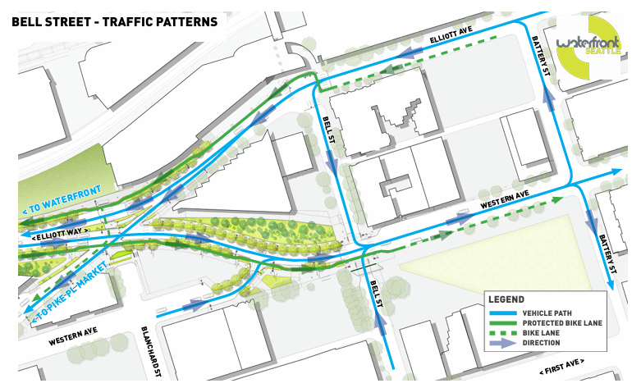(p.17 in presentation)

The reconfiguration will allow for a series of improvements that improve auto, bicycle, and pedestrian connections due to the removal of the former Hwy 99 tunnel and the larger Waterfront project. These improvements include:
- Bike lanes
- Widened sidewalks
- Seating areas
- Furnishings and enhanced plantings
The program also includes the repurposing of a former sign bridge into a project feature that will provide a distinct element for the project. The former sign bridge will include lighting, and a raised base with landscape enhancements.
Meeting Summary
This is the Seattle Design Commission’s (SDC) second review of the project. The purpose of this meeting was to review the schematic design (60%) phase. The SDC voted, 6-0, to approve the schematic design phase for the Bell Street First to Elliott project with several recommendations. The project will not be reviewed again by the Commission.

Agency Comments
None

Public Comments
None

Summary of Presentation

The project team presented information on the following topics:
- Site location and context
- Site overview and circulation
- Community Engagement
- Evolution of design since last review
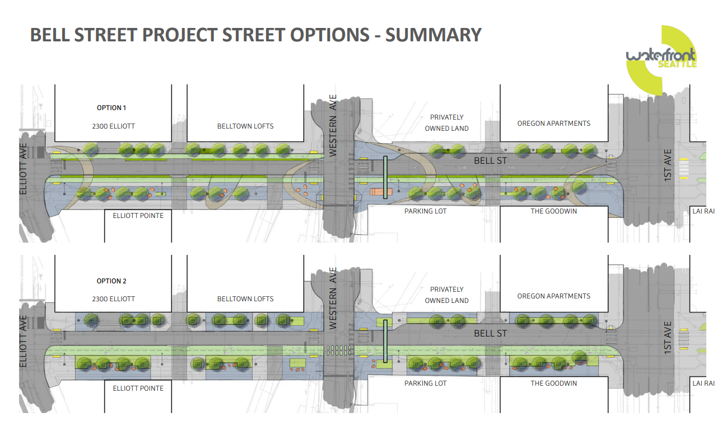 (p. 64 from presentation)
Summary of Commission Discussion and Recommendations
The Commission organized their conversation around these subjects:

- The overall design and its ability to meet the goals of the project
- Circulation and “moving through” spaces – incl. road configuration and bike lanes
- Gathering, lingering, and view spaces
- Equity
- Sustainability
- Integration with Waterfront project and surrounding neighborhood
Overall Design
The commissioners expressed support for the refinements the project team made to the plans. Relocation of the bike lane to the north side of the street, consolidation and shifts in location of plantings and seating, and plans to illuminate the sign bridge addressed previous recommendations of the Commission.

Circulation and “moving through” spaces
Commissioners expressed support for moving the bike lane to the north side of the street, reducing the risk of car and bike collisions and pedestrian-bike conflicts. Incorporating more plantings in the median was also seen as a way the new design addressed the Commission’s recommendation to reduce the potential for bike pedestrian conflicts. Commissioners noted that eliminating plantings on Block 2, and expanding sidewalks, improved pedestrian circulation.

Gathering, lingering, and view spaces
Overall:
Commissioners appreciated the increased clarity in the hierarchy of spaces. They noted that the shift of the bike lane and planting areas improved the quality of spaces for lingering. Trading the plantings at the base of trees for a “rock wash” cobble was seen as a good solution, but Commissioners also suggested the inclusion of pavers that allow permeability.

Sign bridge:
Commissioners discussed the character of the sign bridge lighting and how the sign is attached to the ground. They suggested uplighting the structure instead of integrated lighting. There was no consensus on either approach. Commissioners expressed concern for how the sign bridge will meet the ground. These details will be important.

Stormwater:
Commissioners discussed stormwater and understood that water quality treatment was not possible with this project.

Seating:
Commissioners agreed that boulders are a good solution but encouraged the team to continue to refine their design with attention to comfort,maximizing activation benefits along the corridor, and to bring meaning and metaphor to the steep slope.

Plant selections were discussed. Commissioners appreciated the care given to plant selection, with attention to their viability in this hightraffic, urban space. They questioned whether the “meadow” idea would be successful, given the small size of the planting areas.

Action

The SDC thanked the team for their presentation of the schematic design for the Bell Street First to Elliott project. Commissioners applauded the team for achieving continuity despite changes to staffing.

The SDC expressed appreciation for pedestrianizing this corridor. Commissioners appreciated:
- Shift ofbike lane to the north side of the street
- Connection of newdesign language with older Bell Street segment to the east
- Illumination of historic sign bridge structure
- Retention and celebration of the historic SR99 sign bridge midcentury “engineering as architecture”.
- Rock seating elements
- Exclusion of planting on block 2 for pedestrian space expansion

The commission provided the following recommendations:
- Continue to consider lighting approach on gateway structure as key component of celebratory design/architectural history.
- Consider activation of building frontages as seating locations are optimized.
- Consider whether the meadow idea will be successful given the limited size planting areas.
- Develop this project at a celebratory moment in the Market to MOHAI corridor.
- Refine the boulder design and placement for seating comfort, especially in consideration of people with mobility limitations. Refine the design to best express the overarching “rock outwash” project concept.
The Design Commission does not anticipate reviewing the project again.

