 | MEETING MINUTES
Bruce A. Harrell  Mayor  Rico Quirindongo  Acting Director, OPCD  Jill Crary, Chair  Adam Amrhein, Vice Chair  Matt Aalfs  Phoebe Bogert  Erica Bush  Elizabeth Conner  Ben Gist  Kevin O’Neill  Puja Shaw  Molly Spetalnick  Michael Jenkins  Director  Valerie Kinast  Strategic Advisor  Windy Bandekar  Planner  Juliet Acevedo  Administrative Staff | March 16, 2023  Convened 10:00 am  Adjourned 11:30 am  Projects Reviewed  Bell Street ROW improvements, from First to Elliott  Commissioners Present  Jill Crary, Chair  Matt Aalfs  Phoebe Bogert  Erica Bush  Elizabeth Conner  Ben Gist  Kevin O’Neil  Puja Shaw  Commissioners Excused  Molly Spetalnick  Adam Amrhein  Staff Present  Michael Jenkins  Windy Bandekar  Juliet Acevedo
Office of Planning and Community Development
600 4th Avenue, Floor 5
PO Box 94788
Seattle, WA 98124-4019
TEL 206-615-1349
FAX 206-233-7883
seattle.gov/opcd

March 16, 2023 Project: Bell Street First to Elliott
10:00 am – 11:30 am Type: CIP
Phase: Pre-Concept
Previous Reviews: None
Presenters: Therese Casper, SDOT; Bernie Alonzo and Rikerrious Geter, GGN Landscape Architects
Attendees: Andrew Barash, SDOT
Joy Jacobs, Finance and Administrative Services
Mike Johnson, SDOT
Hallie O’Brien, SDOT
Iris Picat, Enviroissues

Recusals and Disclosures
Molly Spetalnick was recused.

Project Description
The Seattle Office of the Waterfront is proposing to improve Bell Street from Elliott Ave to First Ave. This project is one of the east west right of way connections that is being improved as part of the Waterfront Seattle project.

The segment of Bell Street between 1st Ave and Elliott Ave, will become a one-way road, eastbound between Elliott and Western avenues, and westbound between Western and 1st Avenues. This solution relates to the reconfiguration of the street grid to accommodate the new Elliott Way, which will become a two-way road connecting with the one-way Western Ave and one-way Elliott Ave. There will be a signalized intersection at Western Ave and Bell St for traffic going to or coming from the new Elliott Way. There will also be stop signs located at the intersection for vehicles traveling on Bell St.

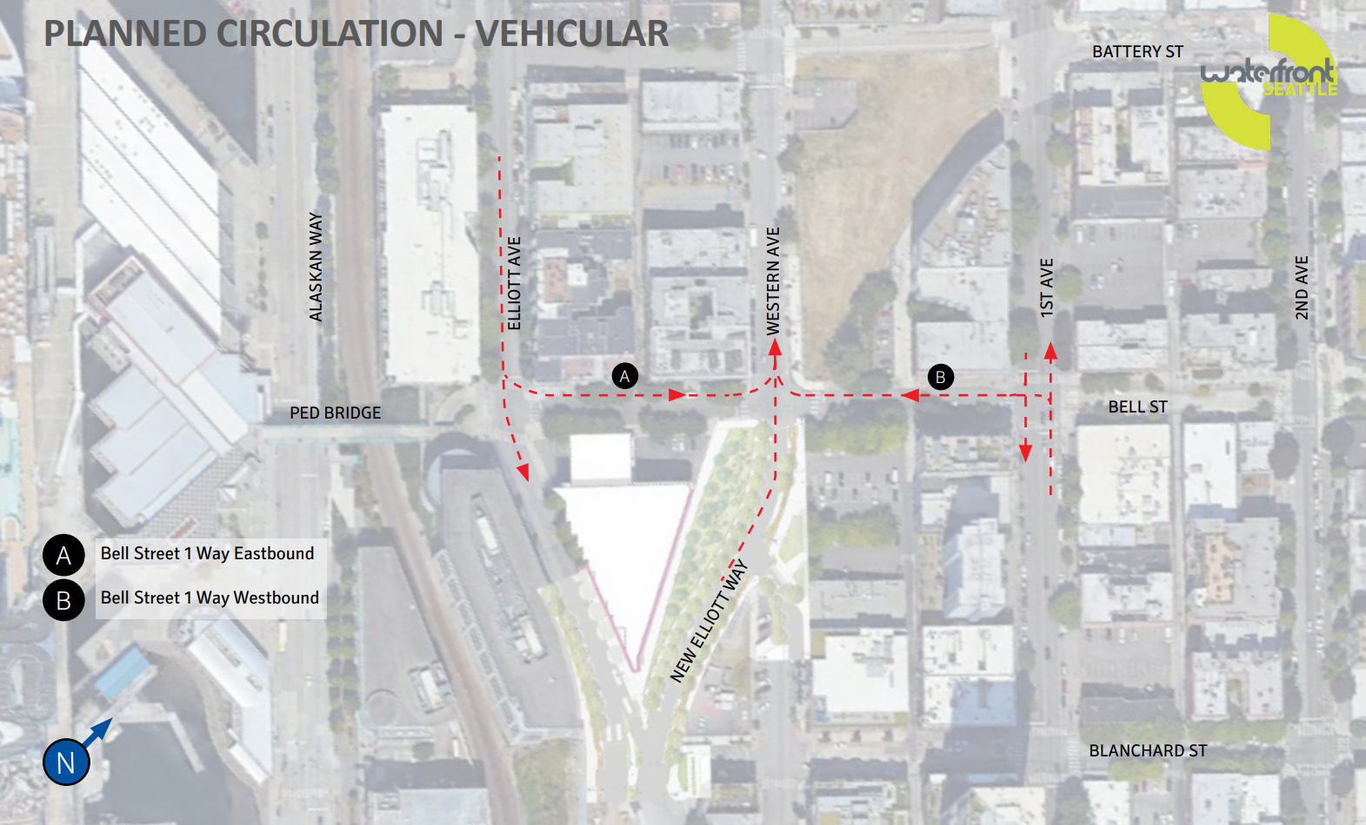 (p 26 of presentation)

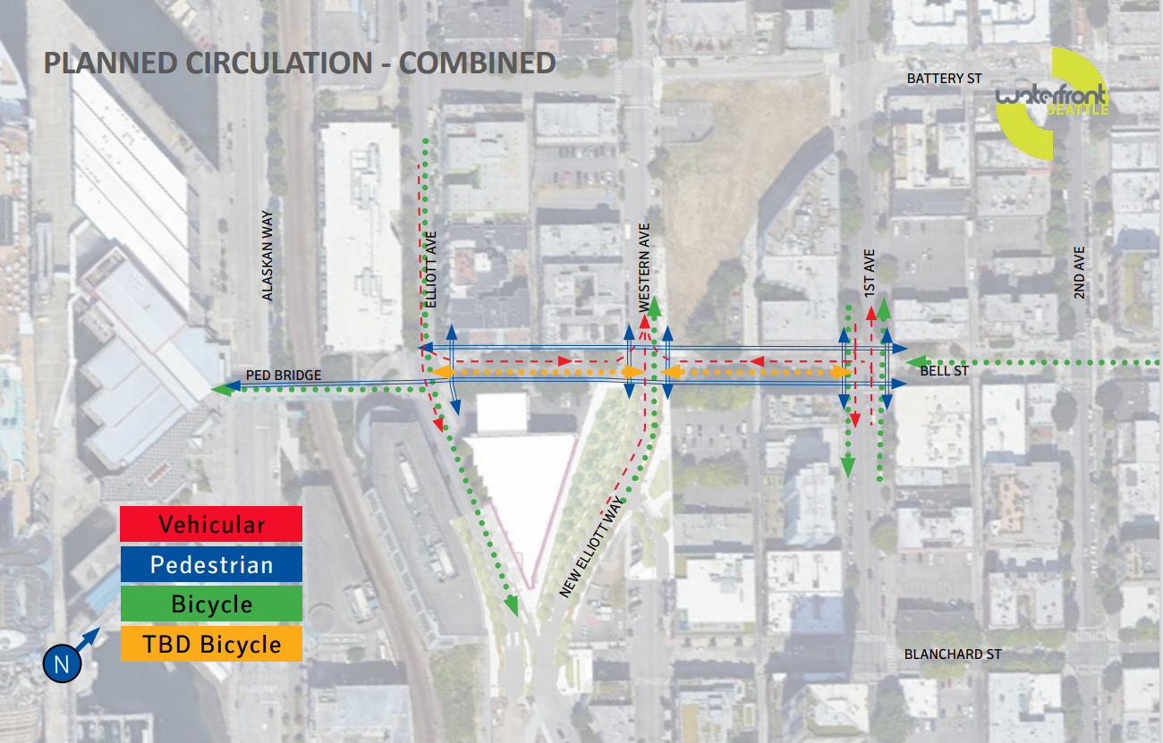 p 31 of presentation
The reconfiguration will allow for a series of improvements that features the repurposing of a former sign bridge on the Hwy 99 viaduct that was located near the project site. Other improvements include:

- Bike lanes
- Widened sidewalks.
- Seating areas
- Furnishings and enhanced plantings
Meeting Summary
This is the Seattle Design Commission’s (SDC) first review of the project. The purpose of this meeting was to review the pre-concept design phase. The design team presented two options –Option 1 Rooms and Option 2 Garden Pockets – for the Commission to review. The Commission review was prior to the selection of a preferred alternative, so the Commission advice was directed toward creating a hybrid of the options. The project will be reviewed again between Schematic Design (60% design) and Design Development (90% design).

Agency Comments
None

Public Comments
None

Summary of Presentation

The project team presented information on the following topics:
- Site location and context
- Site overview and circulation
- Community Engagement
- Option 1 – Rooms
- Option 2 – Garden Pockets
- Differences between the options in terms of:
  - Pedestrian and bike circulation
  - Pedestrian space and seating
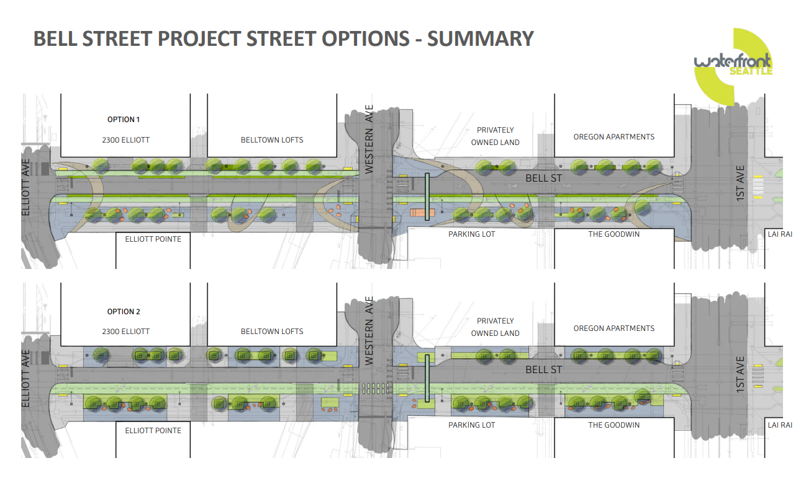 (p. 64 from presentation)
Summary of Commission Discussion and Recommendations
The Commission organized their conversation around these subjects:

- Preference between the two concepts, and advice for a hybrid concept
- Circulation and “moving through” spaces
- Gathering, lingering, and view spaces
- Equity

Preference between the two concepts, and advice for a hybrid
The commissioners expressed a preference for the bike facility design of option 1, but preferred the linearity of the design of open spaces in option 2. The advice for a hybrid is contained in the sections below and in the recommendations at the end of this document.

Circulation and “moving through” spaces
The Commissioners discussed the challenge of circulating bikes where vehicular movements is complex. Commissioners desire was to provide cyclists with a safe and clear ride through the corridor while also protecting pedestrians who might not be aware that the space is shared.

While the commissioners preferred option 2 for the furnishing zones – the crescent shapes seem unrelated to the corridor - they advised that more permeability through the planting and furnishing zone was needed to facilitate movement crosswise/ north south across the linear street corridor.

Gathering, lingering, and view spaces
Commissioners discussed where along the corridor to focus gathering space and asked the team to bring clarity to the hierarchy of spaces. They saw Western and Bell as the best place to create a gathering area because of views of the water and Olympic mountains. There was discussion about the character the sign bridge brings to the space, and commissioners suggested that attention was needed to integrate and build on the sign bridge as an element in a “district.”

Commissioners saw potential in surface water management for creating a water theme that could strengthen the design concept and increase sustainability of the project.

The idea of testing seating locations and bike movements during design phase was discussed, to optimize the layout of elements.

Equity
Commissioners expressed appreciation for the outreach work that had been carried out. They stressed the importance of demographics and how data informs the design.

Action

The SDC thanked the team for their presentation of the pre-design concepts for the Bell Street First to Elliott project.

The SDC expressed appreciation for pedestrianizing this corridor. The playfulness and removability of the seating was applauded. The protected bike lane and hillclimb was appreciated. Commissioners expressed a preference for option 1 regarding bike connections.

The commission provided the following recommendations:
- Continue to develop the Western and Bell intersection as the focal point of pedestrian activity. Employ design choices to strengthen the district identity. Select seating and lighting that works well with the sign bridge character.
- Be judicious as choices are made about reducing the amount, location, and configuration of seating.
- Prioritize areas with good visibility and solar access for seating.
- Increase the visual porosity of the garden pockets and make them less introverted. Disperse the plantings more along the planting and furnishing zone.
- Test the design by placing temporary seating.
- Consider using surface water as an element to help create an exceptional space.
- Consider whether garden space might be added to build on the community’s history of gardening.
- Continue to refine bike facility treatments and turning movements to increase safety of all ROW users.
- Concern that the complex bike and vehicular circulation will necessitate more signage than usual, adding to visual clutter that affects the user experience of the public realm. Refine the design to provide legibility of the route for cyclists while avoiding clutter. The design and signage should clearly indicate to bicycle riders from the east or west where transitions from one type of bike facility to another occur.
- Continue to engage with the community; describe in the next presentation to the SDC where community input has influenced the design.
- Increase clarity of the design language and the relationship of this segment to the full corridor, to I-5, and to the rest of the Waterfront.
The SDC anticipates reviewing the project again when it reaches a point between Schematic (60% design) and Design Development (90%) phases.

