MEETING MINUTES
1305 Stewart Street Public Benefit package
Bruce A. Harrell  Mayor  Rico Quirindongo  Director, OPCD  Jill Crary, Chair  Adam Amrhein, Vice Chair  Matt Aalfs  Erica Bush  Elizabeth Conner  Puja Shaw  Phoebe Bogert  Kevin O’Neill  Ben Gist  Michael Jenkins  Director  Valerie Kinast  Strategic Advisor  Windy Bandekar  Planner  Juliet Acevedo  Administrative Staff | August 17, 2023  Convened 9:00 am  Adjourned 12:00 pm  Projects Reviewed  Commission business  1305 Stewart Street alley vacation public benefit package  Commissioners Present  Jill Crary, Chair  Adam Amrhein, Vice Chair  Elizabeth Conner  Puja Shaw  Erica Bush  Kevin O’Neill  Ben Gist  Phoebe Bogert  Commissioners Excused  Matt Aalfs  Staff Present  Michael Jenkins  Valerie Kinast  Windy Bandekar
Office of Planning and Community Development
600 4th Avenue, Floor 5
PO Box 94788
Seattle, WA 98124-4019
TEL 206-615-1349
FAX 206-233-7883
seattle.gov/designcommission

August 17, 2023 Project: 1305 Stewart Street
10:00 am – 12:00 pm Type: Alley vacation
Phase: Public Benefit review
Previous Reviews: Public Trust review – approved May 4, 2023
Presenters: Rebecca Fuchs and Mark Brands, SiteWorkshop; Jennifer Whelan, Perkins+Will; Ben Rosenfeld, PMB, LLC; Katie Kendall, McCullough Hill.
Attendees: Jeanette DuBois, Beverly Barnett, and Amy Gray, SDOT; Joe Hurley, SDCI;
Avee Oable, Site Workshop

Project Description

PMB, LLC is requesting an alley vacation on a triangular block located in the intersection of the Cascade and Denny Triangle neighborhoods. The north/south alley opens onto Stewart Street to the north and Lower Denny Way to the south. Eastlake Avenue East is on the eastern side of the block.

The existing alley is one block long. The abutments and bridge that enable Denny Way to cross I-5 do not allow the alley to connect to the south. The northern terminus of the existing alley ends at Stewart Street. There is no connecting alley north of Stewart.

The prow of the triangle for the site created because of the alley vacation terminates at the intersections of Denny Way and Stewart Street. The vacation is depicted here:

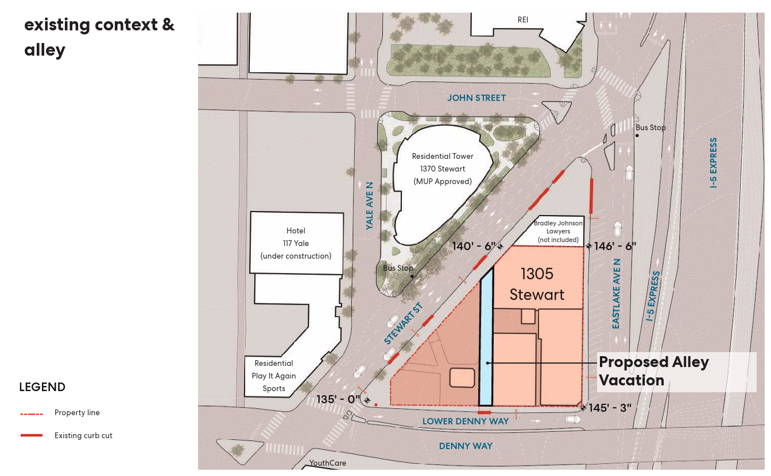

The triangular block is located at the intersection of two city grids. Lower Denny Way is a one block long right of way that is distinct from Denny Way, a major east/west arterial. Lower Denny Way abuts the portion of Denny Way that includes the western abutments for the bridge that crosses I-5.

The vacated alley would allow the construction of a life science research tower with fifteen stories above grade and four parking levels below grade. Access to the site would be provided at Eastlake Avenue East. The development would cover most of the block. A two-story building with surface parking located near the intersection of Eastlake Ave and Stewart Street will be retained. That site does not use the alley and is owned separately from the project under review. The proposed site plan is depicted here:

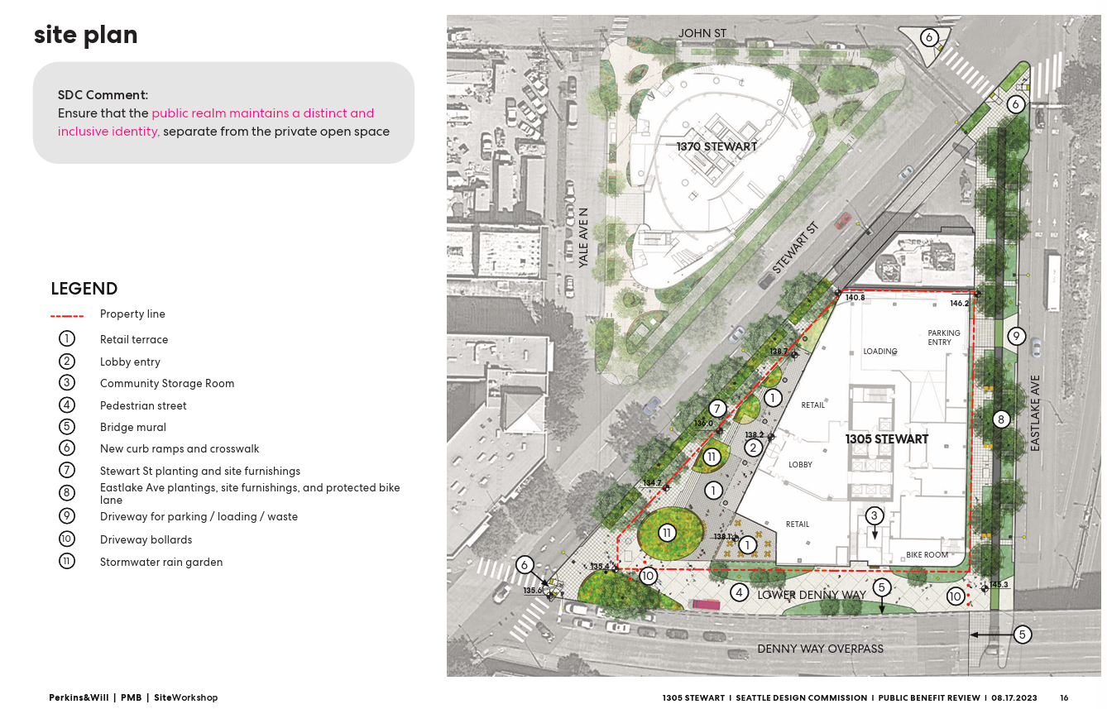

Proposed public benefit package:

This meeting was the first opportunity for the Commission to review and provide directions on the proposed public benefit package for this alley vacation.

As required by the Council’s Street and alley vacation policies, the Commission is required to evaluate whether the proposed public benefit package provides a sufficient offset to address the impacts of the vacation on the remaining rights of way.

The following is a summary of the proposed public benefit package developed by the design team:

- Conversion of Lower Denny Way to a pedestrian oriented right of way, including landscaping and new paving treatment.
- A mural or other feature on the support wall for Denny Way that abuts both Lower Denny Way and Eastlake Avenue East.
- A programming plan for activities on Lower Denny Way that reflects outreach with local residential, business, and cultural communities, including the dedication of a community-accessible storage room to support community programming.
- Dedication of 327 square feet of property abutting Lower Denny Way, near its intersection with Stewart Street, to support the Lower Denny Way proposals.
- Improvements to two intersections – Eastlake Avenue East and Stewart Street, and Denny Way and Stewart Street – to enhance pedestrian safety.
- Improvements along Eastlake Avenue East from Lower Denny Way to Stewart Street, that include bicycle infrastructure, and sidewalk and landscape enhancements.
- Wayfinding signage and other wayfinding elements at various locations around the site.

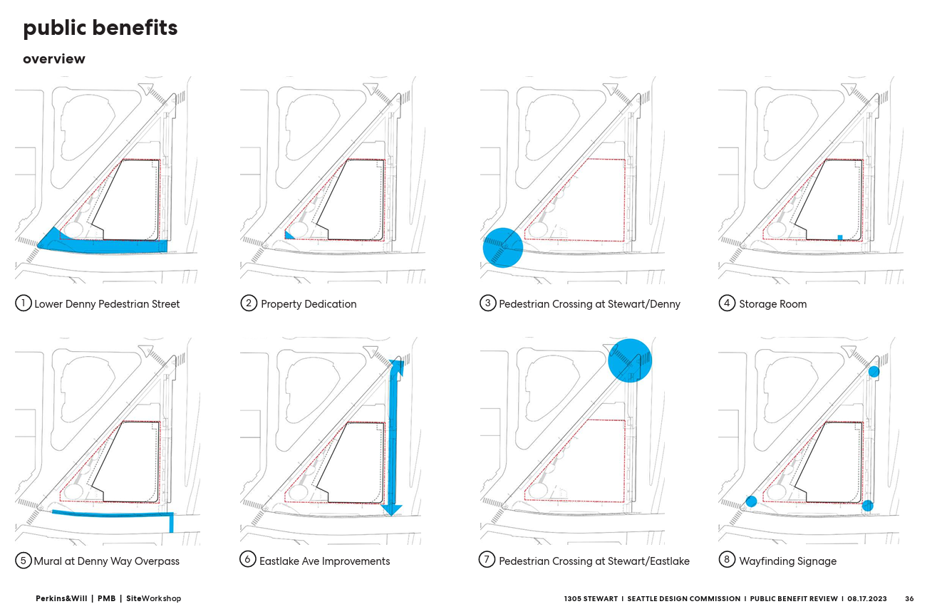
Public comments:

None

Agency comments:

Beverly Barnett with the Seattle Department of Transportation oversees the street and alley vacation process for the Council. She gave an overview of the purpose of a public benefit package in the context of a street and alley vacation. Beverly indicated that the public benefit package provides important concepts and commitments but needs additional work in several areas that include the scope of any programming plan, the proposed mural or artistic endeavor on Lower Denny Way, and the features of the proposed Lower Denny Way improvements.

Joe Hurley from the Seattle Department of Construction and Inspection provided a summary of the land use permitting process and how the project has advanced through the design review process.

Commissioner questions:
Following the design teams’ presentation, Commissioners asked a variety of questions about the basic concepts supporting the proposed public benefit package and details of each of its elements. The following is a summary of Commissioners questions and requests for clarification, based on topics related to the public benefit package:

Lower Denny Way ROW improvements

- How have you refined the landscape and design concepts in Lower Denny Way in their relationship to pedestrian movements, and physical experience, building programming and activities, needed infrastructure, the Lower Denny Way wall, and potential programming areas within the space to reflect community engagement
- Financial commitment to funding artistic endeavors at Lower Denny Way
- Questions regarding the strategy to provide a mural or other artistic element on the Lower Denny Way wall and its relationship to the quality and character of the Lower Denny Way pedestrian and neighborhood experience
- Physical relationship between the planned restaurant spaces and program areas in the Lower Denny Way pedestrian areas, including how grade changes affect connections among the two areas
- How do you know food trucks will be available and interested in Lower Denny Way
- How will building design and programming enhance the Lower Denny Way and Eastlake Ave E pedestrian experiences
- Will there be publicly accessible bathrooms as well as drinking fountains
Mural

- Status of SDOT permitting for the proposed mural or other element artistic endeavor on Lower Denny Way, and the role of any art consultants, City staff, neighborhood groups and individuals, or other entities in developing and executing outcomes
- Agreements with the City’s Office of Arts and Culture or other City departments in connection with artist selection and to review and approval of a mural or other artistic element planned for the Lower Denny Way wall
Programming plans

- How shadowing and noise will affect future programming in the proposed Lower Denny Way pedestrian street and how these aspects will be considered in the design of physical improvements
- The relationship between programming plan concepts and the Commissions August 2017 policy on accepting programming in a public benefit package, including staffing, funding, management, and operations
- The nature and commitment to funding programming activities planned for the Lower Denny Way pedestrian areas
- What are the long-term financial and other commitments to management of your programming activities in Lower Denny Way, including individuals needed, their relationship to building owners/managers/users, and community members
- How utilities are being planned into Lower Denny Way for future programming
Eastlake Ave E

- Whether the proposed Eastlake Ave E bike lane is one or two way and its relationship to the Seattle Bike Master Plan
- The relationship between the Eastlake Avenue E bike improvements, the surrounding pedestrian and vehicular context, and north/south neighborhood connections
- The size and scale of the proposed Eastlake Ave E building screening and its relationship to passing pedestrians and bicycles
Drainage

- Location of the site in the context of the Swale on Yale drainage basin
- Proposals to collect and treat stormwater around the site independent of any part of the public benefit package, including partnerships with Seattle Public Utilities
- Is Stewart Street part of the Swale on Yale system and how it is considered to exceed project related requirements by Seattle Public Utilities
Commissioner deliberations:

The following is a summary of the main themes from the Commissioners deliberations on the scope and concepts for the proposed public benefit package:

- The proposed 327 square foot dedication of property appears to be a required part of the project approval through SDOT permitting. Therefore it should not be considered in the public benefit package
- Significant work in public engagement has been demonstrated in the advancement of the public benefit package since its inclusion in the public trust review, including work with the Cascade Neighborhood Council and nearby neighborhood leaders
- Significant improvements are present at the proposed crosswalk enhancements at Denny and Stewart and Eastlake and Stewart
- Support for the wayfinding proposal
- Support for the proposed Eastlake Ave E ROW improvements
- Questions about how Lower Denny Way can qualify as a public benefit without additional work on landscape concepts, how the landscape plan relates to potential programming, and the role and extent that the proposed artistic outcomes on the vertical wall under Lower Denny Way plays in the identity of the Lower Denny Way outcomes
- Need additional information on programming plan scope and details that are consistent with the Commissions August 2017 policy on accepting programming in a public benefit package
- Need to resolve how the proposed artistic endeavor on the street wall abutting Lower Denny way fits into permitting approvals with City of Seattle
- Need to develop a specific concept for artistic or other features along the Lower Denny Way wall and how they relate to the surrounding public realm and the concepts for programming this space
- Need to involve Commissioners in selection of artists for commissioned work on Lower Denny Way or other similar aspects of the project
The following are specific comments made by Commissioners related to public benefit package elements:

Lower Denny Way ROW improvements
- Be clear in the proposal that vehicular access along Lower Denny Way will remain
- Be explicit with future restaurant tenants that food trucks will be allowed in Lower Denny Way
- Confirm where food trucks are allowed in Lower Denny Way
- Refine landscape design along Lower Denny Way to make sure that the long-term visual and physical public access to the wall structures supporting Denny Way is maintained

Programming

- Consider utility infrastructure (lighting, electrical service, water services, etc.) in Lower Denny way programming plan and how it supports planned or potential programming activities
Mural
- Memorialize the history or other aspects of the site and surrounding neighborhood in the perforated panels along Eastlake Ave E or in the walls intended for artistic expressions on Lower Denny Way
- Need to determine process related issues with getting approval of offsite artistic endeavor
- Coordinate with Office of Arts and Culture on development of concept for artist-created elements, recruitment and selection of artists, approval of artist concept, design, and installation
- Consider three-dimensional approach to artistic features
- Consider relationship of artistic endeavor to public realm along Eastlake
- Ensure that any artwork, including murals or other elements, has dedicated funding and a written process for maintenance and repairs for the life of the project
Drainage

- Pull the stormwater issue out of the public benefit package, as it doesn’t appear to be related
Eastlake Avenue E
- Ensure that the relationship between planting areas and needed infrastructure (lighting, drainage, etc.) along Eastlake are studied and refined to address long-term viability of the spaces

Commissioners indicated that they were not ready to vote on the public benefit package without additional information on the extent of physical improvements to abutting rights of way, the scope and focus of a programming plan for Lower Denny Way to implement community expectations, and how any mural or other artistic endeavor on the Lower Denny Way wall will be approved within the City and the implications of that approval on its long-term viability.

