MEETING MINUTES
1305 Stewart Alley Vacation
Bruce A. Harrell  Mayor  Rico Quirindongo  Director, OPCD  Jill Crary, Chair  Adam Amrhein, Vice Chair  Matt Aalfs  Erica Bush  Elizabeth Conner  Puja Shaw  Molly Spetalnick  Phoebe Bogert  Kevin O’Neill  Ben Gist  Michael Jenkins  Director  Valerie Kinast  Strategic Advisor  Windy Bandekar  Planner  Juliet Acevedo  Administrative Staff | May 4, 2023  Convened 1:30pm  Adjourned 3:30pm  Projects Reviewed  1305 Stewart Street Alley Vacation  WSBLE Update  Commissioners Present  Matt Aalfs  Adam Amrhein  Elizabeth Conner  Jill Crary  Puja Shaw  Erica Bush  Molly Spetalnick  Phoebe Bogert  Kevin O’Neill  Ben Gist  Commissioners Excused  Staff Present  Michael Jenkins  Valerie Kinast  Windy Bandekar  Juliet Acevedo
Office of Planning and Community Development
600 4th Avenue, Floor 5
PO Box 94788
Seattle, WA 98124-4019
TEL 206-615-1349
FAX 206-233-7883
seattle.gov/opcd

May 4, 2023 Project: 1305 Stewart
1:30 pm – 3:00 pm Type: Alley Vacation
Phase: Public Trust Review
Previous Reviews: Pre-petition review – 11/03/2022
Presenters: Rebecca Fuchs, Site Workshop; Jennifer Whelan, Perkins and Will
Attendees: Katie Kendall, McCullough Hill PLLC; Ashley Smith, Perkins and Will; Mark
Brands, Site Workshop; Ben Rosenfeld, PMB

Recusals and Disclosures
none

Project Description

PMB is requesting an alley vacation on a triangular block located in the Denny Triangle neighborhood. The north/south alley opens onto Stewart Street to the north and Lower Denny Way to the south. Eastlake Avenue is the eastern side of the block. The prow of the triangle terminates at the intersections of Denny and Stewart.

The block is located at the intersection of two city grids, which is why the site is triangular. Lower Denny Way is a one block long right of way that is distinct from Denny Way, a major east/west arterial. Lower Denny Way abuts the portion of Denny Way that includes the western abutments for the bridge that crosses I-5.

The vacated alley would allow the construction of a life science research tower with fifteen stories above grade and four parking levels below grade. Access to the site would be provided at Eastlake Ave. The development would cover most of the block. A two-story building with surface parking located near the intersection of Eastlake Ave and Stewart Street will be retained. That site does not use the alley and is owned separately.

The existing alley is one block long. The abutments and bridge for Denny Way does not allow the alley to connect to the south. The north terminus of the alley ends at Stewart Street. There is no connecting alley north of Stewart.

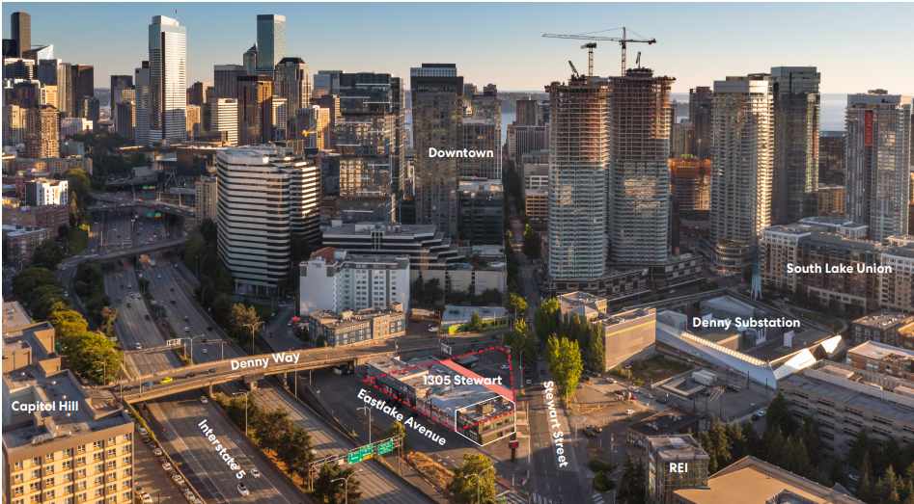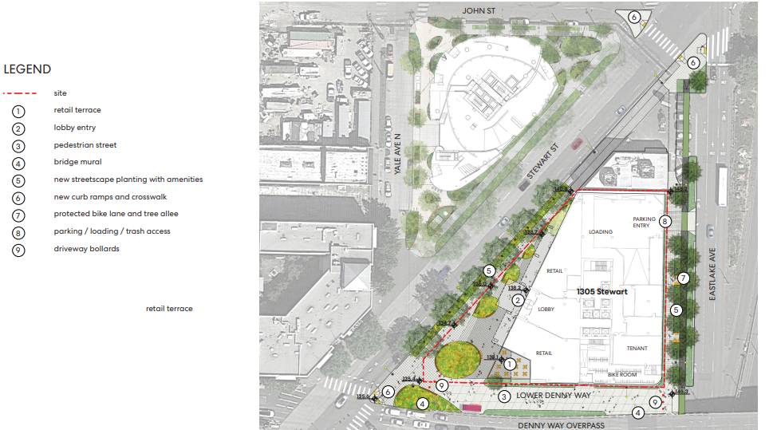

Agency Comments
Beverly Barnett from SDOT provided comments regarding the needs for drop-offs and streetscapes after the vacation of the alley.

Public Comments
None

SUMMARY OF COMMISSION DISCUSSION

Presentation Highlights
- The proposal suggests reorienting the site to prioritize pedestrians, bikes, and stormwater management.
- Natalie Quick provided an update on public outreach efforts, noting difficulties in attendance by people that work or live near the project site.
- The community council expressed a preference for trash and loading activities on Eastlake.
- A letter of concern was received from the Cascade Neighborhood Council regarding existing housing in one of the buildings to be demolished – it was clarified by the owner’s representatives that there is no housing in any of the buildings being demolished.
- The surrounding area has one-way arterials on all sides with numerous curb cuts, posing challenges for residential programs.
- The site to the west has 25% landscaping.
- The 2013 Denny Way streetscape concept plan was mentioned.
- The question of engagement with Youth Care, located to the south, was raised, particularly regarding the mural and potential future collaborations through the urban artwork program.
- Pedestrian traffic was observed primarily crossing Stewart along Denny, with limited use of the north crosswalks to access residential areas. Several collisions have occurred in this area.
- The site is part of the SLU/Ship Canal watershed.
- The proposed project includes considerations for protected bike lanes (PBL) on Stewart, improved circulation patterns, reduced conflicts, and shared vehicular spaces.
- Concerns were raised about the wood power poles at the corner and the role of the open space at the Denny intersection, which could provide refuge and lunch areas.
- It was suggested to clean up the random islands and extend frontage up Eastlake to create a mixing zone and change the crossing to 90 degrees.
- A 14-foot curb lane extension along Eastlake was proposed, featuring conifers in the streetscape.
- A minimum setback of 10 feet on Stewart would provide better views to SLU.
- Soft and flexible programming was proposed for the lower Denny area.
- Stormwater treatment was discussed, including the possibility of using a swale on Pontius Street.
Commissioners Questions and Discussion Items
- Puja's questions regarding Lower Denny as a public right-of-way and coordination with SFD and SDOT were highlighted.
- Erica raised questions about access and engagement with 1811 Eastlake, a permanent supportive housing facility to the south.
- Concerns were expressed about the potential loss of an active edge to the south and the need to address issues on Denny and Eastlake.
- The idea of expanding the buffer on the east side of Eastlake to address sound and air quality issues was mentioned, with further exploration of the WSDOT property.
- Ben raised questions about the power pole at Stewart and Lower Denny, which will need to remain, requiring the team to work around it.

Action

The SDC voted 10 to 0 to approve the Public Trust phase of the vacation, with the following recommendations:

- Revise the public outreach strategy to include more substantial engagement with nearby developments including YouthCare, Melrose Promenade groups, Mirabella (seniors), Cascadia childcare, Manuel Lutheran, and Cascade neighborhood, including options to enhance safety measures for children and seniors.
- Coordinate with DSA (Downtown Seattle Association) and ranger staff.
- Consider including funding and support for active programming to encourage and ensure the activation of the proposed open spaces.
- Continue to prioritize lighting considerations for the project.
- Activate the facade along Eastlake to enhance the streetscape.
- Review truck circulation and make necessary adjustments.
- Reduce the height and width of the parking/loading access to the minimum needed for access.
- Ensure that the public realm maintains a distinct and inclusive identity, separate from the private open space.
- Explore opportunities to lighten the massing of the buildings to create a more open and inviting atmosphere.
- Collaborate with SDOT on the design of the south crossing of Stewart.
- Incorporate equity considerations into the design of public space.
- Address fire department access requirements to ensure safety and compliance.

