MEETING MINUTES
1000 NE 45th Street partial alley vacation
Bruce A. Harrell  Mayor  Rico Quirindongo  Director, OPCD  Jill Crary, Chair  Adam Amrhein, Vice Chair  Matt Aalfs  Erica Bush  Elizabeth Conner  Puja Shaw  Molly Spetalnick  Phoebe Bogert  Kevin O’Neill  Ben Gist  Michael Jenkins  Director  Valerie Kinast  Strategic Advisor  Windy Bandekar  Planner  Juliet Acevedo  Administrative Staff | July 6, 2023  Convened 8:30 am  Adjourned 3:00 pm  Projects Reviewed  1000 NE 45th partial alley vacation  WSBLE Update by Sound Transit  WSBLE update by City of Seattle staff  Commissioners Present  Matt Aalfs  Adam Amrhein  Elizabeth Conner  Jill Crary  Kevin O’Neill  Ben Gist  Commissioners Excused  Puja Shaw  Erica Bush  Molly Spetalnick  Phoebe Bogert  Staff Present  Valerie Kinast  Juliet Acevedo
Office of Planning and Community Development
600 4th Avenue, Floor 5
PO Box 94788
Seattle, WA 98124-4019
TEL 206-615-1349
FAX 206-233-7883
seattle.gov/opcd

July 6, 2023 Project: 1000 NE 45th
1:30 pm – 3:00 pm Type: Partial alley vacation
Phase: Public Trust Review
Previous Reviews: Pre-petition review – 6/9/2022
Presenters: Tim Bates, Sound Transit; Abel Pacheco, Sound Transit; Jeremy Febus, KPFF Engineers; Beverly Barnett, Seattle Department of Transportation (SDOT)
Attendees: Jeanette DuBois, SDOT; Lish Whitson, Seattle City Council – Central Staff.
Jackson-Kennan-Koch, SDOT, Hannah Thorsen, Office of Councilmember
Pedersen; Gerard Buker and Joe Hurley, Seattle Department of Construction
and Inspection; Mara D’Angelo, Sound Transit (by WebEx); Charles Mason,
City of Seattle Office of Housing (by WebEx)

Recusals and Disclosures
Puja Shaw was recused as her firm KPFF was the transportation consultant that analyzed how the vacation and development potential would affect transportation circulation and access at the site and the surrounding properties.

Project Description
Sound Transit (ST) has proposed a partial vacation of an alley segment that terminates at NE 45th between Roosevelt Way NE and 11th Avenue NE. The northern terminus of the alley is at NE 47th Street. The partial alley vacation would affect a 10-foot-wide alley segment that extends from the southern alley terminus at NE 45th north approximately 115 feet north towards NE 47th Street.

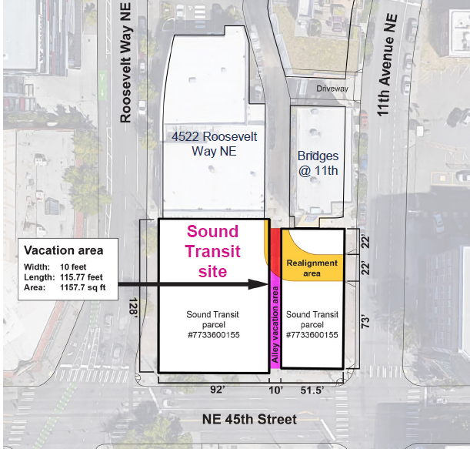
The site is currently used for temporary housing for individuals experiencing homelessness. ST has not proposed a specific development that would be constructed following the partial alley vacation. In lieu of a specific development proposal, ST created a series of development scenarios for the site that are allowed under the land use code, all of which assume mixed use development (ground floor commercial with dwelling units above) and building heights of between 85 and 320 feet. None of the development options that were analyzed assume onsite parking due to proximity to transit options. Access to the site and through the alley would be retained through a new connection to 11th Ave NE.

The following image illustrates buildable area on the site, for either midrise or high-rise development, along with the location of a future connection to 11th Ave NE

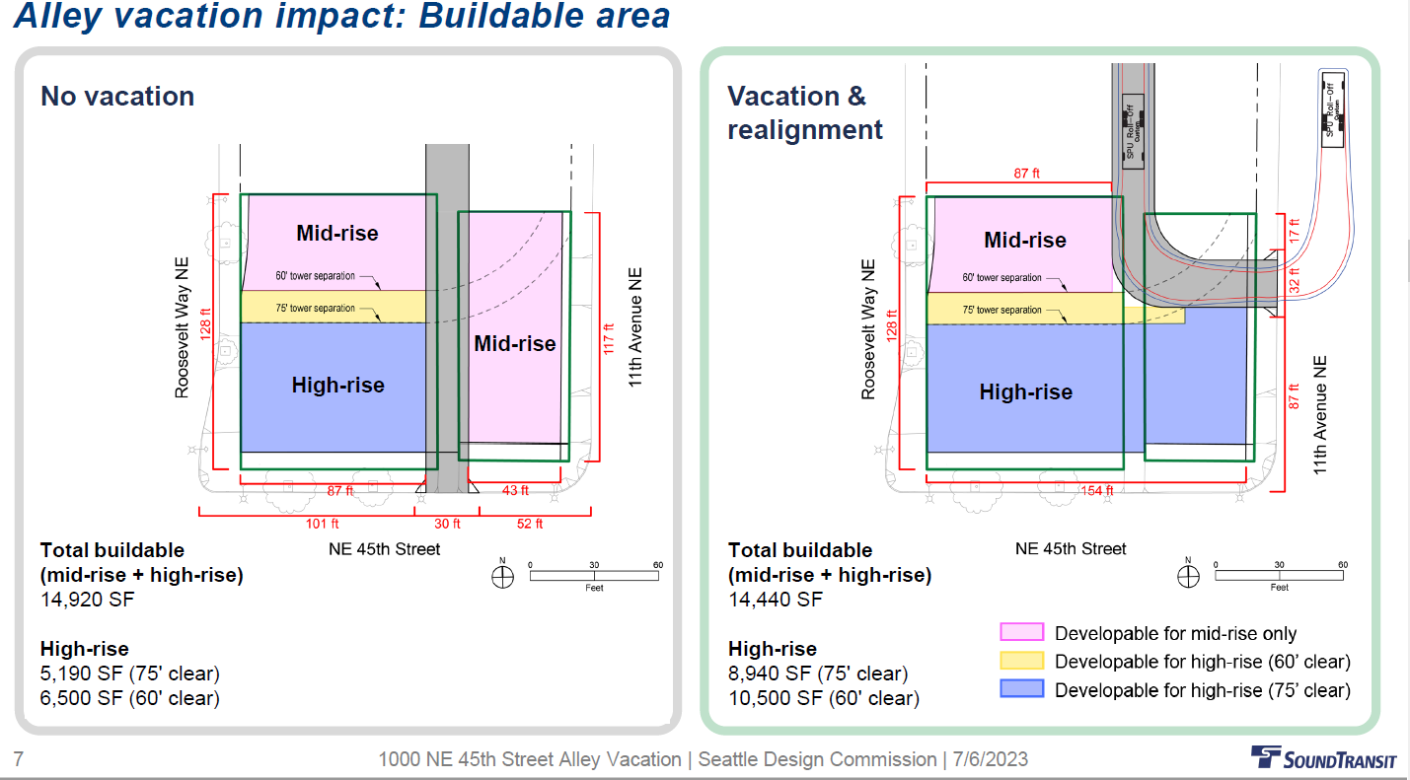

Summary of previous Commission Meeting – 6/9/2022

As required by Council vacation policies, the Commission convened a subcommittee to provide an initial review of the vacation proposal. This meeting is an opportunity for Commissioners to provide input on the proposal prior to submitting a petition to vacate.

At that meeting, it was disclosed that no specific development was being developed for the vacated alley segment. ST staff indicated they would be requesting Council approval to proceed through the alley vacation process without a specific development proposal. Following the Council’s July 19, 2022 Transportation and Seattle Public Utilities’ meeting, the Council did authorize City staff to accept a petition to vacate the alley segment without a development proposal. Council’s approval to proceed was predicated on ST commitment that 100% of the site would be developed with affordable housing.

The notes from that meeting are attached to these minutes.

July 6 Commission meeting – Commission Review of Public Trust

ST provided the Commission with an overview of their proposal and how their assumptions about future development have been refined since their June 2022 subcommittee review. The following slide shows ST’s assumptions about development potential on the site with or without the vacation:

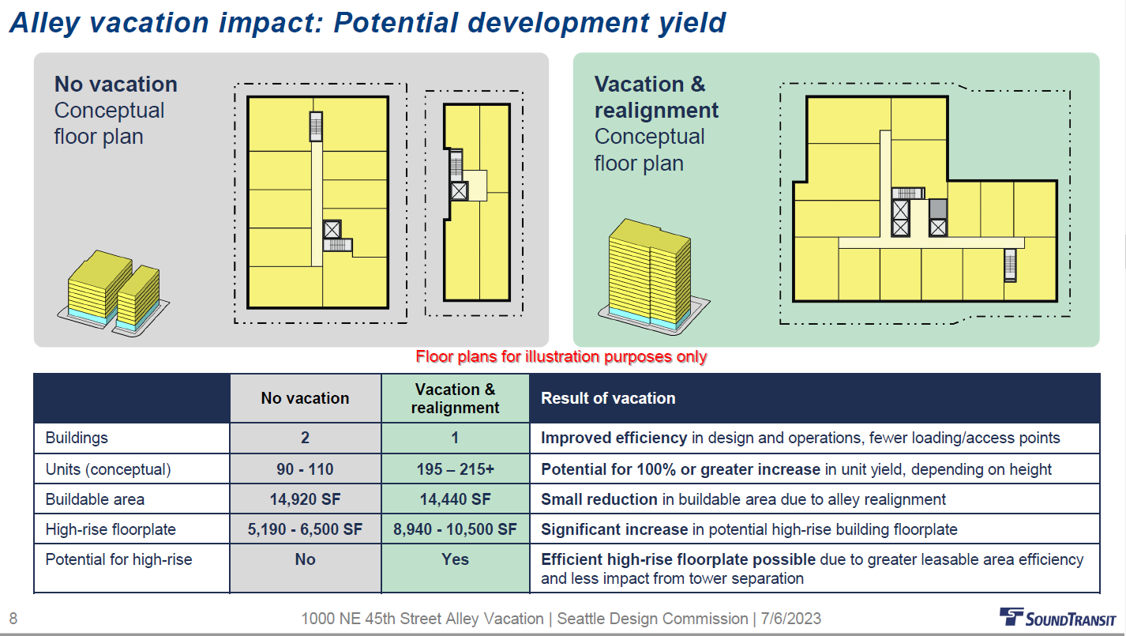

ST’spresentation also highlighted their goals and assumptions for future development on the site including:

- The commitment to make the housing developed for the site 100% affordable at levels to be determined, in conjunction with City of Seattle’s Office of Housing.
- Assumption of no underground parking based on affordable housing development model.
- The relationship of the site with abutting and surrounding existing and future development.
- The alley segment to be vacated and its relationship to abutting properties.
- Development capacity studies that reflect current zoning.
- How future development will integrate with the public realm.
- Implications of the vacation on traffic options at and near the site, including its impact on other properties using the remaining alley segments.
- How service vehicles will access the site following the vacation.
ST’s presentation included an analysis of how the proposed alley vacation meets Council Public Trust policies concerning the role of the right of way and the implications of a vacation on the functions of the right of way.

There are 8 policies that govern Public Trust functions of the right of way:

- Circulation
- Access
- Utilities
- Free Speech
- Public Assembly
- Open Space
- Light and Air
- Views
- Land Use and Urban Form

ST provided the following slide to document the circulation and access impacts of the vacation at and near the site:

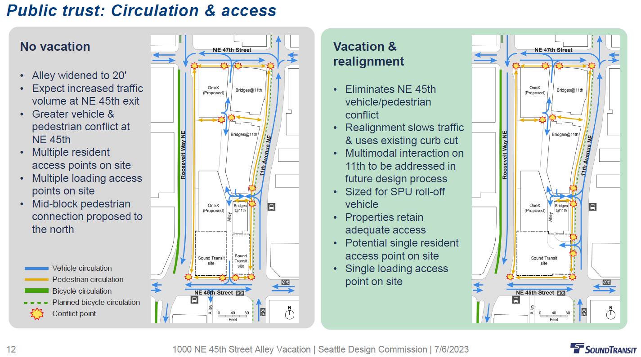
The following is the summary ST provided concerning the remaining public trust policies:

Land Use and Urban Form

- Single building mass and continuous frontage provided on NE 45th.
- High-rise development consistent with neighborhood vision.
- Tower separation requirements will affects high-rise floor plate size and configuration.
Light, Air and Views

- The realigned alley separates building from the northeast property along 11th Ave NE.
- Views to the south from alley would be blocked by new building.
- No known shadowing to parks or other public open spaces
Free speech, public assembly, and open space
- A new structure would create an uninterrupted pedestrian environment on NE 45th, improving opportunity for public use and expression.
- No change to number of access points to alley from the street network
- Realignment of alley to 11th Ave NE provides for a similar amount of publicly accessible space.

Utilities

- Future developers will be responsible for relocating utilities.
- Relocation of electric, telecom, gas, and storm drainage to 11th/NE 45th appears conceptually feasible.
- Preliminary consultation with SCL has taken place.
As the City Council allowed the vacation petition to proceed without a specific development, ST has not developed concepts for a public benefit package. ST intends that any future developer that is selected through an anticipated Request for Proposal (RFP) and subsequent procurement will be responsible for creating a public benefit package. ST expects any future developer to work with the community to create a public benefit package.

Agency Comments

- Beverly Barnett of Seattle Department of Transportation (SDOT) provided the commission with an overview of the process and underscored the unusual nature of this proposal, in that no development is currently proposed.
- Jackson Kennan-Koch of SDOT provided an overview of the internal traffic operations review that was conducted with Sound Transit, including negotiations over the location and attributes of options to connect the alley to a right of way. The 11th Ave N option was deemed the preferred option for traffic operations. SDOT emphasized need to study safety improvements at the future connection of the alley onto 11th to mitigate any impacts of vehicles crossing the sidewalk and entering the roadway at this new mid-block location.
Public Comments

None

Summary of Commissioners questions

Commissioners’ questions focused on the attributes of future development and potential options, access to 11th Ave NE, integration with the public realm, changes in traffic operations due to the vacation, and the RFP/ procurement process. Questions from commissioners included:

- Will high-rise development be required?
- How does the height limit affect potential development options?
- Whether future development is intended for students.
- The range of housing affordability that will be sought and Office of Housing support.
- How the alley vacation and future connection will impact traffic operations on 11th Ave NE and within the alley, including for service vehicles.
- How ST is coordinating with Office of Housing in the future RFP/procurement process
- The relationship of future development with the NE 45th Avenue streetscape
- Sound Transit’s analysis concerning development capacity and ability to maximize affordable housing.
Summary of Commission discussion and deliberation:

The commission focused their discussions and deliberations following categories outlined in Council policies for Public Trust analysis. Public Trust policies address the implications of the alley vacation proposal on the role and purpose of rights of way and how the project proponent has addressed the loss of the street or alley on the remaining functions of right of way abutting or near the site.

The Commission organized their discussion in three groups:

- Circulation and Access, Utilities
- Free Speech, Public Assembly
- Open Space, Light and Air, Views, land use, and Urban Form
As ST has not developed a public benefit package, the Commission did not provide any analysis or direction on that part of the vacation process.

Circulation, Access, and Utilities
Commissioners focused their comments on how vehicles and pedestrian circulation will occur in a safe manner from the new alley configuration. Commissioners also focused their comments on where the location of “back of house” functions (trash, drop offs, deliveries, move-ins) from the vacation. Commissioners raised concerns about the potential impact to Protected Bike Lanes (PBL) planned for west side of 11th Ave NE and how those conflicts will be mitigated when a development is selected in the RFP process.

Free Speech and Public Assembly
Commissioners had no specific comments on these policies.

Open Space, Light and Air, Views, Land Use and Urban Form
Commissioners focused their deliberations on how the loss of the alley segment and consolidation of the two parcels affect urban form. Commissioners also discussed the benefits of the vacation in consolidating two parcels that are relatively small. Commissioners also discussed whether a high-rise development appeared feasible due to the site and its constraints. Commissioners also discussed the benefits of having a continuous structure along NE 45th due to the vacation. Commissioners expressed concern about the residual space at the NE corner of the site abutting 11th Ave NE and its role in providing open space.

Commissioners also discussed and expressed concern about ST stated goals for the project. ST has indicated that the project was intended to have 100% affordable units. However, there is no explicit goal (number of units, levels of affordability, etc.) and how that goal can be realized if a structure up to or meeting the base height limit is the only feasible option due to site constraints.

Commissioners also expressed concern about the nature of this vacation. The lack of a concurrent development proposal with the vacation petition raises many unanswered questions about its implications on the public realm and abutting development. Commissioners understood that the shared Council and ST commitment to affordable housing was the basis for this abbreviated process, as both City and ST believe the RFP process will be strengthened with the vacation in place. Commissioners expressed that any allowance for future vacations without a concurrent development should be highly selective and based on similar strong City priorities. They did understand that future development was intended to meet ST policies on transit supportive development.

Action

The Commission recommends that the City Council approve the proposed partial alley vacation. The Commission also recommends that the Council require Sound Transit to embed the following conditions in their Request for Proposal for future development at this site:

CONDITION 1 - Public Benefit
Prior to applying for a Master Use Permit to construct affordable housing over the vacated alley segment bounded by NE 45th Street to the south, NE 47th Street to the north, Roosevelt Way NE to the west, and 11th Avenue NE to the east, the Seattle Design Commission will review and approve a public benefit package that meets Council policies in Council Resolution 31809, addresses community expectations detailed in the June 2013 University District Urban Design Framework, Section 3.7 for incentive zoning development; and additional community engagement. A proposed public benefit package should include elements in Council Resolution 31809, a plan to implement potential public benefits that will be complete before issuing a Certificate of Occupancy.

CONDITION 2 – Public Trust – Circulation and Access
Prior to applying for a Master Use Permit, present to the SDC the design of the access point of the alley to 11th Ave NE. The commission will evaluate how the proposal minimizes functional impacts to circulation and access from moving vehicular access to 11th Avenue NE. The Commission will also evaluate how potential conflicts with pedestrians and cyclists on 11th Ave NE are addressed through planning and design solutions that improve safety such as:
  - Increasing structure setbacks as necessary to improve sight angles.
  - Limiting the width of any opening to that of the minimum needed to accommodate vehicles.
  - Landscaping areas, bollards, and other elements in the right-of-way, on the site, or integrated with the building.
CONDITION 3 – Public Trust - Urban Form, Light, Air, Open Space

To address the impacts of a structure on NE 45th Street that will be longer due to the loss of the alley, the pedestrian experience along NE 45th Street should be enhanced. Options to enhance the pedestrian experience along 45th Street could include:
  - Installing ground floor windows that maximize visibility and transparency, with operable windows when appropriate for uses within the building.
  - Providing increased building setbacks along NE 45th Street.
  - Planting areas on site and in the right-of-way designed for urban areas with elevated levels of pedestrian movement.
  - Designing and applying building materials that are high quality and varied at a pedestrian scale;
  - Installing street furniture that is designed for active movement along the street and as places of rest; and
  - Designing and installing lighting for pedestrian movement and to enhance building architecture.
  - Design any residual space north of the new alley segment to 11th Ave NE as open space in any public benefit package.
CONDITION 4 – Public Trust - Urban Form, Light, Air, Open Space
If any future structure is not subject to the City’s Design Review program, any new development should consider designs and features that implement guiding principles, urban design recommendations, and environmental sustainability goals in the 2013 University District Urban Design Framework applicable to this site could include:
  - Providing site or structure design features that enhance the corner of NE 45th Street and Roosevelt Way NE.
  - Distinguishing between the upper and lower floors of any structure over the base zoning height of 95 feet.
  - Providing street level uses that activate NE 45th Street, along with structure or design features that accentuate any such uses; and
  - Designing any tower features above 95 feet that reflect the existing and planned context of abutting or adjacent high-rise structures.

