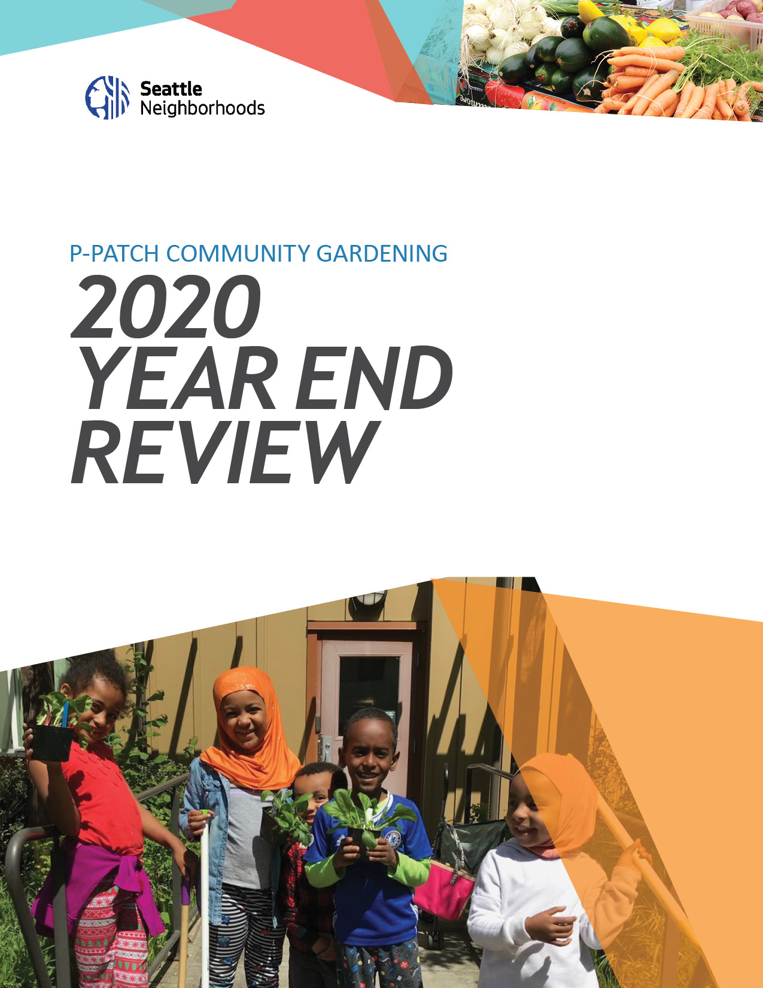
ta

Contents
MISSION STATEMENT 2
ANTI-RACISM STATEMENT 2
P-PATCH 2020 ANTI-RACISM HIGHLIGHTS 3
Staff Workplan Shift Toward BIPOC Communities 3
New Plot Assignment Guidelines 3
Anti-Racism Training & New Anti-Racist Strategies Provided to P-Patch Gardeners 3
2020 PROGRAM OUTCOMES 4
P-Patch by the Numbers 4
Class Recordings Available to All: 5
P-Patch Giving 5
P-Patch Response to Covid-19 6
COVID-19 Neighborhood Accomplishments 6
MEDIA RELATIONS 7
2020 Media Credits: P-Patch Community Response to COVID 7
2020 COLLABORATIONS & PARTNERSHIPS 8
2021 PROGRAM PRIORITIES 10

Seattle Department of Neighborhoods provides resources and opportunities for community members to build strong communities and improve their quality of life. Through our programs and services, we meet people where they are and help neighbors develop a stronger sense of place, build closer ties, and engage with their community and city government.
P-Patch Program oversees 89 P-Patches located throughout the city. Community gardeners grow food on 14.9 acres and provide stewardship for an additional 18.8 acres of public land for a total of 33.7 acres.
As part of the City of Seattle, the P-Patch Program works to meet the Race and Social Justice Initiative goals to end racial disparities. Through observation and data analysis, we know that some racial groups have been chronically underrepresented in the program. We have concluded that these racial disparities exist because of a lack of equal access to the program.

MISSION STATEMENT
The Department of Neighborhood’s work is guided by two broad principles:
- Put race and equity at the center of all decisions and actions.
- Invest in the power of community to forge solutions.
City of Seattle’s P-Patch program provides community garden space for people to grow their own organic and culturally appropriate food, herbs, and flowers. The P-Path Program is committed to food justice, environmental justice, and racial equity by prioritizing under-represented and marginalized communities. In partnership with residents and community-based groups; P-Patch promotes access to healthy food, community health, and resiliency, stewardship of open green spaces through activities such as emergency preparedness, gardening education, farm stands, and growing for giving.

ANTI-RACISM STATEMENT
The P-Patch Program is committed to achieving racial equity and dismantling the institutional racism that has prevented people of color from fully participating in our program. We believe that we each have a responsibility to make our gardens more inclusive and welcoming to all. This requires us to commit to addressing racism and all forms of injustice in our communities and center people most impacted by systemic racism: Black, Indigenous, and People of color (BIPOC).

P-PATCH 2020 ANTI-RACISM HIGHLIGHTS

Staff Workplan Shift Toward BIPOC Communities
- In early 2020, our staff participated in a full-day retreat and revised the P-Patch 2019 Workplan shifting programmatic goals, strategies, and resources toward expanding relationships to BIPOC communities.

New Plot Assignment Guidelines
- In 2020, we adopted new plot assignment guidelines to emphasize priority placement of underrepresented communities in our gardens.
- From January – July 2020, 45% of all new gardeners across the program were placed from priority BIPOC groups.

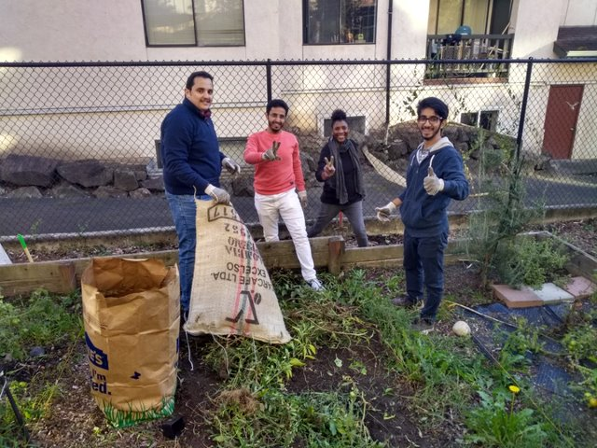
Anti-Racism Training & New
Anti-Racist Strategies Provided to
P-Patch Gardeners
- The P-Patch program is partnering with internal city departments and external facilitators to offer free anti-racism trainings to our gardeners.
- GROW & P Patch collaborated in a “Cultivating Inclusive Communities” training. The training generated 51 participants including 6 staff members and a cross-section of P-Patch gardeners.
- Through our training, we encouraged gardeners to:

- Develop group agreements for making decisions and resolve conflict.
- Read books or articles to learn and promote discussion on topics such as implicit bias, privilege and power, and structural racism in the food system.
- Create a land acknowledgment in each garden to recognize the Duwamish and Coast Salish tribes and support tribal rents.

2020 PROGRAM OUTCOMES
In 2019. DON P-Patch employed one Planning and Development Supervisor who in addition to her core management responsibilities managed three sites, six full-time staff who managed 90 P-Patch gardens, and five coordinators each managing portfolios of up to 20 sites.
P-Patch by the Numbers
NOTE: Certain numbers in this graphic have been rounded up or rounded down.

- Updated key P-Patch documents (i.e. Safety in the Garden) to reflect alternatives to calling 911 and to encourage a more compassionate response to food theft, people experiencing homelessness in the gardens, and mental health emergencies.
https://www.seattle.gov/neighborhoods/programs-and-services/p-patch-community-gardening/toolkit-for-gardeners/tools-for-running-a-garden
- Rewrote “Sharing the Abundance” resource guide thru an equity lens. https://www.seattle.gov/neighborhoods/programs-and-services/p-patch-community-gardening/toolkit-for-gardeners/share-the-harvest#toolsforgiving
- Garden collaborations resulted in a transfer of excess plants from the Ballard P-Patch to Marra Gardens and other Latinx P-Patches in South Seattle.
- P-Patch staff supported BIPOC groups growing at Seattle Community Farm, Yesler Terrace gardens, Black Farmers Collective, Seattle BIPOC Organic Food Bank, Black Stars Farmers, Judkins giving garden, and supporting the food bank plot at High Point Juneau.
- Expanded our media footprint by completing a 2020 P-Patch video to inform the broader community about our program and shift to BIPOC focused engagement. https://youtu.be/DuS4b-2zMb4
- Our staff researched funding opportunities connecting BIPOC businesses and those most heavily impacted by food insecurity.
- Offered 3 virtual Emergency HUB 101 trainings in collaboration with HUB Captains Network; 41 participants- 22 gardens participated. Recording: https://youtu.be/Th681SX5IG0
- Offered 5 virtual organic gardening classes in collaboration with Tilth Alliance; 10 sessions total, approximate total # of attendees: 366, # of class recording views in 2020:154.

Class Recordings Available to All:
Max Your P-Patch  - https://vimeo.com/404571401  - password: P-Patch | Weeds: the good, the bad, the edible  - Date: Jul 11, 2020  - https://us02web.zoom.us/rec/share/RTKieh8CicNgBhDlRmv8Wg0322OqLSA8Sy1NUufydriIm2pedleIoIF6eYl7Le0n.fCvuJZfthpYmfZqv  - Access Passcode: w7C=6Bx*
Habitat Gardening
- Date: Jun 16, 2020 https://us02web.zoom.us/rec/share/ku8uBVFhJH02JCFWQlKzk8yXVTIs-shrWbYt1_G2rYqbqw6zssTcIQ6QKIRSHyP1.D8N49ar0bxEK95N6
- Access Passcode: 1w?=yQ5*
Wind Down the Season  - Date: Sep 14, 2020  - https://us02web.zoom.us/rec/share/4y4lt4gr32STRPcW_H-ft_PKYl3C9wnGiOIHxvpYT2HBtDSZ5dm-ehtDuH-A9-Mp.WcqU07A8WAWYGFeF  - Access Passcode: r7C=6Bx# | Making the Most of a Bountiful Harvest  - Date: Aug 22, 2020  - https://us02web.zoom.us/rec/share/5IVLI-iGZXCSCKVxtUwe5e7JaCnVfSd1HpzofoNNfEgiT0I69vvpyry9NALJjP_i.jH8ywHUlQdFrNuOF  - Access Passcode: +D?s6=6y

P-Patch Giving
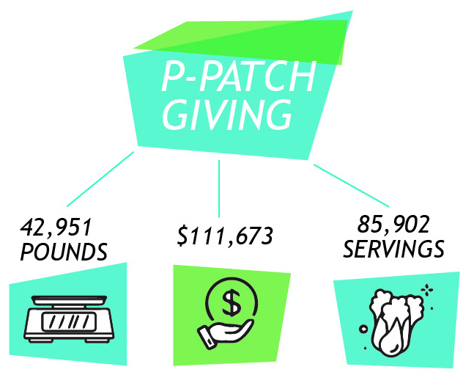
*servings based on the USDA’s estimate of 1/2lb of produce per serving
*$111,673.00 based on average price of organic produce of $2.60 per pound (USDA National Fruit $ Vegetable organic summary)

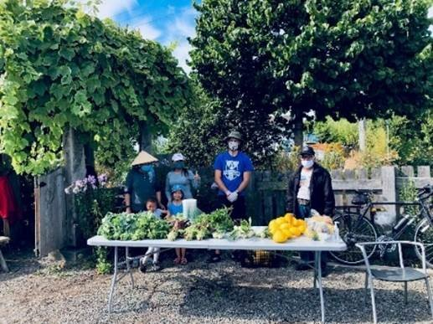
P-Patch Response to Covid-19
Following the guidance from Public Health – Seattle & King County, the Washington State Department of Health, and the Centers for Disease Control and Prevention, the P-Patch program ensured all gardeners had the information and resources they needed to stay safe and healthy.
We all have an important role to play in preventing the spread of COVID-19 and the P-Patch Program provides ongoing guidance to help ensure everyone’s safety. Staff developed and translated into 9 languages the Community Gardening COVID-19 Tip Sheet offering gardeners the necessary information and resources to stay healthy
Covid-19FINALTipSheet.pdf (seattle.gov)
Our program partnered with City Fruit to host 8 pop-up events at Seattle Housing Authority P-Patches. We served over 750 families with over 2,000 pounds of vegetables from P-Patch gardeners.
To better serve our community during the pandemic, we relocated our program staff at the neighborhood level so they could be more accessible to the community.

COVID-19 Neighborhood Accomplishments
- New Holly Rockery P-Patch and Market Garden = 220 people served, and 793 pounds of fruit donated from City Fruit at 4 pop up events in collaboration with the P-Patch Gardeners with over 475 lbs. of veggies giveaways.

- High Point Juneau P-Patch and Market Garden = 250 people served, and 886 pounds of fruit donated from City Fruit at 4 pop up events in collaboration with the gardener’s veggie give always.

MEDIA RELATIONS
P-Patch was proud to partner with media outlets across the region and beyond to promote the value of gardening and growing during a time of crisis. In addition, we were able to complete a P-Patch video highlighting relationships and community building in P-Patch gardens. https://youtu.be/DuS4b-2zMb4

2020 Media Credits: P-Patch Community Response to COVID

- https://foodprint.org/blog/community-gardens/
- https://frontporch.seattle.gov/2020/07/21/community-gardeners-growing-a-more-sustainable-future/

- https://www.pccmarkets.com/sound-consumer/2020-05/planting-a-legacy-seattles-P-Patch gardens/?utm_source=PCC+Community+Markets&utm_campaign=ce93e8d7f5-EMAIL_CAMPAIGN_2019_10_04_12_05_COPY_01&utm_medium=email&utm_term=0_363ba451d4-ce93e8d7f5-231319525

- https://mynorthwest.com/1874657/adopting-old-fashioned-hobbies-quarantine/

- https://www.seattletimes.com/pacific-nw-magazine/on-earth-day-and-beyond-seattle-cultivates-a-community-of-gardeners-who-are-growing-food-for-those-in-need/

- https://www.creators.com/read/c-force/04/20/you-are-what-you-eat-during-pandemic-isolation-period
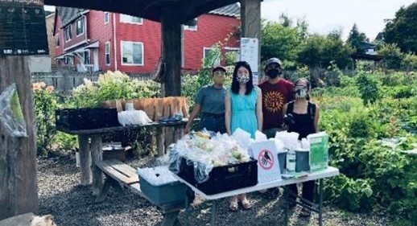
“We noticed that the P-Patch became a haven for people during the shut-down, with some neighbors hosting small "homeschool" sessions on the patio and others playing with their children in the newly landscaped sitting park.”

2020 COLLABORATIONS & PARTNERSHIPS

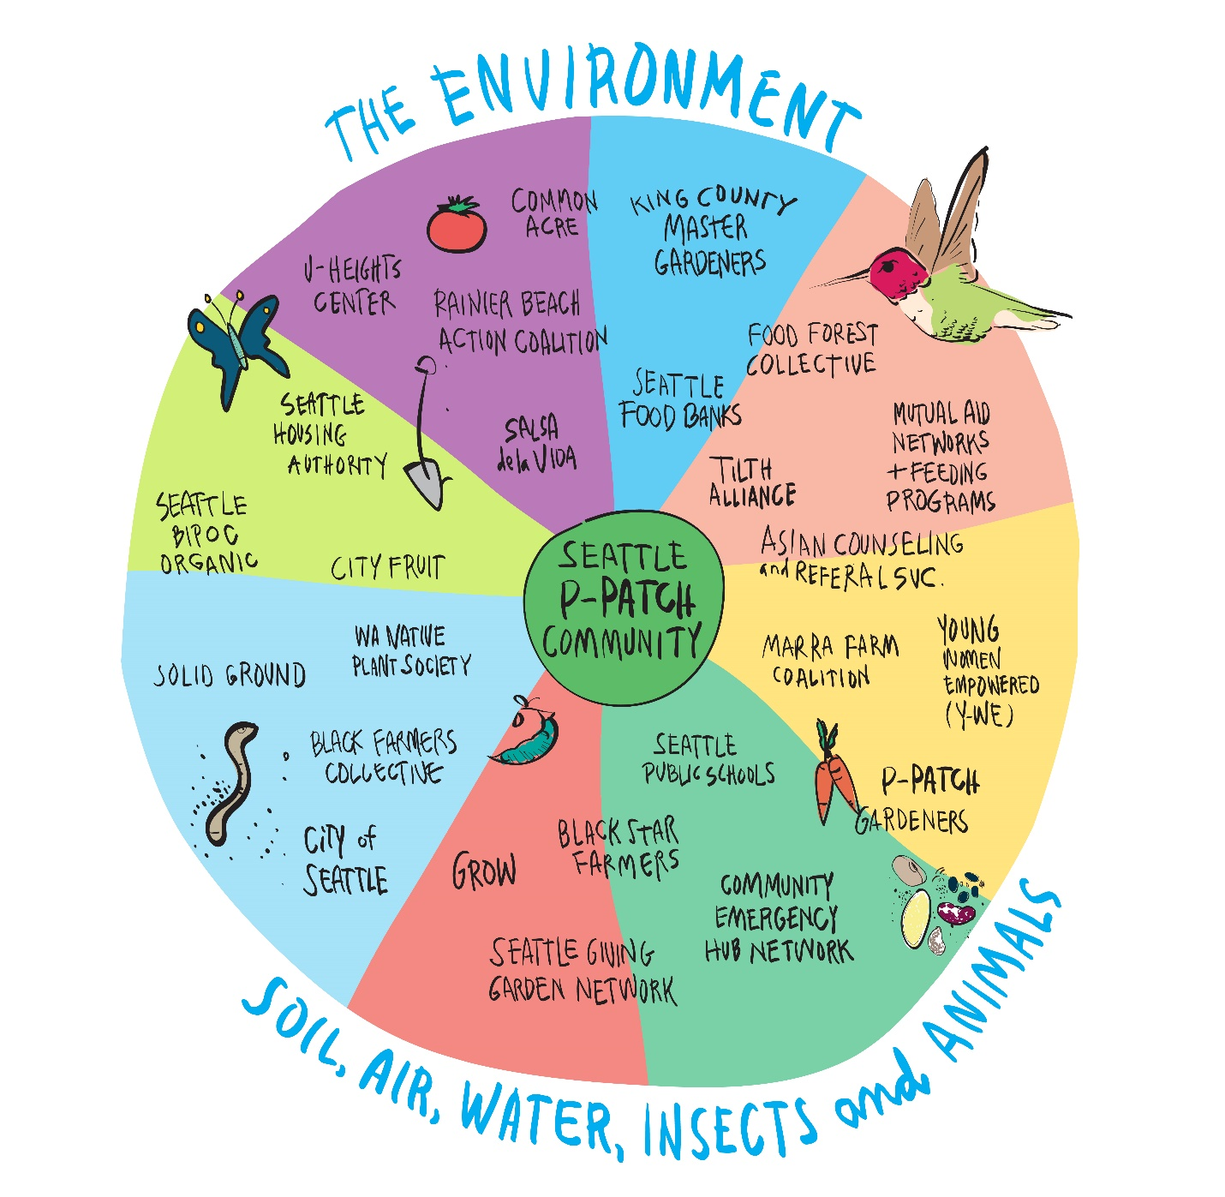

- BIPOC Food Bank
- YES Farm
- Black Farmers Collective
- United Indians of All Tribes Foundation (UIATF)
- Salsa de la Vida
- City Fruit
- Master Gardeners
- GROW
- Tilth Alliance
- Green Thumbs- NYC
- Little Free Pantries
- NW Harvest
- Byrd Barr
- Seattle Peddling Relief/ Cascade Bicycle Club
- Seattle Therapy- Skills for Life
- KCD/ OSE- Grant Technical Reviewers
- HIAB- Emergency Hub in A Box
- Seattle Housing Authority
- Seattle Office of Sustainability & Environment- Food Action Plan
- Seattle Public Utilities - Community Engagement Project & Backflow Assemblies Installation Project
- Seattle Parks & Recreation
- Seattle Parks District
- Seattle Public Library - BLOOM Gardening
- Seattle Public Schools - School Learning Garden Network
- Seattle Together Rainmaker Fun

“Thank you for all your efforts in keeping the P-Patch Program a successful and wonderful service for Seattle residents.”

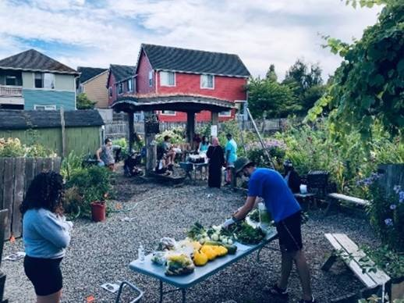

2021 PROGRAM PRIORITIES
As COVID-19 continues, more than ever, community gardens are a key component of providing food security, reassurance, and peace to communities heavily impacted by the global pandemic, especially those struggling to put food on their tables. P-Patch program staff is determined to prioritize those who are most in need and who have been most heavily impacted by the injustices of institutional and economic racism.
In 2021 our programmatic goals will continue to elevate BIPOC communities and foster an environment of inclusion and collaboration for all P-Patch gardeners.
2021 PROGRAM PRIORITIES | TACTICS
Priority 1:  Continue to increase BIPOC participation and improve the experiences of P-Patch gardeners | - Develop a resource list of anti-racism trainings for all gardeners.  - Roll out anti-racism/ discrimination statement via 2021 renewal process.  - Expand on in-language education & trainings.  - Increase leadership development opportunities for BIPOC and LEP gardeners.  - Provide ongoing interpretation support.
Priority 2:  Enhance outreach and engagement of BIPOC communities | - Design educational content to reflect interests that are specific to each BIPOC community.  - Prioritize community- building and storytelling activities.  - Uplift and build new and creative partnerships with BIPOC gardeners and groups.  - Offer stipends for POC gardeners and elders to teach organic gardening classes.
Priority 3:  Develop strategic partnerships & collaborations located in and serving target communities | - Continue new pilot project at Seattle Community Farm in Rainier Valley.  - Continue 2021 pop-up partnership with City Fruit @ Market Gardens.  - Expand relationships with black churches and community groups to grow food.  - Participate in BIPOC urban ag organizations to support community groups.  - Collaborate with internal teams including PACE, Parks District, Community Liaisons, and others to learn engagement best practices and integrate gardeners into larger civic engagement opportunities.  - Offer schools opportunities in garden spaces.  - Collaborate with existing partners to better reflect cultural structures & meet needs.

