Draft dated 4/29/2019

International Special Review District

Design Guidelines

ADD STATEMENT ABOUT WHERE TO GO FOR ADDITIONAL IN-LANGUAGE ACCESS HERE?

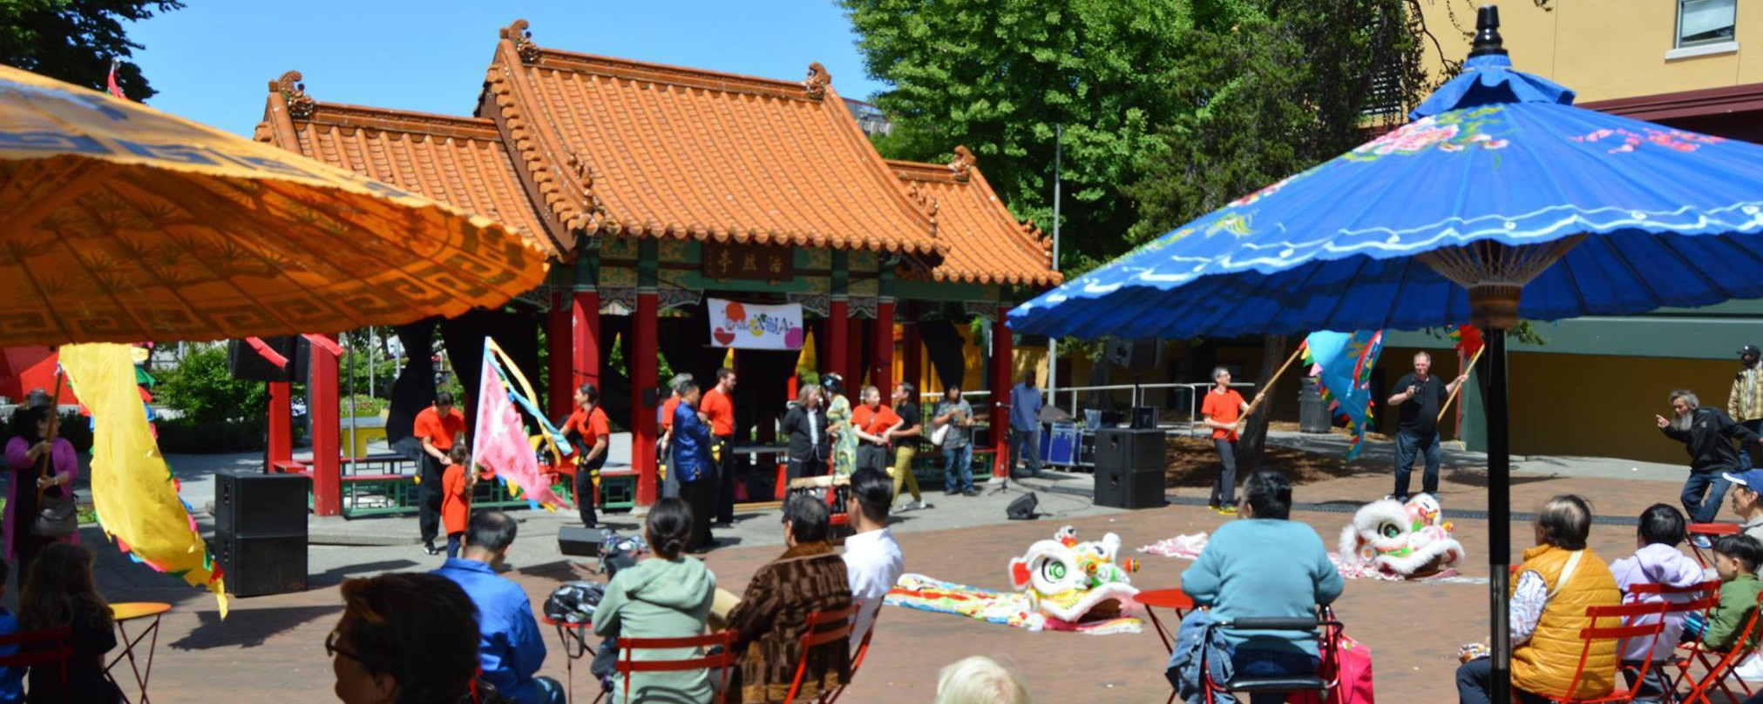
Consultant note: This document is a work in progress. The following pages are a snapshot of where the consultant team is in the process, and are based on several planning documents previously conducted throughout the Chinatown International District, as well as a series of recent workshops with the International Special Review District (ISRD) Work Group (which began in 2017). Any comments received on this draft are much appreciated, and will be reviewed by the consultant team for incorporation into the next draft.
The Urbanist

Acknowledgments

The effort for this document has been incremental over the past decade, by the volunteer members of the International Special Review District (ISRD) Board – who reviewed the existing 1998/2001 Guidelines with the intent of updating the guidelines to reflect the realities of modern-day development.
Cham Bunphotah
In 2017, the City convened the ISRD Design Guideline Workgroup, as part of a broader community-focused planning effort between the Department of Neighborhoods and the Office of Planning and Community Development. The ISRD Workgroup worked with the ISRD Board to provide input and guidance to a consultant team hired to produce the revised ISRD Design Guidelines. The ISRD Workgroup was comprised of Chinatown International District (CID) residents, business owners, property owners and community stakeholders – many of whom have been active in the community for many years. The Workgroup met regularly over the course of eight months to provide feedback on the outline and finesse the guidance that is represented in the following pages. Those individuals were:

Josh Brevoort, Shanti Bresnau (co-lead), Brien Chow*, Rachtha Danh, Michael Jurich, Betty Lau, Carol Leong*, David Leong*, Esther Lucero, Tiernan Martin*, Miye Moriguchi (co-lead), Valerie Neng, Homero Nishiwaki, Mike Omura*, Quyhn Pham, MaryKate Ryan, Rie Shintani, Jessa Timmer, Andrew Tran, Tanya Woo

*indicates current/prior service on the ISRD Board

We would also like to acknowledge the dedicated and continued community support of several CID groups and individuals, which set the stage by providing foundational documents from which this work sprung, including:
- Past ISRD Board members and Board chairs, including Rich Murakami and Martha Rogers, who led some of the Guideline Review Committee discussions
- Chinatown International District Business Improvement Area (CIDBIA)
- Friends of Little Saigon
- InterImCDA
- Seattle Chinatown International District Preservation Development Authority (SCIDPDA)
- Wing Luke Museum of the Asian Pacific American Experience

Additionally, we referenced:
- Seattle Municipal Code 23.66
- Current ISRD Design Guidelines (1988; 1991)
- SparkLab Lighting Study (2018)
- Working ISRD Design Guidelines draft (2017)
- Seattle Citywide Design Guidelines (2013)
- The Secretary of the Interior’s Standards for Rehabilitation and Guidelines
- Illustrated guidelines on Sustainability for Rehabilitating Historic Buildings
- Relevant National Park Service Historic Buildings Preservation Briefs
- Chinatown International District Strategic Plan (1998)
- Chinatown International District 2020 Healthy Community Action plan
- Design Guidelines from neighborhoods in Portland, Vancouver BC, San Francisco, and Los Angeles
- Kroll maps from 1912-20, 1940-60 and ca. 2000, historic Baist maps and Sanborn Insurance Company maps (Seattle Public Library)
- King County Assessor’s archival property records (Puget Sound Archives) and on-line aerial photos
- Photography collections of the Wing Like Museum, University of Washington Libraries Special Collections, Museum of History and Industry, Seattle Municipal Archives and Seattle Public Library
- HistoryLink.org on-line essays
- Quintard Taylor, The Forging of a Black Community – Seattle’s Central District from 1870 through the Civil Rights Era (1994), and a journal article, “Blacks and Asians in a White City,” (Western
Historical Quarterly, 11.1991).
- Edward and Elizabeth Burke, Seattle’s Other History (1979), Vera Ing, Dim Sum – The Seattle ABC (American Born Chinese Born) Dream (2010), and bob Santos and Gary Iwamoto, Gang of Four (2015).
- John D. Nonato, “Finding Manilatown: The Search for Seattle’s Filipino American Community, 1898-2016,’ a UW Tacoma thesis (Winter 2016).
- UW design studio report, “Little Saigon – Community Open Space Initiatives” (2005).
- Kelly Guava and Bao Nguyen, “Art and Cultural Projects Home to Cement Little Saigon’s Historic Presence” from Ethnic Seattle (Feb. 13, 2018).
The Consultant Team, who produced this 2019 version are Grace Kim, Margaret Knight, Emma Sutton and Joann Ware, from Schemata Workshop, in collaboration with Susan Boyle, of BOLA Preservation and Planning, City of Seattle staff supporting this effort were Rebecca Frestedt and Sarah Sodt, Seattle Department of Neighborhoods, and Janet Shull and Gary Johnson of the Office of Planning and Community Development.

Table of Contents

Danny Ngan
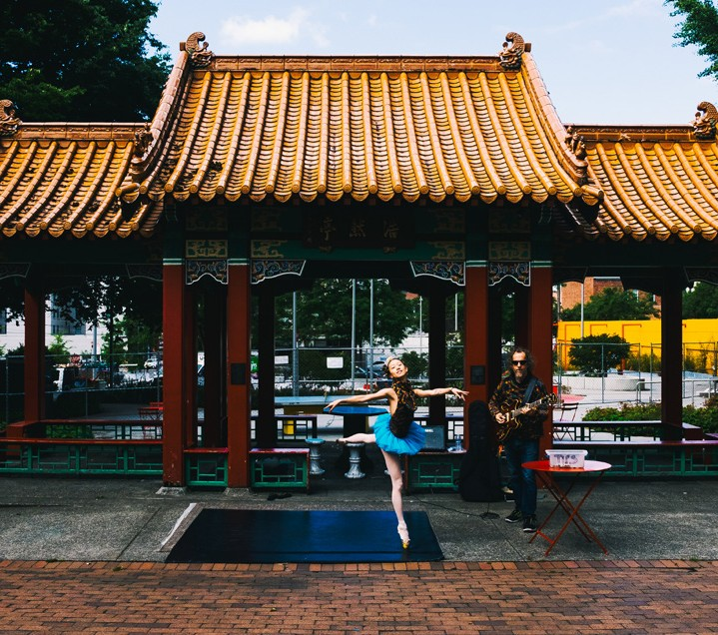
Hing Hay Park
Seattle Department of Transportation
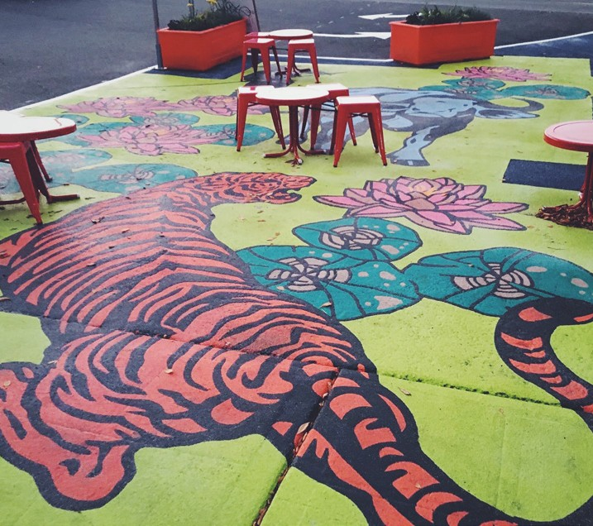
Artwork located in Little Saigon, created through the Pavement to Parks program
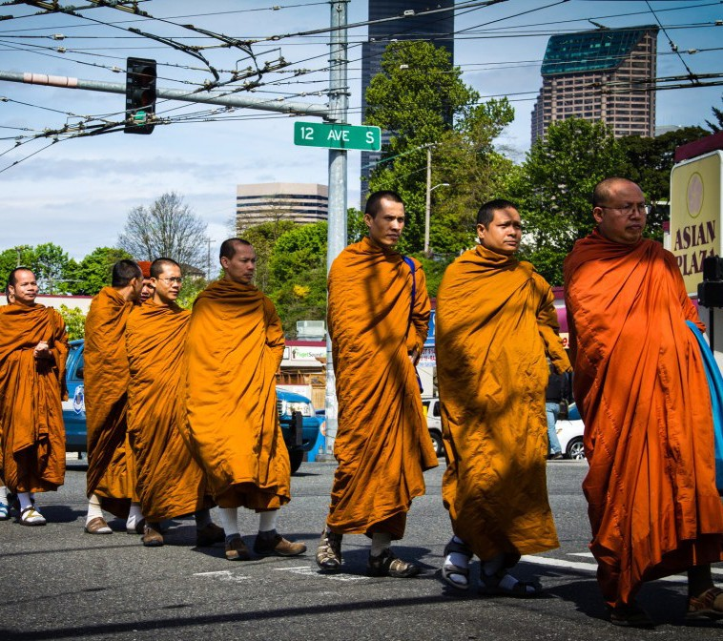
Street crossing at 12th and Jackson

Index of Diagrams
Canopic
Common Signage xx
Character Defining Elements xx
New Buildings xx
Acknowledgments x
Table of Contents x
Introduction x
Reader’s Guide x
ISRD Boundary Map x
History & Background x
Districtwide Guidelines x
Guiding Principles x
- Context & Site x
Response to Context x
Public Realm x
Building Orientation x
Parking and Support Services x

Public Life x
Open Space x
Storefront Design x
Signage x
Awnings and Canopies x
Safety and Security x
Lighting x

Building Design x
Contributing Buildings x
Non-Contributing Buildings x
New Buildings and Additions x
Tall Buildings x

Location Specific Guidance x
- Additional Guidance East of I-5 x
Overview of Area x
Goals for Development x
Context and Site x
Public Life x
Building Design x

Additional Guidance West of I-5 x
Overview of Area x
Goals for Development x
Context and Site x
Public Life x
Building Design x

Document Resources x
Glossary of Terms x
Resources x
Secretary of the Interior’s Standards for Rehabilitation XX
Introduction

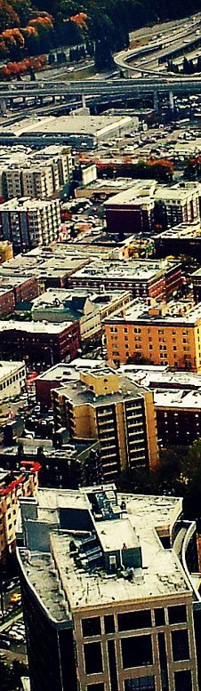
What are the ISRD Design Guidelines?
Seattle Chinatown International District
The International Special Review District (ISRD) is one of eight historic districts in the City of Seattle. It was established in 1973 to promote and preserve the cultural, economic, and historical features of the neighborhood, particularly those features derived from its Asian American heritage. The ISRD Design Guidelines are a set of design standards for the District that contains suggested approaches and strategies for development in the District.

Who is expected to use the ISRD Design Guidelines?
The primary purpose of the ISRD Design Guidelines is to serve as a tool for the community to advocate for high quality design that contributes
to the cultural and historical character of the neighborhood. It is intended to be used by a variety of people including business owners, property owners, community members, design professionals, ISRD Board members, and City of Seattle staff. To ensure that businesses are in compliance with the historic district regulations, property owners and managers should inform new tenants about the district requirements and inform new tenants that a Certificate of Approval may be required before changes are made.

When are the ISRD Design Guidelines used?
Changes to buildings and properties located within the boundaries of the ISRD require that a Certificate of Approval be issued by the ISRD Board and the Director of the Department of Neighborhoods. The ISRD Board uses the ISRD Design Guidelines as supplemental guidance in tandem with the Seattle Municipal Code Chapter 23.66 – Special Review Districts for evaluating proposed changes and new development. In the event of a conflict between these ISRD Design Guidelines and chapter 23.66SMC, chapter 23.66 shall control.
In addition to the ISRD Design Guidelines, the criteria the Board will consider for proposed exterior alterations and treatments, rehabilitation projects and new construction projects include: Secretary of Interior’s Standards for Rehabilitation with Guidelines for Rehabilitating Historic Buildings, and the complete series of Historic Buildings Preservation Briefs developed by the National Park Service. The Board will also consider the age, architectural and historical integrity of the building. “Integrity” refers to the extent of the alterations or changes that have been made to the building over time.
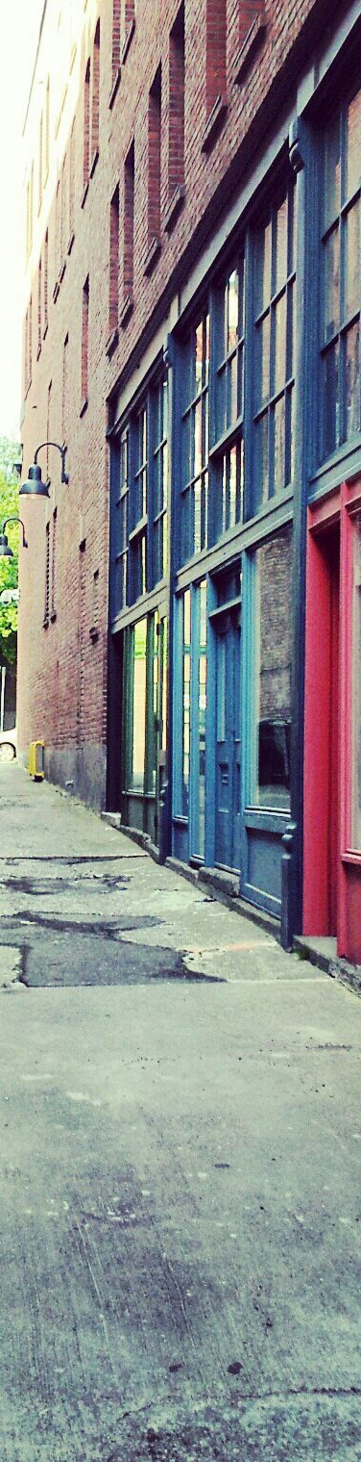
What is the process for applying for a Certificate of Approval?
Seattle Chinatown International District
The following steps provide a general overview of the review and approval process, although the process for individual projects may vary. Please plan to incorporate the timing of applying for obtaining a Certificate of Approval in your project timeline:

  - Step 1: Contact the ISRD Board Coordinator, 206-684-0226, to discuss ideas for proposed changes, new development and associated application materials. The Coordinator and Board can provide design guidance and feedback during the planning stages. Applicants with major projects are encouraged to contact the Coordinator to discuss scheduling an informational project briefing.
  - Step 2: Prepare and submit Certificate of Approval application materials to the ISRD Board Coordinator. The list of required application materials is based on the type of change proposed. Some items may require input from a design professional.
  - Step 3: After an application is determined to be complete, it will be placed on the agenda for the next public meeting of the ISRD Board. This is an opportunity to present the proposed change(s) and answer questions from the ISRD Board, as well as an opportunity for the general public to make comments to the ISRD Board regarding any proposed changes.
Most projects will only require one review before the Board; however, for larger or more complex projects the Board may review a proposal during the conceptual, design development and final stages of the project. This process may involve presentation of “working drawings” to the Board’s Architectural Review Committee (ARC) or more than one review by the full Board. The ARC primarily consists of architects and design professionals who serve on the Board; however, all Board members are able to participate.
  - Step 4: The ISRD Board will recommend to the Director of the Department of Neighborhoods whether to approve, approve with conditions, or deny the application in accordance with SMC 23.66.316. The Director of the Department of Neighborhoods makes the final decision. Either a Certificate of Approval or a Letter of Denial will be issued.

  - Step 5: A Certificate of Approval is not a permit. Applications for other relevant permits from City Departments such as Seattle Department of Transportation and Department of Construction and Inspections must be submitted separately.

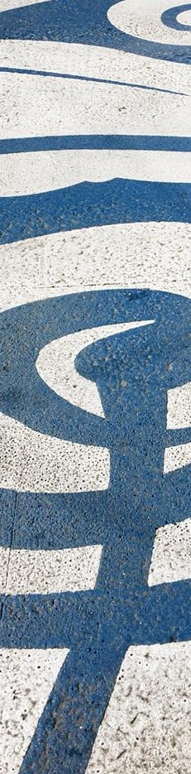
What types of changes require a Certificate of Approval (COA)?
Seattle Department of Transportation
The following changes require a Certificate of Approval to be issued by the Board and the Director of the Department of Neighborhoods before the City of Seattle will issue any permits:

  - Change of Use – A COA is required when the principal use of a building or commercial space changes. For example: restaurant to retail, or residential to office. The ISRD Design Guidelines do not include guidance for uses. Refer to Seattle Municipal Code Sections 23.66.320 through 23.66.328.
  - Colors – A COA is required for a change to exterior paint colors.
  - Facade or Site Alteration – A COA is required for exterior alterations to a storefront or building that are visible from the street or public right-of-way, including but not limited to:

window treatments
    - awnings or canopies
    - security systems, including fencing
    - doors and windows
    - fire escapes
    - masonry cleaning
    - rehabilitation
    - installation of rooftop mechanical equipment
    - landscaping
    - artwork

  - Signs – A COA is required prior to installing a new sign on a building façade or in a storefront window, or changing the face of an existing sign.
  - New Construction – A COA is required for any new construction and major building additions. For larger projects, Preliminary Design and Final Design approval may be required.
    - Preliminary Design Approval – bulk, massing and

scale
    - Final Design Approval – construction documents, materials, colors, finishes, right-of-way improvements and landscaping
  - Demolition – A COA is required to demolish any building or structure. The ISRD Design Guidelines do not include guidance for demolition. Refer to Seattle Municipal Code Section 23.66.318 – Demolition approval.
  - Street Use Permit – A COA is required for changes to the parking configuration or alterations within the public right- of-way, including merchandise displays, sidewalk cafes, and street furniture.

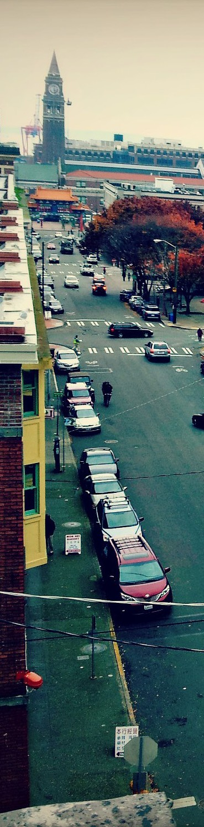
What is the role of the ISRD Board?
Seattle Chinatown International District
The ISRD Board was created to preserve, protect and enhance the The ISRD Board was created to preserve, protect and enhance the cultural, economic, and historical quality of the ISRD, and advise the Director of the Department of Neighborhoods. The Board consists of seven volunteer members: five that are elected by the community in annual elections and two that are appointed by the Mayor and confirmed by City Council. Two of the five elected Board members own property
or a business in the District or who are employed in the District, two of the elected members reside in the District or have demonstrated an interest in the District, and one member is elected at large. ISRD Board members’ terms are for two years, and members may serve up to two consecutive terms.

The ISRD Board has an obligation to uphold the provisions of the Seattle Municipal Code 23.66, and uses the ISRD Design Guidelines, the Secretary of the Interior’s Standards for Rehabilitation, with Guidelines for Rehabilitation Historic Buildings, and the complete series of Historic Preservation Briefs developed by the National Park Service to evaluate applications and proposals.
The ISRD Board meets the second and fourth Tuesday of every month to review applications for Certificates of Approval for change of use, exterior colors, facade alteration, signs, new construction, demolition, and street use. All ISRD Board meetings are open to the public. The meetings are a forum for anyone in the community to observe the decision-making process, and to provide input on proposed changes.

To ensure that questions and answers between the ISRD Board and applicant occur in a public forum, please direct all questions and comments about applications to the ISRD Board Coordinator.

What is the role of the ISRD Board Coordinator?
The ISRD Board Coordinator is a City of Seattle Department of Neighborhoods staff member who stewards the Certificate of Approval application process. They are a resource to the community, and are available to clarify guidelines, application requirements and procedures, review proposed plans, and provide guidance about how to determine whether or not a building is contributing or non-contributing. Contact the ISRD Board Coordinator to schedule an informal meeting to discuss your project or informational project briefing before the ISRD Board. To contact the Board Coordinator, please call 206-684-0226.

Reader’s Guide

Document Overview
The ISRD Design Guidelines contain five sections: Introduction, History and Background, Districtwide Guidance, Location Specific Guidance, and Document Resources.

Design Guidelines are located in two sections: Guidance for Entire District, and Location Specific Guidance. Applicants for a Certificate of Approval must demonstrate that their proposed project is consistent with all applicable Districtwide Guidance and Location Specific Guidance. Since projects vary in size, scope, location, and complexity, not all guidelines apply to all proposals.

The Introduction, History and Background, and Document Resources sections provide additional information to support applicants in the Certificate of Approval process. Italicized and bold words are defined in the Glossary of Terms found in the Document Resources section.
Seattle Municipal Code sections that correspond to portions of this document are noted in italicized text.

The paragraphs below provide an overview of the sections that follow:

“History and Background” Overview
This section provides background information on the history, people, and importance of Seattle’s International Special Review District. This sets the framework for the overall goals of the District and helps build a solid foundation for the guidelines that follow. It is important to note that
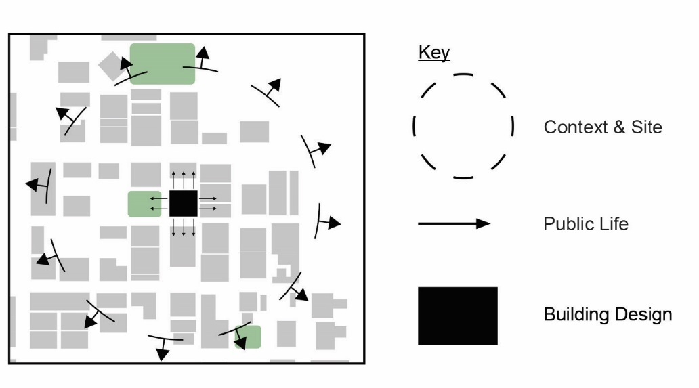
this section is not a comprehensive history of the area. There are many more people, organizations, and events that have contributed to the architecture and cultural heritage of the District.

“Districtwide Guidance” Overview
Guidance provided in this section applies to all properties within the boundaries of the International Special Review District. The ISRD Design Guidelines are organized around three themes:

- Context and Site – This theme focuses on how projects interact with their surrounding neighborhood blocks.
- Public Life – This theme focuses on how projects interact with their immediate surroundings.
- Building Design – This theme focuses on the design of the building itself and is organized by the type of building that is being modified or proposed.

Guidelines within each theme are grouped by category. For example, the guidelines in Public Life are organized into six categories: Open Space, Storefront Design, Signage, Awnings and Canopies, Safety and Security, and Lighting.

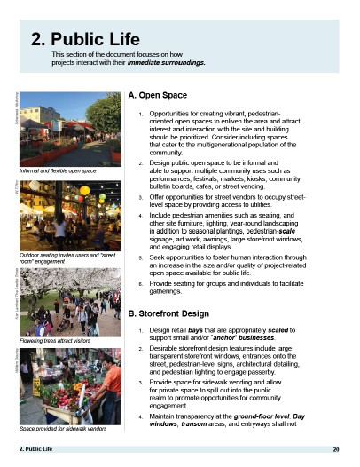
Theme
Theme Summary Category

Guidelines

Category

Guidelines

“Location Specific Guidance” Overview
Guidance provided in this section is meant to be applied in addition
to Districtwide Guidance. Each applicant must first respond to Districtwide Guidance provided for all of the ISRD, and then respond to Location Specific Guidance applicable to the proposed project address, depending on whether the proposed project is located either East of 1-5 or West of 1-5. The Location Specific Guidelines are organized by the same themes as in the Districtwide Guidance.

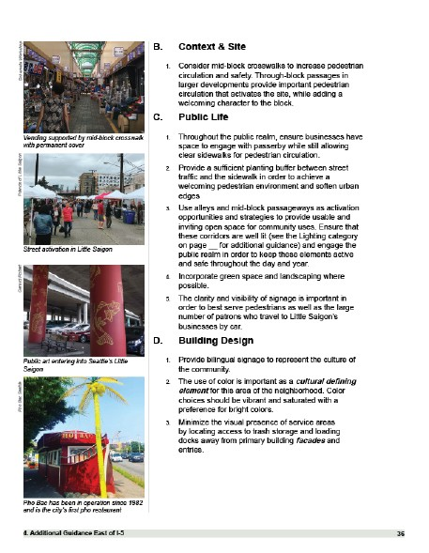
Theme Guidelines Theme

Guidelines

Theme

Guidelines

“Document Resources” Overview
The Glossary of Terms includes words and phrases that have been
identified with text that is italicized and bold.

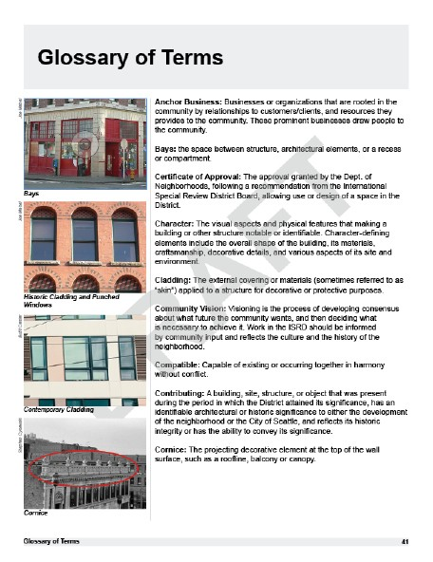
Term and Definition

Example Image

The Resources list includes organizations to contact, or documents to reference for additional information regarding Seattle land use, historic preservation, and the history and culture of the ISRD.

ISRD Boundary Map
The zoning within the International Special Review District includes three different zoning classifications represented by different shaded colors on the ISRD Boundary Map below. Identifying the location of the proposal’s building or property within the ISRD will help readers navigate the applicable ISRD Design Guidelines, as well as the Seattle Municipal Code Chapter 23.66.

Within the bounds of the ISRD exists two other overlay areas as shown on the map, the Seattle Chinatown Historic District, recognized in the National Register of Historic Places; and the Asian Design Character District/Retail Core.
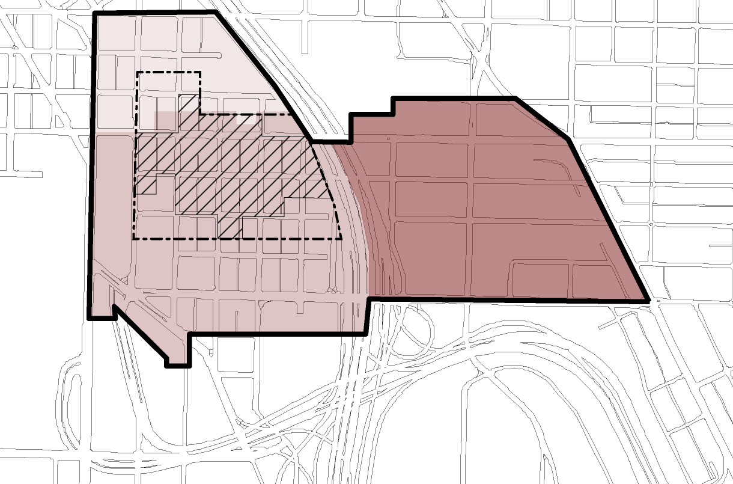
YESLER WAY
S WASHINGTON ST S MAIN ST
S JACKSON ST S KING ST
S WELLER ST

S LANE ST

S DEARBORN ST
S CHARLES ST
N
0 250 500
1000
Feet

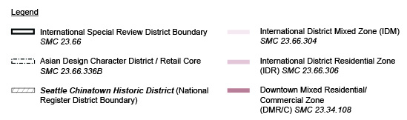
4TH AVE S
5TH AVE S
6TH AVE S
MAYNARD AVE S
7 TH AVE S
8 TH AVE S
9 TH AVE S
10 TH AVE S
12 TH AVE SW
13 TH AVE SW
CORWIN PL S

History & Background

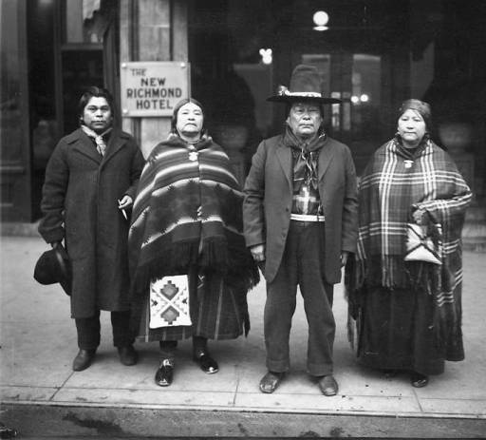
Historic Context

The International Special Review District (ISRD) was first established after fears of displacement of the city’s historically Asian American neighborhood led to community protests in 1972. These fears were due to construction of Seattle’s new Kingdome, and triggered a new movement of preservation advocacy, leading to the passage of an ordinance (SMC 23.66) one year later that created the ISRD.

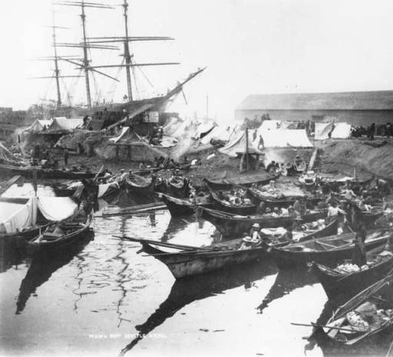
The present day International Special Review District is historically significant as home to people of many ethnicities, ages, backgrounds, and economic statuses, while being a cultural hub for Asian Americans who live throughout the city of Seattle and the Puget Sound region. For tourists and residents from other neighborhoods, the district provides a unique place to shop, eat, and conduct business in a unique collection of buildings and open spaces. The neighborhood’s significance is far more than its built environment. For those who work, reside and worship in the district and for all who visit, it represents enduring themes of persistence, continuity, and renewal in the physical context of an authentic and diverse urban neighborhood.

The following information is not meant to serve as a comprehensive historical account of the neighborhood, but rather to provide a broad overview of the development of the ISRD as it pertains to the built environment. Subsequent paragraphs highlight architectural and cultural contributions of some of the many cultural groups that call the ISRD home. They help reinforce the value of historic and cultural preservation as a foundation to any new developments in the district, which is at the heart of the ISRD Design Guidelines. The answer is not limited to the style or physical appearance of older buildings and streetscapes, but rather the patterns of use and lives that they support, and the continuity with the past and the future of the neighborhood.
Figure 1. A historic photo from 1891 of Native American canoes and tent camps at the foot of Washington Street on what was known as Ballast Island (Museum of History and Industry, neg. NA860.
Figure 2. Above left, later visitors to Seattle from the Yakama Nation in front of the New Richmond Hotel, 1921. (Museum of History and Industry, neg.84.815

First Settlement

Historically the ISRD has served as the first stop for many immigrants and newcomers to the city, with its development inextricably linked to alternating periods of immigration and migration, deportation and settlement, discrimination, and political and cultural achievements. Its history goes back further, however, when the land served as the home to aboriginal people. Native Americans remained in Seattle during the pioneer era when written records and photos began to document ongoing events.

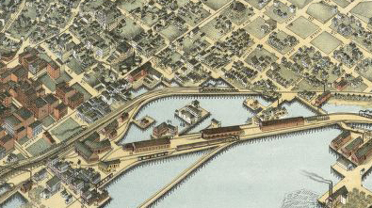
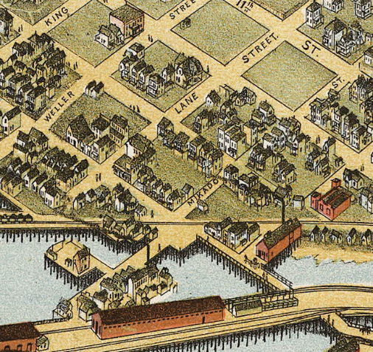
By the 1950s, many tribal members had been forced from reservations to be assimilated in urban centers, such as Seattle. To support this shift, in 1958 the American Indians Service League was established to provide programs and services for the estimated 5,000 Native Americans who lived in the city. Later known as the Seattle Indian Center, in 1988 it relocated from its downtown site to the Little Saigon area of the ISRD, and in 2014 was moved, under protest, to its current home at Main Street and 14th Avenue. The nearby Leschi Center houses the Seattle Indian Health Board, which provides additional services in the form of medical and dental clinics.

Infrastructure & Physical Development

Significant development of the area occurred over a relatively short period, roughly 1907-1929, with construction of many of the brick buildings that remain today making up the identifiable Chinatown and Japantown neighborhoods. Some earlier wood-framed houses and buildings from the 1880s and 1890s remained long into the 20th century, and several survive today.
Figure 3. Below and right, excerpts from Augustus Koch’s 1891 Bird’s Eye Map of Seattle (Library of Congress). The map identifies Mikado Street, later re-named Dearborn Street

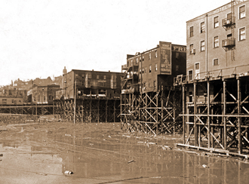
This period of development also includes the nearby construction of King Street Station in 1904-1906, the filling of former tidelands and reconstruction of 4th Avenue and other streets associated with the railroad, and the regrading of the steep slopes along South Jackson and South King Street, beginning in ca. 1908. The regrade projects resulted in the removal of an estimated 106 foot tall ridge between First Hill and Beacon Hill, which allowed for the construction of South Dearborn Street.
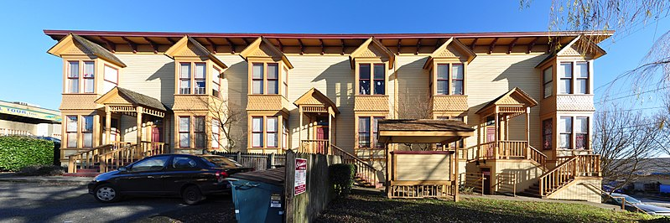
Figure 4. Above, a ca. 1908 view of 5th Avenue S and S Weller Street during the Jackson Regrade (University of Washington Libraries Special Collections).
Figure 6. Above, the landmark Victorian Row townhouses at 1234 S King Street in the Little Saigon area of the ISRD. (Photo by Joe Mabel, Wikicommons).
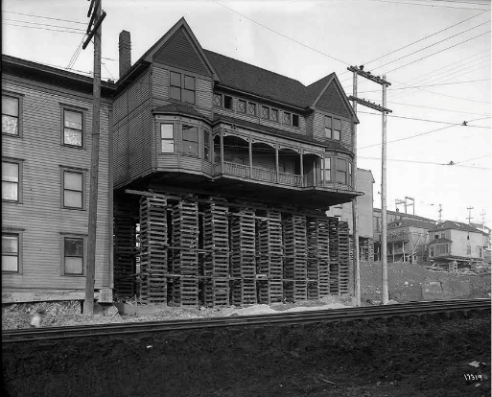
While some wood frame dwellings from the 19th century remain, the western core of the district is made up largely by early 20th century brick masonry buildings. These include many multi-story, walk-up residential hotels that provided small, affordable dwelling units and low-cost housing to Asian immigrant workers and families, along with small retail spaces with large display windows, and wide entry doorways allowing sales along the sidewalk or alley that served this community. The neighborhood’s eastern blocks developed intermittently over the first half of the 20th century, with portions of it housing light industry. In the 1940s, with expansion of roadways along Boren and Rainier Avenues, its stock of commercial buildings began to densify with larger scale business and industries.

The entire area was impacted by the construction of the I-5 Freeway in 1963. Many businesses and homes in the area were demolished due to its construction. It also impacted historic neighborhood institutions. The Chinese Baptist Church lost the pre-school play yard behind the building, thus forcing the church, the pre-school and congregation to re-locate. The freeway severed the community into two distinct west and east sections.
Figure 5. Above, one wood frame building from the late 19th century makes up the upper floors of a mixed-use building at S Jackson Street and Maynard Avenue. Built in 1893, this wood framed building was moved in 1910 to avoid its demolition during the Jackson Street regrade project (Historic photo from the Washington State Historical Society).

Chinatown Emerges

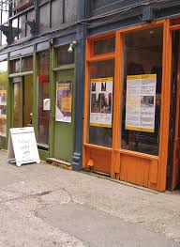
To escape racism and housing discrimination in other parts of Seattle, early Chinese immigrants seeking economic opportunities founded the district’s first Chinatown. Largely single men, they initially worked in labor-intensive businesses such as railroads, and the fishing, cannery, and logging industries where their physical efforts could overcome limited English language skills and discriminatory hiring practices. They primarily lived in three to five story brick single room occupancy (SRO) hotels without kitchens, and as a result of that many services sprung up to support their new lifestyles. Small retail stores and restaurants along the sidewalks provided meals, and medical services by doctors and traditional practitioners.
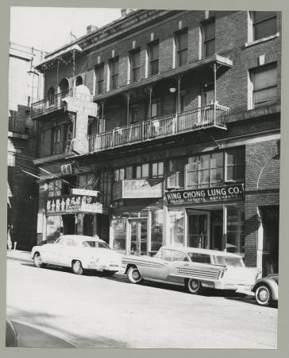
Right, a recent view of nearby Canton Alley (Alliance for Pioneer Square).
Figure 7. Above, buildings in the 700 block of S King Street in 1958 with signs and ornamental metal balconies unique to the area. Storefronts tended to be small, allowing multiple businesses. (Seattle Public Library, spl_shp_21121.)

Between 1930-1950 several of the SRO hotels converted SRO rooms into apartments. Several old wood-frame houses along the corner of South Weller and 7th Ave S. and on 8th Ave. S. between S. Weller and S. Lane Street were occupied by Chinese families, as well. The early Chinese community was served by its own early investment concerns and developers. One of these businesses was the Kong Yick Investment Company, established in 1910 by a group of 170 immigrants to fund the construction of the East and West Kong Yick Buildings. The eastern building, on South King Street, was later rehabilitated as the Wing Luke Museum. The community also established cultural and religious buildings, Chinese-language newspapers, and associations such as the tongs and family associations, many of which are still headquartered in Chinatown, that provided mutual support to members. These important institutions introduced into the built environment small storefronts, integrated multi-lingual signage, decorative metalwork, recessed balconies and tile roofing. These elements, along with the traditional Chinatown Gate are the main character-defining features today.

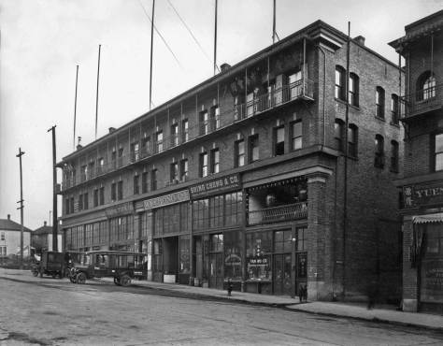

Figure 9. Above, the East Kong Yick Building/Wing Luke Museum as seen in 1918 (Puget Sound Archives).

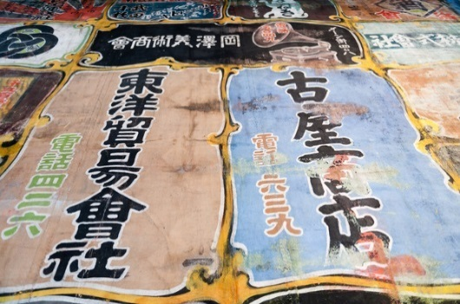
Creation of Japantown

As Japanese immigrants began to arrive, they faced the same type of exclusionary practices as the Chinese had in other parts of the city. To counteract that, these new settlers established a “Japantown,” or Nihonmachi, largely to the north and east of Chinatown along South Main and Yesler Streets; however, the presence of Japanese Americans extended throughout much of the broader ISRD boundaries.

Similar to the Chinese, the first Japanese immigrants were typically younger single men. Their presence resulted in the opening of new bathhouses, barbershops, and entertainment venues. The popularity of judo led to the founding of Seattle Dojo in 1907, a club initially housed in hotel basements in the area. By this date the city’s Japanese population had grown to an estimated 5,000. They opened retail shops, theaters, and restaurants. As immigrants they were prohibited by anti-alien legal restrictions from owning property, but they took on the management of many apartment houses and hotels.
Figure 10. Above left, an ad scrim from the former Nippon Kan Theater, built in 1909. (Wing Luke Museum).
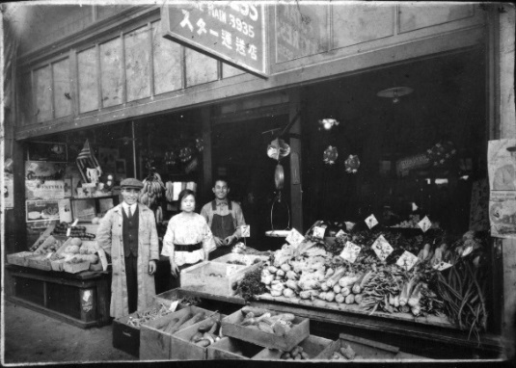
Seattle’s Japanese American community grew to become the second largest such settlement on the West Coast. The arrival of brides from Japan resulted in a demographic shift toward families. Other institutions emerged to support these families, such as the Seattle Japanese Language School and a Japanese language newspaper, both established in 1902, and the founding of temples and churches, including the Seattle Betsuin or Seattle Buddhist Temple in 1901. Later buildings included the Seattle Nichiren Buddhist Church built in 1928, and the Seattle Buddhist Temple built in 1941.
Figure 11. Above right, the Tanagi grocery store, at 653 S King Street in the 1930s. (Wing Luke Museum)
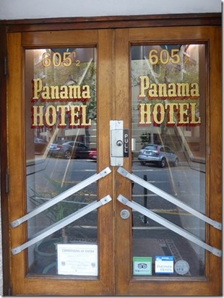
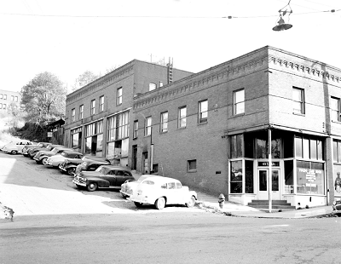

Figure 12. Below, a view of Japantown at 6th Avenue and Main Street in 1949. (Seattle Municipal Archives)

When Seattle began construction of the nation’s first public housing project at Yesler Terrace in the late 1930s, it took many properties and businesses from Japanese and Japanese American owners and occupants; public sentiment led to further housing discrimination in the new nearby public housing project. The mass incarceration of Japanese and Japanese Americans during World War II impacted the community more dramatically, with loss of businesses and assets, and dispersal of many after the war’s end. Some who returned to Seattle settled in other residential neighborhoods or its suburbs. Others lost their livelihoods and did not return to Seattle, as evidenced by the personal artifacts left behind at the Panama Hotel. The Panama Hotel, which houses one of the last remaining intact bathhouses or “sento”, has since been listed as an individually registered building on the National Register of Historic Places and identified as a National Treasure by the National Trust for Historic Preservation.
Figure 13. A current view of the doors to the Panama Hotel. (BOLA, 2018.)

Filipino Immigration

The 20th century also saw the beginning of Filipino immigration to the U.S. following the end of the Spanish-American War and establishment of the Philippines as an American Territory in 1898, a status that remained until independence in 1946. These immigrants arrived in this county as U.S. nationals rather than aliens, however, their ownership of property was restricted until a lawsuit and court challenge established this right in 1941.

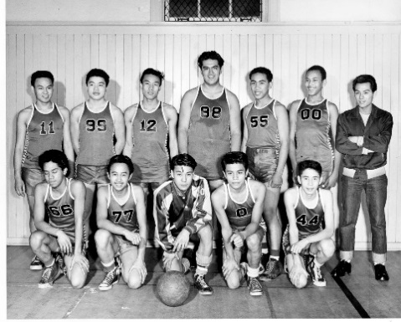
Filipino ethnic and civic groups established their own gathering places throughout the city, such as barber shops, churches, grocery stores and association spaces, located on First Hill and the Central Area. Members of this community also established restaurants, barber shops, groceries and gathering places, such as churches and associations, which were centered largely near South King Street and Maynard Avenue South.

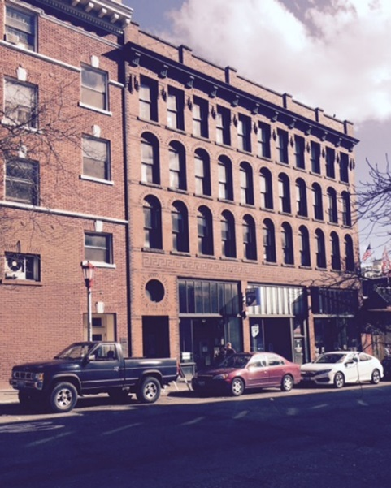
Between 1920 and 1931, many single Filipino men arrived in large numbers to Seattle to take on work in Alaska canneries, summer fish camps and farms, often through contractors in Chinatown. Migrant cannery workers, known as “Alaskeros,” organized the Filipino Laborers Association in 1930 and formed the country’s first Filipino-led union, the Cannery Workers’ and Farm Laborers’ Union Local 18257, in 1933. These men were strong supporters of the labor movement throughout the West Coast, and they remained an active political force in the area. Gradually, as Filipino immigrants married and started families, they moved to other areas of the city, while many single men remained as residents in Chinatown.

The African American Presence

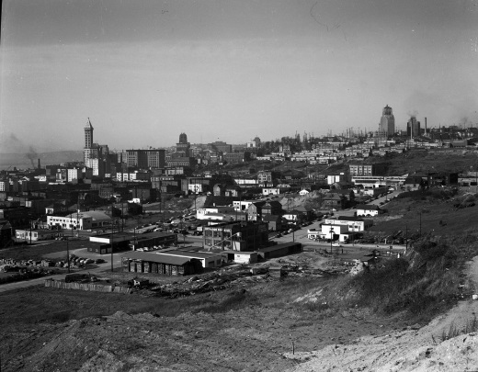
African Americans also came to the ISRD neighborhoods. Many settled in the Nearby Central Area, beginning in the late 19th century, and some worked in the area at the two railroad terminals where they were employed as porters and other service staff to the rail lines. They also opened businesses, such as restaurants, dry cleaners, pharmacies and clubs, and in at least one instance, owned one of the SRO hotels. Their presence and the increased popularity of jazz and the blues strengthened the reputation of Jackson Street as a music, entertainment and business center. Well known clubs included the Entertainment Cabaret at 1238 S Main Street, and the Alhambra, established in 1922, and renamed the Black and Tan in 1933. This club, housed in the basement of a Japanese business at 12th and Jackson Street, showcased many local musicians and some of the country’s greatest artists.
Figure 14. Above left, the Filipino American Basketball team, which played in the Seattle all Asian Buddhist League after World War II (Wing Luke Museum).
Figure 15. Right, the Eastern Hotel, 506 Maynard Avenue, which housed many Filipino workers in the early 20th century. The hotel, built in 1909-1911, houses the Carlos Bulosan Memorial Exhibits.

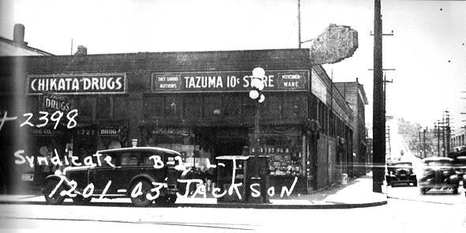

Figure 16. Above, the building that housed the Black and Tan Club (King County Assessor, 1936, Puget Sound Regional Archives).
Figure 17. Above, a view from Beacon Hill at the sparsely developed area in what is now Little Saigon in1952, with Yesler Terrace near the top of the hill and downtown Seattle in the distance. (Seattle Municipal Archives, 43394)

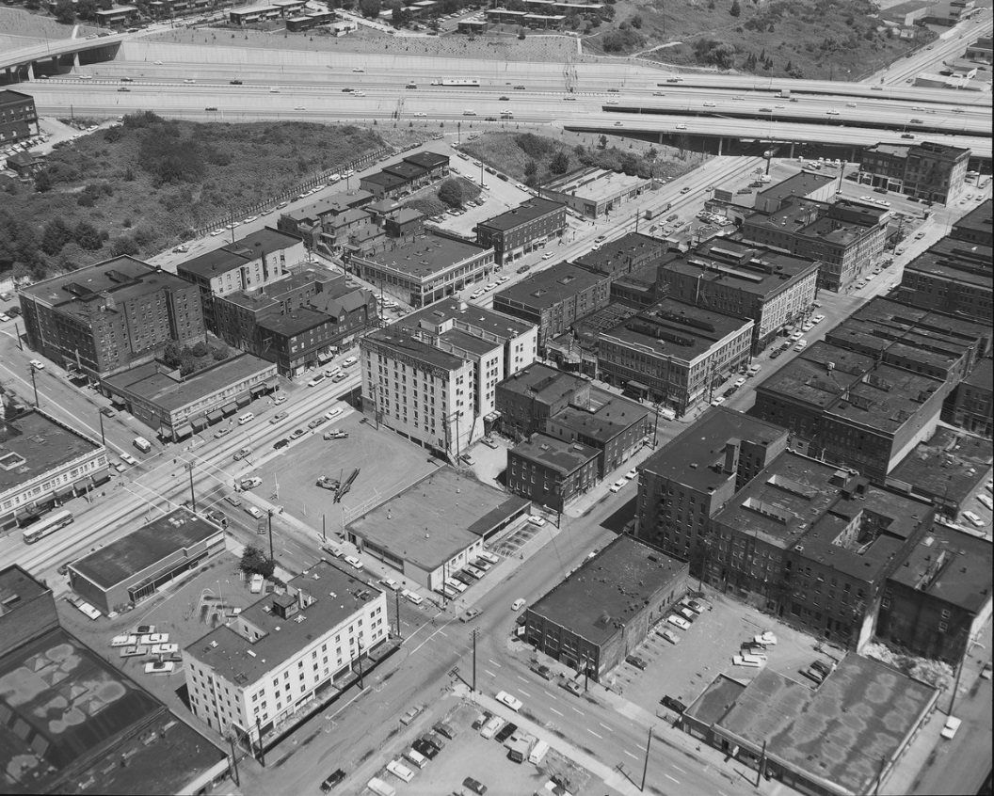

Figure 18. Above, a view in 1969 of the core of the district after construction of the I-5 freeway (Seattle Municipal Archives).

Little Saigon

The areas east of I-5 were cut off from the historic core by the construction of the I-5 freeway. Although the core continued to develop while retaining its residential character, the blocks to the east increasingly housed industrial facilities, warehouses, and auto services. The area centered around 12th and Jackson began to welcome Vietnamese who arrived as refugees after 1975. By the 1980s, new business owners in the area began to cite it as Little Saigon, and it is generally now known by this name.

The Vietnamese who left their homeland in difficult circumstances, after the Fall of Saigon, came to Seattle seeking a secure new home and new opportunities. They established retail stores, restaurants, and commercial businesses in the neighborhood by the mid-1980s. Given this era of development, several included the construction of new buildings and paved parking lots, some of which served as informal outdoor markets. Many of these new community members were ethnic Chinese from Vietnam, including the owners of Viet Wah, which started as a small mom-and-pop business in Chinatown in 1981, and has since opened additional supermarket stores.

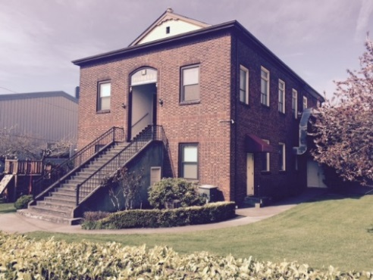
Arriving in the U.S. as multi-generational families, the Vietnamese immigrants settled in many other parts of the city and region, while remaining committed to businesses, services and institutions established in Little Saigon. Their presence added another layer of history to the urban neighborhood which was more commercial focused rather than residential.
Figure 19. Above left, the historic character of the eastern part of the ISRD and Little Saigon is illustrated by the presence of the Nichiren Buddhist Church, at 1042 S Weller, which dates from 1928. The steep front steps are derived from Asian architectural precedents. (BOLA, 2018)

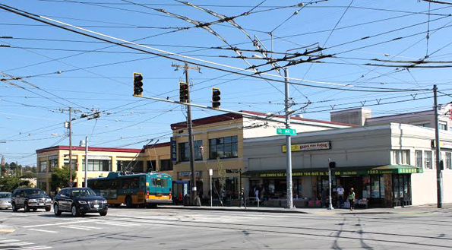
Figure 20. Above right, auto-oriented commerce arrived in Little Saigon beginning with the establishment of business in the 1980s and 1990s such as those centered at 12th and Jackson Street. (BOLA, 2018)

Balancing Past, Present, and Future

Rich cultural histories are woven throughout the ISRD neighborhood, and are embodied within the varied buildings that have, and continue to embrace successive eras and cultures. The importance of reviewing these histories is not to promote any false instances of historicism in new developments, or to outline historically significant elements for replication, as what was once culturally appropriate likely has a different meaning or relevance to present communities. Instead, we must understand the historic and cultural context to be able to find contemporary solutions for the future that are respectful of the existing neighborhood fabric. Developers, architects, and other individuals pursuing projects within the district are highly encouraged to engage with the current community and its community-based organizations, residents and businesses to ensure projects are culturally responsive and pertinent to who is there now.

Page intentionally left blank

Districtwide
Guidance

ISRD Design Guidelines

Guidance provided in the following section is meant to be applied to any project requiring recommendation by the International Special Review District Board for Certificate of Approval.
Joe Mabel

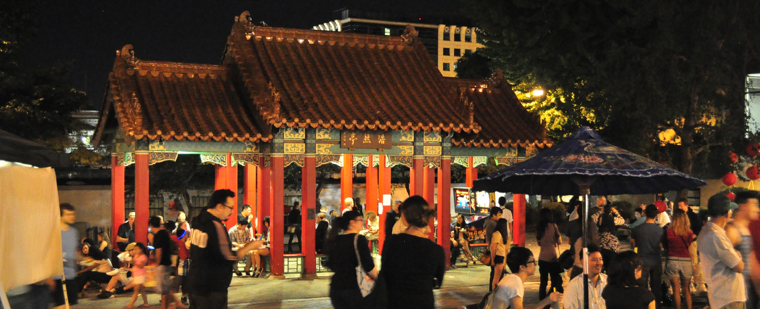

Guiding Principles

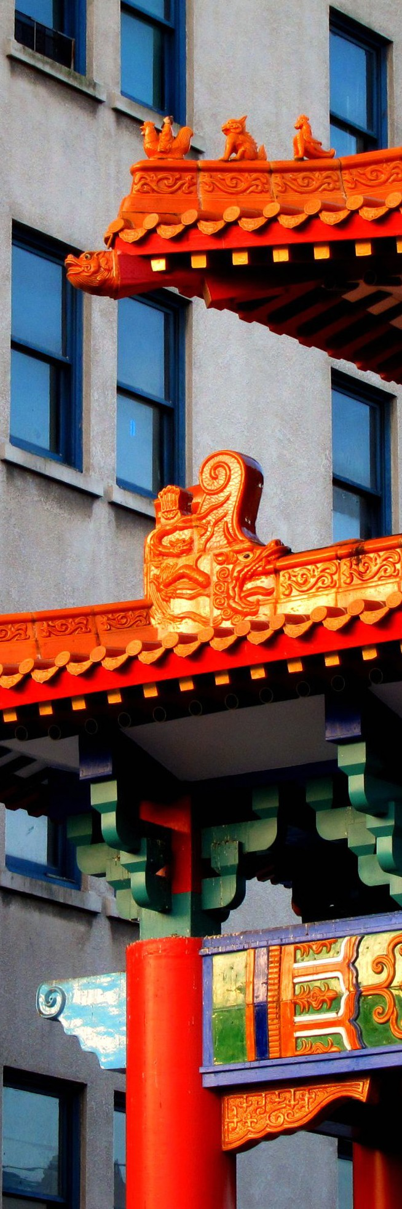
The guiding principles of the International Special Review District (ISRD) are to promote, preserve, and continue the cultural, social, economic, historical, and otherwise beneficial qualities of the area - particularly qualities and features derived from its Asian, Asian American, Asian immigrant and refugee, and Asian Pacific Islander heritage - by:
Amelia Skinner

- Preserving a mixed use, mixed-income residential and business community, consisting of a variety of buildings ranging from historic to
contemporary, which contribute to an active urban environment;
- Encouraging the use of street-level spaces for pedestrian-oriented, locally-owned businesses;
- Encouraging the rehabilitation of existing structures that contribute to the character of the district;
4. Promoting culturally responsive design that
reflects the community vision;
- Ensuring accessibility for visitors, residents, tourists, and workers through a variety of mobility options;
- Encouraging continuity in urban design and wayfinding through preservation and creation of new open spaces, alleys and rights-of- way;
- Promoting public safety by adopting Crime Prevention Through Environmental Design (CPTED) Principles and other crime prevention strategies;
- Supporting environmental sustainability and green building principles and recognizing preservation of historic buildings is a green building strategy.

See Seattle Municipal Code (SMC) Section: 23.66.302 through 23.66.310 for additional information regarding goals for the ISRD.

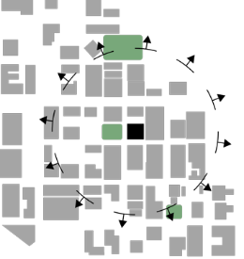
1. Context & Site
This section of the document focuses on how projects interact with their surrounding neighborhood blocks.

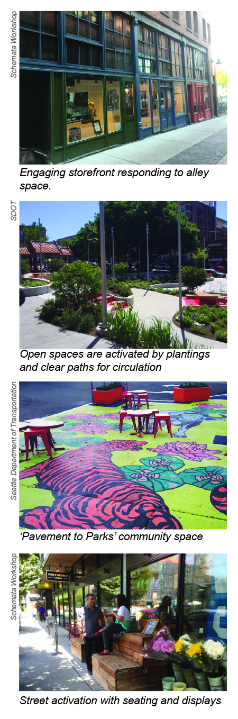

- Response to Context
  - Consider the neighborhood context, characteristics of the site, adjacent buildings plus open space, streets, alleys and proposed uses of the building.
2. Respond to datum lines, street edge relationships and proportions created by existing buildings.
- Incorporate and preserve architectural elements that exist within the neighborhood already such as recessed spaces, balconies, and canopies.

- Public Realm
  - Activate sidewalks and open spaces with pedestrian- oriented features that encourage walking, sitting and other activities. Consider activation strategies for various times of day and year.
  - Provide opportunities for street activation beyond just landscaping and transparency. Focus on the
relationship between storefront design and pedestrian interaction with the streetscape. Important items to consider:
    - Location of the building in relation to the property line
    - Location of parking access
    - Location of landscaping
    - Street trees
    - Street lights
  - Public gathering spaces should accommodate use by multiple generations.
  - Lighting, crosswalks, and materials in the public right- of-way should be consistent throughout the District in order to serve as placemaking features or cultural markers. Variations considered on a case by case basis.
  - Artistic pavement treatments within key intersections are encouraged. The design of crosswalks should be consistent at all four corners of an intersection.
  - A variety of plantings that are responsive to existing landscaping and are drought resistant / low- maintenance is preferred. Common species include flowering trees or bushes. Landscaping and street trees require SDOT approval, in accordance with SMC 15.43.
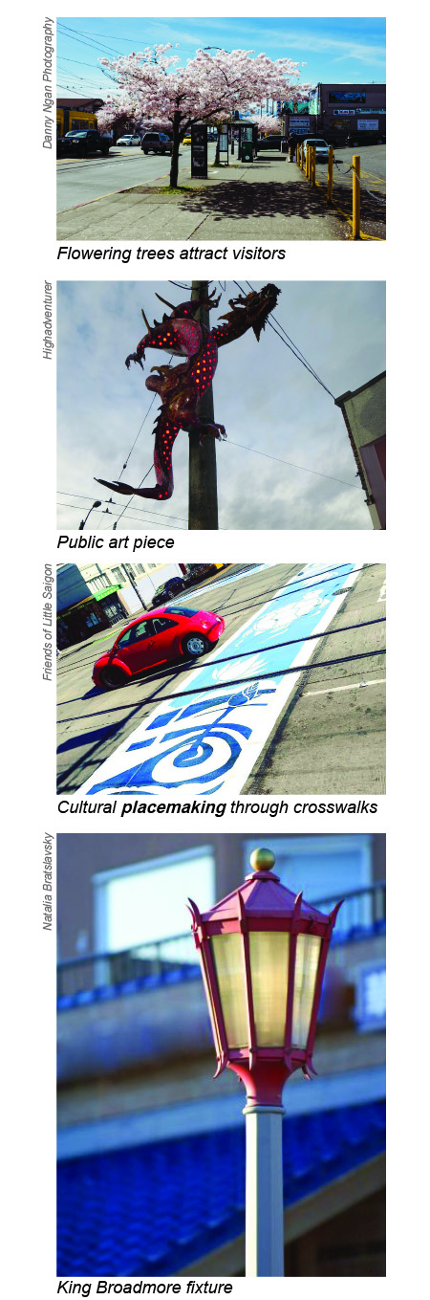
  - Public art that is informed by community input and reflects the culture and the history of the neighborhood is preferred. Artwork should be placed with attention to the method and stability of installation, be scaled and compatible with the character of the District, and should not block or damage architectural or character-defining building features. Consider incorporating public art into the design of elements in the public realm, such as seating, weather protection, light fixtures and transit stops.
  - Provide ample bike parking and easy access to public transit lines. Bike parking should be sited and scaled in such a way that is compatible with the character of the District, and should not block or damage architectural or character-defining building features.
  - Activate typically inaccessible and underutilized alleys by omitting fences when possible. Locate dumpsters and trash enclosures away from alleys to building interiors or non-primary facades when possible.
  - Pedestrian lighting fixtures, when installed within the public right-of-way, should be uniform in style, color and placement to serve as a placemaking feature. Preference is given to the “King Broadmore” or similar style fixture.
See the Public Life section for additional guidance

- Building Orientation
- Buildings and primary entrances shall be oriented toward the street and vehicular access should be located off an alley or side-street, wherever possible.
- Visible access to the building’s entry should be provided.
- Activate vestibule and recessed entries to promote public safety. Examples of activation include lighting, plantings, artwork and seating. Where screening is needed, decorative or artistic treatments are preferred.

Page intentionally left blank

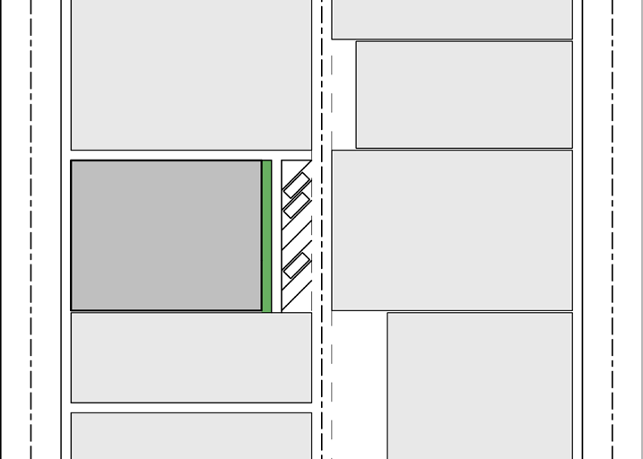
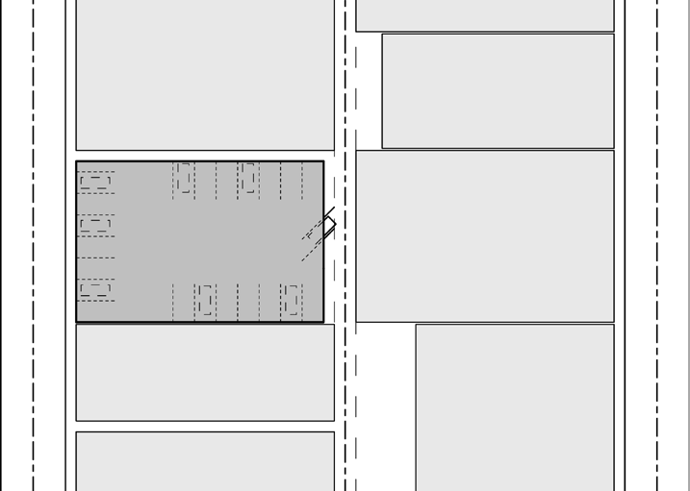
Parking located off an alley

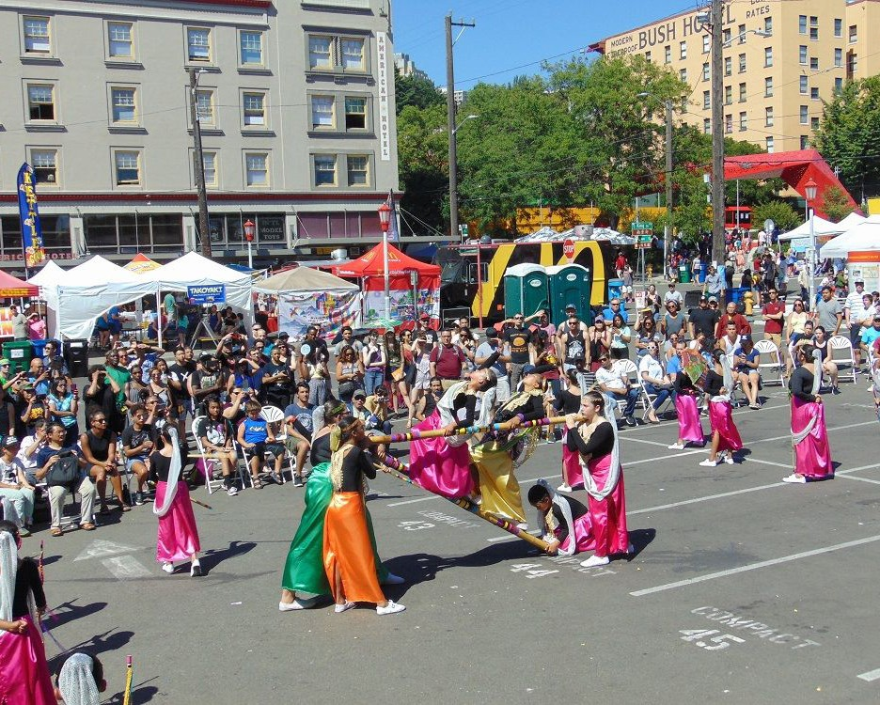
Underground parking
International District Facebook

Parking lots activated for community space

Parking and Support Services
  - Locate parking on less visible portions of the site, such as underground, behind, or to the side of buildings.
  - Reduce the visual impact of parking and service uses with landscaping or architecturally compatible screening.
  - Locate loading docks and other service entries along alleys or non-primary facades whenever possible.
See SMC 23.66.342 – Parking and access for additional information.

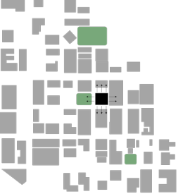
2. Public Life
This section of the document focuses on how projects interact with their immediate surroundings.

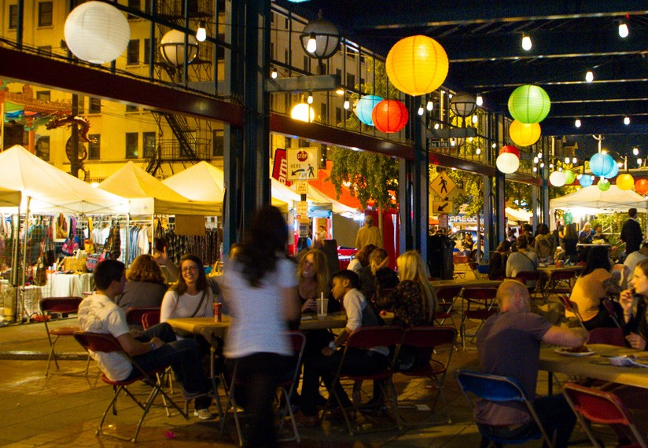
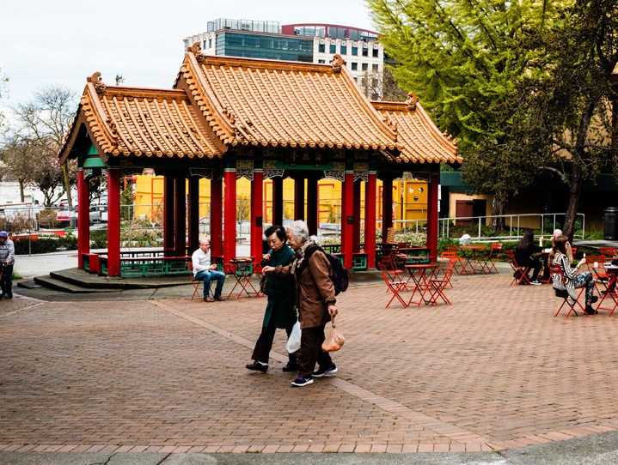
Outdoor seating invites users and “street room” engagement
WLH Oz
W.T.Pho

Hing Hay park provides flexible open
space for various community uses
William Gourlay

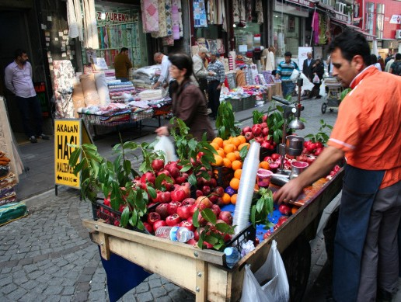
Space provided for sidewalk vendors
Invisible Hour
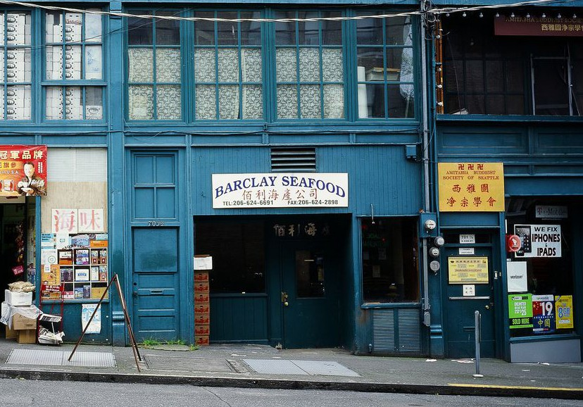
Retail bays designed for small or anchor businesses

Open Space
  - Opportunities for creating vibrant, pedestrian- oriented open spaces to enliven the area and attract interest and interaction with the site and building should be prioritized. Consider including spaces that cater to the multigenerational population of the community.
  - Design public open space to be informal and able to support multiple community uses such as
performances, festivals, markets, kiosks, community bulletin boards, cafes, or street vending.
  - Include pedestrian amenities such as seating, and other site furniture, lighting, year-round landscaping in addition to seasonal plantings, pedestrian-scale signage, art work, awnings, large storefront windows, and engaging retail displays.
  - Provide seating for groups and individuals to facilitate gatherings.
  - Promote public safety with Crime Prevention Through Environmental Design (CPTED) Principles. See Safety and Security, section E, for further details about CPTED principles.

Storefront Design
  - The size of retail bays should be appropriately scaled to support small and/or anchor businesses.
  - Desirable storefront design features include large transparent storefront windows, entrances onto the street, pedestrian-level signs, architectural detailing, and pedestrian lighting to engage passerby.
  - A broad range of exterior colors can be found in the District. When selecting colors, it is important to coordinate proposed colors of the entire building façade and consider compatibility with the colors on other buildings in the District.
  - To enhance the visual interest within the District, if a desired color has been used nearby, consider a different shade, adjust the
tint or add an accent color. Other considerations may include: the architectural style of the building, architectural details and accent colors and the type of materials.

  - Unpainted brick, stone or terra cotta shall not be painted.

II. Public Life

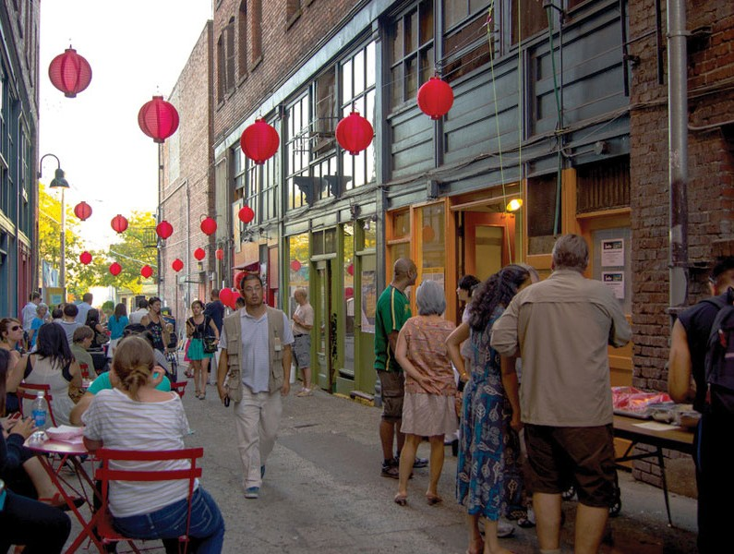
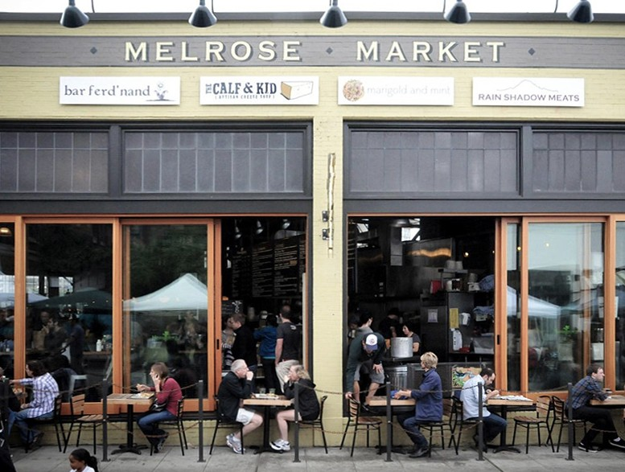
Alleys offer opportunities for informal extensions of public space
Nakano Associates, CHAP
Liz Dunn

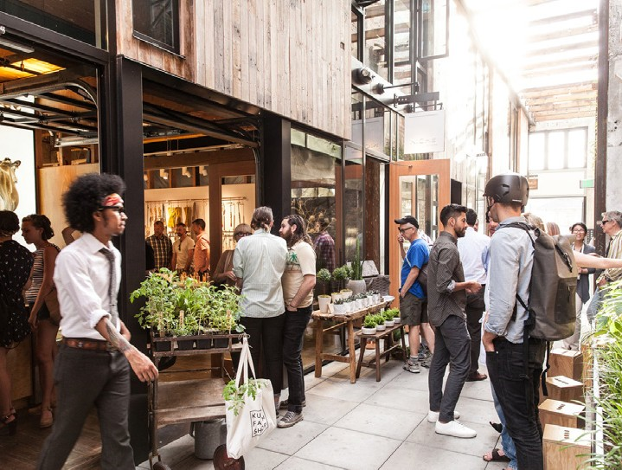
Outdoor seating indicates usage and invites pedestrians
Chophouse Row

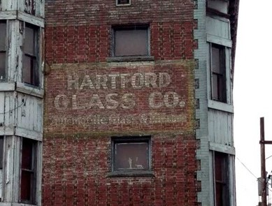
Space provided for vending and pedestrian circulation
Andrea Leksen

Hartford Glass Co. ghost sign
  - Maintain transparency at the ground-floor level. Bay windows, transom areas, and entryways shall not be overly obscured by window treatments, posters, signage, mechanical equipment, security systems or interior furniture and equipment.
  - Maximize visibility into the building interior and visual interest of merchandise displays.
  - Activate storefronts through lighted displays
or prominent decorative light fixtures placed in street level windows to contribute to pedestrian- scale illumination and neighborhood sense of place.
  - Allow space for activities such as sidewalk vending, seating, and restaurant dining to occur. Consider setting structures back from the street or incorporating space in the project design into which retail uses can extend. Storefronts with large overhangs and seating provide passive shading and cooling for the building while simultaneously serving pedestrians.

Signage
  - The ISRD Board considers a sign’s size, shape, location, material, color, method of attachment, and lighting in relation to the use of the building, the design of the building where the sign is proposed, and the location of other signs in the District. Ensure that signs:
    - Do not hide, damage, or obstruct any significant architectural elements of the building;
    - Promote a pedestrian environment while considering visibility for other traffic such as personal vehicles, buses, and bicycles.
  - Multi-lingual signage is encouraged.
  - Prominent, creative and colorful illuminated signage is recommended. Encourage a variety of signs with unique character to signify the business district.
  - Durable, high-quality materials are encouraged.
  - Neon-lit signs and the restoration of historic signage are encouraged to enhance the visual experience along the retail corridors. Clear backing for neon window signs is preferred.
  - Encourage preservation of existing ghost signs.

Oliver Perez
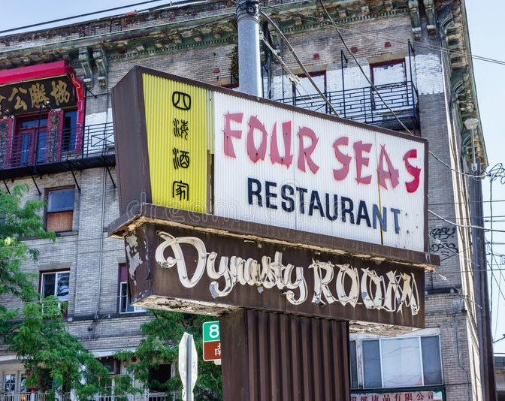
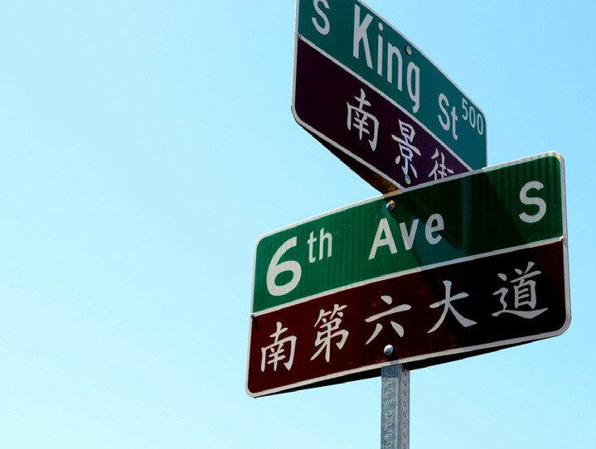
Signage and lighting working in conjunction to highlight programming
Jen Nance

Multilingual signs in Chinatown
flynetpictures
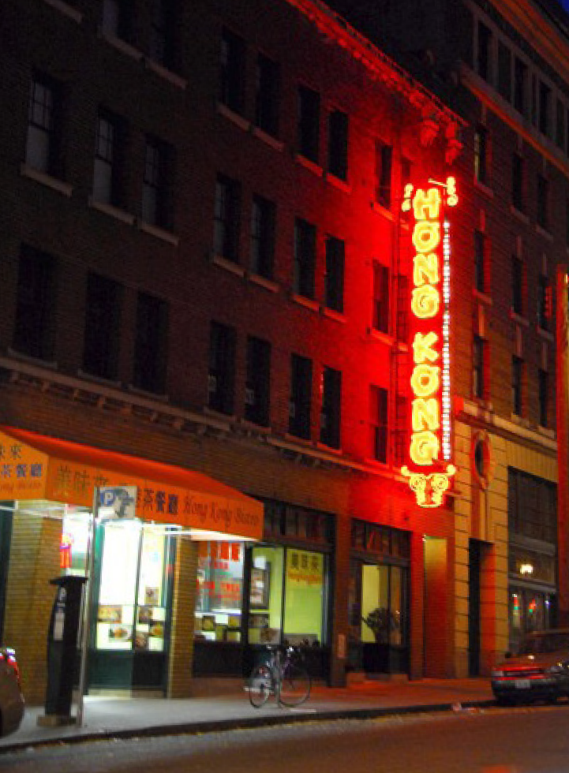
Neon-lit blade sign enhancing the visual
experience of retail corridor at night
  - Encourage signs which relate physically and visually to their location and reflect the character and unique nature of the building use. Signage should be compatible in character, scale, and location while still allowing businesses to present a unique identity.
  - Buildings with three or more tenants should consider developing a signage plan within the context of architectural and open space concepts, and coordinate the details with facade design, lighting, location, and other project features to complement the project as a whole. At minimum, a sign plan should: a) identify the total number of building and tenant signs allowed and b) provide direction of the location, size parameters and shape of each. Building sign plans may, at the applicant’s option, include proposed sign colors, materials and method of lighting.
  - The following signage types are not permitted in the District:
    - Free-standing signs (except for those in parks
and those authorized for surface parking lots)
    - Portable signs
    - Roof signs
    - Off-premises advertising
    - Signs that flash, change-images, incorporate video display methods, or have text that appears in motion
See Seattle Municipal Code (SMC) Section: 23.66.338 - Signs for additional information regarding signage for the ISRD.

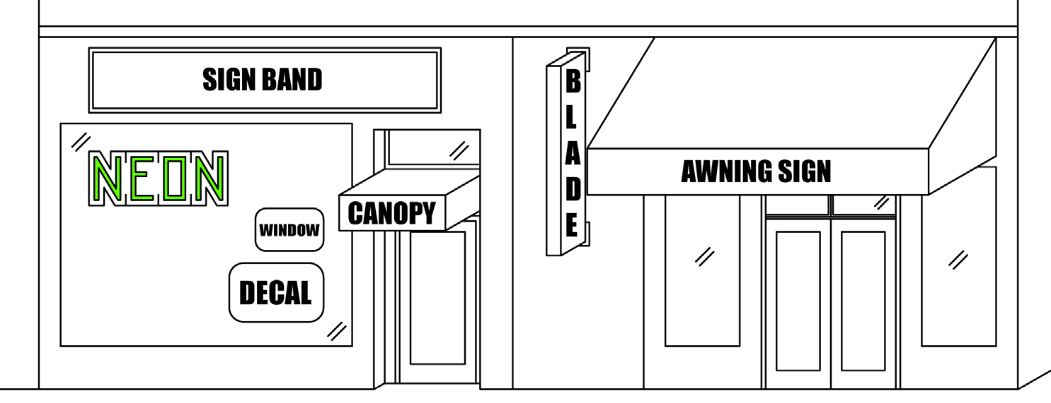

Common sign types are illustrated above Blade signs are a type of projecting sign. Sign bands are a type of non-projecting sign

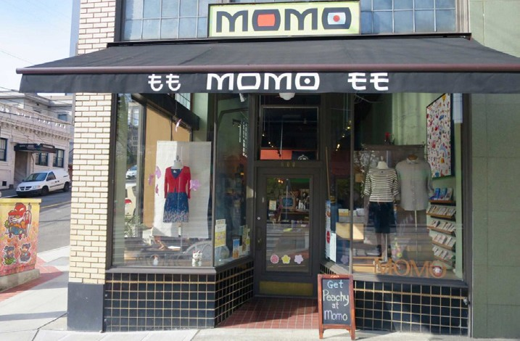
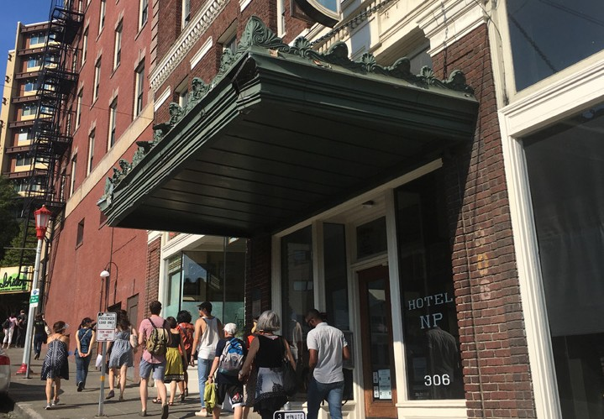
Example of fabric awning, also clear signs and storefront transparency allows passersby to interact with the building’s interior
Schemata Workshop
Thomas Klefeigem

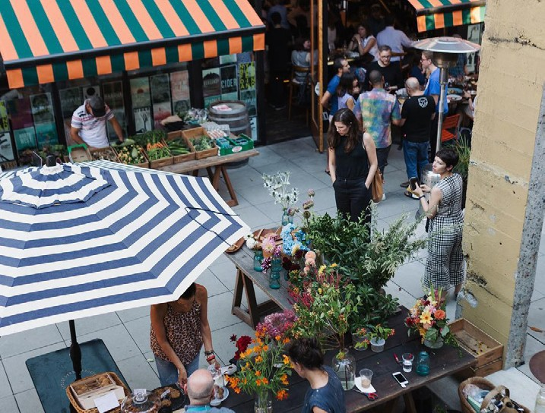
Canopies provide shelter over walking paths
Chophouse Row

Vending supported by temporary cover

Awnings and Canopies
  - Provide practical coverings, such as fabric awnings or metal canopies, for weather protection and screening from the sun.
  - Use awnings and canopies as decorative visual elements for a facade or storefront.
  - Design awnings and canopies to fit within their respective openings and be secured to structural elements of the building.
  - Avoid covering, masking or damaging existing architectural building features.
  - Awnings that project over the sidewalk should extend a minimum of five feet (5’).
  - Canvas is the preferred awning material. A matte finish is preferred when a material other than canvas is proposed.
  - Include illumination to minimize dark areas. Light fixtures placed within awnings should be encased or screened from view from below.
  - Where signage is proposed for the surface of the awning, graphics should be limited to the business name and/or logo and coordinated with other storefront signage.

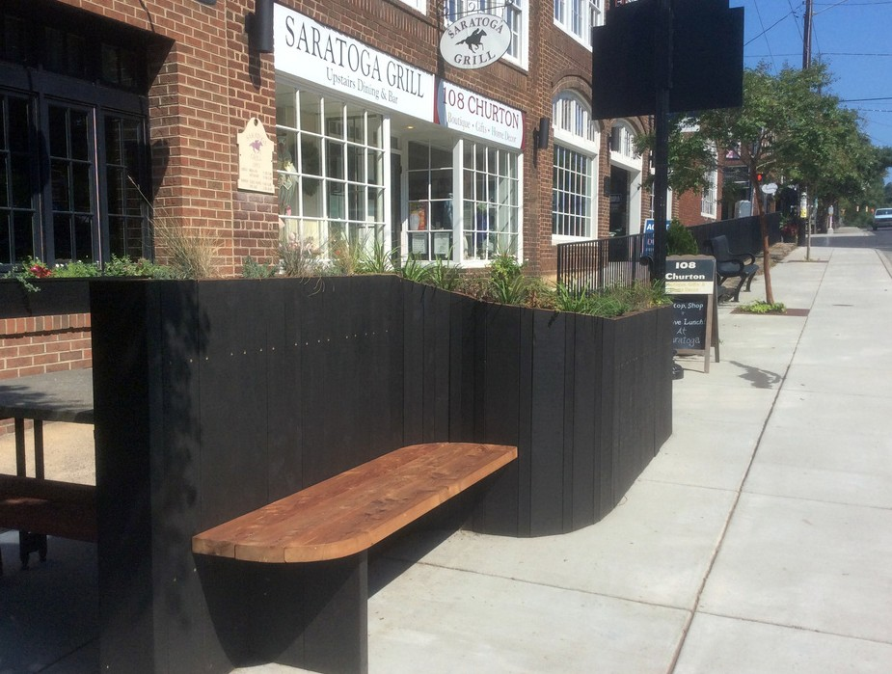
Fence with planters and seating for pedestrians
Steel Masters NYC
Tammy Grubb, The Herald Sun

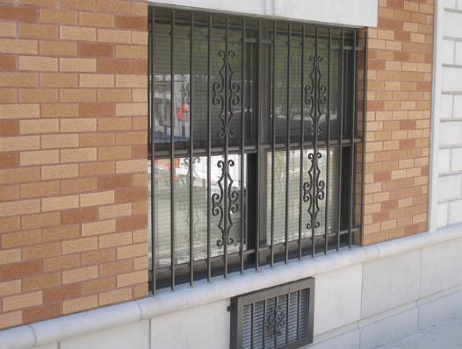
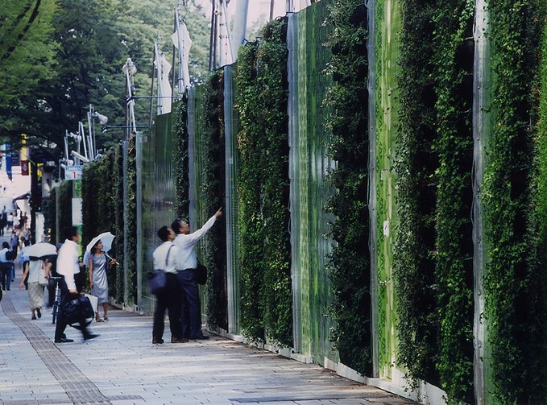
Prohibited bars installed on the outside of the building facade
Klein Dytham Architecture

Screening with lighting for security without compromising visuals
Danny Woo Community Garden

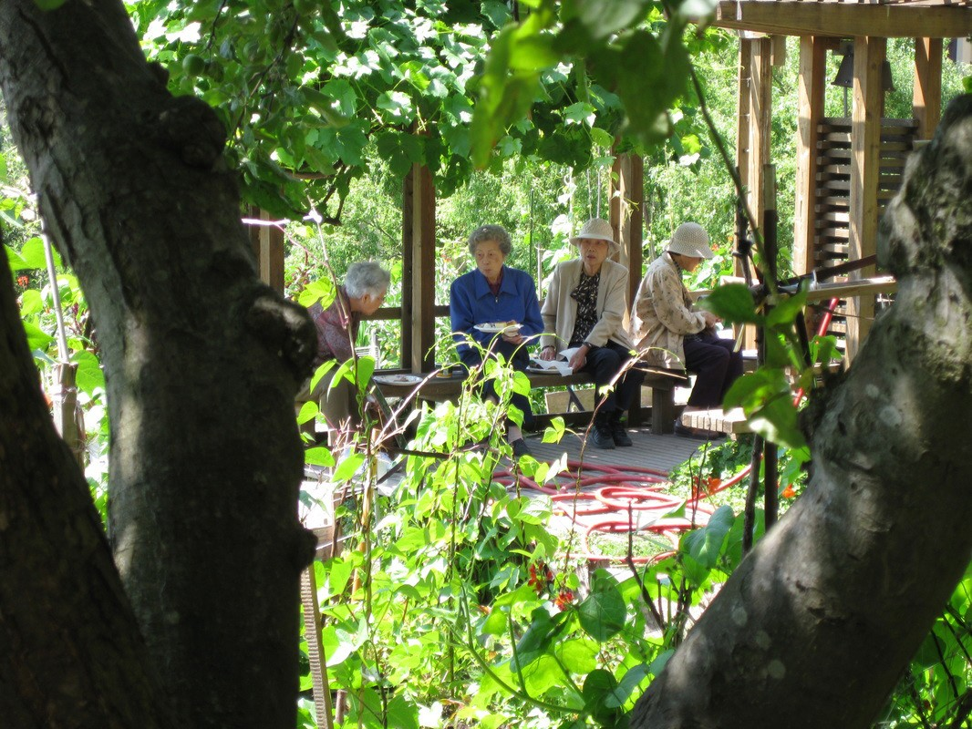
Seating in open spaces encourages gatherings

Safety and Security
  - Crime Prevention Through Environmental Design (CPTED) is a set of design principles used to create an environment to deter criminal activity. Employ CPTED principles by encouraging more “eyes on the street”:
    - Create a safe environment by providing lines of sight and encouraging natural surveillance
through strategic placement of doors, windows,
balconies, landscaping, and street-level
uses.
    - Provide lighting at sufficient intensities and scales, including pathway illumination, and pedestrian and entry lighting.
    - Where appropriate, ensure transparency of street-level uses, by opening views into spaces beyond walls, plantings, corners, or narrow passageways.
    - Preference is given to electronic or alarm systems or other security measures that do not have an adverse visual impact on the exterior façade. Examples include, but are not limited to: transparent window security film, increased lighting and cameras.
    - If using fencing or screening elements, choose semi-transparent rather than opaque materials. When opaque materials are desired, ensure there is sufficient visual porosity.
    - Where added security measures are deemed necessary, ornamental gates are preferred for street front entrances. Permanent
bars installed on the building facade are prohibited.
    - Added security measures, when necessary, shall have minimal visual impact and shall not obscure storefront visibility. When possible, the need for potential security measures should be considered from the outset in order to integrate security into design, and prevent the need for additional external security systems.

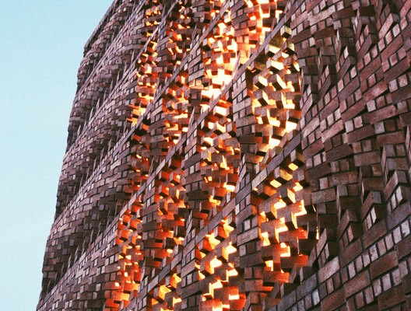
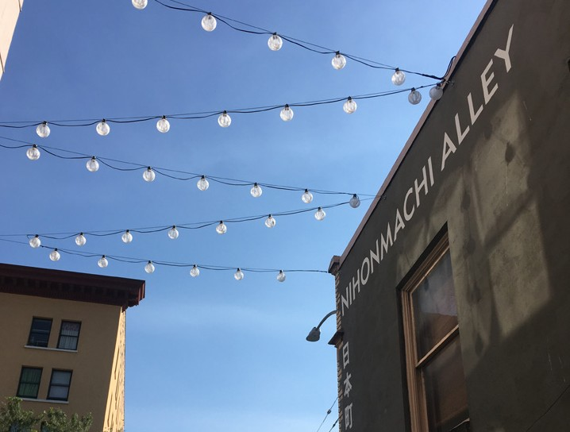
Bricks used for facade articulation
Cavin Teo
Anagram Architects

Alley activation aided by pedestrian lighting
Sebastien Scandiuzzi

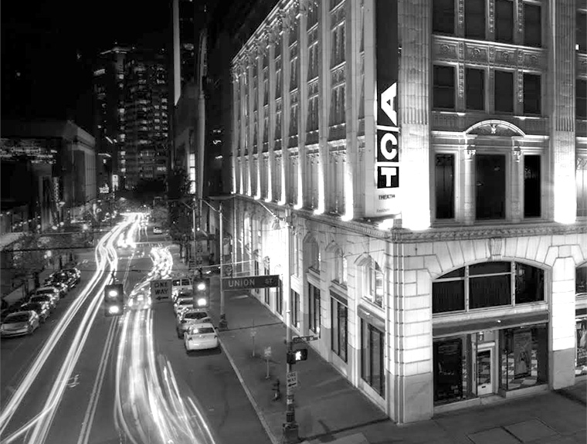
Illuminating elaborate and historic architectural features and details on building.
Chophouse Row

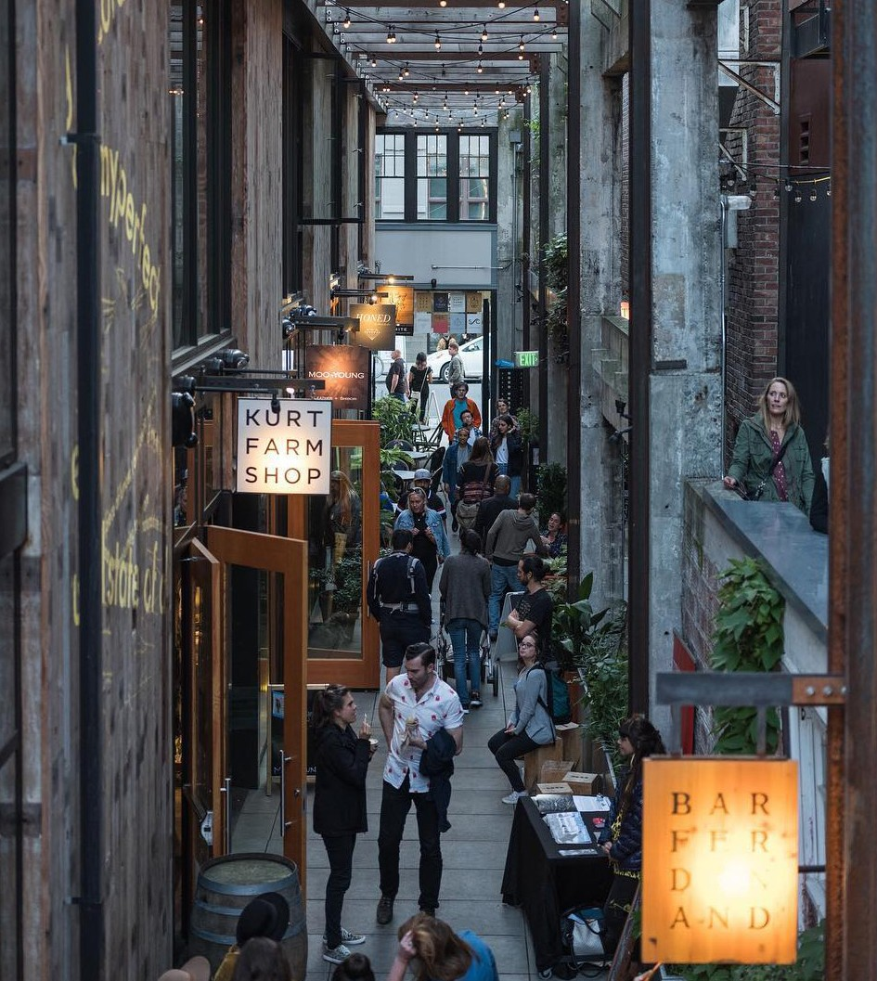
Lighting highlighting building programing

Lighting
  - Select light fixtures that complement the architecture and design of the building. For older buildings, it may be appropriate to select fixtures that draw inspiration from historic building photos.
  - Selectively illuminating elaborate and historic architectural features and details on buildings is encouraged. Directing light toward building facades, walls and roof lines, or integrated lighting within such elements provides valuable vertical surface illumination, which helps the surroundings to appear brighter and more welcoming.
  - Where appropriate, incorporate exterior light fixtures onto buildings at the pedestrian level (between the ground and 16 feet up) to help pedestrians see more clearly.
  - Provide even lighting levels that do not create a contrast of overly-bright and overly-dark spaces. While lighting is an important component of safe spaces, excessive lighting can cause glare at night.
  - Glare is difficulty seeing in the presence of bright light and can be distracting and sometimes debilitating and should be avoided. Strategies to reduce glare from light fixtures and signage lighting include:
    - Use light fixtures that shield direct view of the
light bulb or light source
    - Use light fixtures with shades or lenses that
are translucent
    - Reduce the brightness of the light source

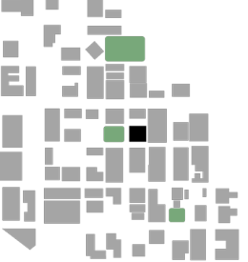
3. Building Design
This section of the document focuses on the design of the building itself.

This section of the document focuses on the design of the building itself and is organized by the type of
building that is being modified or proposed.

- Contributing Buildings – This section provides guidance for modifications to buildings within the boundaries of the International Special Review District that contribute to the cultural or architectural significance of the District. The ISRD Board coordinator is available to assist property owners and Certificate of Approval applicants with determining if their building is contributing.
- Non-Contributing Buildings – This section provides guidance for modifications to buildings within the boundaries of the International Special Review District that are not identified as contributing. The ISRD Board Coordinator is available to assist property owners and Certificate of Approval applicants with determining if their building is non- contributing.
- New Buildings and Additions– This section provides guidance for any new construction of buildings and additions to buildings within the ISRD. If the building is 85 feet in height or taller, the guidelines from Tall Buildings also apply.
- Tall Buildings – This section provides additional guidance for any new construction of buildings 85 feet in height or taller.
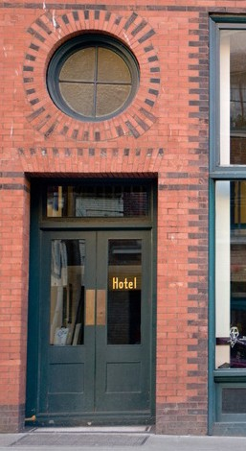
The View From Right Here
Defining Contributing and Non-Contributing
For more information regarding contributing/non-contributing status, please see Seattle Municipal Code 23.66.032 - Contributing structures; determination of architectural or historic significance.

Another resource is the Seattle Chinatown Historic District National Register Nomination – this is a subarea of the larger International Special Review District. The National Register Nomination identifies the classification of buildings within the area of the Seattle Chinatown Historic District – buildings are identified in this document as either contributing (primary and secondary)
or non-contributing. The nomination is available electronically on the ISRD website. The ISRD Board coordinator is available to assist property owners and applicants regarding the status of a building.

Existing building in the ISRD

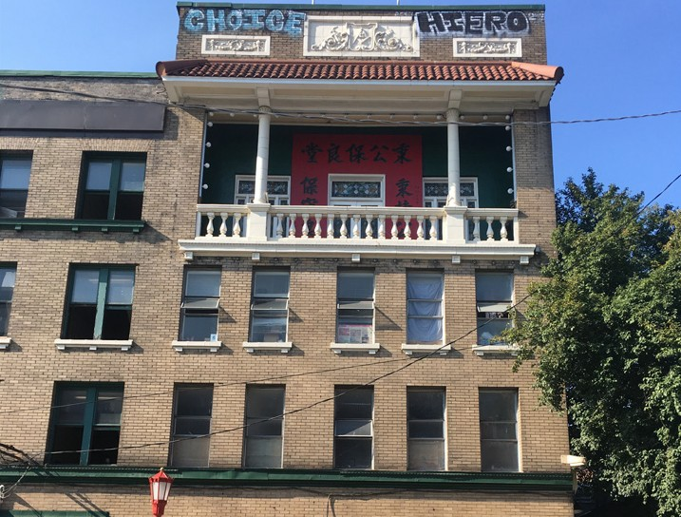
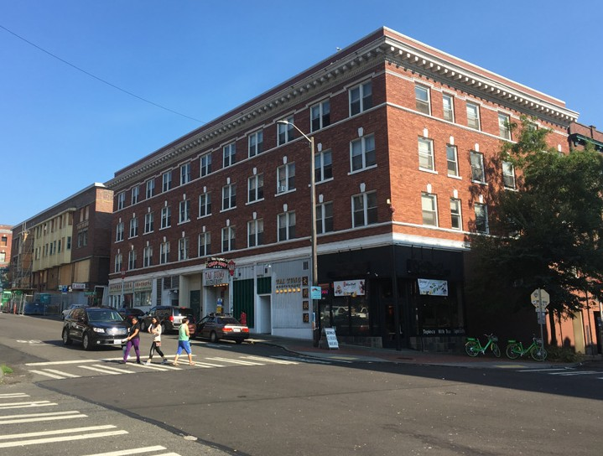
Contributing building with an example of projecting cornice
Schemata Workshop
Schemata Workshop

Example of recessed balcony
- Contributing Buildings
The Secretary of Interior’s Standards and Guidelines for the Treatment of Historic Properties addresses different approaches to the preservation of contributing buildings.
Relevant to the ISRD are the Standards and Guidelines for Rehabilitation. Rehabilitation, in contrast to restoration or new construction, allows for alterations and even new additions if necessary, for the continued use or new uses of a historic building. These guidelines recognize that usefulness is key to preservation of buildings and to the economic vitality of a community.

Rehabilitation guidance is included below:

  - Historic elements that are character-defining include
but are not limited to;
    - Tall storefronts with transoms and large

bays
    - Display windows
    - Wide doorways at the ground floor along the
sidewalk or alley
    - Upper floors have rectangular shaped “double hung” wood windows with two glazed panels elements, which slide vertically to open.
    - Projecting trim bands and

cornices
f. Recessed balconies
g. Flat roofs

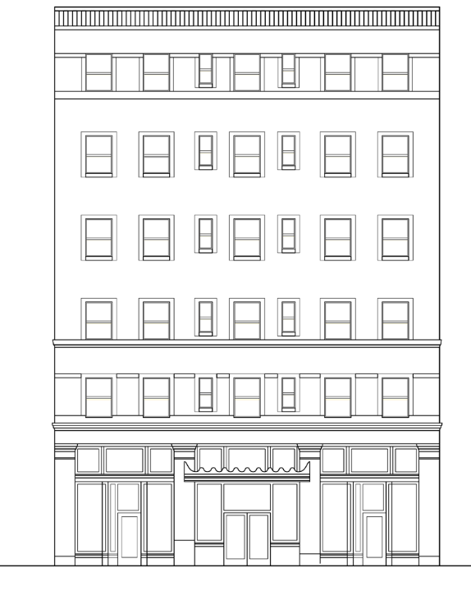
Flat roof with parapet and cornice

Simple form less than ten stories Masonry facade with decorative brickwork Rectangular shaped wood windows

Trim band
Canopy over entry Translucent window and door transoms

Display windows

Diagram of character defining elements
High ground floor storefront bays with
recessed entries and wide doors

Publix

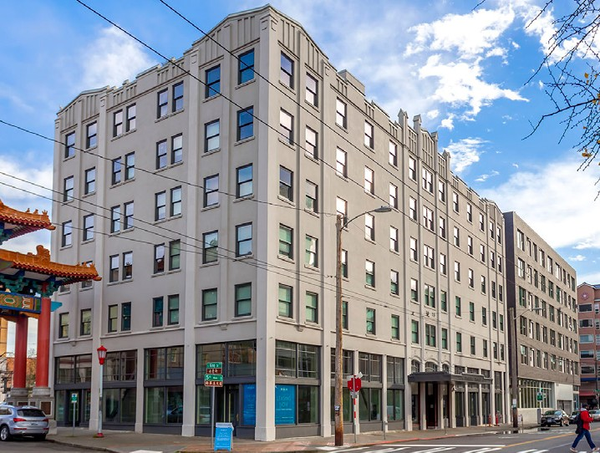
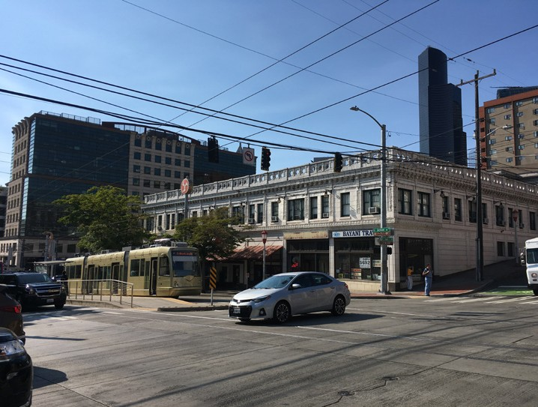
Contributing building with examples of character defining elements and a strong street edge
Schemata Workshop

Contributing with examples of wide
doorways at the first floor
  - Knowledge of the historic district and its resources at the outset is key to begin to identify the architectural forms, details, materials, and the features that define a building’s historic character.
  - In order of importance, priority should be given to the (1) the preservation and maintenance of building materials, (2) repairs, and (3) the replacement of deteriorated features, “in kind”.
  - While all buildings are different and distinct, there are consistent materials and features exhibited throughout the District. Such materials include those that make up the structure, such as heavy timber and wood or steel framing and brick masonry, along with stone, terra cotta and wood windows.
  - Rehabilitation should be based on historical documentations such as photographs or original and/or previous drawings. When no evidence of the original design exists, the new design and materials should be compatible with the character of the building and adjacent properties.
  - Characteristic building siting includes a strong street edge, with buildings placed directly along the property line, rather than with setbacks. Any modifications
to contributing buildings should keep these key components in mind.
  - Seismic retrofits should respect the historic character and materials of the building; and regardless of whether the seismic retrofit work is exposed or hidden, it should be visually unobtrusive and compatible in design with the building.
- Non-Contributing Buildings
  - When modifying existing non-contributing buildings, features from the context of nearby contributing buildings can serve as design clues. Overall patterns, based on the repetition of building elements from contributing buildings, are useful to assure a
new design will fit into the district. Such patterns
include:
    - The placement of buildings in relationship to the street or alley and sidewalk
    - Areas for exterior retail displays, and space for pedestrian access to storefronts
    - Building heights at the first floor
storefronts
    - The rhythm of windows and door openings and patterns of window sash divisions
    - Horizontal trim bands and cornice and roof lines

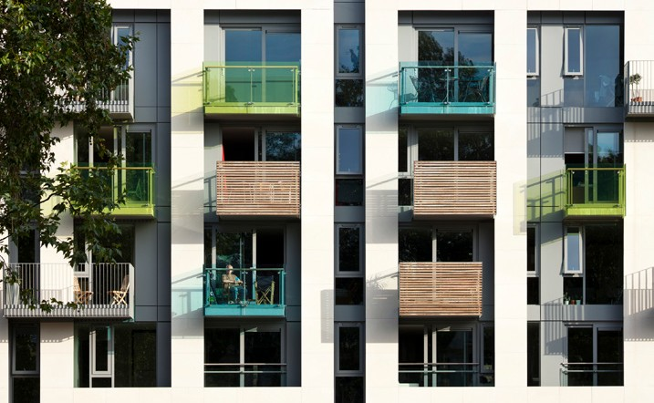
Use of balconies to provide depth, color and interest to building facade
Teakha
Tim Crocker, Pollard Thomas Edwards

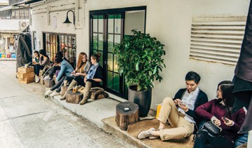
Human scaled elements along building face activate the public realm
Elephant Grounds

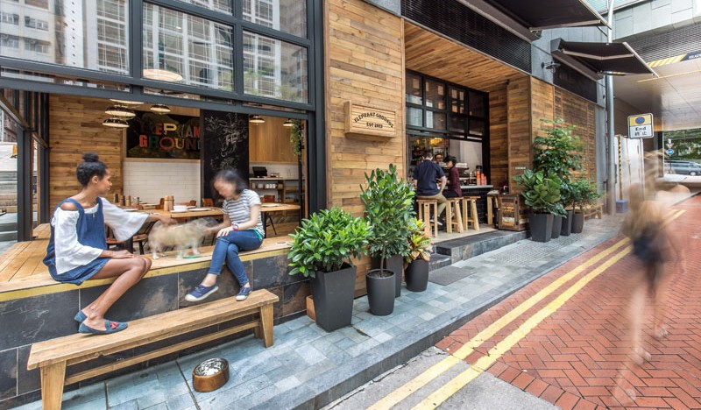
Seating and operational glazed openings invite pedestrian interaction

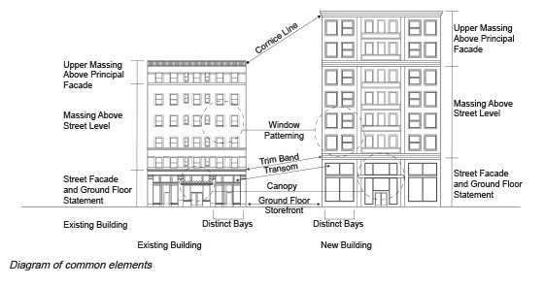
New Buildings and Additions
  - Where appropriate, make connections to neighboring buildings by using compatible materials, proportions, modulation, articulation, fenestration, color, landscaping, detailing, texture and relief.
  - When designing the massing (height, bulk, scale) of the building, consider the massing of surrounding buildings, characteristics of the site and nearby open spaces.
  - Break up large expanses of blank facade with design elements such as green walls, art, material modulation, and ornamental screening. Avoid blank walls on street facing facades.
  - Include architectural elements such as balconies, awnings, canopies, decorative lighting, and patterning of materials to add depth, and texture.
  - Building exteriors should be constructed of durable, high-quality and environmentally-sustainable materials that are compatible in color, texture
and proportion with buildings in the immediate
area.
  - Incorporate welcoming and human-scaled design elements, especially at the lower stories, to engage pedestrians and create a vibrant street frontage.

Mithun

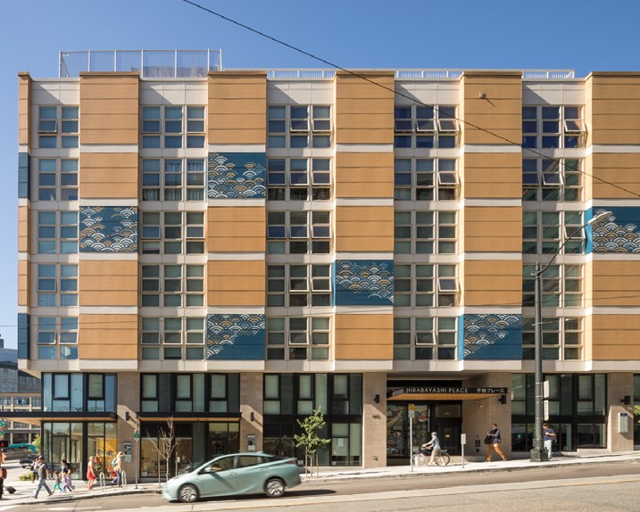
Example of a new building in Japantown with a strong street edge.
Fogarty Finger Architecutre
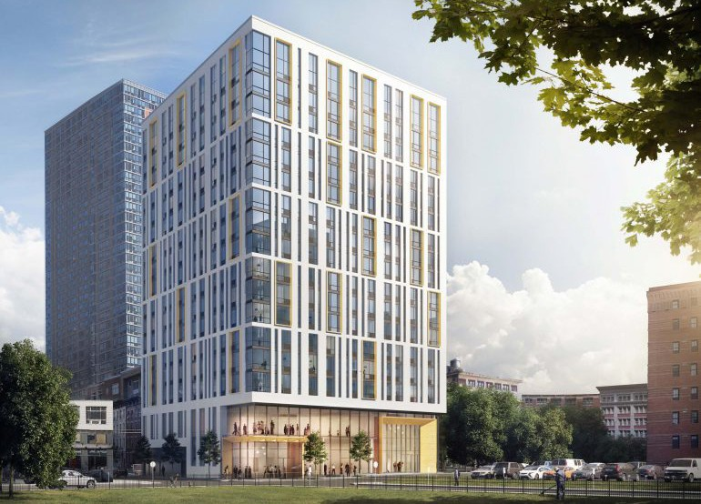
Floor groupings provide buildings with
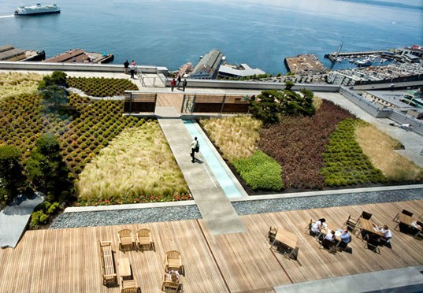
multi-story intermediate scale elements
RIC Sky Garden

Roof garden provides integrated rooftop design as a transition to the skyline
Paolo Boeri Studio

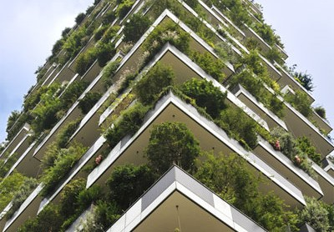
Terraces and landscaping provide functional facade modulation and a compelling design viewed from below.
  - Where appropriate, design the exterior of the building
to reflect interior use.
  - Identify opportunities for the building and site to include outdoor and semi-outdoor spaces that activate the pedestrian experience and public realm, including alleyways.
  - Where appropriate, consider operational, glazed openings that can be completely opened to the street, increased height in lobbies, and/or special lighting for storefront displays.
  - Design new buildings and additions to reflect contemporary architectural practices. Avoid materials and designs that create a false sense of history.
  - Consider visibility of the building from multiple key perspectives in the District.

See SMC 23.66.332 – Height and Rooftop Features and SMC 23.66.336 – Exterior building finishes for additional information

Tall Buildings
The following guidance applies to new construction buildings that are 85’ in height or taller:

  - Integrate and transition to differing heights and existing visual datum of the surrounding building context.
  - Locate tall form geometries to:
    - Reduce adverse shadow or reflected light impacts on parks, plazas, and open spaces;
    - Consider facade placement in relationship to adjacent structures;
    - Ensure light and open space to the public realm.
  - Consider the relationship of the tower massing to the neighboring buildings in proportion, scale, and texture. Strategies may include, but are not limited to:
    - Incorporate multi-story, intermediate scale elements (i.e. floor groupings, gaskets, offsets, projections, terraces, etc.)
    - Facade plane changes, depth, shadow, texture

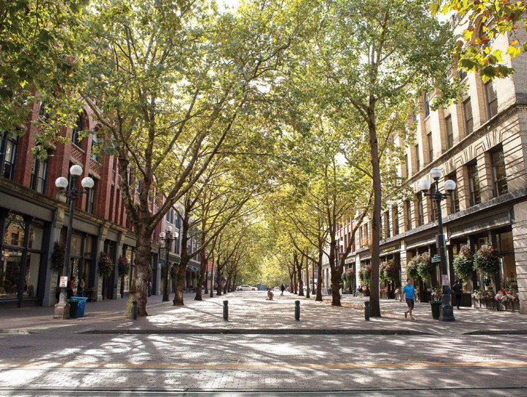
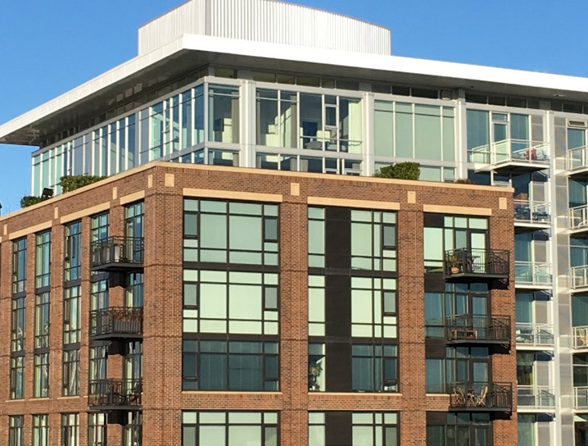
The building base should complement the neighborhood character
OPCD file photos
Olivia Brent

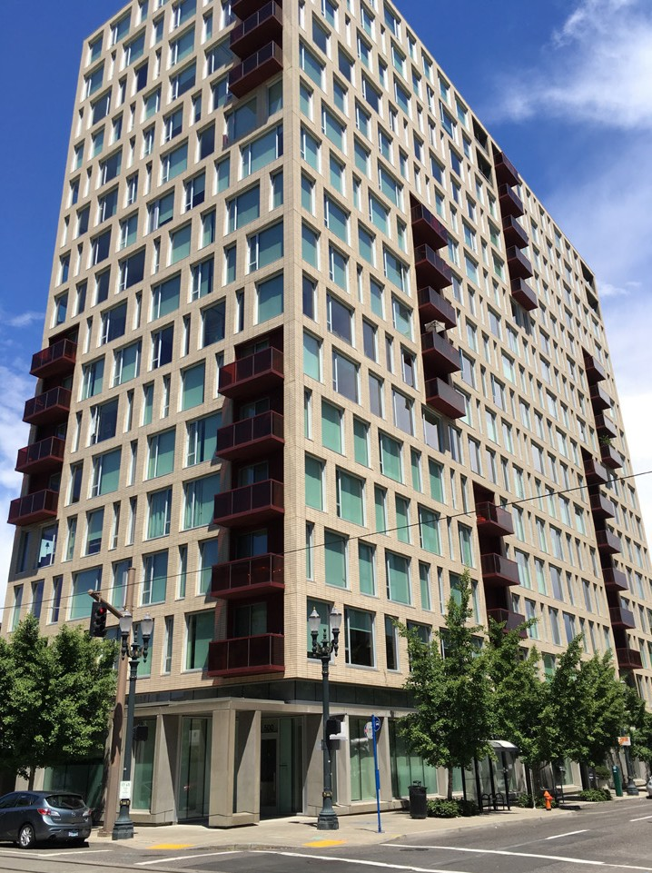
Modulated massing and an upper portion that adds visual interest
OPCD file photos

Balconies break up the facade and provide human scale
to provide a finer scale and break up large expanses of material
    - Carved, angled, or shifting forms to modulate building massing
    - A podium base to clearly demarcate the transition of tower to street level and mark the portion of the building experienced by pedestrians
  - Intentionally consider all sides of tall buildings, because tall forms are visible from many vantage points in the area, including those on Interstate-5.
  - Design the upper portions of taller buildings to contribute visual interest and variety to the skyline.
  - Clearly identify primary pedestrian entrances. Provide multiple entries where appropriate, and consider activating adjacent streets and alleyways where possible.
  - Carefully detail elements that are readily seen by pedestrians at street level. Examples may include soffits, balconies, and exterior ceilings.
  - Integrate all rooftop elements and uses into the overall design (i.e. mechanical screens, maintenance equipment, amenity spaces, lighting, etc.).
  - Avoid opaque, colored, or tinted glass on large expanses of building facades.
  - Employ sensitive massing strategies that relate the scale of the building to the width of the street that the building fronts. A corner lot may require a different approach for each street fronting facade.
  - Where possible, pursue a smaller building footprint while taking advantage of the allowable height. Smaller floor plates may help facilitate a viable green building strategy by allowing for daylighting, natural ventilation, on-site water management, and other passive design opportunities.
  - Ensure that the first three floors of the building above street level complement the architectural and cultural character of surrounding buildings.

Location Specific Guidance

ISRD Design Guidelines

Guidance provided in the following sections is meant to be applied in addition to guidelines outlined in previous sections.
Each applicant must first respond to guidance provided for all of the ISRD, and then seek out location specific guidance

associated with their project address, either East of 1-5 or West of 1-5.
Ethnic Seattle

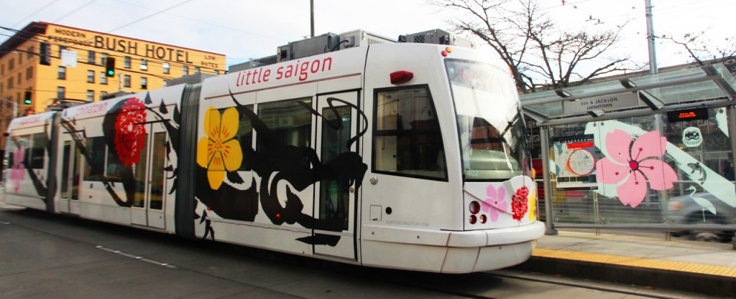

4. Additional Guidance East of I-5

Overview of Area

Little Saigon is located East of I-5, and is home to Seattle’s Vietnamese and Vietnamese American community. Along with other Asian businesses, Vietnamese business owners moved into the neighborhood in the 1980s, and the result of the community they established still defines this area of the District today. One of the biggest character-defining elements of Little Saigon is the prevalence of warehouse and low-rise commercial buildings which house markets, grocery stores, specialty stores and more. These warehouses are integral to many of the nearby businesses throughout the District. The markets and specialty stores serve as an invaluable resource for Seattle’s local residents, and have also made Little Saigon a destination neighborhood for people coming from afar. As each phase of development continues to reshape the scale of this built environment, it is critical for these businesses to remain at the heart and soul of the neighborhood.

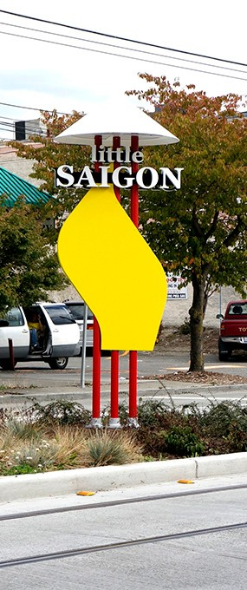
Goals for Development East of I-5
Lui NWAW
  - Promote a vibrant Asian American community by supporting and providing space for cultural assets.
  - Preserve and enhance the cultural and neighborhood assets that are already thriving in the area (i.e. successful restaurants, markets, non-profit organizations, and specialty stores).
  - Increase the area’s Vietnamese cultural identity and sense of place.
  - Promote a pedestrian-friendly community with open
public spaces.
  - Provide spaces to support economic pathways to job opportunities.
  - Promote and support the development of a variety of housing types.

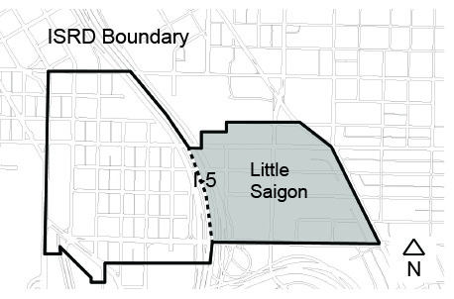

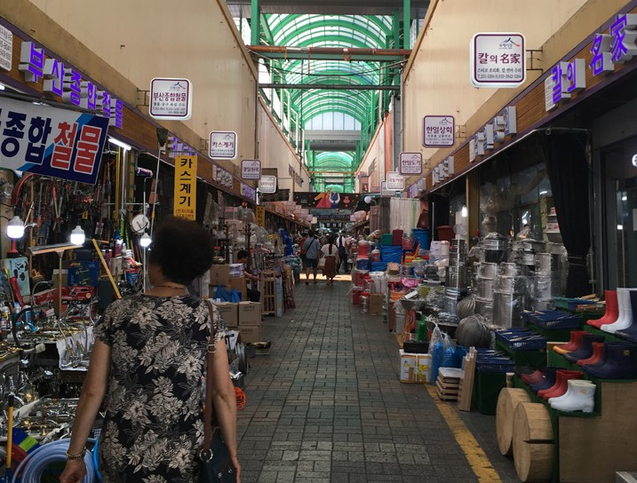
Vending supported by mid-block crosswalk
Schemata Workshop
with permanent cover
Friends of Little Saigon

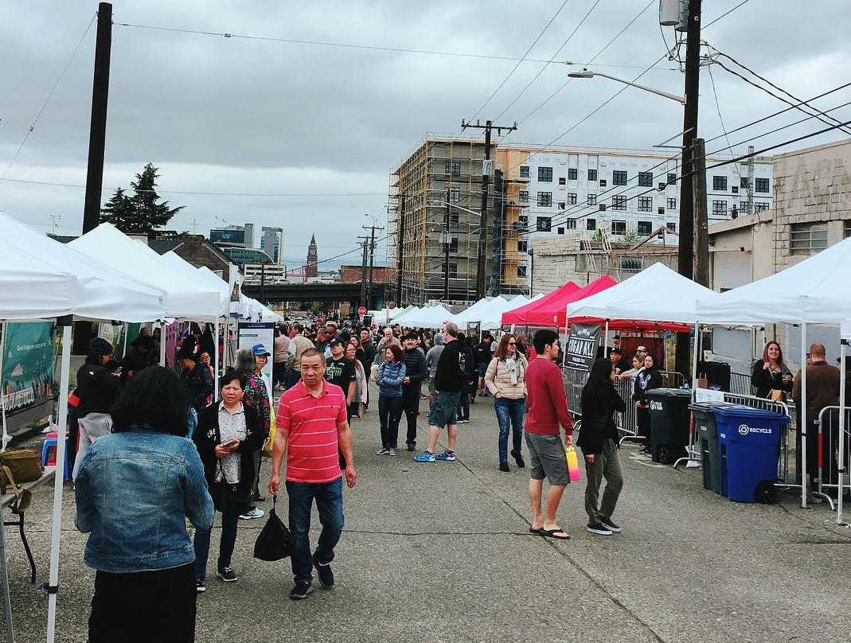
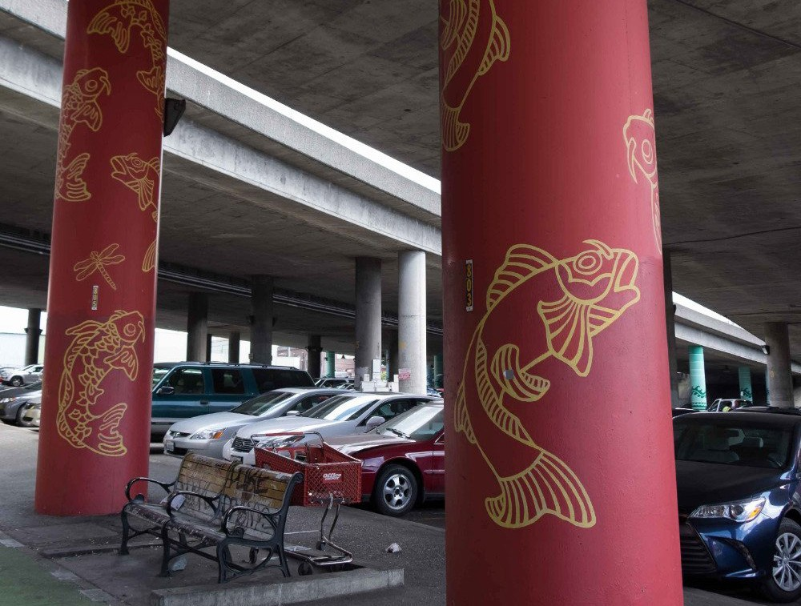
Street activation in Little Saigon
Gerard Robert

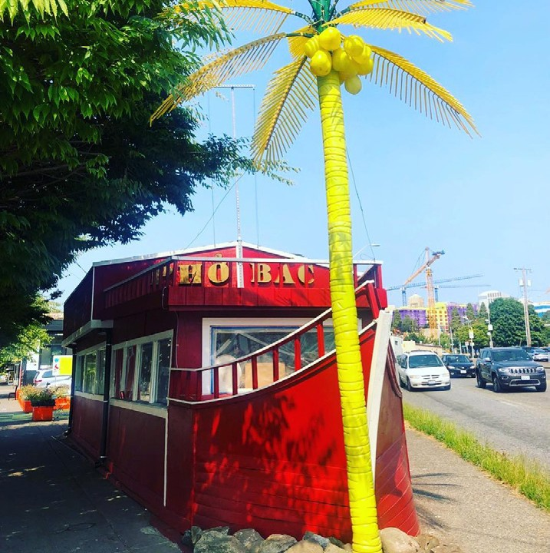
Public art entering into Seattle’s Little Saigon
Pho Bac Seattle

Pho Bac has been in operation since 1982
and is the city’s first pho restaurant

Context & Site
  - Consider mid-block crosswalks to increase pedestrian circulation and safety. Through-block passages in larger developments provide important pedestrian circulation that activates the site, while adding a welcoming character to the block.

Public Life
  - Throughout the public realm, ensure businesses have space to engage with passerby while still allowing clear sidewalks for pedestrian circulation.
  - Provide a sufficient planting buffer between street traffic and the sidewalk in order to achieve a welcoming pedestrian environment and soften urban edges
  - Use alleys and mid-block passageways as activation opportunities to provide usable and inviting open space for community uses. Ensure that these corridors are well lit and engage the public realm in order to keep these elements active and safe throughout the day and year.
  - Incorporate green space and landscaping where possible.
  - The clarity and visibility of signage is important in order to best serve pedestrians as well as the large number of patrons who travel to Little Saigon’s businesses by car.

Building Design
  - Provide bilingual signage to represent the culture of the community.
  - The use of color is important as a cultural defining
element for this area of the neighborhood.
  - Minimize the visual presence of service areas by locating access to trash storage and loading docks away from primary building facades and entries.

5. Additional Guidance West of I-5

Overview of Area
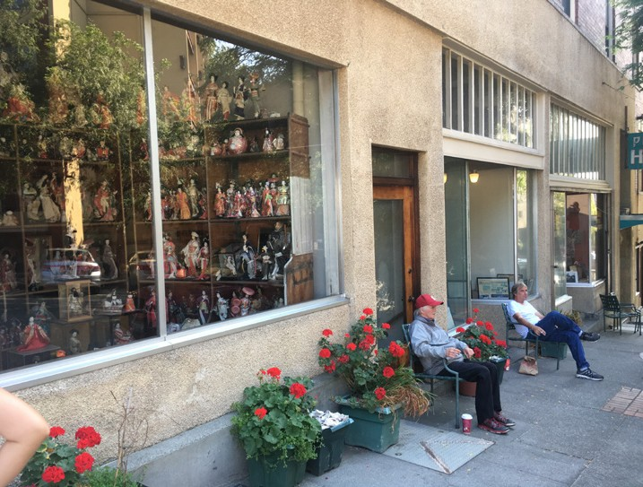
The West side of the International Special Review District includes two primary cultural nodes: Chinatown and Japantown. Chinatown is south of Jackson St and centered on South King Street. Japantown is north of Jackson St, centered on South Main Street and has a steep topography. The area West of I-5 includes the International District Residential Zone (IDR), the International District Mixed (IDM) Zone, Union Station Corridor, and Retail Core/Asian Design Character District. Refer to the Seattle Municipal Code sections 23.66.304, 23.66.306 and 23.66.310 for individual zone goals and objectives.
Shecmata Workshop

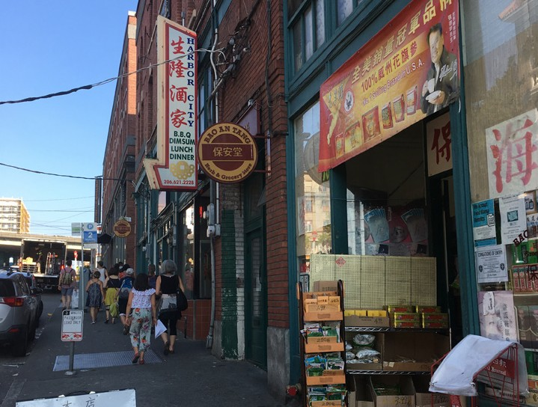
Seating outside storefront
Scehmata Workshop

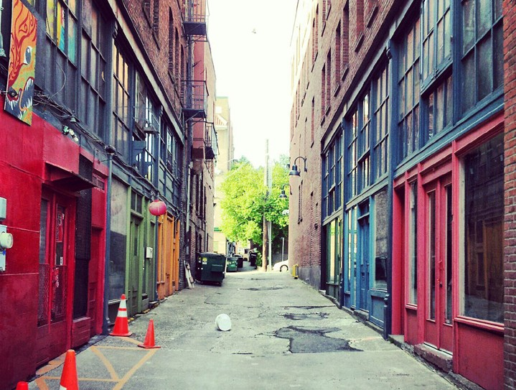
Vibrant storefronts attract pedestrians
Ben Grace

Canton Alley

The area West of I-5 also includes the Seattle Chinatown Historic District, nominated to the National Register of Historic Places Inventory in 1986.

The area West of I-5 is characterized largely by three- to six- story brick or stucco buildings built during the late 1800s and early 1900s and many served as Single Room Occupancy (SRO) hotels. These buildings are similar in material and style to the buildings constructed elsewhere in the country at the time with identifiable features such as flat roofs, masonry wall surfaces, punched openings, decorative cornices and ground floor storefronts. They are built right up to the
property line and create a very strong urban street fronts. The Chinese, Japanese, and Filipino immigrants who constructed, owned, rented, and occupied these buildings adapted them over time to reflect their cultural heritage by incorporating architectural features such as upper story recessed balconies, awnings, tile work, decorative ironwork, banners, ornamentation and signage. For example, the upper story recessed balconies built by family associations follow a Southern Chinese tradition of providing cool and pleasant outdoor living space overlooking street activity. These cultural elements have come to characterize the West side of the ISRD and are also reflected in some of the one- and two- story commercial buildings in the area.

A building typology common in this part of the ISRD features small scale ground-level retail with residential units on the upper stories. In Japantown, the steep slope of the streets has allowed for a mezzanine level of shops, offices and meeting rooms.

Another character defining element of the area West of I-5 is the historic alley network, for instance, Canton Alley. Storefronts and residences opened onto the alley, which created a public space for local residents to gather and socialize.

The mixed-use character of the neighborhood combined with parks and
open space create a lively pedestrian-oriented streetscape.

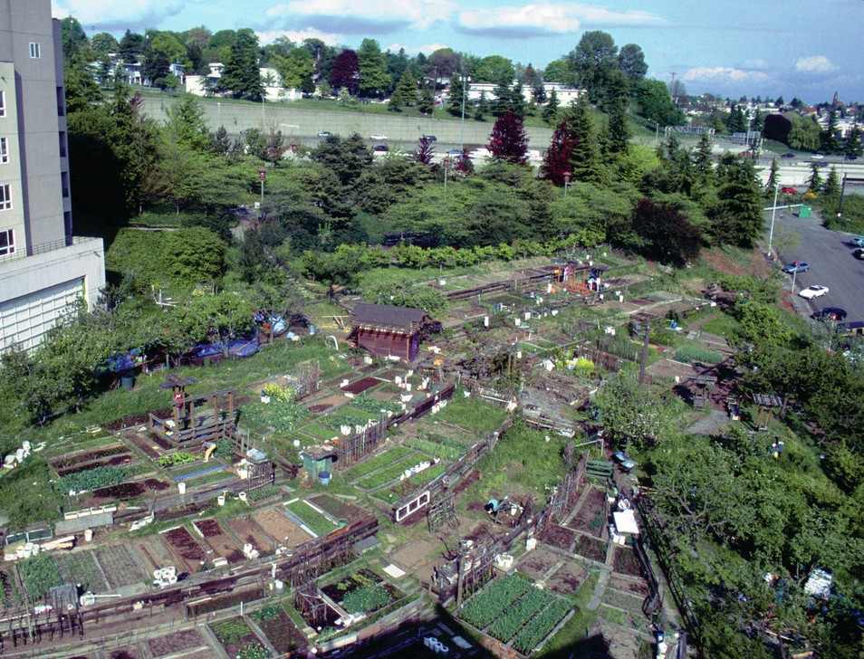
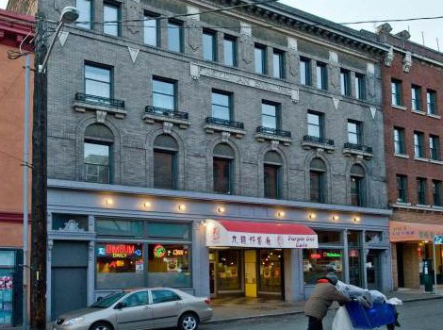
Community garden in Japantown
Jean Sherrard
Danny Woo Community Garden

Typical facade articulation in Chinatown
Joe Mabel

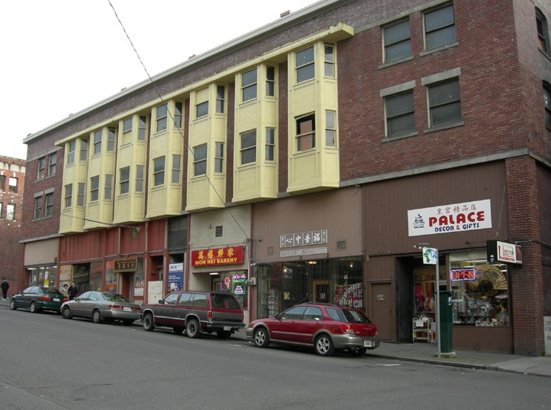
Retail bays in Chinatown
International District Facebook

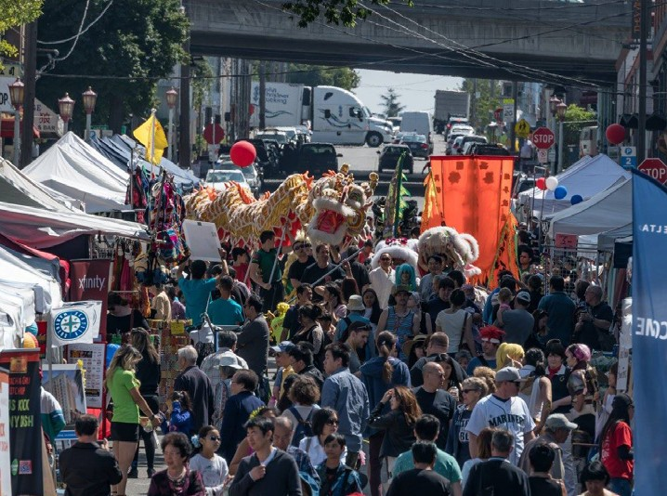
Street festival in Chinatown

Goals for Development West of I-5
  - Preserve the cultural character and history of the neighborhood by encouraging the rehabilitation of existing character contributing buildings.
  - Assure new development is compatible in scale and character with existing buildings and positively contributes to the District’s sense of place.
  - Support the multi-generational community that lives,
works, and visits the neighborhood.
  - Ensure the area thrives economically and environmentally for local residents and businesses, and develops further as a destination for community members and visitors alike.
  - Ensure the public realm is developed in such a way that benefits and enhances the existing neighborhood character.
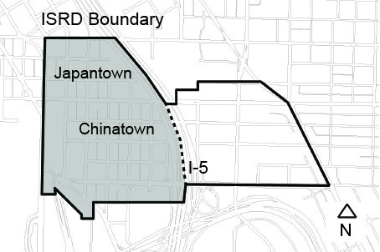

Context and Site
  - Use existing design features, materials and landscaping to create a consistent streetscape experience. Examples of character defining streetscape elements include but are not limited to the King Broadmoor pedestrian light fixtures, and glass sidewalk prism lights.

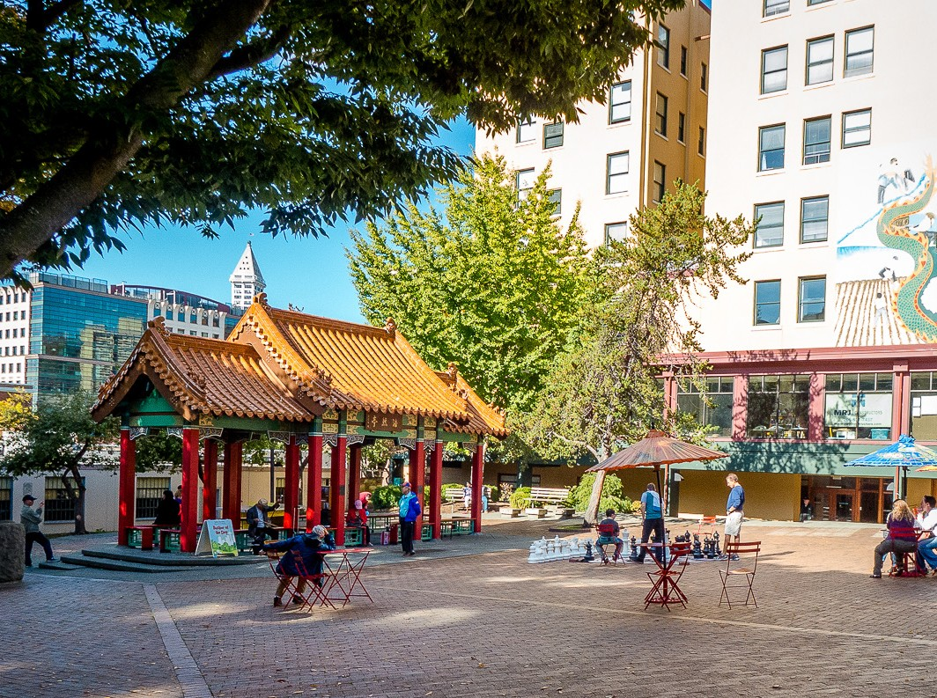
Hing Hay Park
Wing Luke Musem
Phoebe Poon
Steve Brock
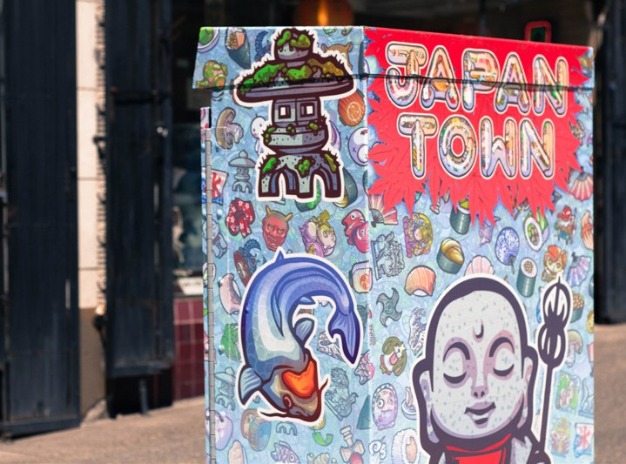
Japantown street art
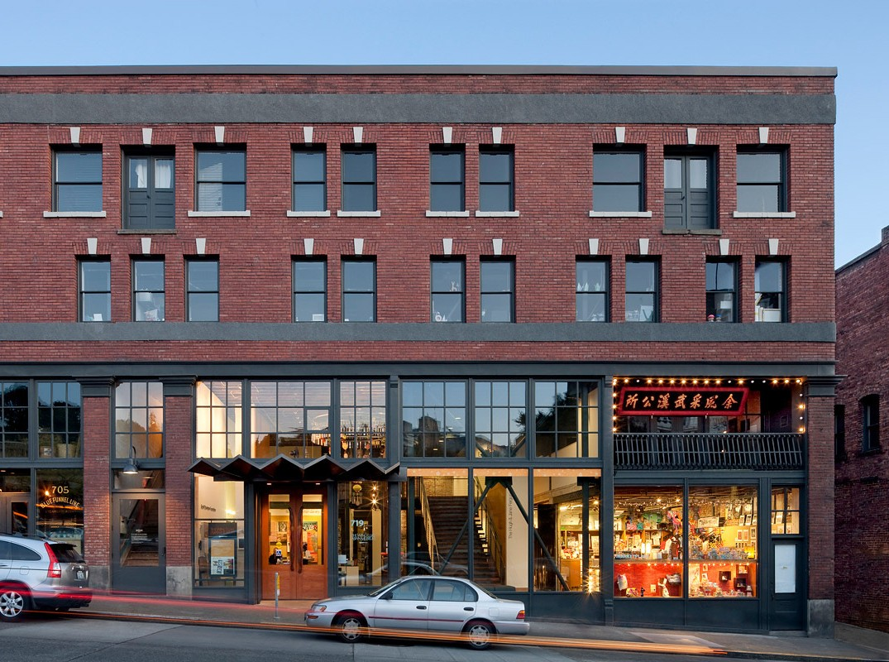
Wing Luke Museum, originally, opened in 1967.

Public Life
  - Consider the neighborhood’s historic and cultural heritage and include meaningful, authentic and culturally relevant art, signage, or ornamentation.
  - Activate alleys with pedestrian-scaled retail and residential uses.
  - Screen and separate garbage/waste storage spaces from retail and residential uses.

Building Design
  - Consider existing design features, materials, and landscaping to create a consistent streetscape experience. Examples of character defining streetscape elements include, but are not limited to the King Broadmoor pedestrian light fixtures, brick paving patterns, and glass sidewalk prism lights.
  - Incorporate culturally appropriate design elements and architectural concepts consistent with the District’s character. Character defining elements may include, but are not limited to:
    - Upper story recessed balconies
    - Signage in Asian languages and characters
    - Tilework at entryways
    - Decorative ironwork
    - Recessed entries with a high level of detail
    - Inspiration drawn from the history of the site
  - Modulate and scale street-level storefronts to be compatible with storefronts in adjacent contributing buildings.
  - Use durable, high-quality materials and finishes that are compatible with adjacent contributing buildings. Whenever possible, use brick to create texture, pattern and detail.
  - Design windows and window openings to respond to the depth, alignment, details and proportions
of windows from nearby contributing buildings. Consider using similar materials such as wood, or materials with similar frame profiles, depth, and relationships to the exterior cladding.

Marcus Yam, The Seattle Times

Document Resources

ISRD Design Guidelines

The following pages provide definitions, both written and visual, to many of the terms used throughout the design guidelines document.

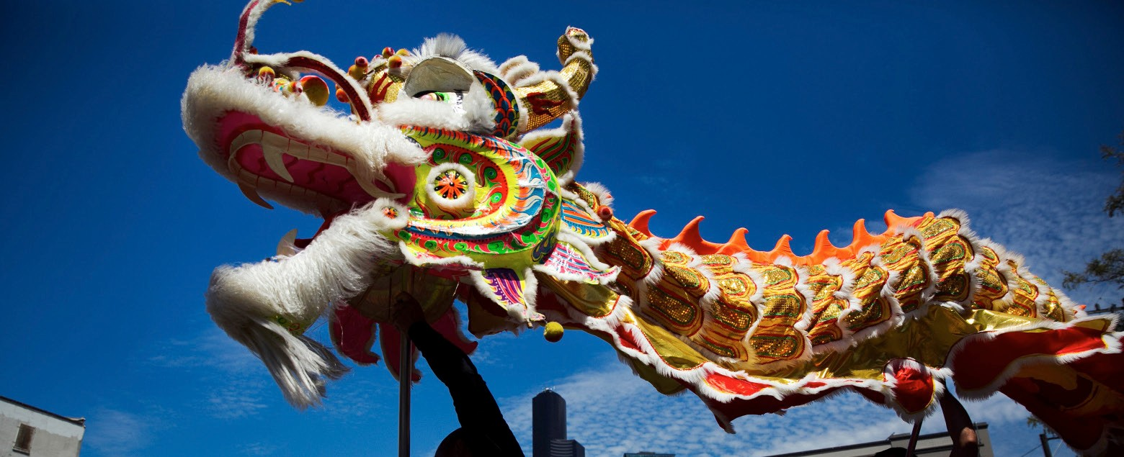

41
Glossary of Terms

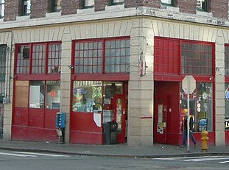
Bays
Joe Mabel
Joe Mabel

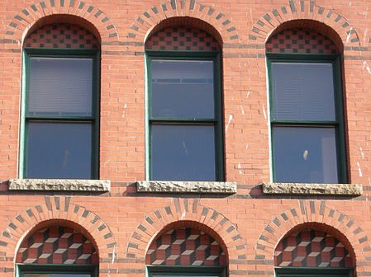
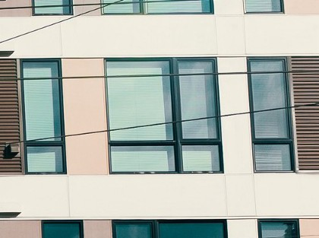
Historic Cladding and Punched Windows
Bullit Center

Contemporary Cladding
Stephen Cysewski

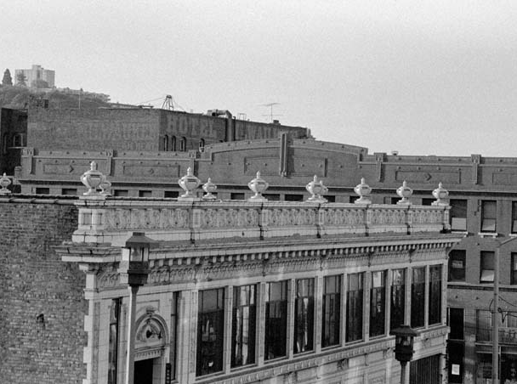
Cornice

Anchor Business: Businesses or organizations that are rooted in the community by relationships to customers/clients, and resources they provides to the community. These prominent businesses draw people to the community.

Bays: the space between structural, architectural elements, or a recessed portion of a storefront.

Certificate of Approval: The approval granted by the Dept. of Neighborhoods, following a recommendation from the International Special Review District Board, allowing use or design of a space in the District.

Character: The visual aspects and physical features that make a building or other structure notable or identifiable. Character-defining elements include the overall shape of the building, its materials, craftsmanship, decorative details, and various aspects of its site and environment.

Cladding: The external covering or materials (sometimes referred to as “skin”) applied to a structure for decorative or protective purposes.

Community Vision: Visioning is the process of understanding what future the community wants, and then deciding what is necessary to achieve it. Work in the ISRD should be informed by community input and reflects the culture and the history of the neighborhood.

Compatible: Capable of existing or occurring together in harmony
without conflict.

Contributing: A building, site, structure, or object that was present during the period in which the District attained its significance, has an identifiable architectural or historic significance to either the development of the neighborhood or the City of Seattle, and reflects its historic integrity or has the ability to convey its significance.

Cornice: The projecting decorative element at the top of the wall
surface, such as a roofline, balcony or canopy.

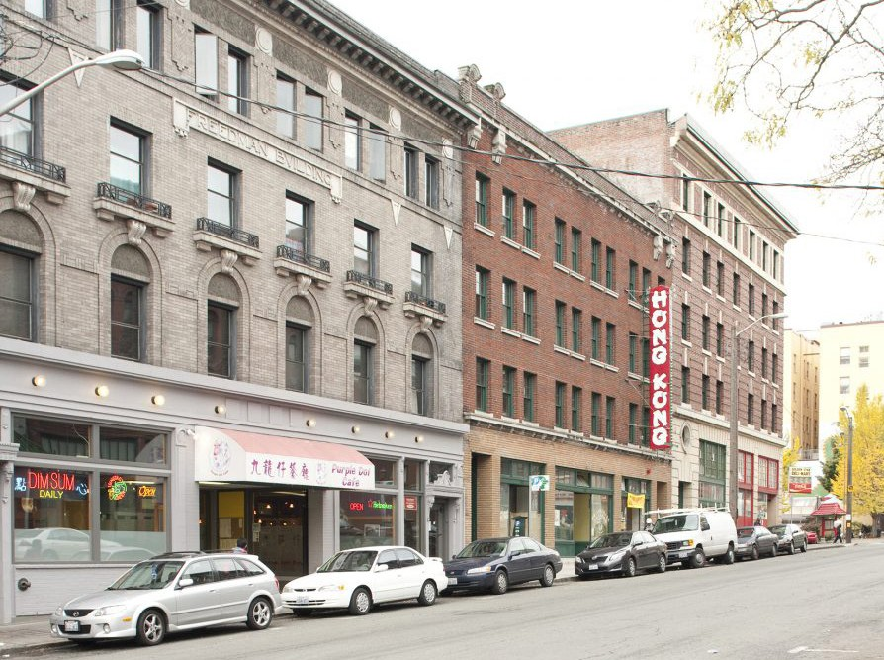
The cornices, trim bands and similar stories create horizontal datums.
Curtis Cronn
Spencer Haung
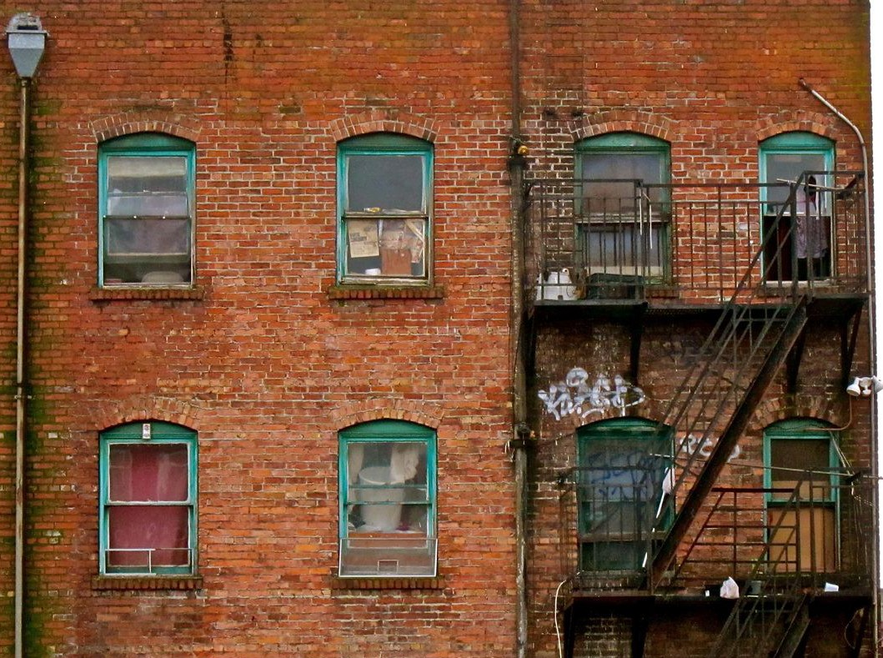
Fenestration

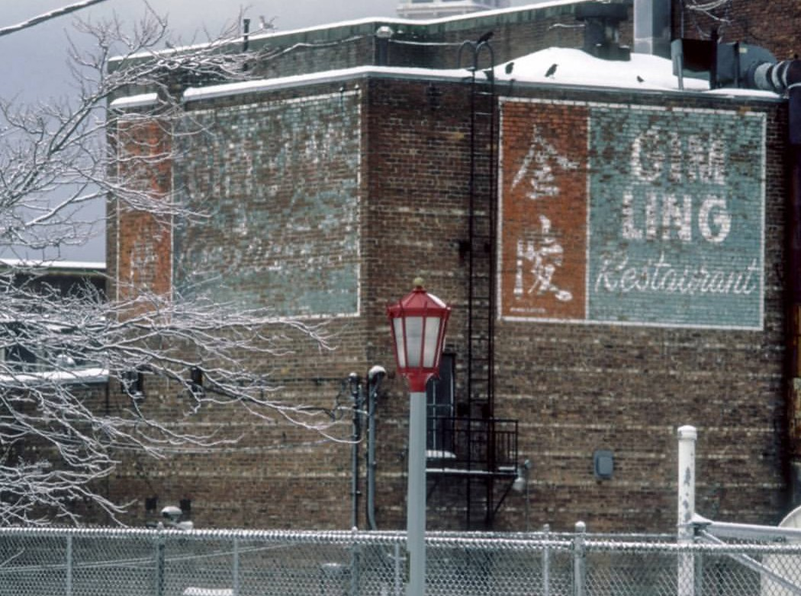
Ghost Sign
BDM17
Seattle Chinatown International District

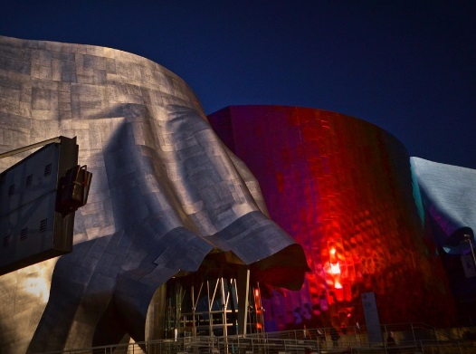
Glare caused by reflective surface of
building
Crime Prevention Through Environmental Design: A multi-disciplinary approach to deterring criminal behavior through environmental design specifically altering the physical design of the communities in which humans reside and congregate in order to deter criminal activity is the main goal of CPTED.

Cultural: Relating to the set of customs, traditions, and values of a community.

Culturally Appropriate / Responsive Design: A process that yields a design that is reflective of the Asian-American community and other communities of the ISRD. This includes, but is not limited to, reaching
out and thoughtfully engaging community stakeholders, and researching the ideas, people, and resources in the History and Background Section and Resources Section. Designs should not apply any features that can be interpreted as cultural appropriation without the understanding and history that a specific cultural group can provide.

Datum: A visual marker which ties together or anchors all other elements of the design. It can be a line, like a road with houses arranged along its length, a flat plane, or even a 3D space. Many buildings all share a plane which acts as a clear datum— it’s the ground on which they are built.

Facade: The front or primary face of a building or any visible side of a building that faces a street or other open space.

Fenestration: The pattern, alignment and rhythm of windows in a building.

Frontage: The length of the building which directly faces a road, or the main face of a business.

Ghost Sign: An old advertisement or faded mural that had previously
been painted on to the side of a building and is retained or re-introduced.

Glare: Reflected light causing disruption in view.

Glazed: Made of glass.

Historic, Historical: Dating from a past time and having a importance.

Massing: a term which refers to the perception of the general shape and form as well as size of a building.

National Register of Historic Places: The official Federal list of districts, sites, buildings, structures, and objects significant in American history, architecture, archeology, engineering, and culture. National Register properties have significance to the history of their community state, or the nation.

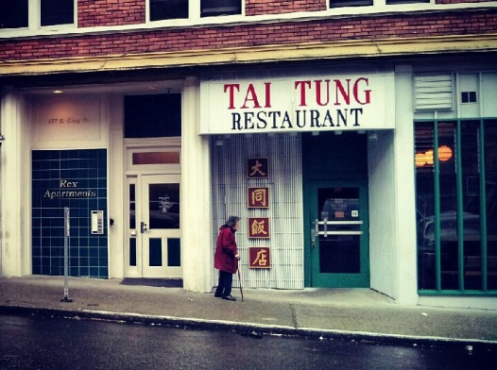
Non-Contributing: A non-contributing building, site, structure or object either was not present during the period during which the District attained it significance, or due to alterations, additions, or other changes, no longer possesses historic integrity reflecting its architectural or historic character.
Seattle Chinatown International District

Recessed Entry
Seattle Chinatown International District

Soffit
The View from Right Here

Transom with transom window above
Placemaking: A multi-faceted approach to the planning, design and management of public spaces which capitalizes on a local community’s assets, inspiration, and potential, with the intention of creating public spaces that promote people’s health, happiness, and well-being.

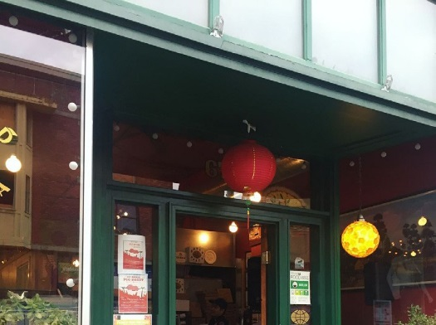
Punched Opening: An opening created in the exterior wall of the
building and filled with a window or door.

Recessed: Attached by setting it back into the wall or surface.

Right-of-Way/Public Space. Sidewalks, streets, planting strips, medians, and alleyways that are not privately owned and are open to vehicular or pedestrian traffic that can be used by all members of public.

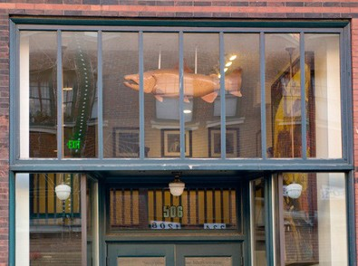
Scale: Refers to the relationship between the dimensions of a building, street, adjacent buildings, streetscape, and/or outdoor space.

Seattle Chinatown Historic District: The Seattle Chinatown Historic District is listed in the National Register of Historic Places and sits within the larger International Special Review District.

Soffit: The underside of an architectural structure such as an arch, a balcony, or overhanging roof.

Street Edge: The interface between public or private places and a street. In an urban situation this would typically be a building overlooking the street.

Sustainable, Sustainability: Building methods and materials that promote environmental quality, economic vitality, and social benefit through the design, construction, operation, maintenance, and deconstruction of the built environment without compromising the success of future generations.

Transom window: A row of windows, separated by mullions above the entrance or storefront. Also referred to as “clerestory” windows.

Wayfinding: Information systems that guide people through a physical environment and enhance their understanding and experience of the space.

Window Treatments: Interior decoration for a window or window frame. Examples include shutters, blinds, shades, curtains, films, and treatments to the glass.

Resources

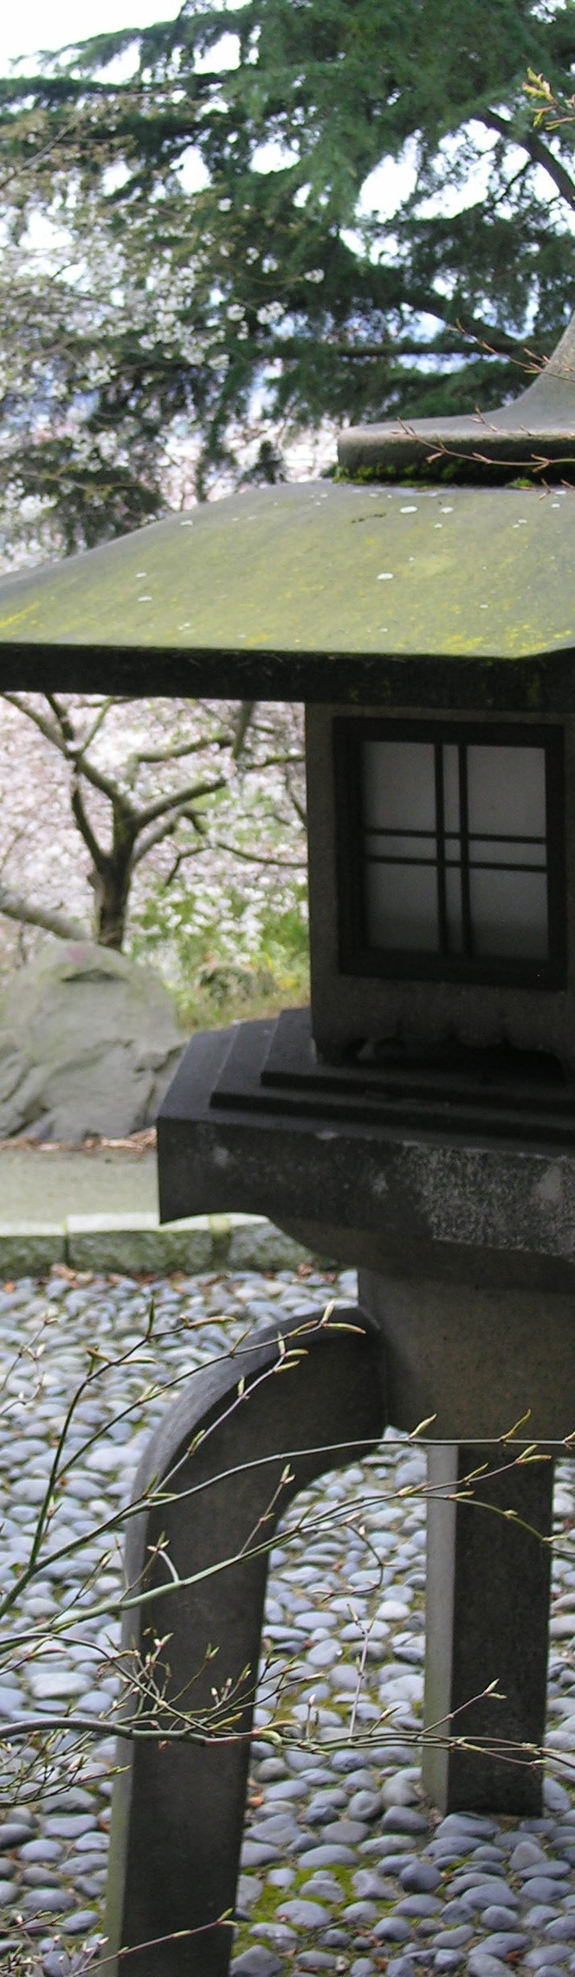
Documents
R. Frestedt
- Seattle Chinatown Historic District National Register Nomination
- Seattle Municipal Code Chapter 23.66
- The Secretary of Interior’s Standards for the Treatment of Historic Properties with Guidelines for Preserving, Rehabilitating, Restoring & Reconstructing Historic Buildings
- National Park Service, Technical Preservation Services, Preservation Briefs

Local Organizations
The following organizations have publicly available resources available in the form of online databases or libraries.

- Densho preserves the testimonies of Japanese Americans who were unjustly incarcerated during World War II.
- History Link is an online encyclopedia of Washington State history.
- The Museum of History and Industry (MOHAI) museum preserves artifacts and stories of the Puget Sound region’s diverse history.
- The Wing Luke Museum connects people to the dynamic history, cultures, and art of Asian Pacific Americans through vivid storytelling and inspiring experiences.

National Organizations
The following organizations are resources for articles, briefs, and publications about historic preservation and new construction in historic districts.

- The National Park Service carries out historic preservation through the designation of historic sites, documentation, and physical preservation.
- The National Trust for Historic Preservation protects
significant places.

Mildred Tanner Andrews, Pioneer Square – Seattle’s Oldest Neighborhood, 2005, pp. 153-154.
David B. Williams, “Mikado Street in Seattle,” May 11, 2015, in GeologyWriter.com blog)
Wing Luke Museum, “History Behind Our Building.”
Gary Iwamoto, “A Samurai to Seattle, 1894,” International Examiner, August 30, 2005.
Fred Cordova, “60th Anniversary Program, Filipino Community of Seattle,” December 15, 1995.
Ron Chew. Remembering Silme Domingo and Gene Viernes: The Legacy of Filipino American Labor Activism, 2012).
John D. Nonato, “Finding Manilatown: The Search for Seattle’s Filipino American Community, 1989-2016,” UW Tacoma undergraduate thesis, March 22, 2016.
Viet Wa, “Our History– About Us.”
James Tabafunda, “A History of Change in Little Saigon, NW Asian Weekly, August 23, 2014.

