DRAFT OH Investments Report -- Excerpts
Rental Affordability, unit sizes and Populations served

Funding Priorities
Rental housing projects funded in 2018 include both population-specific housing and buildings that are open to any income-eligible resident. The projects address the range of City population priorities contained in the OH Housing Funding Policies adopted by City Council:
- Individuals and families experiencing homelessness: 2 buildings to serve people experiencing homelessness; 1 building for formerly homeless residents of permanent supportive housing who are ready to move on to housing with a reduced level of on-site services
- Seniors and people with disabilities: 1 senior housing project with healthcare and social services for elders on the ground floor. 1 building serving people with mental illness, including those experiencing homelessness.
- Low-wage working families and individuals: 6 buildings with a mix of apartments sizes serving a range of household incomes
Selected 2018 Income Levels
AMI = Area Median Income
30% AMI
$21,050 for a single person
$27,100 for a three-person family
50% AMI
$35,100 for a single person
$45,150 for a three-person family
60% AMI
$42,150 for a single person
$58,700 for a three-person family
Rental Affordability
Rental Housing Funded in 2018
10 Projects / 1,204 Units

Capital Funds Leveraged
Rental Housing Development: Of the City’s total capital investment in rental housing production and reinvestment, $68 million is dedicated to new housing development. This $68 million in OH investment will result in a total investment of $422 million in new low-income housing, not including ground floor commercial or community spaces. The $354 million that augments City funding derives from multiple sources, with the largest being private activity bonds and private equity investment through the federal Low Income Housing Tax Credit program, both of which are administered by the Washington State Housing Finance Commission. The $354 million in non-City resources produces an extraordinarily high leverage ratio for the 2018 funding round. The federal Low Income Housing Tax Credit program’s designation of much of Seattle as a “difficult to develop area” in 2018 boosted the value of 4% tax credits; this change to the tax credit program is responsible for much of the increase in the leverage ratio.

2018 Highlights
- $422 million total investment in low-income housing development
- $5.20 in other public and private investment leveraged for each City dollar
- Private equity through federal tax credits remains the most significant source
- Extraordinary leverage results from a 2018 boost to the value of the 4% federal tax credit, increasing equity investment
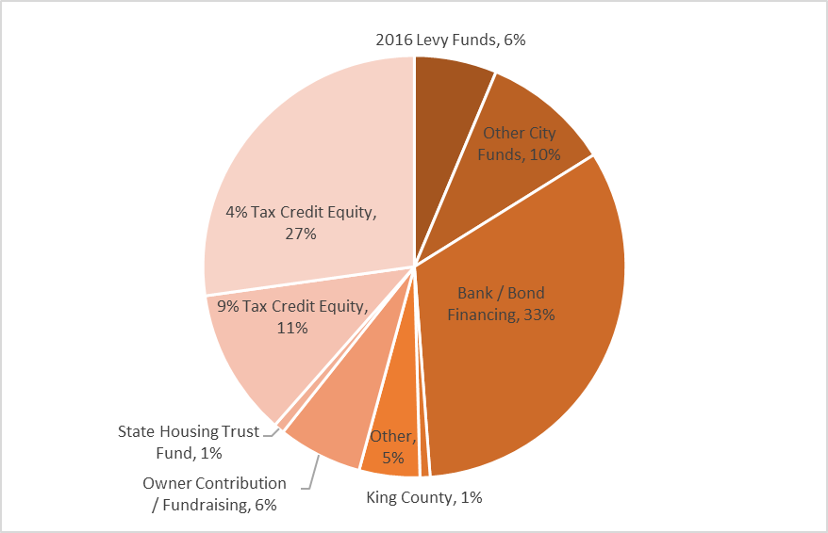
Capital Funds Leveraged - Rental Production
Rental Projects Funded in 2018
10 projects / 1,204 units

Homeownership Development: Ownership development projects can achieve comparable leverage to rental housing. The homebuyer’s mortgage and down payment brings the largest share of permanent financing, typically covering one-half to two-thirds of the cost of each home. Subsidy sources are generally limited, however. The State Housing Trust Fund is typically the largest public source other than Seattle Levy; some projects also leverage significant philanthropic and volunteer contributions.

The new Othello homeownership development project funded in 2018 has an estimated development cost of over $29 million. The project sponsor is securing significant King County, State and private lender investment. City funding will leverage approximately $5 for each City dollar invested, including the homebuyers’ mortgage and down payment.
Households served in Housing Programs
Through investment of Housing Levy and other housing funds over the past 37 years, there are now over 16,000 income- and rent-restricted apartments in City-funded rental housing that is in operation or under development. In addition, over 1,050 homebuyers purchased their first home with an affordable City-funded loan, including buyers who purchased one of 200 permanently affordable homes developed with City assistance.

Rental Housing
In 2017, the most recent data, 12,444 affordable apartments had been in operation for a year or more. This housing served 13,603 resident households over the year.
Race/Ethnicity of Residents Renter Households, 2017
- 41% White
- 31% Black/ African American
- 13% Asian/ Pacific Islander
- 5% Hispanic
- 8% Multi-racial
- 3% American Indian/ Alaska Native
- Extremely low incomes: 73% of households with income
at or below 30% AMI
- People of color: 59% of residents -- a higher proportion
than among Seattle’s lower income renter households
- Special needs: Over half identified as having special needs
Special Needs Households Served
7,683 Renter Households, 2017

Homebuyer Assistance
OH has provided purchase assistance for first-time homebuyers since the early 1990’s, using Housing Levy, federal funds and other fund sources. Households with incomes up to 80% AMI are eligible, although some programs are designed to serve a lower income population. In recent years, OH has funded an increasing amount of permanently affordable housing, which is available at an affordable price upon resale for eligible home buyers for at least 50 years.
Home purchase assistance promotes more diverse and equitable neighborhoods, and provides opportunity for households with lower incomes, and for racial and ethnic groups with lower rates of homeownership, to increase their wealth. Seattle has now assisted more than 1,050 first-time homebuyers; demographic data is based on 843 first-time homebuyers assisted over the course of the past two housing levies.
Home purchase assistance has been provided to:
Race/Ethnicity of
Homebuyer Households
2003 - 2018
- 61% White
- 16% Asian/ Pacific Islander
- 15% Black/ African American
- 4% Hispanic
- 2% Multi-racial
- 1% American Indian/ Alaska Native
- 1% did not report
- People of color: 39% of homebuyers
- Low income households:
- 19% with income at or below 50% AMI
- 18% at or below 60% AMI
- 63% at or below 80% AMI

Home Repair
The Home Repair program assists low-income homeowners to make critical repairs that enable them to stay in their home. The program provides loans to homeowners with incomes up to 80% AMI and grants to homeowners up to 50% AMI.
In 2018, the program served 44 homeowners, including:
Race/Ethnicity
Homeowners receiving Home Repair Grants and Loans, 2018
- 47% White
- 18% Asian/ Pacific Islander
- 14% Black/ African American
- 12% Hispanic
- 9% Multi-racial
- People of color: 53% of homeowners
- Low income households:
- 48% with income at or below 30% AMI
- 23% at 31% to 50% AMI
- 15% at 51% to 60% AMI
- 14% at 61% to 80% AMI
- Older adults: 64% of households had at least one member
who was 60 or older

