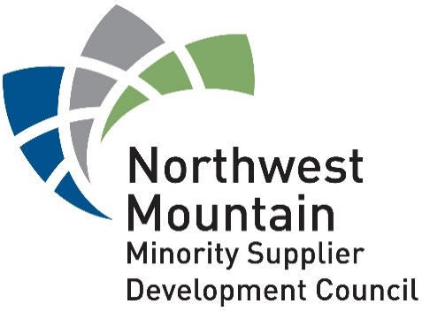

12 Month Report for the
Technical Assistance Services Agreement
No. FAS 2019-001

Fernando Martinez, Northwest Mountain MSDC
Zavere Weeks, Northwest Mountain MSDC
And
Miguel Beltran, City of Seattle, Dept. of Finance and Admin. Services
Carmen Kucinski, City of Seattle, Dept. of Finance and Admin. Services

City of Seattle FAS 2019-001
Technical Assistance Services Project

Table of Contents
Introduction 3
Project Specifications 3
Timeline: 3
Project Scope of Work: 3
Project Success Defined: 3
Project Location: 3
Project Qualifications: 4
Project Team: 4
Project Approach 4
Strategic Alliance 4
Outreach 4
Social Media 5
Technical Assistance 6
Surveys: General Interest, Enrollment, and Exit Surveys 7
Who to do Business With? 9
Project Results Summary 10
COVID-19 12
Barriers to Entry 13
Experience Requirement: 13
Inclusion Plan: 13
Anecdotal Feedback: 14
Lessons Learned 14
Conclusion 15
Appendix 17

Introduction
The Northwest Mountain Minority Supplier Development Council (Northwest Mountain MSDC) in partnership with the City of Seattle has executed the first 12 months of Technical Assistance Services (TAS) contract. The contract has been extended through April 2021. The purpose of FAS2019-001 “is to provide procurement and contracting related technical assistance services to firms interested in doing business with the City of Seattle in a prime or subcontracting capacity with specific focus on WMBE firms, reporting outcome information to the City.”
The City of Seattle decided to invest in the business community insuring disadvantaged businesses access to opportunities. The investment is designed to support the Technical Assistance Services Contract which required the Northwest Mountain MSDC (Council) to deliver 1,040 hours of Technical Assistance training to 52 firms seeking to do business with the City of Seattle.
The Council successfully delivered 1,224 hours of Technical Assistance Development to 55 firms within the 12-month timeframe. In effect, the Council overperformed by delivering 117.6% of contracted training hours to 105.7% of contracted Seattle Businesses. The 117.6% in committed hours of training and the 105.7% of supported business firms demonstrates the Council’s continuous efforts to be as efficient as possible. Through this streamlined training process, the Council increased the value to the City of Seattle’s investment by 5.7%.

Project Specifications
Timeline: October 31, 2019 – October 30, 2020
Project Scope of Work: The Northwest Mountain MSDC will provide 1,040 hours of Technical Assistance Services (Technical Assistance is Defined: “the teaching which improves the technical capabilities of a business beyond current state”) to 52 businesses wanting to do business with the City of Seattle. Programming will be customized to meet the specific needs of the individual business.
Project Success Defined: Instituting our SMART Goal Approach we define success as follows:
- Specific: Deliver group and individualized Technical Assistance Development to provide Small and WMBE businesses with the tools to compete for business with the City of Seattle.
- Measurable: 52 participants successfully completing 20 hours for a total of 1,040 hours of Technical Assistance Development.
- Achievable: The Council has a history of competency. We have the credentials to perform the work based on our history with the City of Seattle. We have the capabilities (the know-how) and skills to build coalitions to support our efforts to develop Small and WMBE businesses. Our Council has the capacity to take on the workload to deliver over 1,000 hours of development. Our contracts and past performance with the City of Seattle has proven we successfully deliver projects on time and on budget.
- Realistic: We are in the real business of developing Minority Business Enterprises. This skill easily transfers to Small and Women owned businesses.
- Timely: We commit to delivery of a successful project within the specified time frame, October 31, 2019 – October 30, 2020.
Project Location: Project is headquartered out of Seattle, WA. The scope of work has high preference for City of Seattle businesses. However, to effectively build the City of Seattle WMBE pipeline, firms located outside of Seattle will
be accepted to participate.

Project Qualifications:
- WA State Business License
- For profit and non-profit firms are eligible
- Small and Minority or Woman Owned Businesses interested in working with the City of Seattle
- Complete intake interview process to ensure Council develops individualized assistance programming
- Program Compliance
  - Registration with the City of Seattle
  - Registration with the Online Business Directory

Project Team:
- Project Executive: Calvin Goings, Department Director, City of Seattle FAS
- Project Sponsor: Liz Alzeer, Purchasing and Contracting Division Director, City of Seattle FAS
- Project Lead: Miguel Beltran, Contracting Compliance Manager, City of Seattle, FAS
- Project Assistant: Carmen Kucinski, Asst. Contracting Compliance Manager, City of Seattle, FAS
- Project Consultant: Fernando Martinez, Northwest Mountain MSDC
- Project Administrator: Zavere Weeks, Northwest Mountain MSDC

Project Approach

Strategic Alliance
- TRIO Group – Marketing
- Just Launch – Strategic Communications
- University of WA Foster School of Business, Consulting & Business Development Center – Advanced Classroom Curriculum
- Craft3 – Community Development Financial Institution – Financial Education and Access to Capital
- Other Value Driven Partners – Collaborated as needed
(See Appendix: Attachment #1)

Outreach
- Participated in 100 Outreach Events
  - Introduced TAS to over 2,500 individuals and businesses
  - Conducted several sessions in Spanish presenting to the Latino Business Community
  - City of Seattle Departmental Event Participation (English and Spanish)
- Leveraged non-governmental organization (NGO) Partnerships to Market TAS
  - Referrals from partner non-governmental organizations (NGOs: Ethnic Chambers, NAMC, Tabor100, Others)
    - Referred some businesses to SBA, PTAC
- Leveraged governmental organization partnerships
  - OMWBE
  - City of Seattle Interdepartmental Team and Project Managers
- Leveraged Social Media, i.e., Facebook, LinkedIn, Twitter
  - Facebook Construction Workgroups
- TAS Introduction at 46 Northwest Mountain MSDC Events
- Northwest Mountain MSDC Website Presence and Email Communications
Council outreach efforts were tiered into several segments, thereby requiring various approaches. Level 1: Leverage Existing Partners: University of WA Consulting and Business Development Center, WA State OMWBE, NWMMSDC Certified MBEs, and Partnering Chambers of Commerce. Level 2: Community Organizations with whom the Council has Relationships: NAMC, Tabor 100, Centro De La Raza, City of Seattle Departmental WMBE Leaders, Black Business Coalition, Snohomish County. Level 3: Non-relational entities: including Ethnic Chambers of Commerce, and other recommended organizations.
Outreach to Level 1 partners allowed us to create immediate connections and build acquaintances with firms we could engage, introduce, and enroll as TAS participants. Outreach to Level 2 organizations included direct and relational contacts, which netted our ability to participate in their meetings to engage, introduce, and enroll TAS participants. NAMC proved to be the most valuable support asset from which we recruited and supported participants. Snohomish County invited us to speak at numerous of their outreach sessions. Our effort to collaborate with Centro De La Raza in Seattle’s South End was interrupted by the health and economic pandemic. WMBE Department Leads invited us to participate, present, and engage in several outreach events. Some of our relational organizations did not respond to our request to share information with their communities. Outreach to the Level 3 community was a referral and cold call effort.

Partner/Direct & Relational/Referral  Organizations | Presented to Number of Attendees
Level 1: UW Consulting and Business Development Center, OMWBE, NWMMSDC Certified MBEs, Partner Chambers | 1,322
Level 2: NAMC, Tabor 100, Centro De La Raza, City of SEA, Black Business Coalition, Snohomish County | 47
Level 3: Non-relational entities, Ethnic Chambers of Commerce | 1,199

The 2019 – 2020 Health and Economic Pandemic forced everyone (no one remained untouched) to do business in a new way, namely remote video conferencing. The social engagement energy was quickly sapped away, requiring us to attend as many meetings as possible via conference call to recruit the right firms to do business with the City of Seattle. Despite the Health and Economic Pandemic shifting business processes, we overachieved our goal. We recruited and trained 55 businesses.

Social Media
Technical Assistance Services mainly focused its outreach efforts on digital platforms including the TAS webpage hosted on the NWMMSDC website, Facebook, LinkedIn, and Twitter. The webpage was an excellent tool for the program, as it included background information, contact forms, the intake form, event calendar, opportunities, and blog posts with announcements. The site is available in Spanish and English with translation services available upon request. The City of Seattle’s website was responsible for about 15% of the traffic through the site. Specifically, the site saw 627 unique visitors over the course of the contract with an average session time of 2:30 minutes. We noticed a higher percentage of desktop users to mobile users (85% versus 15%). 20 of the participants were able to successfully enroll using the digital intake form. The page shared 43 events and 10 blog posts with announcements.

Moreover, the Technical Assistance Services (TAS) conducted community engagement campaigns via Facebook and LinkedIn. Messaging was intended to increase overall awareness of the TAS program and simultaneously engage businesses in dialog around contracting with the City of Seattle. This method of outreach proved effective in providing information and address business owners’ concerns. Outreach spanned the three business categories which typically contract with the City: Routine Products and Services; Consulting; and Construction. TAS utilized LinkedIn for the promotion of events and to broaden network channels to community leaders and organizers. This platform served as a great tool for connecting with individuals that share events and participate in training. Twitter drove the least traffic to the TAS program.

Similarly, general TAS campaigning on social media platforms (Facebook, Twitter, and LinkedIn) helped build general awareness of the program with the Council’s followers and extended community. It helped build awareness but not as much engagement since we find that users are not always actively looking for small business resources. We identified early in our campaign that businesses were visiting our site, however online outreach required a boost for engagement. To gather market intelligence, it was necessary to find spaces where small businesses in Routine Products and Services; Consulting; and Construction congregate for support. With this in mind, we began a more active approach in communicating and outreaching via Facebook Private Groups. Private groups with specific business interests, Routine Products and Services; Consulting; and Construction. Through this private group outreach TAS was admitted to six group pages, enabling us to communicate with members and gauge interest in City contracting. TAS was able to address questions, concerns, share information, build awareness around City of Seattle contracting and redirect traffic to the website and TAS consultant’s email and phone. Our Facebook private group outreach connected us to 11,362 individuals and businesses, contributing to the enrollment of three businesses to the TAS program.
Key Community Groups Reached:
- Seattle Entrepreneur Networking 933 Members
- Seattle Tacoma Black Professionals 96 Members
- Contractors of Seattle 458 Members
- Contractors in Seattle 899 Members
- Seattle Black Business Directory 8,200 Members
- Local Small Business Referrals 776 Members

Technical Assistance
- Customized Programming
  - Individualized Technical Assistance
    - Intake Interview/Survey Process
      - Participants shared their desired support, training, and development
    - Customized program curriculum to match specific business needs
      - Six-Week Program Participation
      - Marketing and Capabilities Statement Development
      - One-on-One Coaching & Consulting
      - Networking & Introductions
    - Tiered Education Program
      - Individually Customized
      - Basic Business Training
      - TAS Accelerator Training & Development
      - Executive Level Training
  - Group Technical Assistance Settings
    - Six-Week TAS Curriculum-Based Sessions (See Appendix: Attachment #2)
    - University of WA Foster School of Business Programming
  - Individual Coaching & Counseling Sessions
  - Combination of Individual & Group Sessions
- Monthly & Quarterly Progress Reports
- Exit Surveyed Participants
  - Feedback from Participants via Survey
    - 14% Response Rate
      - “TAS was very helpful in explaining city’s procurement, contracting process and requirements. We were already registered with City of Seattle. But we are missing out opportunities because we cannot show references for our company. If there is a small project that City of Seattle can provide us that is below the threshold, it will help us to show our expertise.” Antony Promod, Logic Intelligence
      - “Challenge in how to respond to proposals when proposals ask for Company’s past project experiences. For my company I hire staff with project experience. But proposals ask for company experiences. I cannot compete with other companies that do have the experience. Second, I need help in crafting a response to explain my company is based on performance of my staff.” Tanya Jimale, Jimale Technical Services
“Within 3 – 4 weeks company teamed with 4 primes on 3 city on-call contract opportunities. All 4 teams won. The company is working on 2 short-term work orders.” Tanya Jimale, Jimale Technical Services

Surveys: General Interest, Enrollment, and Exit Surveys
The TAS Team conducted three surveys to measure needs against delivered services. Our initial findings during the General Interest Survey concurred that all the participants wanted to take advantage of all available learnings. As we engaged deeper into their specific needs during the Enrollment Survey, businesses began to understand this was going to require an investment of time. Participation would require minimal efforts of approximately 10 hours just to build a Capabilities Statement and over 22 hours if they wanted to take advantage of the full suite of services. It would require delegation of authority to run their business if necessary. This was a time of awakening for some of the businesses. Participants started with a high degree of energy. However, it became very apparent that the main reason for their participation was to get a contract with the City of Seattle. Absent a contract, their energy waned and the TAS Team spent a significant amount of time tracking and encouraging participants to continue down their chosen path of skills improvement. Through all the starts and stops, our team delivered on the participants’ desired outcomes. TAS exceeded participants’ expectations 33% of the time.

Technical Assistance Surveys
Survey Questions | General Interest | Original Enrollment | Updated Enrollment | Exit
 | 1% Response Rate | 100% Response Rate | 25% Response Rate | 14% Response Rate
 | Most Valuable Assistance | Assistance Seeking | Assistance Seeking | Assistance Received
Business Essentials | 7.00% | 4% | 6.00% | 10.00%
Capabilities Statement Development | 10.00% | 9% | 9.00% | 7.00%
Credit Education | 3.00% | 6% | 6.00% | 5.00%
Financing your Business | 11.00% | 9% | 8.00% | 5.00%
Finding City Solicitations | 17.00% | 12% | 15.00% | 20.00%
Leadership | 3.00% | 4% | 3.00% | 0.00%
Go/No Go Decisioning | 7.00% | 2% | 7.00% | 6.00%
Marketing Strategy | 14.00% | 12% | 12.00% | 19.00%
OMWBE Registration | 0.00% | 7% | 7.00% | 1.00%
OBD Registration | 6.00% | 16% | 9.00% | 17.00%
Responding to RFXs | 12.00% | 10% | 9.00% | 5.00%
Understanding Terms and Conditions | 10.00% | 9% | 8.00% | 5.00%
*See Appendix: Attachment #3 for chart depictions.
In a similar fashion, participants held a high expectation of mixing the learning sessions to match the Council's Auditory, Visual, and Tactile (AVT) learning process. The main desire was to meet in a combination of both group and individual settings. The TAS team exceeded the participants’ expectations in every category. As COVID-19 reared its ugly head, we moved to 100% virtual engagements.

Technical Assistance Surveys
Survey Questions | General Interest | Enrollment | Exit
 | 1% Response Rate | 100% Response Rate | 14% Response Rate
 | Best Way for Service Delivery | Best Way for Service Delivery | How was Service Delivered
Group Sessions (Virtually) | 17.00% | 12.00% | 20.00%
One-on-One Sessions (Virtually) | 11.00% | 47.00% | 30.00%
One-on-One Sessions (Phone) | 6.00% | 7.00% | 9.00%
Combination of both Group & One-on-One Sessions | 57.00% | 24.00% | 28.00%
Recorded Presentation | 4.00% | 6.00% | 4.00%
Other | 5.00% | 4.00% | 0.00%
*See Appendix: Attachment #4 for chart depictions.
Through the surveying process, we observed that firms with annual earnings of less than $50k largely requested support in registering on the Online Business Directory and typically selected a broader range of services from the TAS program. This group represented 38% of total firms enrolled. Firms in the $50k to $500k range of annual earnings were interested in learning how to optimize the Online Business Directory as well as finding City solicitations. Marketing assistance was the most requested service amongst firms with an annual income between $500k and $1M. Firms with earnings above $1M, most frequently requested help with finding City solicitations.

Upon enrollment, the most requested services were support with the Online Business Directory, Finding City Solicitations and Marketing Development. In response to these requests, the TAS program provides Online Business Directory registration support and maintenance education to each firm enrolled. Further probing into the request for support in finding City solicitations has revealed that firms enrolled in the program desire to find specific opportunities that best fit their business model. To meet this request, we have created bi-weekly Opportunities Search Sessions.
In-Process and Exit Survey participation was found to be largely unresponsive. Moving forward, we made it clear to TAS participants that while the City of Seattle assumes all costs of training and services received through this program, the only real cost to our firms is their active survey participation. The responses we receive guide the TAS program towards continuous improvement.
Out of the 55 firms enrolled into the Technical Assistance Services program, it is important to note that 100% participated in the entry survey, 4% of firms participated in at least two of the three surveys, and only 2% of firms participated in all three surveys (Entry, In-Process and Exit). 71% of enrollees completed the recommended training.

Who to do Business With?
Intake interview and surveys showed the majority of TAS participants, as stated above, selected they wish to do business with all City of Seattle Departments. We break the responses down in the following table:
City Departments | Number of TAS Participant Seeking Business Specific Dept.
Department of Transportation | 6
Public Utilities | 3
Seattle City Light | 4
Finance and Administration Department | 0
Other | 1
All Departments | 43

Similarly, TAS participants began tapering their zeal for doing business with every department and started narrowing their scope. In the attached table below are the results of TAS participant narrowing their scope to specific areas where opportunities fit their capabilities. They continue to seek work with the City of Seattle in general, but in am more refined and informed approach, i.e., live opportunity, understanding the history of the opportunity, matching their competencies to the opportunity to increase probability of success. Main challenge is establishing communication.

Project Results Summary
Business Ethnicity
55 Business Firms Enrolled in Technical Assistance Services Program |  | Pacific Islander | Asian | Eastern Asian | Black/African American | Native American/  AK Native | Hispanic/Latino | Caucasian | % of Ethnic Business Ownership
 |  | 0 | 11 | 0 | 27 | 1 | 6 | 10 | 82%
 | Revenues |  |  |  |  |  |  |  | % of Ethnic Revenue Segmentation
 | Less than $50K |  | 1 |  | 18 |  | 2 | 2 | 38%
 | $50K - $500K |  |  |  | 5 | 1 | 1 | 3 | 13%
 | $500K - $1M |  | 6 |  | 2 |  | 2 | 2 | 18%
 | Greater than $1M |  | 3 |  | 2 |  | 1 | 3 | 11%
 | Profitable |  |  |  |  |  |  |  | % of Profitable Ethnic Businesses
 | Yes |  | 9 |  | 20 | 1 | 6 | 8 | 65%
 | No |  | 1 |  | 6 |  |  | 2 No Comment | 35%
 | Employee Mix
 | Total Number of Employees |  |  | Total Number of Part-Time Employees |  |  | Total Number of Ethnic Minority Employees |  | % of Ethnic Minority Employees
 | 844 |  |  | 73 |  |  | 233 |  | 27%
* Measurement of Percentage Ethnic Minority Business Effects

- Provided 1,224 hours of training and development to 55 businesses interested in working with the City of Seattle
- 55 Individualized Programs created and delivered in accordance with services requested
  - Delivered six-week TAS Curriculum programs
  - Shortly after launching first six-week TAS Curriculum, shifted to a five-week TAS Curriculum
    - Continuous Improvement guided the TAS Team towards delivery of “Opportunity Search” sessions
      - Delivered six opportunity search sessions outside of the TAS Curriculum
    - Continuous improvement guided the team to launch a Business Basics Curriculum
      - Decision was founded on intake interview process, and,
      - Participants grasp of Business skills
        - “Learn the Five Key Elements of an Effective Business”
  - Strategic Communications – Effective Sales Training Program
- Programming helped the team develop a tiered approach for the TAS Programming
  - Level 1: Provide support to the firms that are only interested in registering and finding business opportunities (No interest in curriculum-based development)
  - Level 2: Business Basics for those firms that are struggling to launch
  - Level 3: TAS Curriculum for businesses that have a history of success, but remain working in the business rather than on the business
  - Level 4: Advanced Finance & Accounting, Negotiations, and Operations training delivered in partnership with the University of WA, Consulting and Business Development Center
  - Level 5: Executive Level Strategy Development (See Appendix: Attachment #2)
- Advocated for TAS Participants
  - Introduced several TAS participants to the City of Seattle contracts management personnel
    - Networking and relationship building
    - Problem solving
- Customized requested services to match TAS participants
  - Time and resource commitment to TAS programming
  - Designed customized training path
    - TAS team delivered 100% of designed training curriculum
      - 82% of businesses completed the mutually agreed to TAS development program
        - Currently, two TAS participants are in the process of completing their TAS training
      - 18% of TAS participants did not complete designed training
        - Reasons are unknown (no communication)
  - Team Continuous Improvement and efficiencies resulted in a 17.6% growth in training hours and 5.7% growth in supported firms
The year 2019 ended on a tenuous balance with the early stages of the Coronavirus Pandemic. The Technical Assistance Services Program launched as scheduled. 2020 came around, and the Coronavirus Pandemic more significantly affected our region. During this time, we continued to outreach and deliver training in person, in classroom, and online. We were utilizing our AVT (Audio, Visual, Tactile) Approach to learning. We were providing time to process the learning in-between sessions. Everything was moving nicely until March 2020 arrived - for a moment, the earth stood still.
The virus that first emerged in December 2019, now known as COVID-19, turned into a pandemic that was rapidly spreading across the country and the globe. We quickly shifted to 100% online engagement, recruitment, and training. The drawback to this, was the loss of personal engagements, conversations, and relationship building. The upside was that we were able to do more with less. This shift in approach allowed us to deliver a higher Return-on-Investment than originally planned.
Contract Requirements | Actual Results | Return-on-Investment
52 Small and WMBE firms complete TAS Curriculum | 55 Small and WMBE Firms Completed the Established Curriculum | 105.7% Increase in Businesses participating in TAS
1,040 Total Hours of Development, i.e., 20 hours per business | 1, 224 Total Hours of Training, i.e., 22.25 hours of development per business | 15% increase in development hours per business
$3,850 Investment per business | $3,636 Investment per business | 5.5% reduction in development cost thereby allowing increase in business participation

The original TAS program design grew organically into what has proven to be the most beneficial process for all participants. The program is not a one-size fits all model. It is a custom-tailored approach to support businesses that face the most challenges (i.e., Small and WMBE businesses). This process created confidence within many of the businesses to pursue activities, both internal and external to the City of Seattle. Through this process, we are confident (based on survey feedback), that the approach was successful and will net positive returns to both the City of Seattle and TAS participants.

COVID-19
2019 ended and 2020 started as “normal” with some uneasiness surrounding the scaling up of a global economic and health crisis. Then February 2020 came about, and the Seattle area became Ground Zero for the COVID-19 Pandemic in the United States. Soon enough the Health and Economic Pandemic struck, paralyzing the region, country, and world. In our own microcosm, the City of Seattle went into a State of Emergency on March 5, 2020, when Mayor Durkan announced the use of emergency powers to address the threat on public health and safety as a “precautionary measure” Beekman, Daniel. “Seattle City Council approves Mayor Jenny Durkan’s coronavirus emergency, makes some request.” Seattletimes.com. March 5, 2020
The impact of this rightfully employed measure significantly affected the contracting process. Internally, the City of Seattle halted all face-to-face engagements and encouraged employees to work remotely. Planned networking events such as the 2020 Regional Contracting Forum were cancelled. Some events such as First Fridays and the City of Seattle Departmental Consulting Business Opportunity Forum were moved to a virtual platform. In each instance, personal engagement and relationship development was inhibited.
Successful sales and contracting requires engagement. The probability of success is dependent upon the number of engagements in pursuit of available opportunities. The higher the number of engagements, the higher the probability of success in winning a contract. The pandemic slowed everything down. As a result of canceling all live events effective networking where people meet in an inviting environment did not come to fruition.
Specifically, the COVID-19 Pandemic has affected the TAS program in three distinct areas: recruitment; delivery of services; and impact to firms.
The initial engagement of firms through the TAS program from November 2019 into the beginning of March 2020 were live outreach and locally hosted events. As COVID-19 intensified its presence in Washington, the Council innovated its approach regarding engagement, recruitment and service delivery which was executed 100% virtually beginning in April 2020. To date we are recruiting, interviewing, counselling, and delivering training to all TAS participants 100% virtual (protecting the health and safety of our team members, TAS participants, and our Community-at-large). Although we had a clear line of sight into our performance metrics, our approach had to change considering the economic crisis we had not experienced in over 100 years. Our innovative approach enabled us to quickly adapt and deliver scheduled events and training sessions.
We immediately learned that our two-to-one recruitment model was no longer effective. Pre-COVID-19, recruitment would have required value-added conversations with 104 firms. To recruit the required 52 firms, we marketed TAS to 2,568 firms, a 214% increase in prospecting. Additionally, we hosted, co-hosted, and participated in 100 events. We successfully recruited 55 firms, meeting 105.7% of our goal.
Participating firms operate in various industry segments. Consultants saw a thinning of available opportunities. Businesses in the sale of products and services experienced a reduction in sales. Consultants in the diversity and equity space were inundated with offers. The construction industry fared well. Janitorial services remain in strong demand.
Overall, the slow down in business opportunities, lack of live engagements, and the move to virtual meetings 100% of the time has negatively impacted Small and Minority Owned Businesses. TAS, under Council leadership and management continues to improve itself while in-process to better serve the needs of all participants.

Barriers to Entry
A key element in strategy development is identifying “what to do” and just as important is understanding “what not to do.” In the process of supporting Small and Minority Businesses in the development of their technical expertise and understanding of how to do business with the City of Seattle, we uncovered several barriers to entry. The following observations were made from our perspective as Supply Chain Inclusion Subject Matter Experts. We also considered and listed barriers as seen from a Technical Assistance Participant’s perspective.
Experience Requirement: Small and minority firms are precluded from participating in contracting opportunities based on experience.
  - Up-Front & Out of the Gate Barriers:
    - If a business has not worked on a City of Seattle contract, you cannot bid, simply due to lack of experience with the City of Seattle.
    - If a business has not worked with the prime contractor/consultant as a subcontractor, you cannot bid simply due to the lack of experience with the City of Seattle.
    - There is no value if a firm wishes to contractually create a Joint Venture (formed to carry out a specific purpose over a limited duration of time) and bid on a project to enter a restricted market. The Joint Venture must demonstrate having worked together for five years to be considered as having adequate experience. Without the expected experience, there is no value in bidding.
    - If a business is limited in what they can share because of Non-Disclosure Agreements (contractually business cannot disclose specific information), sharing their experience will be inhibited. There is no value in bidding.
Inclusion Plan: Good Faith Efforts are not driving improved performance and effectively close the market to other subcontractors.
  - Prime contractors/consultants decide how much is to be subcontracted.
  - Prime contractors/consultants select subcontractors and repeatedly use them.
  - Prime contractors have built working relationships with subcontractors and rarely go out to market and source for new subcontractors.
    - Market is closed to other Small and Minority businesses to bid as subcontractors and support the project.
    - Existing subcontractors’ growth is stymied as prime contractors do not allow for market price adjustments. Once primes know the subcontractor’s pricing, it is included in the overall contract price with little room for growth.
      - No added value for the City of Seattle due to leveraging the status quo and quashing competition.
  - Good Faith Efforts to establish inclusive goals and deliver performance based on those goals, does not guarantee inclusive performance.
    - Keeping the marketplace closed to new subcontractors does not create value for the City of Seattle.
    - Good Faith Efforts to meet Good Faith Effort Plan does not guarantee an inclusive result.
Anecdotal Feedback: Technical Assistance Services participants were candid in sharing their reality regarding Barriers to Entry.
Technical Assistance Services Participating Firm | Described Barriers
Ato Apiafi Architects | Discrimination against African Americans
Biz Diversity | No Barriers
Cann Tiling | Capital required to initiate City work
First Metals | Cannot find a project where the City can use my services
Harden Consulting Group, LLC | No Barriers
Logic Intelligence | Non-disclosure agreement prevents us from showing experience
PS Contractors and Construction Management | Skillset is usually provided within prime contractor’s management team, cannot secure work as sub
JTS Seattle | Skillset is being replaced by technology within Prime Contractors’ management systems, cannot secure work as a sub
Yates Consulting | “There are many barriers the city must address, and I cannot elaborate on them all here. I know the city will be conducting a disparity study in the future and I am hoping it will help identify some barriers.”
Prefer Not to Be Identified | “Fear of retaliation if I speak freely”

Our observations as Subject Matter Experts, appear to align directly with some of the participants’ observations as well. That is, in the subcontracting sector, opportunities are closed. Conversely, some participants have not experienced any barriers. It is important that the City of Seattle explore the value of Tier 2 subcontracting via industry benchmarks and contractual language.

Lessons Learned
City of Seattle Technical Assistance Services has proven to be both successful in helping Small and Minority Businesses develop their technical skill set and helping develop our team’s understanding of business in some areas we did not know before. Below are five key learnings from the first 12-months of managing TAS.
- Similarity between Public and Private Sales Cycles: In the Private Sector, sales cycles can take between two and three years to come to fruition. We determined that relationship building with City of Seattle buyers mirrors the Private Sector and takes time to build.
  - Recommendation: 1. Increase number of virtual Consultant Business Opportunity Forums. 2. TAS Leadership will create forums for TAS participants to specifically meet Prime Contractors one-on-one.
- Need to develop a Business Basics Curriculum: We determined that our Technical Assistance Curriculum was too advanced for some of the program enrollees.
  - Recommendation: 1. Introduced the Council’s C³ +Q = Competency Model for participants to gain a better understanding of what competency looks like. 2. Developed a program called “Business Builder” to ground those in need of more rudimentary business skills.
- Drive a directed Tier-2 Inclusion Model: Tier 2 Model will require Prime Contractors to more appropriately source subcontractors versus leveraging the regular go-to firms, a model that is not inclusive in the above table.
  - Recommendation: 1. Contractually direct specific spend goals through data captured in the upcoming disparity study. 2. Direct Prime Contractors to develop a Tier-2 Subcontracting Model which will drive competition at the subcontracting level and provide substantive experience.
  - Recommendation: Let the competition begin: 1. Segment the project into discernable pieces. 2. Issue that segment of the contract via RFP to a team of WMBEs and Small Businesses. 3. Measure performance while WMBEs and Small Businesses gain experience
- Technical Assistance Services Curriculum has enabled market expansion: Participants have expressed the fact that the curriculum has enabled them to engage with other public agencies as well as the private sector. Value is being derived across both the public agency and private sectors.
  - Recommendation: Leverage the investment the City of Seattle has made in their business acumen development and use it to secure business in all available markets.
- COVID-19 Recruitment Efforts: Moving from live engagements to virtual engagements drove increased outreach efforts by 214%. The Council introduced Technical Assistance Services Program to over 2,500 individuals through various communication mediums.
  - Recommendation: 1. Continue leveraging lessons learned to insure the TAS Team meets the 40-to-1 ratio of introductions for engagement. 2. Continue communicating the value ($3,636 per business) of the City of Seattle Technical Assistance Services to WMBEs leveraging all mediums of communications, including video conferencing, one-on-one conferencing, non-governmental organizations and their constituent events, and all business-related social media platforms.

Conclusion
The Northwest Mountain MSDC commends the City of Seattle’s efforts to invest ($3,636 per business) in our Small and Minority Business communities. Ideally, we are building a pipeline of competent businesses to support the City of Seattle’s contracting needs. This investment has enabled the participants to also expand their market in other public agencies and the private sector.
The Northwest Mountain MSDC exceeded the established goal of supporting the development and growth of 52 businesses by investing 1,040 hours of training. As the project lead, we are pleased to have achieved a 5.7% increase in businesses supported (total of 55) and delivered a 17.6% increase in training hours, all within the specified budget.
We knew how important outreach would be to succeed and immediately began through our own resources and community, as well as expanded community. As a result, we hosted and participated in 100 outreach events and spoke to over 2,500 individuals (since the beginning of March, virtually).
It is our assessment that the first 12-months of the Technical Assistance Services Program has been successful. The program achieved its stated goals as mentioned above. It also achieved several community centric goals:
- Registered 18 new businesses on the City of Seattle’s Online Business Directory,
- Positioned 55 businesses within the City of Seattle Supplier Pipeline, and the City of Seattle Prime Contractor Pipeline,
- Prepared 55 businesses for the general Seattle market,
- Provided 46 ethnic minority businesses with Technical Assistance Development
  - 82% of the total businesses served are ethnic minority owned,
  - 48% of the total businesses served are African American owned.
The Council continues to engage in outreach, delivery, and improvement of the Technical Assistance Services designed within this project. We look forward to providing an updated review in April 2021.

Appendix
Attachment #1: TAS Process Map
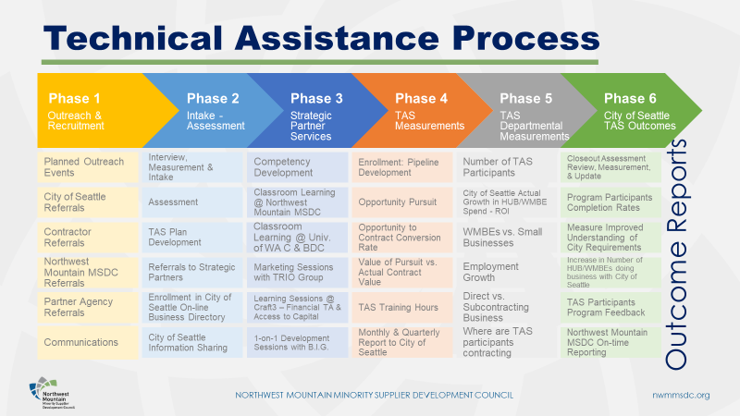
Attachment #2: TAS Workshop Description
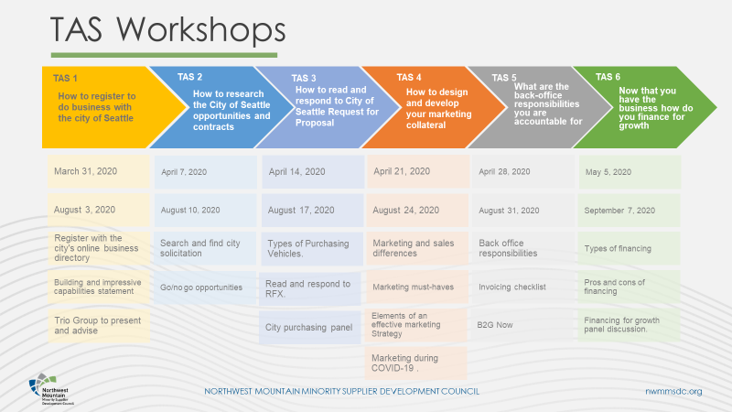

Attachment #3: General, Enrollment, and Exit Survey Charts
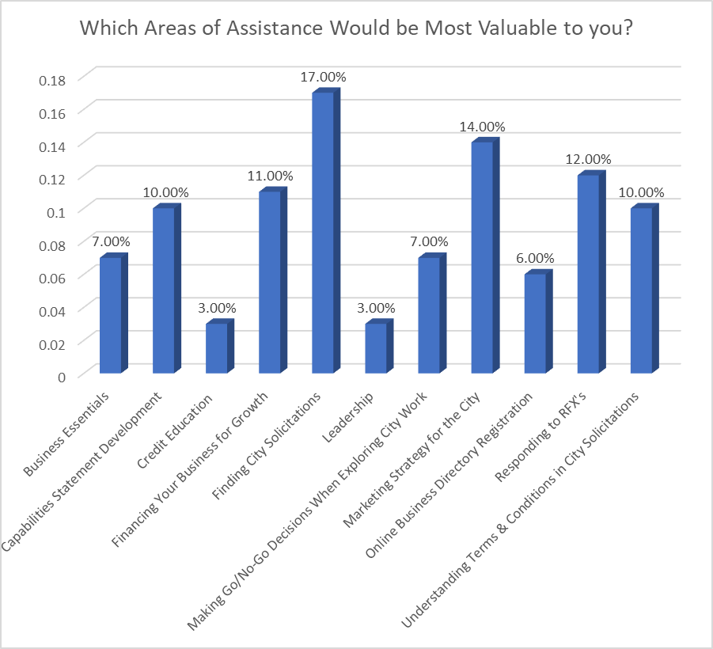
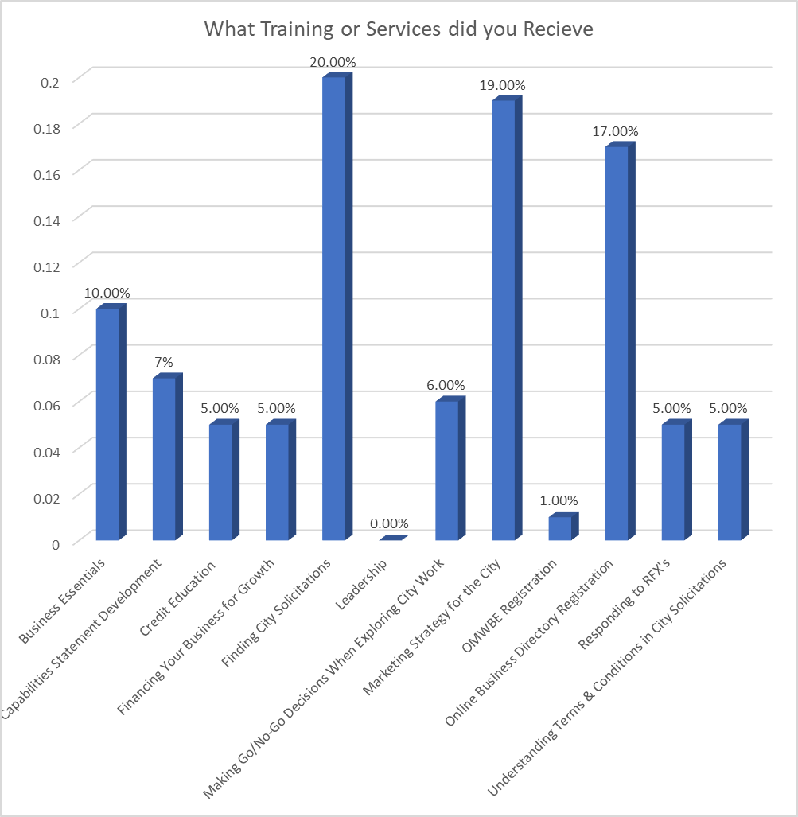

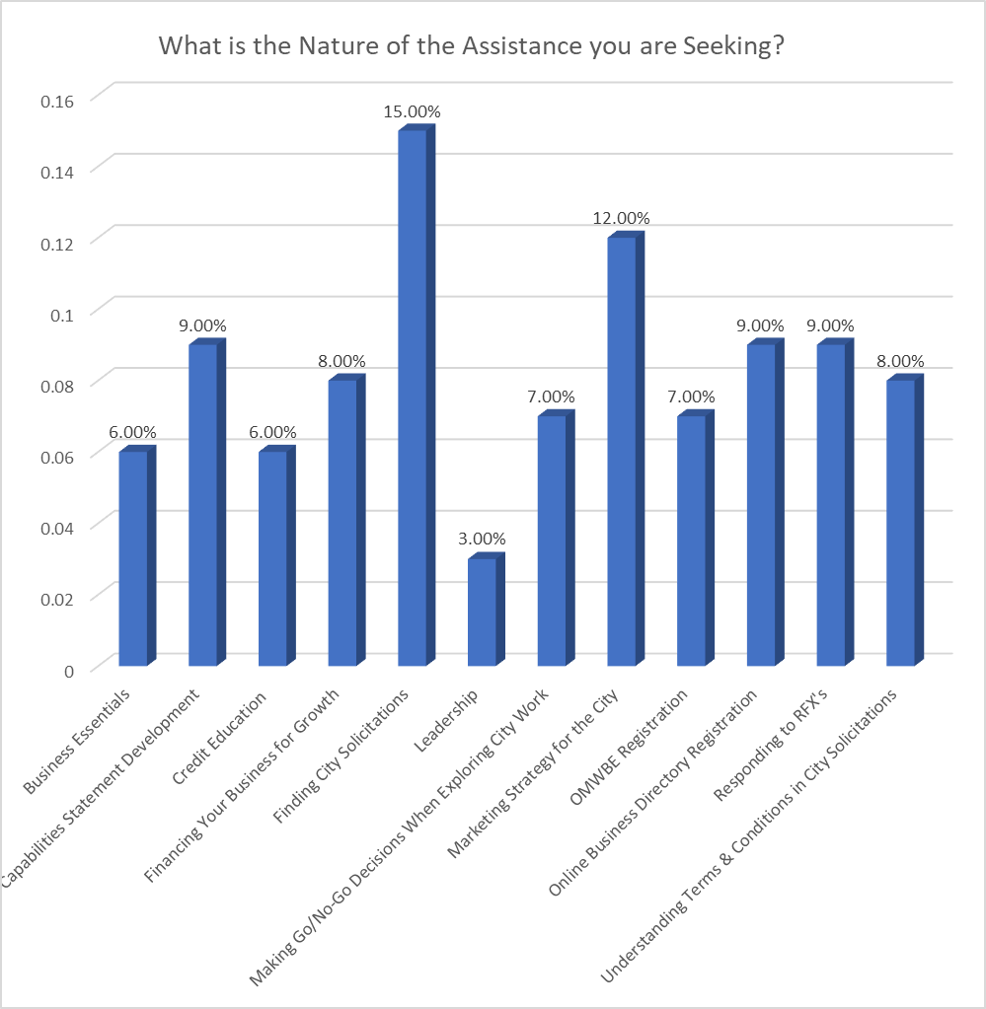
Attachment #4: Service Delivery Survey
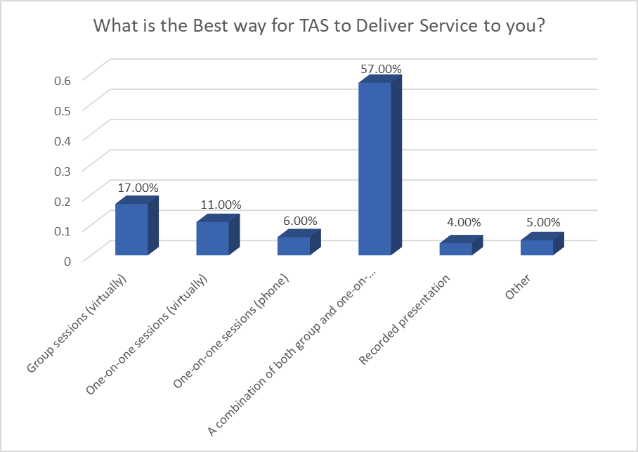
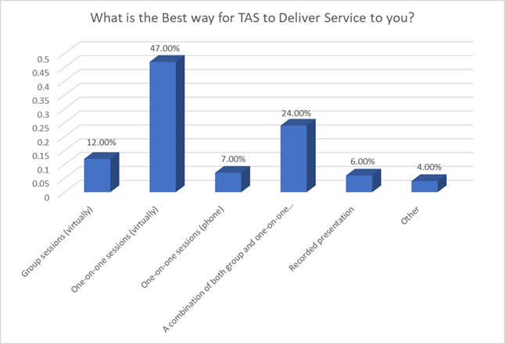
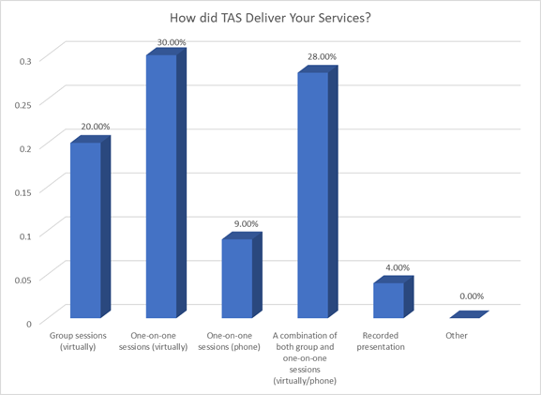

Surveys:

