Families, Education, Preschool and Promise Levy
Culturally Specific and Responsive Programming
Kingmakers of Seattle Request for Investment (RFI) Application

INTRODUCTION
The Department of Education and Early Learning (DEEL) is requesting applications from schools interested in providing culturally specific and responsive programming through the Kingmakers of Seattle (KoS) program. Funding for this investment opportunity is provided by the City of Seattle’s Families, Education, Preschool and Promise (FEPP) Levy approved by voters in November 2018. Culturally Specific and Responsive (CSR) investments through the FEPP Levy Expand access to high quality service and supports that increase positive identity development, academic knowledge, and social emotional learning for Black/African American males and other historically underserved students.

This RFI is an opportunity to expand DEEL’s investment in culturally responsive programming provided through Kingmakers of Seattle to two (2) additional high schools beginning in school year 2021-22. Funding will be awarded through a competitive request for investment (RFI) process managed by the City of Seattle Department of Education and Early Learning (DEEL) and in partnership with Seattle Public Schools’ Office of African-American Male Achievement (AAMA). Full program implementation is contingent upon financial contributions from Seattle Public Schools (SPS) in addition to DEEL funding. Successful applicants may receive up to five years of financial support (through SY 2025-26) from DEEL and SPS conditional upon annual performance. Annual funding allocations will be contingent upon services provided and students served.
To be considered for funding, eligible applicants are invited to submit a RFI application by 3:00pm Monday, May 3, 2021. DEEL will notify successful applicants by Friday, June 18, 2021 . RFI materials and updates are available on DEEL’s Funding Opportunities webpage. DEEL will not provide individual notice of changes, and applicants are responsible for regularly checking the webpage for technical assistance information as well as any updates, clarifications, or amendments.

Eligible Applicants:
- Chief Sealth International High School
- Cleveland STEM High School
- Franklin High School
- Garfield High School
- Rainier Beach High School

Selected applicants will receive:
- Financial support from SPS’s Office of AAMA and DEEL to provide Kingmakers of Seattle programming beginning in SY2021-22
- 1.0 FTE AAMA Student Family Advocate/Kingmakers Facilitator
- Performance earnings for outcome achievement
- Technical assistance and professional development
- Mentorship program support

APPLICATION TIMELINE

Event | Date/Time*
RFI Application Issued | Wednesday, April 7, 2021
Information Session (pre-recorded presentation) | Friday, April 9, 2021
Technical Assistance Session | Wednesday, April 21, 2021
Technical Assistance Office Hours | Friday, April 23, 2021, 9-10am  Tuesday, April 27, 2021, 12-1pm  Thursday, April 29, 2021, 4-5pm
RFI Application Due Date | 3:00pm Monday, May 3, 2021
Applications Reviewed and Rated | Friday, May 7, 2021 – Friday, May 21, 2021
Presentation / Interview / Review Panel Deliberations | Monday, May 24, 2021 –  Wednesday, May 26, 2021
Notification Issued to All Applicants | Friday, June 18, 2021
*Dates and times are subject to change

INVESTMENT GOALS

The City of Seattle is committed to ensuring all Seattle students and families are afforded the opportunity to live and thrive in Seattle by investing in education. The goal of the City of Seattle Families, Education, Preschool and Promise (FEPP) Levy is to partner with families and communities to advance educational equity, close opportunity gaps, and build a better economic future for Seattle students.

K-12 & Community – Culturally Specific and Responsive (CSR) Investments within the FEPP Levy support these goals by providing high-quality service and supports that increase positive identity development, academic knowledge, and social emotional learning for Black/African-American males and other historically underserved students.

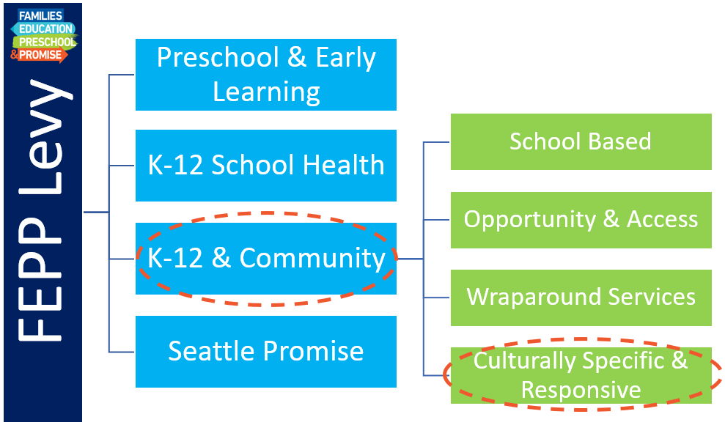
DEEL is seeking applications from eligible Seattle Public Schools high schools committed to improving results for students furthest away from educational justice and opportunity. Applicants will submit proposals to improve student performance on defined outcomes and increase the number of students graduating from high school prepared for college or career. Proposals will be guided by an outcomes-based approach and programming framework designed to improve results for Seattle students and families. All Levy proceeds are supplemental and complementary to existing public funding and may not be used to supplant state-mandated services.

The Kingmakers of Seattle program got its start as part of the City’s Our Best initiative. Our Best was an explicit, ambitious, and bold demonstration project rooted by the City of Seattle’s commitment to racial equity through targeted universalism. The principles of the initiative live on in DEEL’s work broadly and through the 2018 FEPP Levy’s Culturally Specific and Responsive investment strategy specifically. This includes:
- Asset-based Approaches: Investment strategies are guided by the belief that young Black males and other historically underserved youth do not need fixing—systems and structures do. DEEL supports policy, program, and leadership approaches that are rooted in asset-based methods and foster the strengths, vitality, and expertise of young Black, Indigenous, and persons of color.
- Focusing on what works: Investments are informed by research and recognize that a young person’s success requires investments in their education, economic mobility, safety, health, and positive connections to a caring adult in their community.
- Commitment to the success of all young people: Strategies are aligned with the City’s overarching commitment to ensure that every young person achieves success on their journey to adulthood.
- Targeted strategies to achieve universal goals: FEPP Levy CSR investments are rooted in targeted universalism. Challenges faced by young Black men and boys reflect the failures of key institutions that shape their development and life prospects. Ensuring that all Seattle residents have access to opportunity requires focused approaches to dismantle barriers and transform systems that have hurt our most marginalized communities.
- Challenges faced by young Black men and boys are generational and structural: Investment strategies must be accompanied by change-oriented actions at the systems level that are long-term in scope and considerate of the complexities of a multi-issue challenge.

PROGRAMMING, ELILGIBILTY, AND EXPECTED OUTCOMES
Kingmakers of Seattle is an elective program for Black male middle school and high school students, referred to as Kings, taught by Black male facilitators. Seattle Public Schools and the City of Seattle’s Department of Education and Early Learning (DEEL) launched Kingmakers in 2017 to engage, empower, and encourage young Kings in a brotherhood-centered program. Programming supports the cultural, historical, social, and emotional needs of young Black boys and teens as it relates to their identity.

Kingmakers is structured around Khepera, an African-centered curriculum that emphasizes studying Black history, increasing literacy, building self-esteem, and offering academic mentoring. Facilitators participate in professional development throughout the year to better teach and reach Black males and provide care coordination support. Additionally, schools selected for Kingmakers programming are awarded funds to provide evidence-based mentoring services and healing-centered approaches that promote positive identity development and college and career readiness across their campus.

Eligibility
Program expansion for school year 2021-22 is focused on creating connected pathways from middle to high school for students engaged with Kingmakers. Investment will be directed toward Seattle Public Schools high schools with historically high concentrations of African American/Black males and other students of color and those within the matriculation pathways of current Kingmakers middle schools. To be eligible, schools must:
- Serve high school age youth matriculating from Aki Kurose, Denny, or Mercer middle school
- Be in Seattle Public School districts 5, 6, or 7
- Have a three-year enrollment trend of 10% or more African-American male students

High schools eligible for this investment based on the above criteria are as follows:
    - Chief Sealth International High School
    - Cleveland STEM High School
    - Franklin High School
    - Garfield High School
    - Rainier Beach High School

Program Components
Kingmakers will be implemented by trained facilitators operating at selected Seattle Public Schools middle and high schools. Facilitators are selected and placed through the collaborative efforts of school leaders and SPS’s Office of African-American Male Achievement.

Programming components include:
- Elective classes utilizing curriculum that is engaging, academically rigorous, and culturally responsive and informed by a partnership with Kingmakers of Oakland (KoO)
- Care coordination services
- Mentoring services
- Student leadership development
- Professional development and technical assistance

Expected Outcomes
Schools selected for funding will be required to collect data, monitor student progress, and achieve program outcomes connected to:
- Program participation
- School attendance
- Students passing core courses with grades of C or better
- On time promotion and graduation
- Reductions in disciplinary incidents
- Student relationships with trusted adults
- Sustained mentor-mentee matches
- Student participation in mentoring and enrichment activities that provide exposure to college and career interests
- Student self-efficacy and cultural identity
- School climate and culture

PROCESS AND CRITERIAL FOR EVALUATION
Kingmakers of Seattle RFI applications will be evaluated according to the following process:
- Part I: Technical Compliance Review - Applications will be reviewed for technical compliance to verify that the application was submitted complete and on-time and that DEEL’s expectations for labor harmony are met. DEEL reserves the right to reject any application that is late or incomplete as well as exclude any pages that exceed the stated page limits.
- Part II: Scoring Criteria - A review panel will evaluate applications using the RFI Scoring Criteria. Application scores and review panel discussions will inform review panel recommendations for funding awards.
- Part III: Evaluation Process and Contract Negotiations - DEEL will consider review panel recommendations, FEPP Levy investment alignment, and other priorities named below. Final funding decisions will be made by the DEEL Director based on scoring and other relevant factors. DEEL will notify each applicant of the decision and will authorize award of agreements.
Part I: Technical Compliance Review
To be considered technically compliant, submitted applications must contain the items below. The application may be deemed not technically compliant nor evaluated further if the checklist items are absent or incomplete.
DEEL reserves the right to waive immaterial defects or irregularities and may conduct follow-up interviews to obtain additional information from completed applications. DEEL reserves the right to screen applicants without further discussion of the application submitted.
Compliant | Technical Compliance Checklist
Yes No | Submitted on time (deadline is 3:00 PM Monday, May 3, 2021) either electronically or in paper copy.  - Submitted electronic copy to DEELFunding@seattle.gov.  - Submitted paper copy to DEEL (see “Instructions to Applicants”)
Yes No | Submitted a complete application inclusive of all required sections by deadline.
Yes No | Submitted electronic or paper copy of RFI Application in PDF or Word correctly  - Sections 1-2: Response is typed, single- or double-spaced, size 11 font, page-numbered, single- or double-sided, and all submitted together as one document  - COVID-19 Addendum: Response is typed, single- or double-spaced, size 11 font, page numbered, single- or double-sided, and maximum of 500 words
Yes No | Confirmed use of standard practices and policies for labor harmony (Section 3) that uphold city principle of ensuring agencies work to prevent labor disputes, which may lead to work stoppages or adversely impact the ability of FEPP Levy-funded programs to achieve intended outcomes.

Part II: Scoring Criteria (detailed in Appendix A)
Section | Score
School Narrative | 40
Principal and Staff Commitment | 10
Labor Harmony | Not scored, part of technical compliance review
COVID-19 Addendum | Not scored, part of technical compliance review
Interview | 50
Total Points | 100

Part III: Evaluation Process and Contract Negotiations
The review panel will rank applications from highest to lowest and make initial funding recommendations. Allocation decisions may be based on service to focus students and priority populations, geographic considerations, and the scope of services to be provided.

If an applicant is selected for funding, the applying organization should be prepared to collaborate with DEEL to finalize a workplan based on their RFI proposal that will be incorporated into a contract. Awarded applicants should be prepared to discuss and negotiate aspects of their RFI proposal prior to completing the contract. These aspects may include, but are not limited to, the amount of funding, proposed programming and/or services, focus student participation, and performance measures.

DEEL reserves all rights not expressly stated in the RFI, including awarding partial funding and negotiating with any applicant regarding the amount of funding and other terms of any contract resulting from this RFI. If DEEL and any applicant selected under this RFI are unable to come to agreement on a final contract, DEEL may, in its discretion, choose not to provide funding.

ADDITIONAL REQUIREMENTS

Successful applicants will enter into a contract for services with the City of Seattle and will need to adhere to the following additional contractual conditions. Conditions may be amended, or additional requirements may be included during the contract negotiation process.

TERM
- Contracts will begin September 1, 2021 and extend through August 31, 2022. Annual contract reauthorization is possible through the 2025-26 school year and conditioned upon achievement of contract outcomes.

CONTINUOUS QUALITY IMPROVEMENT (CQI)
To ensure quality implementation and achieve desired results, DEEL commits to:
- conducting regular site visits to observe programs, discuss implementation, and provide feedback,
- ensuring the existence and/or development of systems to collect, monitor, and analyze data, supporting the use of quality assessment tools, and
- providing access to learning opportunities that emphasize high-quality program implementation.

DATA COLLECTION AND REPORTING
- Schools will designate a data point of contact who will be responsible for exchanging data through secure means. DEEL will provide training and reference materials to staff on the proper steps and protections to take when exchanging sensitive data.

PAYMENT, RECORDS, AND AUDIT
- The City shall pay the Agency up to the stated Contract Price. The total Contract Price will include two types of compensation: Base Pay and Performance Pay. As used in this Agreement, “Base Pay” means reimbursement for the Agency’s actual and approved costs identified in the project budget. “Performance Pay” means payment that is earned only upon Agency’s demonstration that the Work timely achieves the outcome and indicator targets negotiated after RFI awards have been determined and defined in the contract agreement.

- The Agency shall timely furnish such other reports and information as may be requested by DEEL related to this Agreement or the Work, including statements and data specifying services provided, and data demonstrating achievement of the minimum outcome and indicator targets. The City shall have the right to withhold payment to the extent that missing or inadequate documentation does not demonstrate entitlement to payment.

APPEALS PROCESS
The Seattle Department of Education and Early Learning (DEEL) will notify applicants in writing of the outcome of the submission. Written notification will be sent via email to the email address submitted on the Cover Sheet.

Any applicant wishing to appeal the decision must do so in writing within four (4) business days of the email notification of DEEL’s decision. An appeal must clearly state a rationale based on one (or more) of the following criteria only:
- Violation of policies or guidelines established in the RFI process
- Failure to adhere to published criteria and/or procedures in carrying out the RFI process
Note: Disagreeing with the outcome is not a valid reason to appeal the decision and will not be considered.

Appeals must be sent by mail or by email to the following:

By Mail:
Dwane Chappelle, Director
Seattle Department of Education and Early Learning
Kingmakers of Seattle RFI Appeal
P.O. Box 94665
Seattle, WA 98124-6965

By Email:
DEELFunding@seattle.gov
Subject line: Kingmakers of Seattle RFI Appeal

The DEEL Director (or designee) will review the written appeal and may request additional information from the applicant. A written decision from the DEEL Director (or designee) will be sent within five (5) business days of the receipt of the appeal. This decision is final.

INSTRUCTIONS TO APPLICANTS
Submission:
Applications may be submitted electronically or in paper form. All attachments must be received on or before 3:00 PM Monday, May 3, 2021.

The following sections, unless noted otherwise, must be submitted to constitute a complete RFI application submission:
- Cover Sheet
- Section 1: School Narrative
- Section 2: Principal & Staff Commitment
- Section 3: Labor Harmony
- COVID-19 Addendum

Responses to each of the sections must follow the page limits identified in the instructions for each section.

Electronic submission
Deliver to: DEELFunding@seattle.gov
Please use the following naming convention in the subject line of your email and for the electronic files attached:
[Organization Name] – Kingmakers of Seattle RFI

Paper submissions
If submitting paper response, all sections must utilize the submission templates provided, be on 8½” X 11” paper, typed or word-processed, size 11 font, single- or double-spaced, page-numbered, single- or double-sided, and stapled together.

Deliver to:
By Mail:  Seattle Department of Education and Early Learning  Kingmakers of Seattle RFI  PO Box 94665  Seattle, WA 98124-6965 | By Hand:  Seattle Department of Education and Early Learning  Kingmakers of Seattle RFI  Seattle Municipal Tower  700 5th Ave, Suite 1700  Seattle, WA 98104

Questions:
Please direct submission process questions via email to DEELFunding@seattle.gov and include “Kingmakers of Seattle RFI” in the subject line.

COVER SHEET
FEPP Levy Kingmakers of Seattle Request for Investment Application

SCHOOL INFORMATION:
School Name
School Principal
Mailing Address
Email Address
Contact Phone

APPLICANT CONTACT INFORMATION:
Name
Title/Role
Phone
Email
Name
Title/Role
Phone
Email
Primary contact person for questions about this RFI: Secondary contact person:

SUMMARY OF PROPOSAL:
Anticipated number of focus students to be served annually
Number of sections in school’s master schedule:
Grade level(s) to be served: | 9th grade 11th grade  10th grade 12th grade
Implementation Rollout  (if applicable) | Year 1: |  | Year 2:
 | # of sections: |  | # of sections:
 | Grade level(s): |  | Grade level(s):

AUTHORIZED SIGNATURE OF LEAD ORGANIZATION APPLICANT:

To the best of my knowledge and belief, all information in this application is true and correct. The document has been duly authorized by the governing body of the applicant who will comply with all contractual obligations if the applicant is awarded funding.

Name and Title of Authorized Representative:
Signature of Authorized Representative |  | Date
SECTION 1: School Narrative
Responses to Section 1 are to be no more than 5 pages (8½” x 11”), typed or word-processed, size 11 font, single- or double-spaced, page-numbered, and submitted with all other sections. Applicants are strongly encouraged to use the submission template provided. Any content that exceeds the page limits provided will be redacted and not considered as part of application review.

Responses should be prepared simply and economically, providing a straightforward, concise, and complete description of the school, needs of the focus population, and implementation plans for the programming components and expected outcomes detailed on page 4 of this document. In your narrative, please address the following.

- Provide an overview of your school including relevant history, mission or theory of change, types of culturally specific programming offered, and any other high-level information that provides a general understanding of your school and how it operates.

- Describe your school’s prior experience working with Black/African-American males and other students and communities of color. For example, your response may include:
- How your organization assesses the needs of the students and communities you serve
- How data is utilized to inform services and/or programming
- What strategies your organization has implemented and what results have been achieved with respect to serving Black/African-American males

- Explain why Kingmakers of Seattle is needed in your school community and your rationale for pursuing this strategy. Provide strong reasoning for how the Kingmakers of Seattle program will address the needs of Black/African-American students and families in your school community.

- Describe how you intend to integrate Kingmakers of Seattle into your school’s programming and culture. Provide evidence of your organizational capacity to take on this work, including students to be served, sections to be offered, as well as implications for all staff, school support structures, and family engagement.

- Describe the measurable impacts and improved student outcomes you intend to achieve by incorporating Kingmakers of Seattle into your school culture.

- Describe how you partner with young people, community members, and/or other organizations to support student learning and development. Please provide an example of how partnership(s) benefit the work you do and the students you serve.

SECTION 2: Principal and Staff Commitment
Please review the requirements below, discuss them with your school community, and indicate your commitment. By signing this document, the principal agrees to the terms for participating in the RFI process and to the conditions of operationalizing Kingmakers of Seattle (KoS) in the school community.

- Designated Contact Person(s) and Application Team
- The principal will manage or designate a key individual to participate in the RFI process.
- The principal or designee will convene members of an RFI team to work on the school’s application and monitor progress toward completion.
- Information Sessions, Technical Assistance, and Professional Development
- The principal/assistant principal and other key members of the application team will review the RFI pre-recorded informational presentation. It is recommended that one or more team members attend the technical assistance session on April 21. Technical assistance office hours will be available on April 23, 27, and 29 for schools that have additional questions/need after reviewing the pre-recorded presentation and attending the TA session.
- The principal commits to engaging with and learning from foundational KoS principals.
- School leaders commit to supporting participation in KoS planning activities and professional development.
- The principal will ensure the Kingmakers Facilitator on staff is supported on campus, provided with professional learning and development opportunities, and able to attend KoS required engagements with Kingmakers of Oakland, DEEL consultants, and SPS’s Office of AAMA.
- Collaborating with SPS’S Office of AAMA and Community Partners
- The principal will act as or identify a school contact person to collaborate with SPS’s Office of AAMA.
- The principal will identify a key staff contact person(s) who will collaborate with community partner(s) to deliver mentoring and other services needed for program implementation.
- Operational Capacity and Community Support
- The principal will engage school staff, students, and community partners to garner support in seeking KoS programming as well as support for the proposed plan to achieve Levy outcomes.
- The principal commits to a minimum annual financial contribution of $1,500 from school budget for KoS activities.
- The principal will ensure a dedicated classroom is made available for KoS in SY21-22.
- The principal commits to including a minimum of two (2) KoS sections in the SY21-22 master schedule and three (3) or more KoS sections in all future years of KoS implementation.

Principal Name |  | Director of Schools Name
Principal Signature |  | Director of Schools Signature
Date |  | Date

SECTION 3: Labor Harmony
Responses to Section 3: Labor Harmony are to be completed using the template provided and submitted with all other sections. Attachments do not count towards the page limit and are to be submitted as a separate file.
The City values agencies that work to prevent labor disputes, which may lead to work stoppages or adversely impact the ability of FEPP Levy-funded programs to achieve intended outcomes.

In your response, please indicate if your agency is committed to avoiding labor disputes that disrupt services by checking the appropriate box.

☐ Yes ☐ No

If your organization has standard practices and policies that uphold this principle, such as a labor harmony agreement or a collective barging agreement, please provide website link or attach with your submission as a separate file (Word or PDF). This attachment will not count towards the page limit.

COVID-19 Addendum
The extent and duration of COVID-19 outbreak remains unknown and the impacts on our communities and our economy are still in flux. DEEL is interested in proactively addressing impacts to the extent possible and asks applicants to anticipate potential implications for service proposal. Please respond to the following questions to the best of your ability. Responses will not be scored as a part of your application’s evaluation.
In the event public health guidelines place limits on social interactions and/or gathering places like schools and community spaces during the 2021-22 school year, what aspects of your program/service delivery do you anticipate may be impacted?
Please check all that may apply.
☐ Programming site/facility
☐ Schedule (e.g. start/end dates, frequency)
☐ Delivery of services/programming activities
☐ Students served
☐ Staffing
☐ Partnerships
☐ Transportation
☐ Meals/Snacks
Please provide a brief description (maximum 500 words) of how the impacted programming/services identified above may be sustained or if they would need to be suspended in the event of unforeseen school closures or the inability to provide direct, in-person services to identified focus students.

APPENDIX A: SCORING CRITERIA

Scoring Criteria | Score
School Narrative:  - Provides description of school, its history, mission or theory of change, and brief description of relevant programs, services, and outcomes  - Demonstrates track record of achieving positive academic and non-academic outcomes for Black/AA males  - Demonstrates commitment to targeted universalism and prioritizing support to Black/AA males  - Details capacity and level of experience collecting, managing, and analyzing data to inform service/program delivery  - Demonstrates school-wide commitment to culturally responsive practices, pedagogy, or exemplary curricula  - Demonstrates a strong approach to supporting and engaging students, families, and community that is responsive to cultural and linguistic needs  - Demonstrates commitment to improve student outcomes on defined measures  - Demonstrates ability to provide services through strategic community partnerships  - Demonstrates organizational plan and adequate staff to support implementation proposal  - Ability to leverage multiple funding sources to maximize impact | 40
Principal Commitment:  - Principal commits to engage with and learn from foundational KOS principals  - Principal commits to providing a minimum of two KoS sections in master schedule for SY2021-22 and to 3 or more KoS sections in master schedule in all future years of KoS implementation  - Principal commits to providing a dedicated KoS classroom for SY 2021-22  - Principal commits to minimum annual financial contribution from school budget for Kos  - Principal commits to support participation in planning/preparation activities  - Principal commits to participate in Kingmakers of Oakland (KoO) professional development and technical assistance  - Principal commits to fully support facilitator participation in SPS AAMA, DEEL, and KoO provided professional development and technical assistance activities | 10
Presentation / Interview:  - Demonstrates consistency with written proposal and offers clarity on application information  - Successfully addresses how the school will meet principal and staff commitments as stated in Section 2  - Offers evidence of adequate facilities, capacity, and management systems to support implementation and provide oversight of program budget, operations, and data analysis  - Provides evidence of staff or implementation team that reflects the priority student population  - Utilizes the local community as an extension of the classroom learning environment  - Incorporates culturally responsive professional learning in staff development plans  - Shows evidence of authentic student leadership and development in implementation plan | 50
Labor Harmony:  - Meets expectations for resolving labor disputes/disruptions in service delivery | Y/N
COVID-19 Addendum:  - Provides description of potential program impacts and whether they could be sustained or if they would need to be suspended in the event of unforeseen school closures or the inability to provide direct, in-person services | Y/N
TOTAL | 100

APPENDIX B: FEPP LEVY HEADLINE INDICATORS

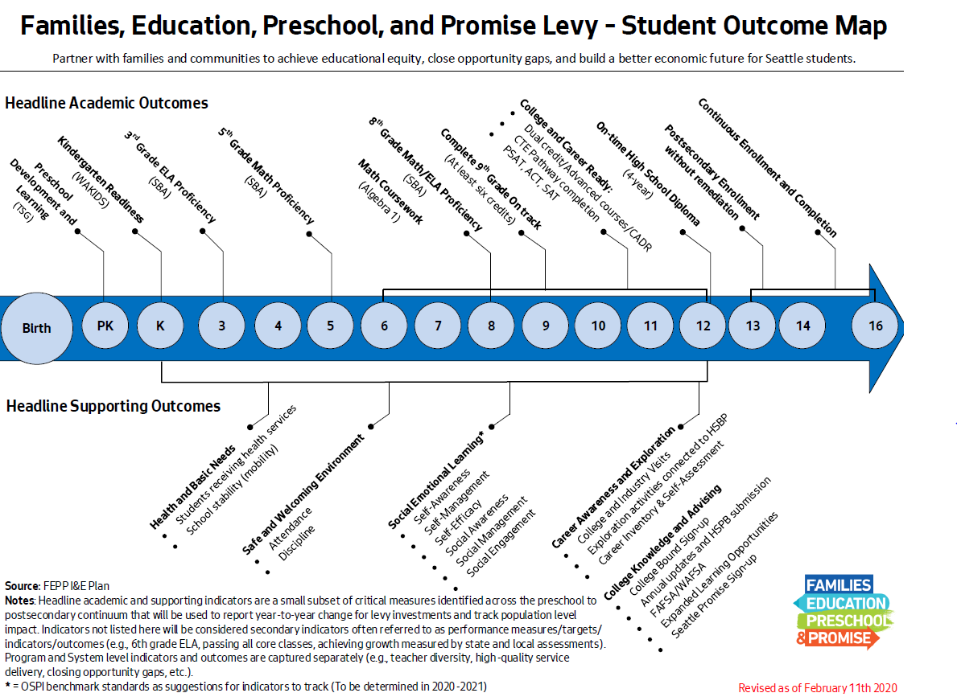

APPENDIX C: GLOSSARY

Term | Definition
College and Career Readiness | Being prepared and ready to qualify and succeed in entry-level, credit-bearing college courses leading to a post-secondary degree or certificate, or career pathway-oriented training program without the need for remedial coursework.
Community-based Organization (CBO) | A public or private organization of demonstrated effectiveness that is representative of a community or significant segments of a community and provides educational or related services to individuals in the community.
Continuous Improvement | Ongoing, real-time data monitoring and reporting of indicators and outcomes to understand fidelity of program implementation, progress towards intended results, and program effectiveness
Culturally Responsive | The ability to learn from and relate respectfully with people of one’s own culture as well as those form other cultures.
Educational Equity | Access to educational opportunities and academic achievement are not predicated on a person’s race.
Equity/Equitable | Just and fair inclusion into a society in which all can participate, prosper and reach their full potential.
Historically Underserved Students | Students who experience systemic inequities in educational achievement because of their race, ethnicity, socioeconomic status, refugee and immigrant status, English proficiency, special education needs, community wealth, familial situations, housing status, sexual orientation, or other factors. (See also: Students of Color)
Mentoring | Activities such as guiding, coaching, influencing and advising supports that typically occur intergenerationally (between youth and adults) but also intra-generationally (between peers), formally and informally, and in both one-on-one and group contexts.
Our Best | The City's first-ever initiative focusing specifically on improving life outcomes for young Black/African-American men and boys in education, safety, health, economic mobility, and positive connections to caring adults.
Outcome | The condition or status of children, youth, communities, or systems. Represents a specific result a program or strategy is intended to achieve. It can also refer to the specific objective of a specific program.
Race and Social Justice Initiative (RSJI) | The City of Seattle’s commitment to realize the vision of racial equity and citywide effort to end institutionalized racism and race-based disparities in City government. More found at www.seattle.gov/rsji.com.
Racial Equity | Racial equity is the condition that would be achieved if racial identity no longer predicted outcomes. Racial equity is one part of racial justice, and thus includes works to address root causes of inequities, not just their manifestation. This includes elimination of policies, practices, attitudes and cultural messages that reinforce differential outcomes by race or fail to eliminate them.
Request for Qualification | Assesses an agency’s qualifications to perform a scope of work.
Students of Color | Students from non-white racial or ethnic backgrounds.
Targeted Universalism | Pioneered by john a. powell, targeted universalism means setting universal goals that can be achieved through targeted approaches. Targeted universalism alters the usual approach of universal strategies (policies that make no distinctions among citizens' status, such as universal health care) to achieve universal goals (improved health), and instead suggests we use targeted strategies to reach universal goals.

