**SEATTLE ARTS COMMISSION**

Minutes

Monthly Meeting

Tuesday, June 10, 2025

Virtual Meeting

(Only Zoom due to tech issues in conference room)

**Commissioners present:** Kayla DeMonte, Holly Jacobson, Yoon Kang-O’Higgins, Avery Barnes, Ed King, Megan Kiskaddon, Kate Nagle-Caraluzzo, Jo Mikesell, Ricky Graboski, Yolanda Spencer, Linda Lowry, Leslie Anderson, Vanessa Villalobos

**Staff in attendance**: Allie Lee, Kelly Davidson, Ashraf Hasham, Jason Huff, Blake Haygood, Jeremy Beliveau, Otts Bolisay

**Guests:** Freddy Monares (KNKX)

**Call to Order, Introduction, Land Acknowledgement (4:07)**

* Holly called the meeting at 4:04pm
* Spotlight on local Indigenous artists (Yolanda)
  + [United Indians canoe carving](https://www.king5.com/article/news/local/seattle/south-lake-union-canoe-native-american-development/281-6380ae87-45d5-4a8c-a198-283c5a7d14a3?fbclid=IwY2xjawK1mDVleHRuA2FlbQIxMQBicmlkETFHbjZaR3ZUekdLYTlyeUZ1AR7w5gLvuJanYs68TNKAOEA8uOdWZOdwCE5ts4tac_ENDjrhn7TRtc2njEhmRg_aem_FrDXtTByUAWSEHggzEQ9Rw)

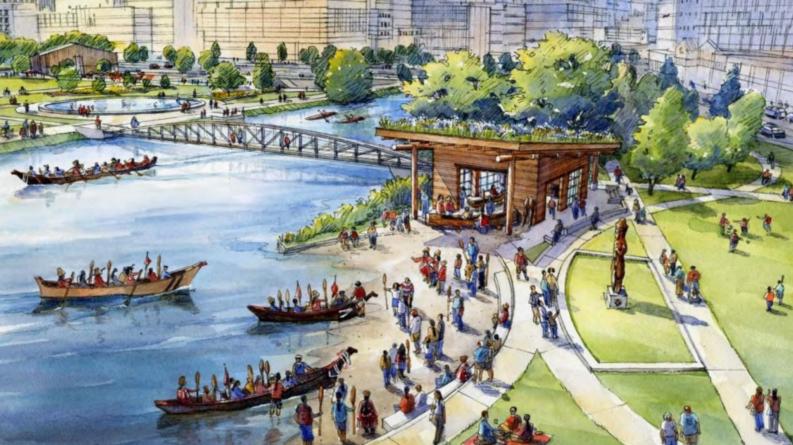

* Approval of minutes
  + Avery moved to approve the May minutes. Yoon seconded the motion. Approved.
* Public Comment:
  + No public comment.

**Directors Report  
Briefing: Kelly Davidson**

* Recap of 6/9 Creative Advantage celebration at ARTS at King Street Station
* FEPP Levy advocacy; final vote is 6/12
* ARTS Budget – City depts submitted budget memos to City Budget Office
  + ARTS fortunate not to make reductions at this time
  + Admissions tax had reduction; we operate on same year budget, and looking to active summer for revenue boost
  + Putting in ask for Hope Corps to be permanent; additional funding for Creative Advantage; requesting for Cultural Planning funding – how are we engaging with community and what does Seattle arts community need from us
    - Trying to keep it as succinct and as prioritized as possible
  + [budget process diagram](https://www.seattle.gov/documents/Departments/FinanceDepartment/2526proposedbudget/BudgetProcessDiagram.pdf)
* WA Funders Cultural Collaborative / NEA grants – WA Funders Cultural Collaborative convenes monthly, which includes a variety of government and non-government groups – NEA is top of mind for all. Manny from Inspire WA also attends. If you have questions to bring to that space, let us know. We get updates on what’s happening, and are planning for collective messaging
  + Kelly/Allie can send more info on what’s discussed at the WA funders space and how to connect
  + Group is also talking about how to get involved with social prescribing/art pharmacy for our community. T
    - SAC expressed interested in this; this creates a positive narrative around arts, data is there as a need, and it’s not something just nice to have
    - Holly/Path with Art is closely involved in this work.
* Longest Day event on 6/21 (Sat) at King Street Station Plaza: [LONGEST DAY: Solstice Revelry, Saturday, June 21, 2025, 2:30 - 9:30 p.m. - ARTS Events - Arts | seattle.gov](https://www.seattle.gov/arts/experience/arts-events?trumbaEmbed=view%3Devent%26eventid%3D182990688)

**SAC Questions & Comments**

* Megan – Does SAC letter go in with the budget memo?
  + Kelly - No, the memo information is factual; however SAC’s budget letter timing is great because it primes the electeds
  + Budget process review/approval order: CBO 🡪 Mayor 🡪 Council

**Co-Chairs Report  
Briefing: Kayla DeMonte**

* Round robin introductions for our new commissioners
* New commissioners introduction
  + Ed King (Pottery Northwest)
  + Kate Nagle-Caraluzzo (Town Hall Seattle)
  + Jo Mikesell (Shunpike)
* Ed and Kate have been confirmed at City Council Committee. Jo will be confirmed in July.
* SAC/SMC Arts Education FEPP Levy letter - <https://artbeat.seattle.gov/2025/05/29/seattle-arts-commission-2025-levy-letter/>
* Budget Priorities letter to Mayor will be sent out tomorrow; commissioners comments will all be reflected
* July meeting – will do reintroduction of committees; FED is doing some restructuring to align with ARTS’s Creative Placemaking division. Will help as we head into August retreat, and thinking about new committee leadership, we will levelset and move into second half of year.
* August – annual retreat, same date as normal meeting, extended time 12-5pm
  + Location TBD; townhall could be option
* Holly - Thank you Kayla for all the heavy lifting while Holly was out for a month.
* Leadership training for the next half of year since Kayla and Holly will be terming out at end of year

**Committee Deep Dive – Cultural Investments Committee (CIC)  
Briefing: Avery Barnes**

* Overview of CIC’s purpose statement

*The Cultural Investments Committee—comprised of Arts Commissioners, ARTS staff, and community members—supports Seattle’s arts sector by:*

* + *Providing guidance and feedback on ARTS’ racially equitable grant processes & investment strategies*
  + *Advocating for equitable, accessible, and inclusive cultural investments in support of the Seattle ARTS Office and the arts sector in our city and region*
* Introduction of [grant programs](https://www.seattle.gov/arts/programs/grants) that CIC reviews - Arts in Parks, Youth Arts, Artists at Center, Centering Art & Racial Equity, CityArtist, Civic Poet, smART Ventures, The Creative Advantage Community Arts Partner Roster, Langston Hughes Performing Arts Institute Facilities Grant, Cultural Facilities Fund, Hope Corps/Downtown Activation Plan
  + More info here on what ARTS has open this year, and when: <https://artbeat.seattle.gov/2025/02/04/2025-grants-and-funding-opportunities/>
* Encourages new commissioners to consider joining CIC

**Announcements  
Briefing: All**

* Megan - Northwest New Works fest this week/end at OtB: <https://ontheboards.org/events/24-25/nwnw>  (industry comp code: friendzone)
* Ed – Joyful Resistance at Town Hall Seattle - <https://townhallseattle.org/event/joyful-resistance/>
* Seattle Art Fair coming up soon – Avery, Ed, Jo will be participating/will have a booth
* Avery – TASWIRA is also hosting a 6-day multi-media Film Festival. Learn More: <https://www.arrivedcollective.co/at-the-garden>
* Yoon - June 27 at Pier 62 Indigiqueer Festival <https://waterfrontparkseattle.org/blog/event/indigiqueer-festival/>
* Jo - <https://www.eventbrite.com/e/scenius-social-tickets-1357090266519?aff=oddtdtcreator>
* Holly - Path with Art Queer Visions @ A/NT gallery <https://www.pathwithart.org/eventscalender/2025/6/4/pwa-x-ant-queer-visions>
* Holly – Path with Art [Art After Hours: June Gathering](https://www.pathwithart.org/eventscalender/2025/art-after-hours-june)
* Vanessa - [La Sala](https://www.lasalanw.org/) – please support the mission, come out to West Seattle; check out [Balorico Dance](https://www.balorico.dance/)
* Vanessa - Support separated families without resources; as we talk about the arts let’s also talk about parallel realities happening <https://waisn.org/public-resources/>

Meeting adjourned at 5:24pm.