Cultural Facilities Fund 2025 Application Preview

# INTRODUCTION

Use this document as a helpful worksheet to gather your responses before you copy and paste them into the online application. **It may not be used in place of the online application.** If you don’t have computer or internet access, contact the Cultural Facilities Fund Project Manager, as soon as possible: [culturalfacilitiesfund@seattle.gov](mailto:culturalfacilitiesfund@seattle.gov) or call Ashraf Hasham, Partnerships, Education, and Grants Manager at 206-514-1057.

We have interpreters who can speak to you in your language, including American Sign Language (via video). Call us and tell us what language you speak. Expect a short pause while we find an interpreter to join the call.

**Applications must be submitted by Tuesday, Aug. 5, 2025, 5:00 p.m. Pacific.**

## **GENERAL INFORMATION**

To streamline the application for organizations interested in applying to both the Cultural Facilities Fund and the [Centering Art & Racial Equity program](https://www.seattle.gov/arts/programs/grants/centering-art-and-racial-equity-grant), the two grants share the same online application. **The application for both is available through the City of Seattle’s grant portal at** [**https://seattle.fluxx.io/**](https://seattle.fluxx.io/).

The application contains a mix of multiple-choice and open-ended questions, as well as requests for file uploads. We estimate this application will take approximately XX hours to complete. If you are also applying to the Centering Art & Racial Equity program, you will need to plan for additional time to apply.

The application **deadline is** **5 p.m. Pacific,** **Tuesday, Aug. 5, 2025.**Please allow plenty of time to complete your application in advance of this deadline. Applications will not be accepted after the deadline.

# STEPS TO APPLY

1. **Read the guidelines,** which can be found on the [Cultural Facilities Fund webpage](https://seattle.gov/arts/programs/grants/cultural-facilities-fund) or linked in the application on Fluxx, to confirm eligibility and appropriate project scope.
2. **Go through this Application Preview document** to note what you will need to follow-up on: Project Budget Form, Facilities project narrative questions, demographic information, etc.
3. If you decide to apply, you should reach out in advance to others in your organization that you’ll need support from and **schedule time to gather the information you’ll need**.
4. **Make sure you have an account** in the City of Seattle’s online grant portal at: [**https://seattle.fluxx.io/**](https://seattle.fluxx.io/)
   * If you have received a grant award from the Seattle Office of Arts & Culture in the past few years, then you probably have an account.
   * If you haven’t received a grant award since before 2022, or you’re not sure if you have an account, please feel free to contact [culturalfacilitiesfund@seattle.gov](mailto:culturalfacilitiesfund@seattle.gov) to look that up for you ***before*** you start an application.
   * If you’re sure you have an account but can’t remember how to login – *your username is the email address you registered with.* If you’ve forgotten your password, use the password reset option to update your password. Note that the system will block you from access if you enter the wrong password too many times. You’ll need to wait 24-hours before you can try again.
5. **Start an application.** Do this at least a month in advance of the deadline so that there’s time to seek support if you need it.
   * After logging in, go to the vertical gray menu bar on the left-side of the page.
   * Under the [INFORMATION] section, click on [Office of Arts & Culture]

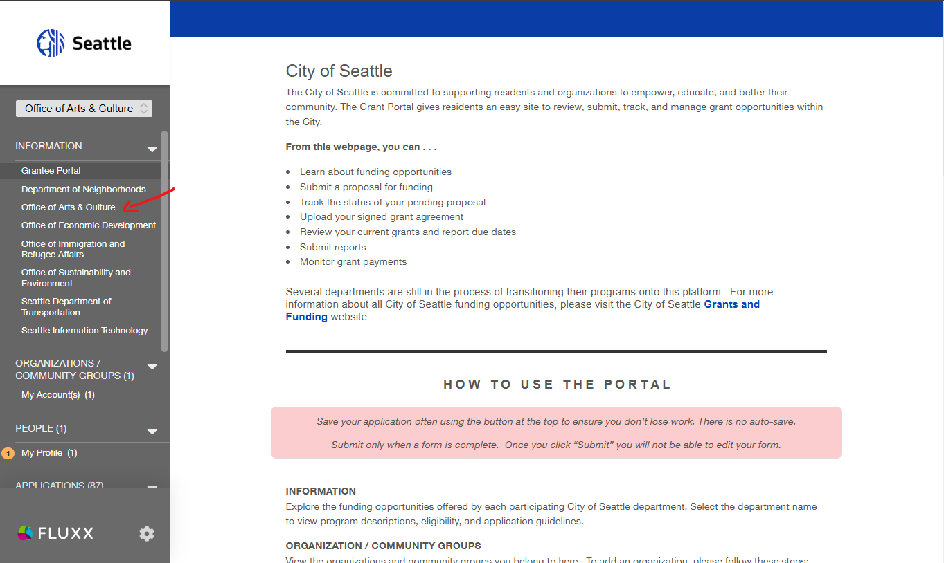

* + Our grants page will open up on the right. Scroll down until you find the [Cultural Facilities Fund] listing.
  + Click on the [Start NEW Centering Art & Racial Equity and Cultural Facilities Fund combined application].
  + A blank application will open up.
  + Click on the [Edit] button in the top right corner of the application.
  + You will need to fill in the “Organization Name” field to save the application. Please be sure to fill in *at least* this field and then click [Save] or [Save and Close] before logging off or shutting down. **If no “Organization Name” is selected, you will not be able to find the application again.**

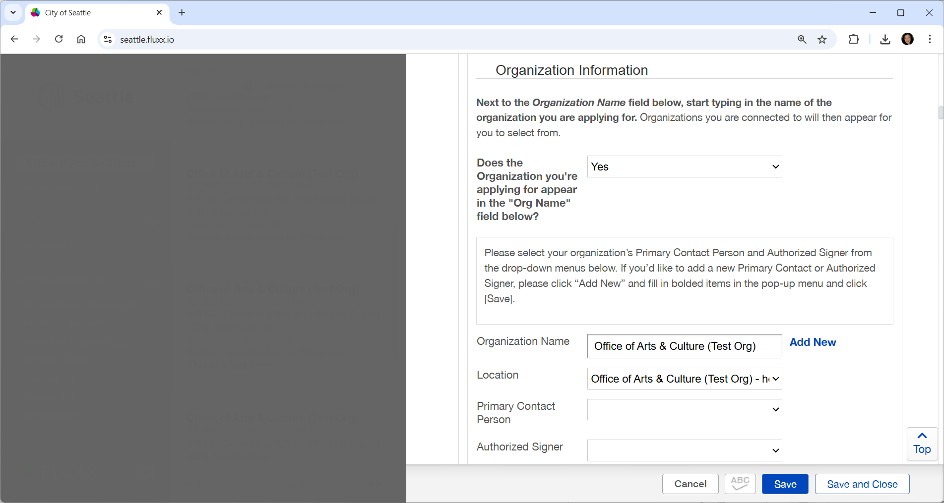



1. You may **return to the application at any time** by logging in and scrolling down the gray vertical menu bar on the left to the [APPLICATIONS] section and clicking on [Applications in Progress]. Your application summary box will open up on the right. Click on the summary box to open the application up to the right. *Your application may show up as “ARTS: Centering Art and Racial Equity (CR) Application” regardless of whether you are applying for that program, Cultural Facilities Fund, or both, since the two grants share the same base application.*

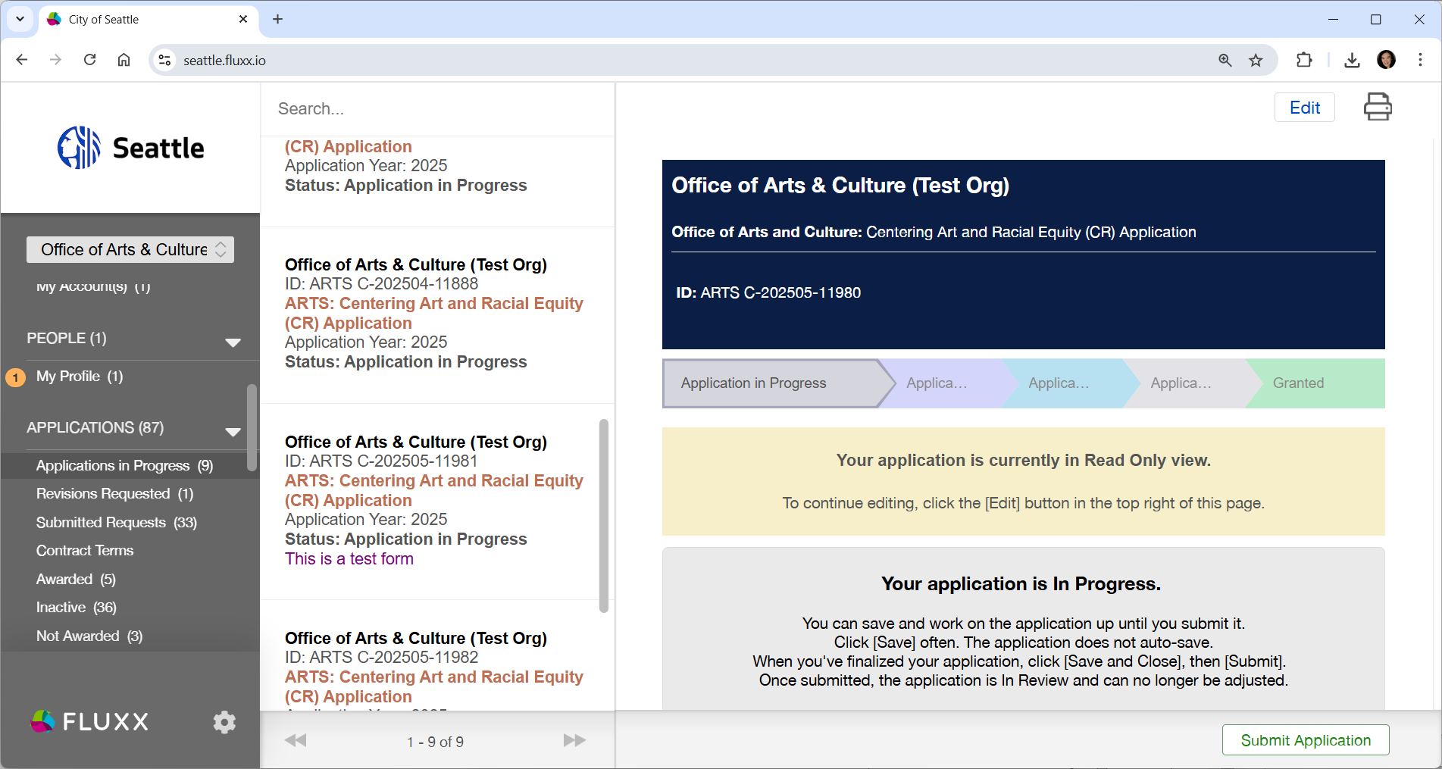



1. 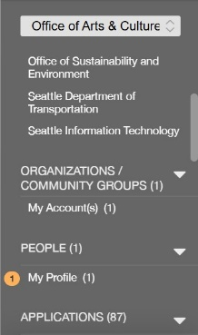When you have a chance, you should **double-check and update your Organization and Individual account profiles**.
   * On the gray vertical menu bar, scroll to [ORGANIZATIONS/COMMUNITY GROUPS] and click on [My Account(s)] to update your organization profile.
   * After that, scroll to [PEOPLE] and click on [My Profile] to update your personal profile.
   * The [Edit] key is on the top right corner of the page.
   * Click [Save and Close] when you are done.
2. **Attend a workshop**.

* Please see the schedule below (pages 10-11) or in the grant guidelines on the Cultural Facilities Fund webpage.
  + If you cannot attend a workshop, a pre-recorded workshop will be available online as soon as it is ready.

1. **Work on your application.**
   * Give yourself plenty of time.
   * Write your application as if you were telling a new friend about your facilities project. Don’t assume they know anything about your organization or project and be clear about what makes your organization or project worth knowing about. Provide specific examples that bring your organization or project to life for them.
2. **Submit your application early.**
   * Give yourself extra time to submit in case you run into any technical issues.
   * If anything is missing when you try to submit, the system will give you an error message and take you to each part of the application that needs to be updated.
   * Sometimes after you fix all the errors and try to re-submit, the system will show you a few last errors to fix. All of this takes time, so give yourself plenty of time in advance of the deadline to resolve and resubmit in an iterative way.

## **IMPORTANT NOTICES**

* **Need tech support?**Contact the Cultural Facilities Fund Project Manager at [culturalfacilitiesfund@seattle.gov](mailto:culturalfacilitiesfund@seattle.gov) or Ashraf Hasham, Partnerships, Education, and Grants Manager at 206-514-1057.
* **Saving Your Application:** The grant portal does *not* autosave; we encourage you to click the [Save] button regularly.
* **Internet Browsers:** The City’s grant portal uses the Fluxx grants management software, a women-led, industry-leading cloud-first grant platform. Safari, Chrome and Edge are all compatible internet browsers.
* **Privacy Notice:** Information that you provide in your online application will become part of a record that is subject to public disclosure. The Office of Arts & Culture will not publish this information, but we are legally bound to provide it upon request. For more information, see the Public Records Act, RCW Chapter 42.56. To learn more about how we manage your information, see our Privacy Statement at [seattle.gov/tech/initiatives/privacy](https://seattle.gov/tech/data-privacy).

## **ELIGIBILITY**

The **Applicant** must:

* Be an incorporated Seattle-based art, cultural, heritage, or arts-service organization.
  + Applicants may be incorporated as a not-for-profit organization or be fiscally sponsored by a nonprofit.
  + Applicants may be incorporated as a for-profit organization. A for-profit applicant’s gross annual revenues for the most recently completed fiscal year may not exceed $5,000,000.
* Represent communities most impacted by structural racism and oppression, and/or demonstrate a commitment to being an anti-racist organization through an intersectional lens.
* Demonstrate at least a three-year history of providing public benefit to Seattle residents.
* Site Control:
  + For “pre-capital” expenses, such as feasibility studies, or architectural or engineering services, no site control is required.
  + For facility improvement, building, renovations, and other explicitly capital projects, the applicant must control the facility through ownership or a lease (at least five (5) years of site control, which can be a combination of years remaining on a lease and a unilateral option to extend).
* Demonstrate a record of on-going artistic or cultural accomplishments in Seattle.
* Have a Federal Tax ID number, City of Seattle Business License, and be based in the city of Seattle.

The **Project** must:

* Occur [within Seattle City limits](https://data-seattlecitygis.opendata.arcgis.com/maps/seattle-city-limits-2).
* Have at least 50% funding for the project in place (not including this request) before applying **for requests over $25,000**. This funding can take the form of approved grants, individual pledges, organizational cash on-hand (this must be cash that is literally “in the bank”), and/or in-kind contributions of both labor and materials.
* Begin after January 2026 and be completed before December 31, 2027. If the proposed project is part of a larger capital campaign, the larger campaign can have dates the begin or end outside of January 2026 – December 31, 2027. The specific activity funded through this award, however, must occur within these dates.

The **Project** should address at least two (2) or more of the following priorities:

* Increasing investment in communities of most impacted by structural racism and oppression
* Urgent-need remodeling or renovation of existing facilities, or creation of new facilities
* Improvements to a historic building
* Allow for significant organizational growth
* Expand accessibility per the Americans with Disabilities Act
* Address building, fire, or energy code requirements/updates
* Have broad or deep community impact

**Unsure or would like to discuss your eligibility?** Contact the Cultural Facilities Fund Project Manager at [culturalfacilitiesfund@seattle.gov](mailto:culturalfacilitiesfund@seattle.gov) or Ashraf Hasham, Partnerships, Education, and Grants Manager at 206-514-1057.

# APPLICATION PREVIEW

These questions are for applicants interested in the Cultural Facilities Fund. For those interested in also applying to the [Centering Art & Racial Equity program](https://seattle.gov/arts/programs/grants/centering-art-and-racial-equity-grant), please follow the link to that webpage.*Please note that* ***Bolded*** *questions are required.*

***The following core questions are shared between BOTH Cultural Facilities Fund and Centering Art & Racial Equity programs:***

* **Which program/s are you applying for?**
  + Centering Art & Racial Equity
  + Cultural Facilities Fund
* Organization Information
  + **Organization Name, Mailing Address, Email, Phone, Federal Tax ID #**
    - **Please note that only organizations with Federal Tax ID #s are eligible.** If you are a new organization *not* already in our online grant system, please select that you are an **Organization** *(defined as a Nonprofit or Small Business that has its own Tax ID number) and* ***NOT*** *a* ***Community Group*** *(defined as a group working together but with no official documentation nor Tax ID number) when filling in your organization information.*
  + **Primary Contact Person Name, Title, Email, Phone**
  + **Authorized Signer Name, Title, Email, Phone**
  + **Do you use a fiscal sponsor?**
    - **If Yes, Fiscal Sponsor Org Name, Contact Name,** Position/Title, **Email,** Phone
  + **Best phone number or email address to reach you about this application?**
  + **Date Organization formed**
  + **Mission Statement** (Maximum Characters: 1,000)
    - Please share your organization’s mission statement. You may also include your Vision and Values, space permitting.
  + **Public Benefit** (Maximum Characters: 1,000)
    - Please share a brief, high-level description of the types of public benefit your organization provides for people in Seattle. Examples: free or discounted access; educational engagement programs; the creation of paid income for artists and cultural workers; more inclusive participation for a greater diversity of communities; access for people with disabilities, etc.
  + **Organization History** (Maximum Characters: 2,000)
    - Please share a brief history of your organization.
  + **Are you a 501(c)3 Non-profit? A WA State Non-Profit Corporation?**
    - These questions help us understand our sector and are not requirements for funding.
  + **How many Full-Time Equivalent (FTE) staff work for your organization?**
    - **Paid FTE?**
    - **Volunteer FTE?**
    - Additional Personnel Notes (optional)
  + Website link (if applicable)
  + **Primary** and Secondary Art Discipline/s
  + **In what City Council District does most of your programming take place?**
  + If you provide programming in additional City Council Districts, please select them.
  + How did you hear about this opportunity?
* Community Involvement
  + **You will need to acknowledge that you understand that the Office of Arts & Culture will not publish organizational demographic information, but we are legally bound to provide it upon request.**
  + **How do you define your community?**
    - *Describe those you work with, including your staff, artists, supporters, volunteers, collaborators and board. Share about your efforts to engage, partner with, create access for, and include them. Please include information about both those involved in making decisions within your organization as well as who your audience is.* (Maximum Characters 1,500)
  + Mission and Community
    - **Does your organization's mission explicitly center and/or reflect a specific cultural community based on race?**
      * **If yes, which? Please select one. We encourage using the text box if you do not see your org reflected in the options or need space to elaborate.**
    - **Does your organization's mission explicitly center and/or reflect a specific community based on social identity? Select all that you feel safe in sharing.**
  + Programming & Services
    - **Do your programming and services explicitly center and/or reflect a specific cultural community based on race?**
      * **If yes, which? Select one. Use text box below to elaborate if your programming and services center more than one.**
    - **Do your programming and services explicitly center and/or reflect a specific community based on social identity? Select all that apply.**
  + Leadership
    - **What percentage of your organization’s leadership (Executive Staff, Board) is filled with BIPOC People of the Global Majority?**
    - **Please select any community/ies that each make up 25% or more of the leadership of your organization (Executive Staff, Board).** If your organization is mostly volunteer-led, this may include unpaid leadership. Select up to four, as applicable.
  + Non-Leadership Staff/Artists
    - **Over the past two years, what percentage of your non-leadership staff, artists and contract workers was filled with BIPOC People of the Global Majority?**
    - **Please select any community/ies that, over the past two years, each make up 25% or more of the combined non-leadership staff, artist and contract workers of your organization.** Select up to four, as applicable.
  + Audience & Supporters
    - **Over the past year, what percentage of your community partners, audience, and supporters was represented by BIPOC People of the Global Majority?**
    - **Please select any community/ies that, over the past year, each make up 25% or more of the community partners, audience, and supporters of your organization:** Select up to four, as applicable.

***The following questions are specific only for those applying to Cultural Facilities Fund***

* Project Information
  + **Project Name (what is the short name of this project?)**
  + **What type of project is this application requesting support for?** (Select one)
    - Capital Expenses
    - Pre-Capital Expenses
  + **Please provide a brief overview of the proposed facility project** (Maximum Characters: 300)
  + **What is the name of the facility (this may be the same as the name of the organization)?**
  + **Street address of facility project**
  + **Facility project zip code**
  + **In what neighborhood will the proposed facility project take place?**
  + **In what City Council District will the proposed facility project take place?**
  + **How does your organization control the project site?** 
    - Own
    - Lease/Rent
      * **Through what date does your current lease continue?**
      * **Through what date could your current lease options extend your occupancy?**
    - Other
      * **If you answered “Other”, provide a short explanation**
  + **What is the expected total cost for this facility project?**
  + **Which tier of funding are you requesting?**
    - Tier One – up to $25,000
    - Tier Two – greater than $25,000 and up to $50,000
  + **How much funding are you requesting for this facility project?**
  + **Will you be able to proceed with this facility project if you do not receive your full request?**
    - No
    - Unsure
    - Yes
      * **If you receive less funding than requested, please share (briefly) any changes you may need to make to accommodate.** (Adjust timeline, reduce project, renovate one studio instead of two, etc.) (Maximum Characters: 300)
  + **Facility Project Description (Maximum Characters: 2,000)**
    - Describe the project for which you are seeking funds.
    - Explain why it is an urgent need for your organization. Why now?
    - How will the project help you better serve your mission? How will if affect your operations during and after construction/renovation? Have you planned for the project’s ongoing maintenance costs?
  + **Facility Project Impact (Maximum Characters: 2,000)**
    - How does the project support the organization’s ability to address historical inequities in meeting the needs of communities most impacted by structural racism and oppression?
    - Describe the benefits this project will provide for your organization, artists, and the community you serve. How will the project contribute to great cultural opportunities for the broader Seattle community? How will the project create greater racially equitable access?
    - How will this funding, and this project, allow you to provide greater access to your programming?
  + **Relevant Expertise / Experience / Accomplishments (Maximum Characters: 1,000)**
    - Who will manage this project? Why are they qualified and what role will they play?
  + **Facility Project Implementation** **(Maximum Characters: 2,000)**
    - Describe your organization’s plan for making this project happen. What contingency plans do you have in place for potential issues/delays (weather, funding shortfalls, staffing, etc.)? How did you develop the budget?
    - What is your funding progress to date? Be as specific as possible about the funding and in-kind donations you already have confirmed for the project.
  + **Facility Project Timeline** **(Maximum Characters: 1,000)**
    - Describe the timeline for this project. What has happened to date and what will be accomplished by when?
* **Facility Project Budget**
  + Complete and upload **Project** **Budget Template**, which can be found on the Cultural Facilities Fund webpage or linked on the application on Fluxx.
* **Image Work Samples**
  + **Attach up to three images for the proposed project.** These can be an architect’s renderings, or sketches on a napkin. They can be photos of the site, or stock photos of the type of renovation or the materials to be used. They can be images of the problem to be solved, or of the solutions you’ve spotted elsewhere. Make your images compelling and part of your case for funding.
  + *If you provide more than 3 total images, the panel will be instructed to only review the first 3 images you provided in the order they appear on the application. If you upload one file that contains 3 images, that will count as 3 images.*
* Before submitting, you will need to select **“Yes”** to the following statement:
  + **I agree that I am authorized to submit this application on behalf of the applicant organization, and that the statements herein are true, complete and accurate to the best of my knowledge.**

# Application Support

Join a virtual workshop to learn more about this grant and how to submit your best application. The first hour of each workshop will focus on applying for our Centering Art & Racial Equity Grant. If you are also interested in learning about this Cultural Facilities Fund grant, you should plan to stay for the full 90 minutes. **If you are only interested in applying to our Cultural Facilities Fund, you can join for the final 60 minutes.**

## Workshop 1

Thursday, May 29, 2025, 10:30 a.m. –12:00 Pacific

[RSVP to 5/29](https://www.seattle.gov/arts/experience/arts-events?trumbaEmbed=view%3Devent%26eventid%3D182685574)

** ASL-interpreted

Monday, June 2, 2025, 2:30 – 4:00 p.m. Pacific

[RSVP to 6/2](https://www.seattle.gov/arts/experience/arts-events?trumbaEmbed=view%3Devent%26eventid%3D182685635)

## Workshop 3

Tuesday, June 24, 2025, 12:00 – 1:30 p.m. Pacific

[RSVP to 6/24](https://www.seattle.gov/arts/experience/arts-events?trumbaEmbed=view%3Devent%26eventid%3D182686393)

## Workshop 4

Wednesday, July 9, 2025, 1 – 2:30 p.m. Pacific

[RSVP to 7/9](https://www.seattle.gov/arts/experience/arts-events?trumbaEmbed=view%3Devent%26eventid%3D182686067)

# What Happens Next?

## Panel Review Process

We will be working with a community of panelists to review everyone’s applications in relation to the criteria for this grant. Applications will be read, discussed, scored, then ranked by score. Our staff facilitates the panel process but does not vote or try to influence the outcome.

## Award Decisions

We hope to notify you about the status of your application by November 2025.

If selected for funding, we will work with you to develop a scope of service representing the public benefit connected with City of Seattle funds and enter into a contract before year-end deadlines in early December 2025.

Starting January 2026, awardees may carry out their funded projects and our staff will work with awarded organizations to complete necessary paperwork to receive payment and provide progress reports along the way.

# Questions?

Please feel free to contact the Cultural Facilities Fund Project Manager at [culturalfacilitiesfund@seattle.gov](mailto:culturalfacilitiesfund@seattle.gov) or Ashraf Hasham, Partnerships, Education, and Grants Manager at 206-514-1057.