NW MARKET ST PAVING

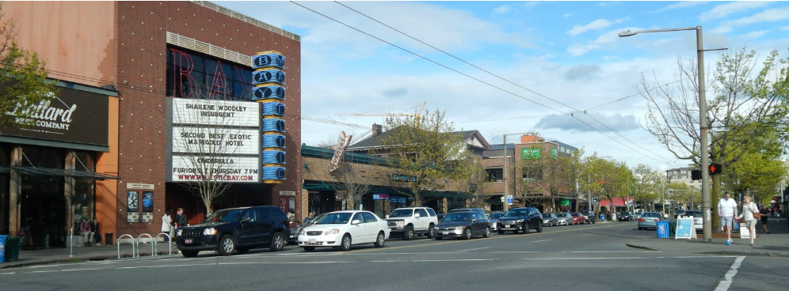

Join us at our upcoming drop-in session!

Tuesday, December 3
5-7 PM
Ballard Library
5614 22nd Ave NW

Drop in any time to learn more about the project and talk to the project team. We hope to see you there!

Contact:
www.seattle.gov/transportation/NWMarketPaving
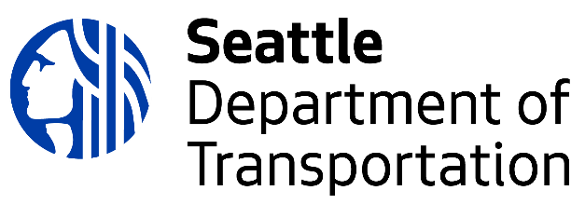
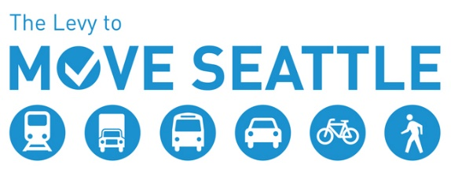
NWMarket@seattle.gov | (206) 775-8824

