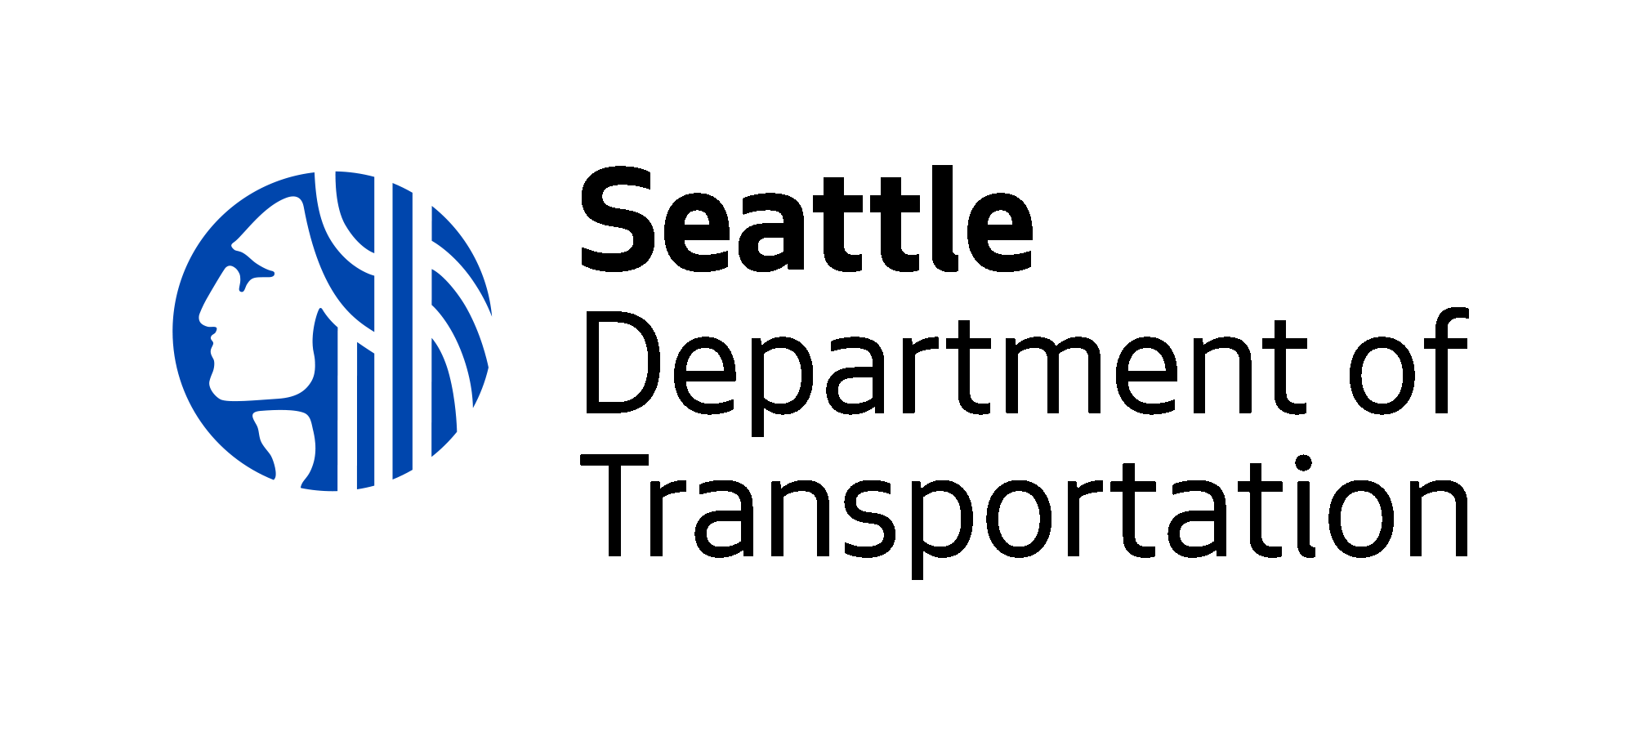
City of Seattle
Policy & Operations Advisory Group

POAG Meeting Agenda — January 2021 (Meeting #6)

Thursday, January 28, 2021
6:00 PM – 8:00 PM
Electronic Meeting

Panelists (POAG members and staff): https://seattle.webex.com/seattle/onstage/g.php?MTID=e199510345c22c68bc7a8e8d161657744

Attendees (general public):
https://seattle.webex.com/seattle/onstage/g.php?MTID=e5430cdf8a2319d249b96a679a0f19222

6:00 PM Welcome
SDOT Director Sam Zimbabwe

6:15 PM Modal Integration Policy Framework & Future Implementation
-Policy Framework and review of draft language
-Next Steps: near-term and longer-term implementation
-Feedback & discussion

7:30 PM Discussion of POAG experience

7:55 PM Wrap-up, next steps, and appreciation

This POAG meeting will be held via Webex Events. No download is needed to join the meeting – the meeting can be attended through your web browser.

If you have any questions, please email ellie.smith@seattle.gov.

